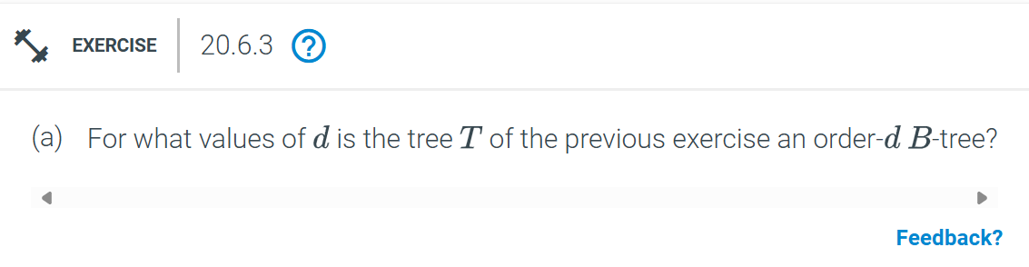
Values of a and b for (a, b) tree
a = 5
b = 8
Value of d for ordered B-tree
d = 5
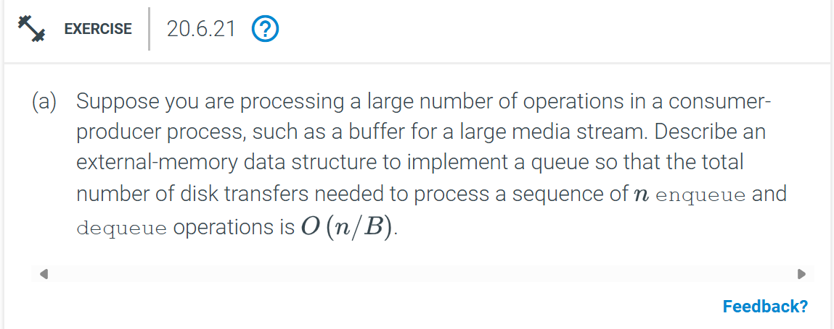
We can use a circular buffer stored in external memory with block size B
Each enqueue and dequeue operation only moves data in blocks of size B
Total disk transfers: O(n/B)
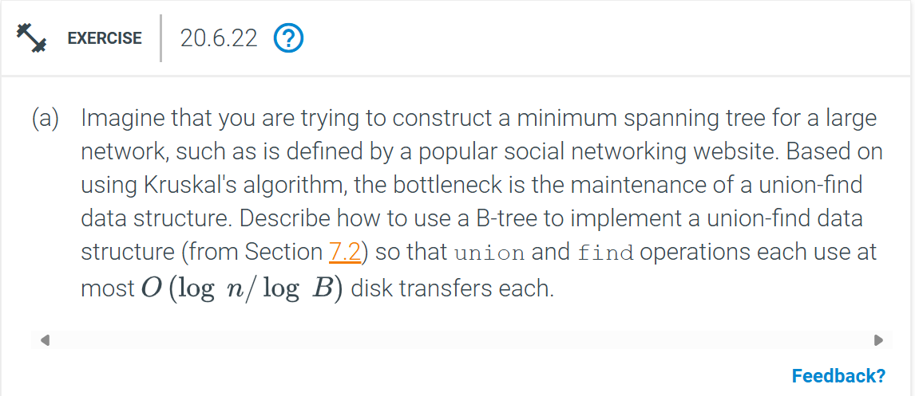
We can store each tree in the union-find structure as a node in a B-tree with block size B
Each union and find operation takes O(log n / log B) disk transfers
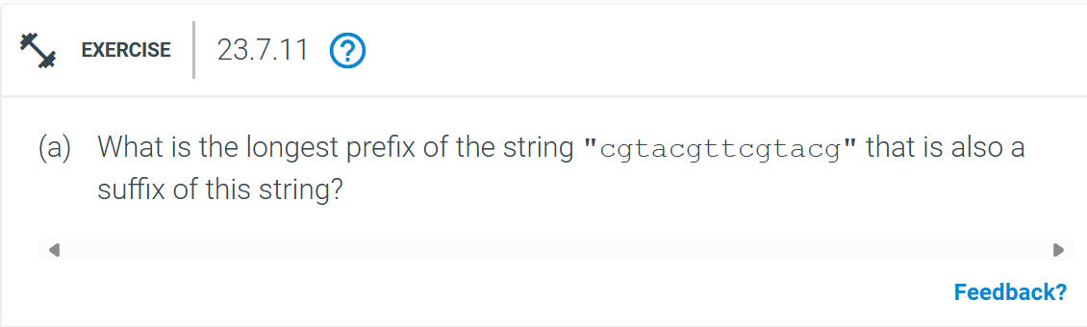
The longest prefix is cgtacg.
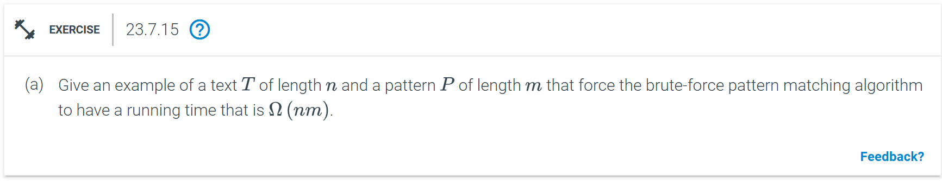
Text T: `aaaa...aaab` (length n, with n-1 occurrences of `a` followed by one `b`)
Pattern P: `aaa...aaa` (length m, with m occurrences of `a`)
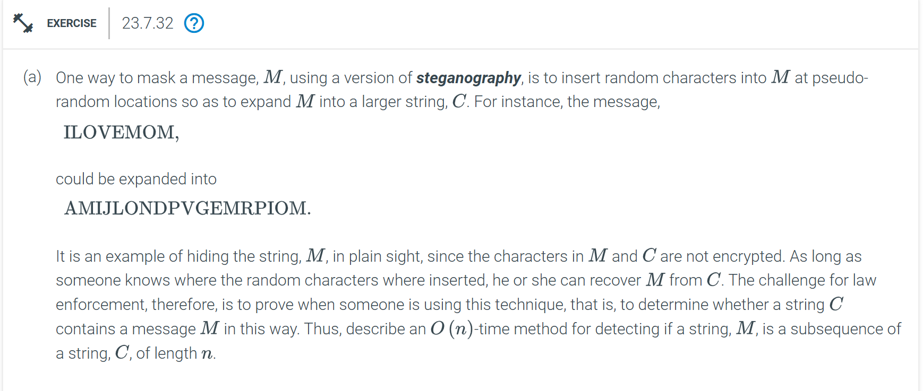
Pseudo-code
Initialize pointers i = 0 for M and j = 0 for C
While i < m and j < n
If M[i] = C[j] increment i
Increment j
If i = m return true
Else return false

