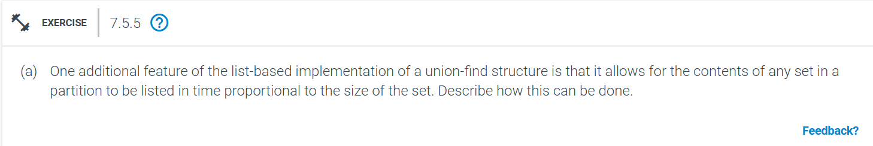
In a list-based union-find (also known as disjoint-set data structure), the goal is to keep track of elements partitioned into disjoint sets, allowing efficient union and find operations. To implement an additional feature of listing the contents of any set in time proportional to the size of the set, a suitable modification to the union-find structure is required.
Algorithm:

1. Union Operation:
- Find the representative elements (leaders) of the two sets using path compression.
- Compare the sizes of the two sets. Attach the smaller set's linked list to the larger set's list.
- Update the size of the larger set's leader.
- Maintain the head of the larger set as the representative of the union.
2. Find Operation:
- Use path compression to directly link elements to their set leader (representative).
3. Listing the Elements of a Set:
- To list the elements of any set, first find the set's representative (leader) using the find operation.
- Then, starting from the head of the linked list of that leader, traverse the linked list and collect all elements.
- This operation takes time proportional to the size of the set, since we visit each element exactly once.
Time Complexity:
- Union by size: O(log n) in the worst case due to union by size and path compression.
- Find operation with path compression: O(log n) (inverse Ackermann function α(n), which grows very slowly and is practically constant).
- Listing elements of a set :O(k), where k is the number of elements in the set. This is proportional to the size of the set, as desired.
By using a linked list for each set and performing union by size, we ensure that listing the contents of any set is efficient and proportional to the size of the set, while union and find operations remain fast.

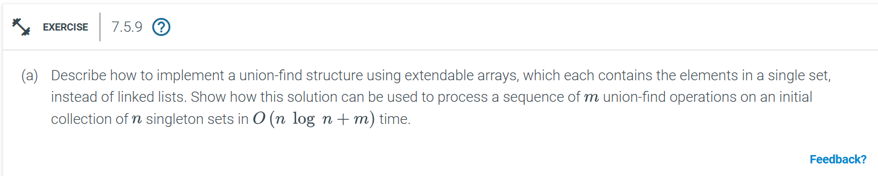

To implement a union-find structure using extendable arrays rather than linked lists, we can use advantage of union by size and path compression to ensure efficient performance for union-find operations. Here’s how the implementation works:
Algorithm:
1. Union Operation:
- First, perform a `find(x)` and `find(y)` to get the representatives (leaders) of the two sets containing `x` and `y`.
- Compare the sizes of the two sets.
- Always apend the smaller set's array to the larger one.
- If `set1.size <= set2.size`, merge `set1` into `set2`.
- Add all elements of the smaller set to the larger set’s array and update the size of the larger set.
- Update the representative of all elements in the smaller set to point to the representative of the larger set.
2. Find Operation:
- Traverse up the parent pointers until the representative (leader) of `x` is found.
- Apply path compression to flatten the structure, making future `find` operations more efficient. In path compression, every element traversed points directly to the set leader.
3. Union-Find Initialization:
- Initialize `n` sets, each containing a single element. This means every element is its own representative initially, and the array for each set contains just one element.
Time Complexity Analysis:
Union by Size and Path Compression: The time complexity of each `find` operation is almost constant, technically O(log n) due to the use of path compression, which flattens the tree structure over time. The union operation takes time proportional to the size of the smaller set being merged into the larger set. Since every element can only be merged into a larger set a limited number of times (logarithmic number of times due to union by size), the overall cost of all union operations is (O(nlog n) for an initial collection of n elements.
Sequence of Union-Find Operations:
- Suppose we perform m union-find operations. The total running time for all operations is bounded by O(nlog n + m):
- O(nlog n) is the cost of performing n-1 unions on the n elements, because union-by-size ensures efficient merging.
- O(m) is the cost for processing m operations. Most of these will be constant-time find operations due to path compression.

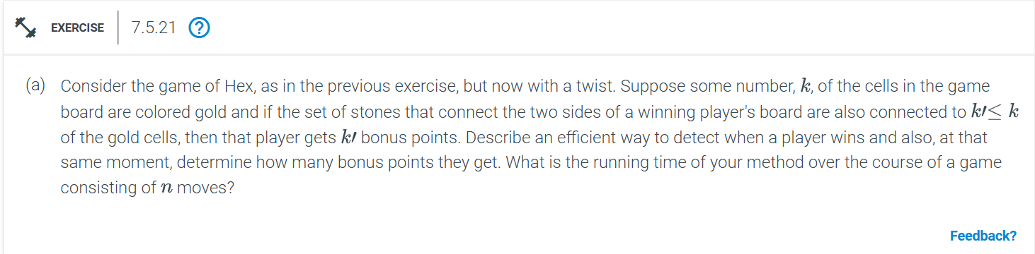

We need to:
1. Detect when a player wins (forms a connecting path between opposite sides of the board).
2. At the same moment, determine how many gold cells their winning path connects to, awarding them bonus points accordingly.
Using Union-Find with Gold Cell Tracking we can approach the issue as:
1. Union-Find with Connected Components:
Union-find can efficiently track connected components of the player's stones.
Each player has two virtual nodes: one for each side of the board they aim to connect. For example, for player 1:
A virtual node for the top side and one for the bottom side.
During the game, when a player places a stone, you perform `union` operations to merge this stone with its neighboring stones (if they belong to the same player). This keeps track of which stones are connected.
2. Tracking Gold Cells:
Modify the union-find structure to also track the number of gold cells in each connected component. Each set in the union-find structure will store:
Gold count: The number of gold cells in that component.
Connected to virtual nodes: Whether the component is connected to either side of the board via the virtual nodes.
3. Detecting a Win:
- A player wins when their stone component connects the two virtual nodes (i.e., top and bottom sides for player 1).
- After each move:
- Check if the component containing the newly placed stone connects the two virtual nodes. If it does, the player has won.
4. Counting Gold Cells:
- When the player wins (the two virtual nodes are connected), you can directly access the gold count for that component. This will give you the number of gold cells in the winning path.
Time Complexity Analysis:
Union-Find Operations:
- Each union-find operation (union or find) takes O(alpha(n)), where (alpha(n)) is the inverse Ackermann function, which is extremely slow-growing and can be considered constant for all practical purposes.
-Over the Course of the Game:
- There are n moves in the game (one per player placing a stone).
- Each move involves a constant number of union and find operations (at most 4 neighbors for each placed stone).
- Hence, each move takes O(alpha(n), so processing all n moves takes O(nalpha(n)).
- Gold Cell Count:
- The gold count is maintained and updated during each union operation, which involves summing the counts of the two sets being merged. This operation is constant time per union, so it does not add to the complexity.
Total Running Time:
The total time complexity for processing all n moves is O(nalpha(n)), which is very close to linear time since alpha(n) is extremely slow-growing and effectively constant for all practical purposes.
This approach ensures efficient detection of the winning condition while also keeping track of bonus points from gold cells.
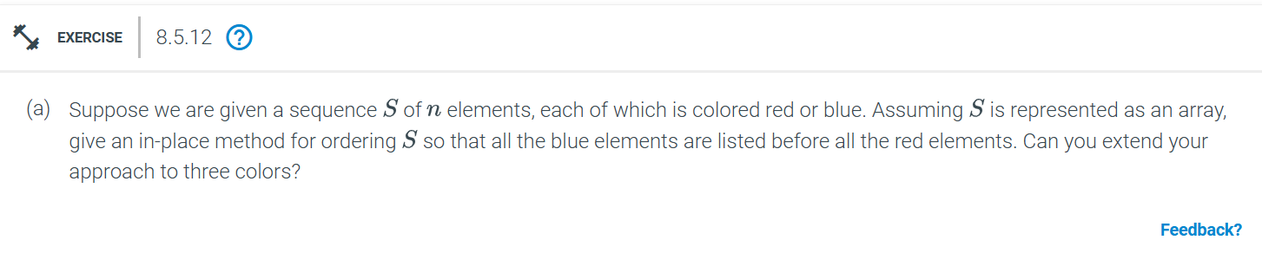
We can reorder the array in-place, which means we want to avoid using any extra space for a separate array.
Part 1: Two-Color Sorting (Red and Blue)
This is a variation of the partition problem (used in the quicksort algorithm) and can be solved using a two-pointer technique. The goal is to place all the blue elements before the red ones.

def partition_two_colors(S):
left, right = 0, len(S) - 1
while left <= right:
if S[left] == 'blue':
left += 1
elif S[right] == 'red':
right -= 1
else:
# Swap red at left with blue at right
S[left], S[right] = S[right], S[left]
left += 1
right -= 1

Time Complexity: O(n), where n is the length of the array.
Space Complexity: O(1), since we are sorting the array in-place without using extra space.
Part 2: Three-Color Sorting (e.g., Red, Blue, and Green)
def partition_three_colors(S):
low, mid, high = 0, 0, len(S) - 1
while mid <= high:
if S[mid] == 'blue':
S[low], S[mid] = S[mid], S[low] # Swap blue to the front
low += 1
mid += 1
elif S[mid] == 'green':
mid += 1 # Keep green in the middle
else: # S[mid] == 'red'
S[mid], S[high] = S[high], S[mid] # Swap red to the back
high -= 1

- Time Complexity: O(n), since each element is processed at most once.
- Space Complexity: O(1), since no extra space is used besides a few pointers.
This approach efficiently sorts the array with three colors in linear time and constant space.
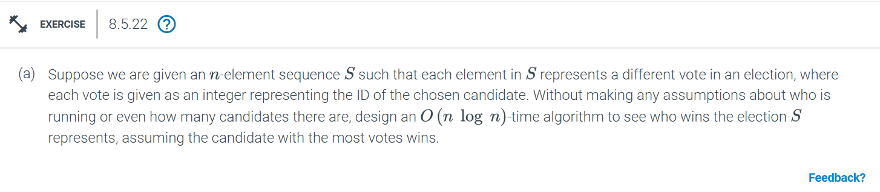
We can use a two-step process. The first step involves counting the votes for each candidate, and the second step involves determining the candidate with the maximum votes.

Pseudocode for Sorting-Based Approach:
def find_winner(S):
# Step 1: Sort the votes (O(n log n))
S.sort()

# Step 2: Count the votes for each candidate (O(n))
max_votes = 0
current_votes = 1
winner = S[0] # Assume the first candidate is the winner initially

for i in range(1, len(S)):
if S[i] == S[i - 1]:
current_votes += 1
else:
if current_votes > max_votes:
max_votes = current_votes
winner = S[i - 1]
current_votes = 1 # Reset the vote count for the new candidate

# Check the last candidate's vote count
if current_votes > max_votes:
winner = S[-1]

return winner
Step 1 sorts the array in O(nlog n).
Step 2 iterates through the sorted array to count votes, which takes O(n).
- The total time complexity is O(nlog n).
The sorting-based solution is O(n log n), and is less optimal than the hash map-based solution, which runs in O(n). However, the sorting approach is still valid if hash maps are not allowed or if we want to stick to comparison-based methods.

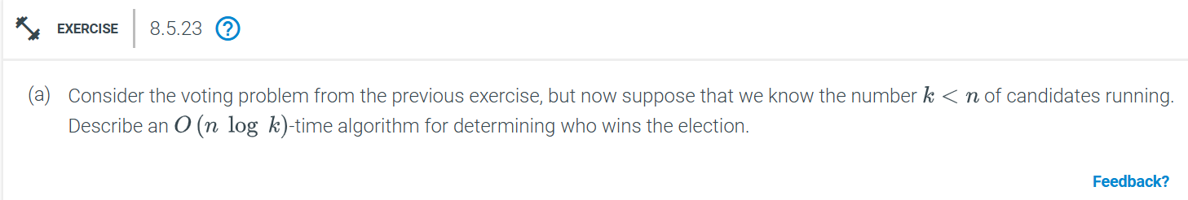
When we know there are k candidates running in the election (with k < n), we can improve upon the previous solution and achieve a time complexity of O(n log k) by using a balanced binary search tree (BST) or a heap (priority queue) to track the votes.
Pseudocode:
from collections import defaultdict
import heapq

def find_winner_with_k_candidates(votes, k):
# Step 1: Count votes using a dictionary
vote_counts = defaultdict(int)

for vote in votes:
vote_counts[vote] += 1

# Step 2: Maintain top-k candidates in a min-heap
heap = []
for candidate, count in vote_counts.items():
heapq.heappush(heap, (-count, candidate)) # Use -count to simulate max-heap

# Step 3: Find the candidate with the most votes
most_votes, winner = heapq.heappop(heap)
return winner
This algorithm has the total time complexity is O(n log k), leveraging the fact that there are only k candidates, making the vote count updates more efficient than processing each candidate separately.
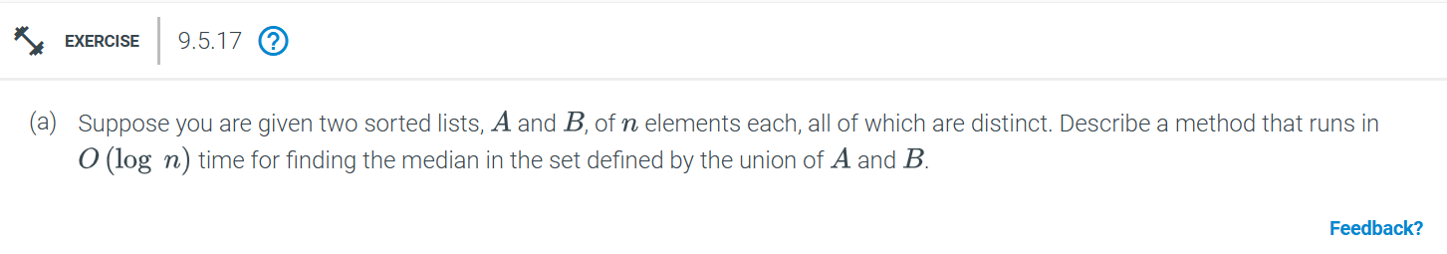
To find the median of the union of two sorted lists A and B, each of size n, in O(log n) time, we can use a binary search approach to efficiently locate the median.

def find_median_sorted_arrays(A, B):
n = len(A)

# Ensure A is the smaller array
if len(A) > len(B):
A, B = B, A

low, high = 0, len(A)

while low <= high:
i = (low + high) // 2
j = n - i

A_left = A[i - 1] if i > 0 else float('-inf')
A_right = A[i] if i < n else float('inf')
B_left = B[j - 1] if j > 0 else float('-inf')
B_right = B[j] if j < n else float('inf')

# Valid partition
if A_left <= B_right and B_left <= A_right:
if (2 * n) % 2 == 0:
return (max(A_left, B_left) + min(A_right, B_right)) / 2
else:
return max(A_left, B_left)

# Move the binary search bounds
elif A_left > B_right:
high = i - 1
else:
low = i + 1
Time Complexity:
Binary search on one array takes O(logn).
The partitioning and checking step takes constant time, O(1).
Thus, the overall time complexity is O(log n).
This approach efficiently finds the median in O(log n) time by using binary search to balance the partitions of the two sorted arrays.
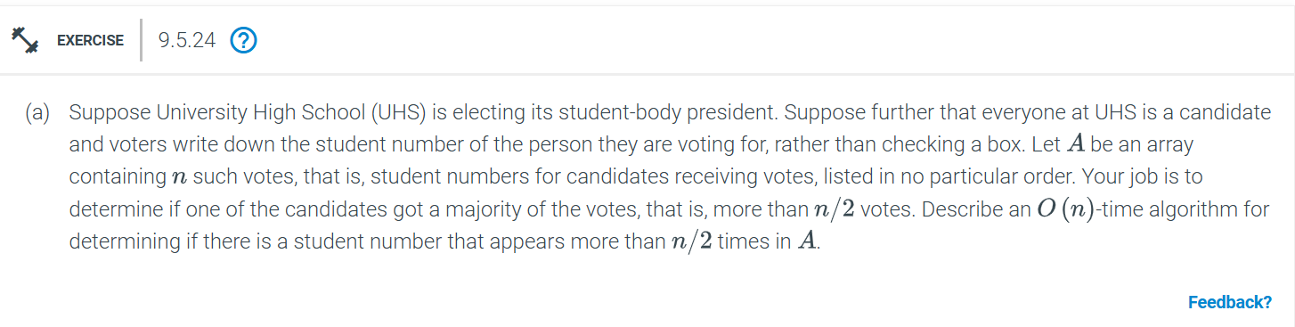
The problem of determining whether there is a student (candidate) who has received a majority of the votes (i.e., more than n/2 votes) can be solved using an following:
Pseudocode:
def find_majority_candidate(A):
n = len(A)

# Step 1: Find a potential majority candidate
candidate = None
count = 0

for num in A:
if count == 0:
candidate = num
count = 1
elif num == candidate:
count += 1
else:
count -= 1

# Step 2: Verify the candidate
count = 0
for num in A:
if num == candidate:
count += 1

# Check if candidate has more than n/2 votes
if count > n // 2:
return candidate
else:
return None # No majority candidate
Time Complexity:
The time complexity of the algorithm is O(n) because we make two passes over the array: one to find the candidate and one to verify it.
The space complexity is O(1), as we only use a few extra variables to keep track of the candidate and count.
This determines whether there is a majority element in the list of votes, using a clever vote cancellation strategy to identify a potential majority candidate in a single pass and then verifying it with a second pass.

