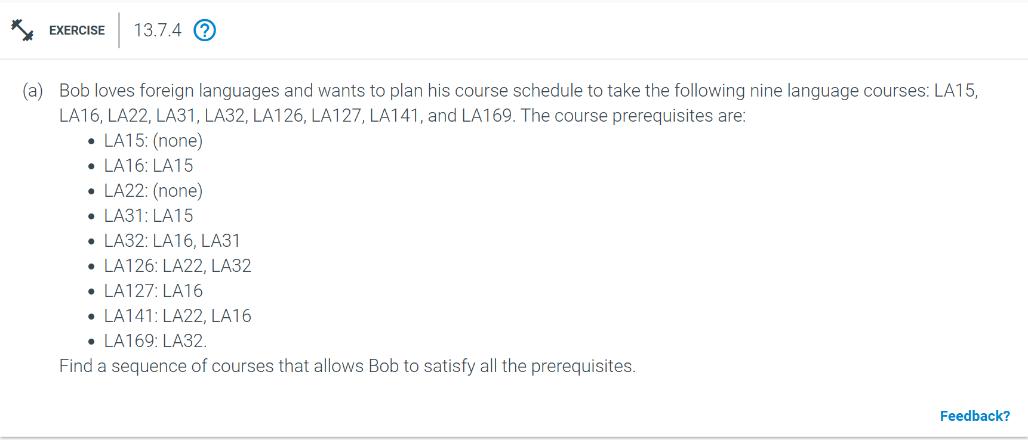
The Sequence in which Bob can satisfy all prerequisities will be:
- LA15
- LA22
- LA16
- LA31
- LA127
- LA141
- LA32
- LA169
- LA126

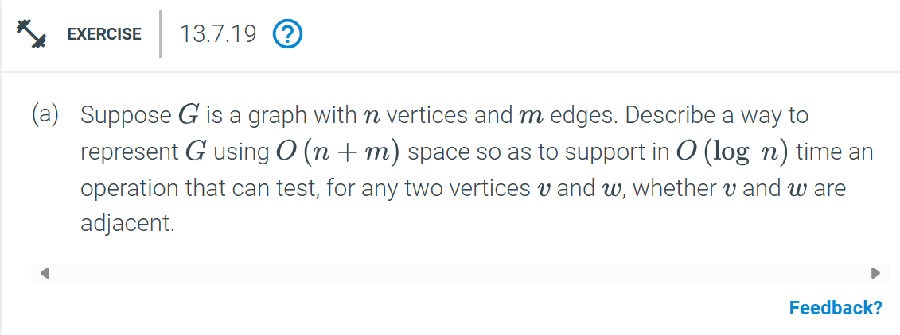

To represent a graph G with n vertices and m edges, we can use an adjacency list.
1. Adjacency List: For each vertex, maintain a sorted list of its neighbours. This representation uses O(n + m) space, as each edge appears only once in the list of each vertex.
2. Testing Adjacency: To check if two vertices v and w are adjacent, we can binary search w in the sorted adjacency list of v (or vice versa). This takes O(log n) time.
**Answer:**
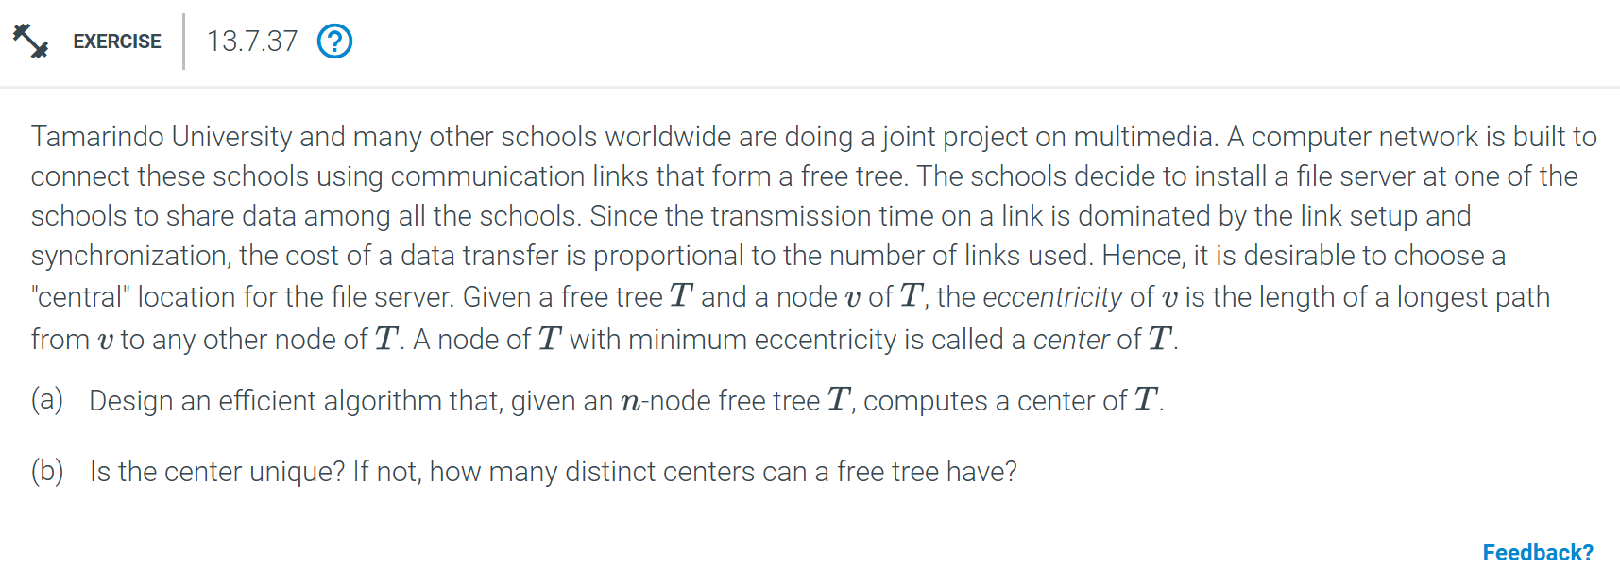
(a) To find the center of an n-node free tree T:
1. Pick an arbitrary node and perform a BFS or DFS to find the farthest node u from it.
2. Perform another BFS or DFS from u to find the farthest node v from u. This path from u to v is the diameter of T.
3. The center of T lies in the middle of this diameter path. If the diameter has an odd length, there will be two central nodes; if even, only one.
Time complexity: O(n)
(b) The center is not necessarily unique. A free tree can have either one or two distinct centers depending on whether the diameter has an odd or even length.
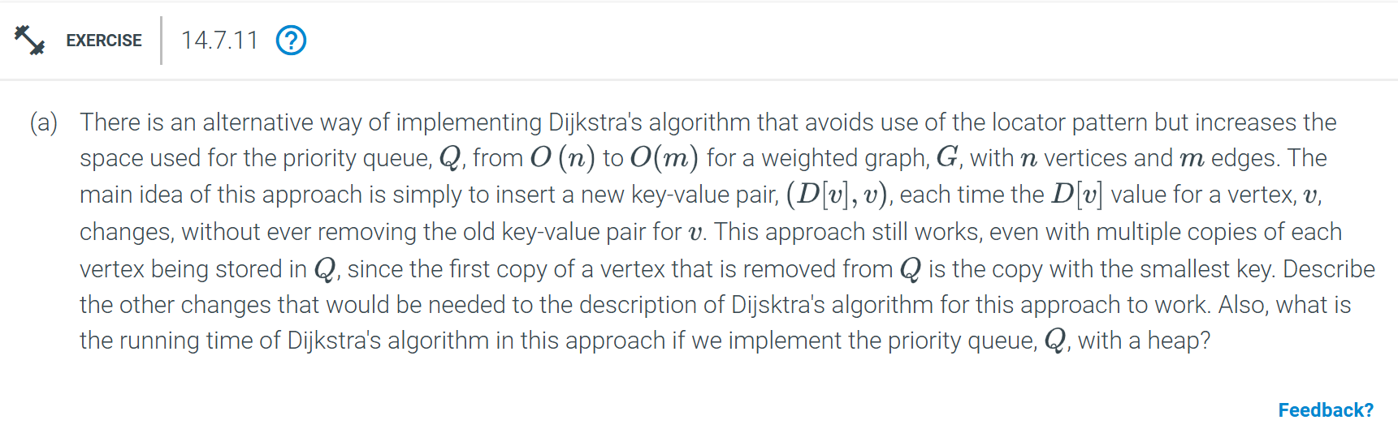
With this approach to Dijkstra’s algorithm, the following changes are required:
1. Each time a vertex v is extracted from the priority queue Q, check if the extracted distance D[v] is the current shortest distance to v . If it is outdated, discard this entry and continue to the next.
2. When updating the distance D[u] of a neighbouring vertex u, simply insert the new key-value pair (D[u], u) into Q without deleting the previous entry.
3. Maintain the condition that the first time a vertex is removed from Q, it is guaranteed to be the minimum distance entry for that vertex.

**Answer:**

To find the minimum-cost monotone path in G,
1. Graph Construction: Represent each game position as a vertex in G with coordinates (x, y), where x is the horizontal position. Ensure edges only connect vertices with x-coordinates that increase, ensuring left-to-right movement.
2. Modified Dijkstra’s Algorithm:
- Initialize a priority queue to store vertices with their cumulative path costs.
- Begin from the starting position with an initial cost of zero.
- For each vertex v with current minimum cost D[v], relax only the edges e = (v, w) where x(w) > x(v), meaning w is to the right of v.
- If D[w] (cumulative path cost to (w) decreases by moving through e, update D[w] and add (D[w], w) to the priority queue.
3. Termination: Continue the above steps until the ending position is extracted from the priority queue with its minimum cost, which represents the minimum-cost monotone path.
Time Complexity: Since we only consider left-to-right edges, the algorithm runs in O((n + m)log n)), where n is the number of vertices and m the number of edges.
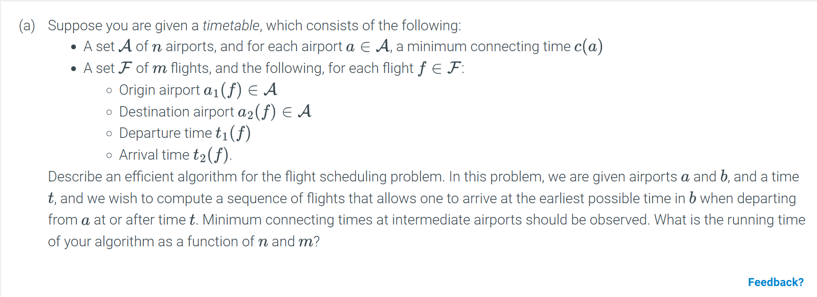
We can use a modified version of Dijkstra’s algorithm for the earliest arrival path in a time-scheduled network.
1. Initialize:
- Create a priority queue Q.
- For each airport x in A, initialize arrival[x] = infinity.
- Set arrival[a] = t (starting airport at time t and insert (t, a) into Q.
2. Dijkstra's Algorithm with Flight Constraints:
- While Q is not empty:
1. Extract the airport x with the earliest arrival time from Q.
2. For each outgoing flight f from x:
- Let y be the destination airport a2(f) and t1(f) the departure time of f.
- If t1(f) >= arrival[x] + c(x) (ensuring minimum connecting time is observed):
- Calculate the new arrival time at y: new_arrival = t2(f).
- If new_arrival < arrival[y]:
- Update arrival[y] = new_arrival .
- Insert (new_arrival, y) into Q.

3. Termination:
- The algorithm stops once Q is empty or the destination airport b is reached.
- The earliest arrival time in b is stored in arrival[b].
Running Time:
- The algorithm has a running time of O((n + m) log n), where n is the number of airports and m the number of flights, due to the priority queue operations and edge relaxations.

