**4.8** **Diagram**

## UseCase Diagram

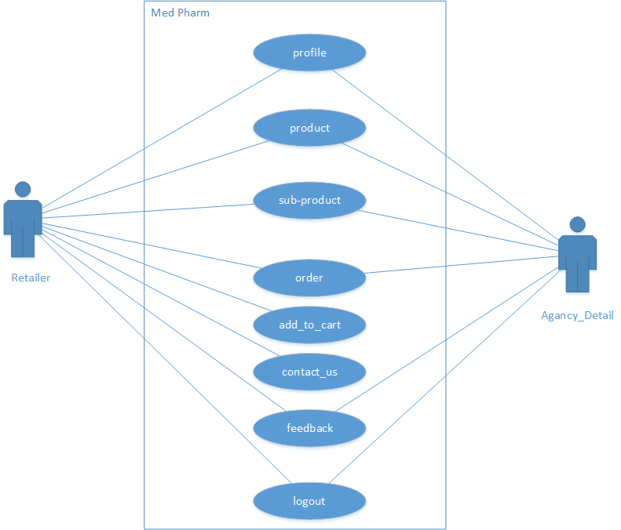

**Figure 4.1** Use Case Diagram

## Class Diagram

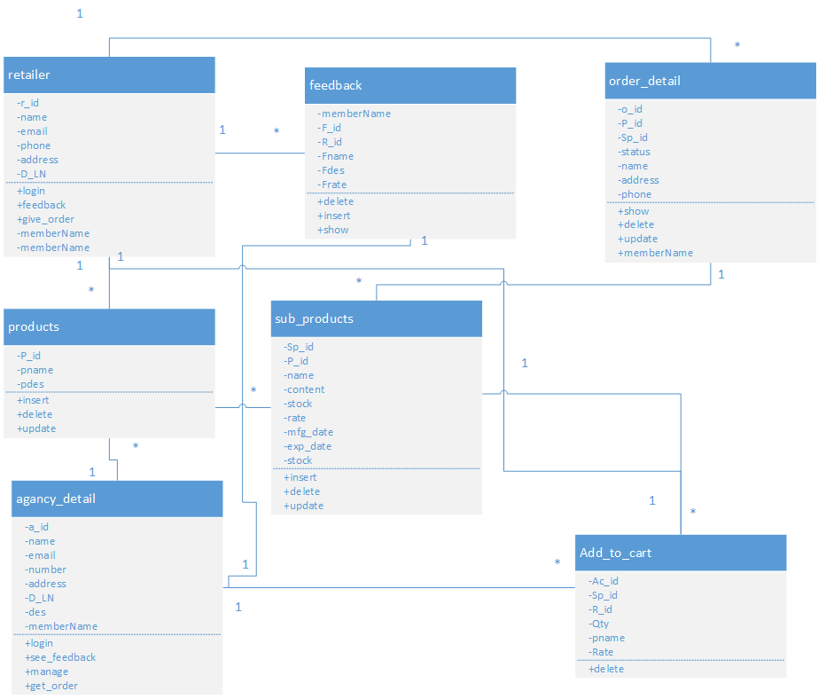

**Figure 4.2** Class Diagram

## E-R Diagram

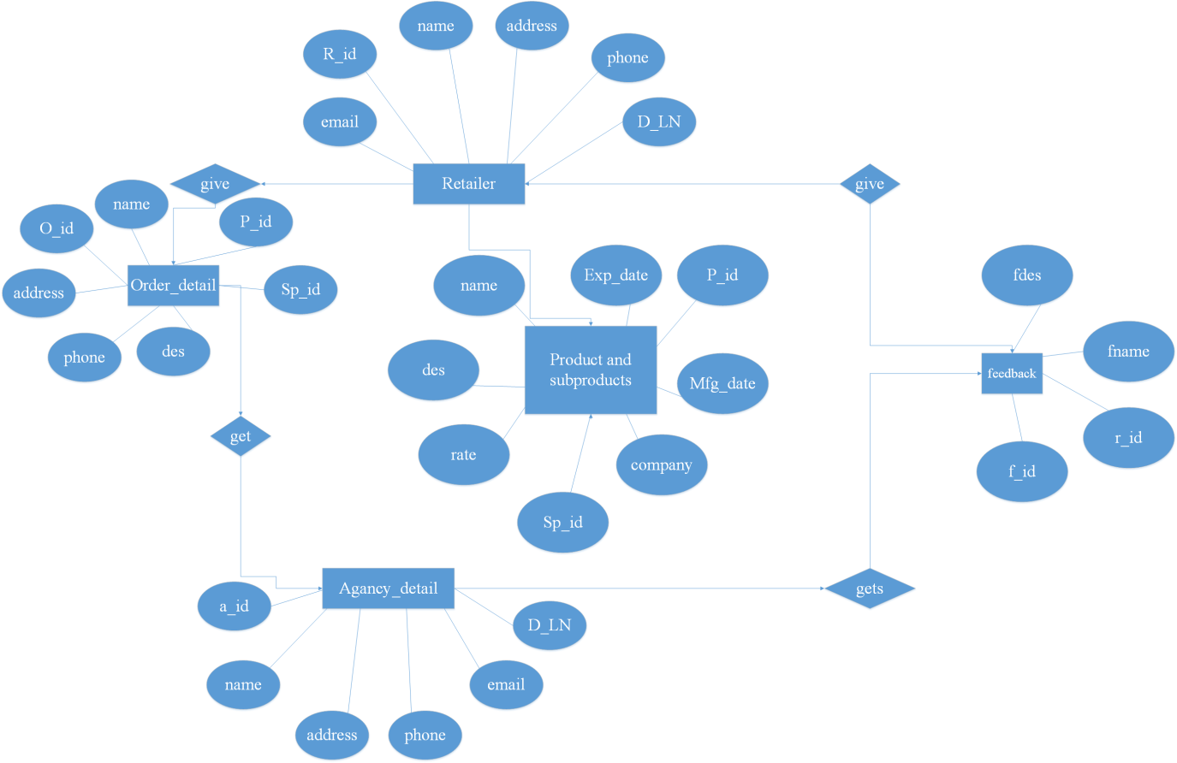

**Figure 4.3 E-R** Diagram

## Activity Diagram

**Activity for stokiest**

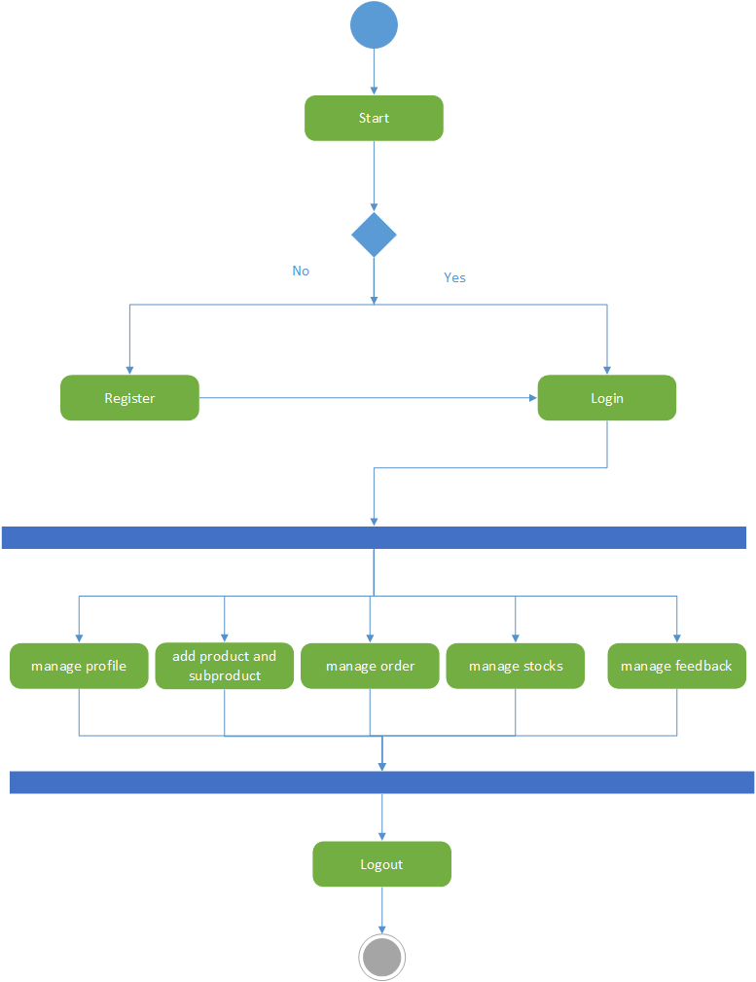

**Figure 4.4** Activity Diagram for stokiest

**Activity for retailer**

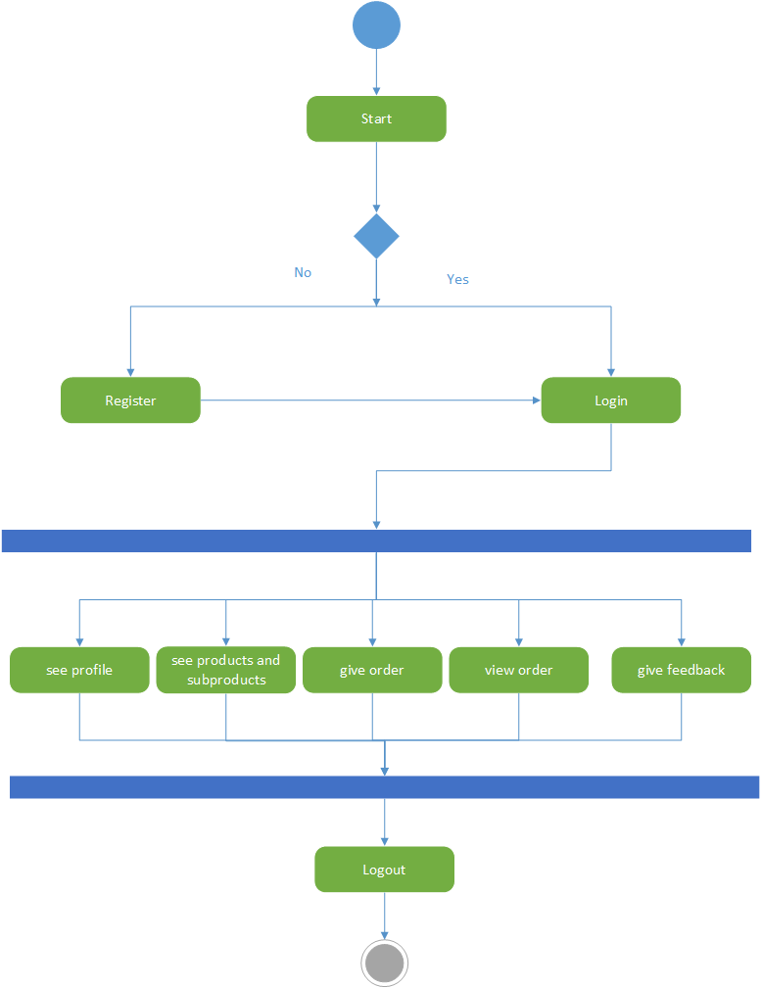

**Figure. 4.5** Activity Diagram for retailer

## Sequence Diagram

## Sequence Diagram for retailer

## C:\Users\MANAN\Downloads\DS\2nd Presentation\seq_retailer.png

## 

**Figure.4.6** Sequence Diagram for retailer

**Sequence Diagram for stokiest**

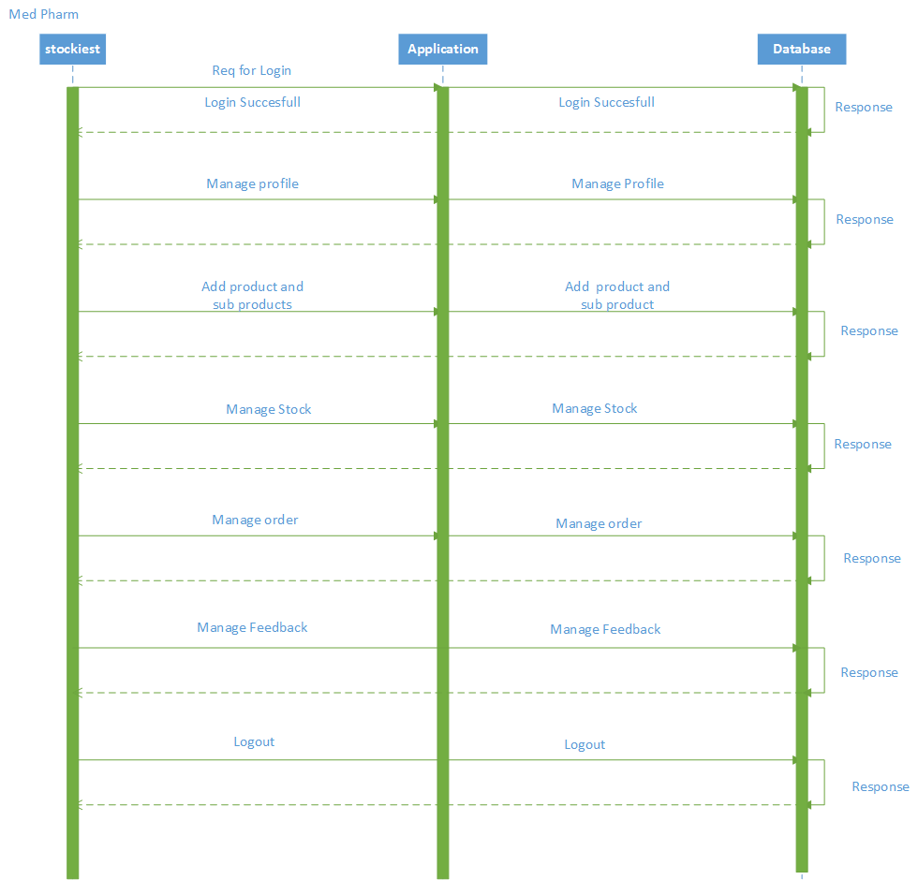

**Figure.4.7** Sequence Diagram for stokiest

## Data Flow Diagram

**DFD 0**

**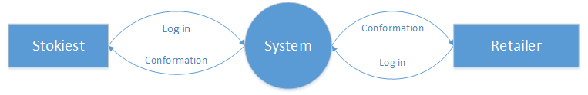**

**Figure.4.8** DFD 0

DFD 1

**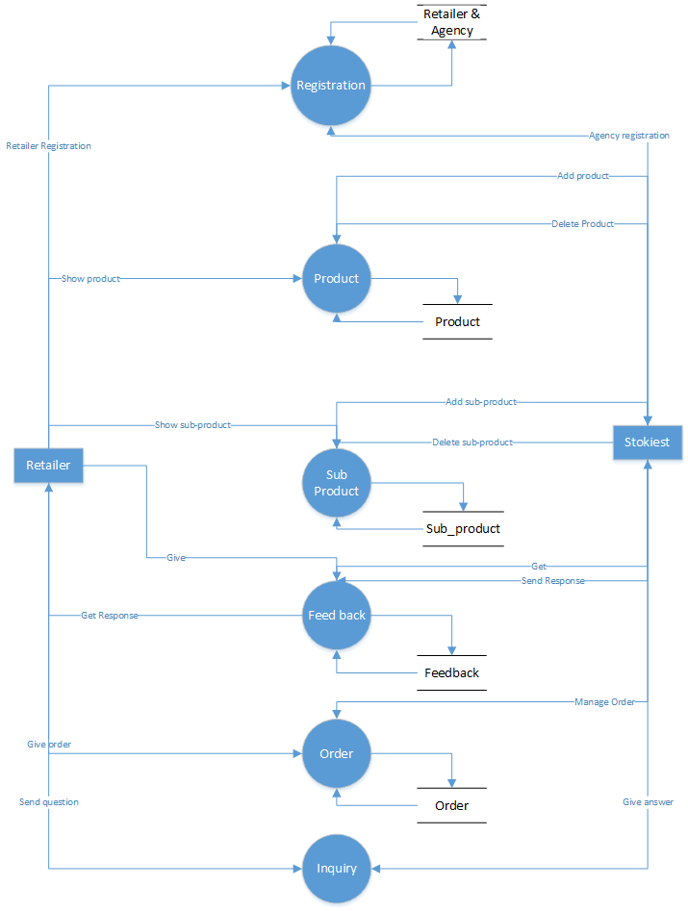**

**Figure.4.9** DFD 1