## 5.3 Input/Output and Interface Design

**5.3.1 Samples of Form Report and interface**

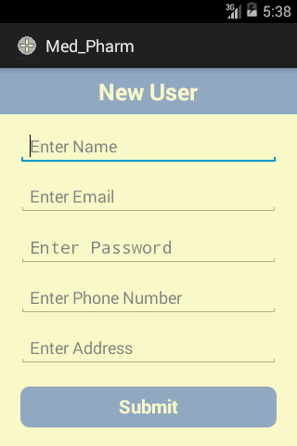 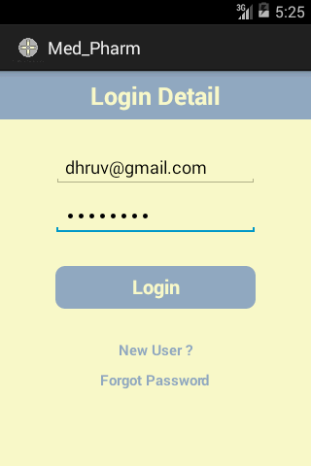

Figure 5.1 New User Registration Figure 5.2 Login Page

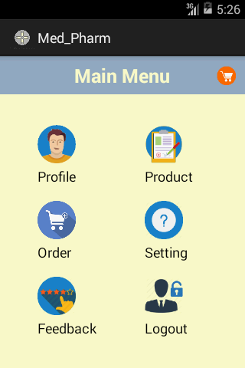  Figure 5.3 Menu Page Figure 5.4 Profile Page

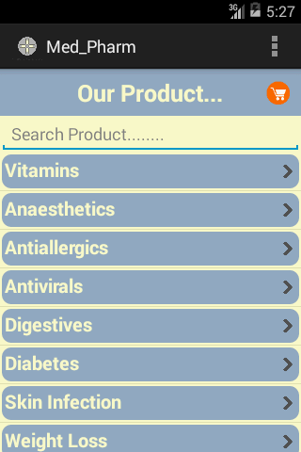 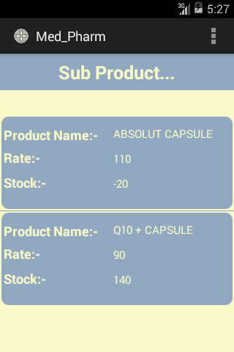

Figure 5.5 Product Page Figure 5.6 Sub_Products Page

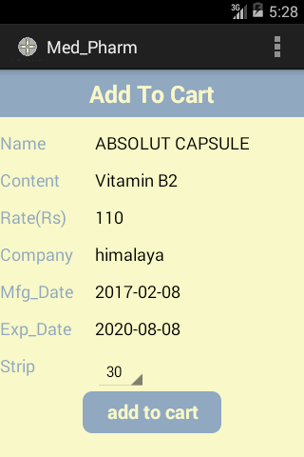 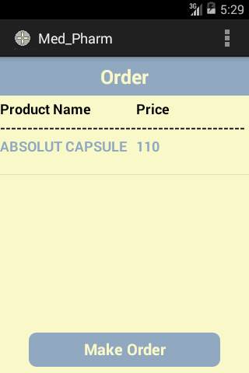

Figure 5.7 Detail Sub_Product Figure 5.8 Add_To_Cart

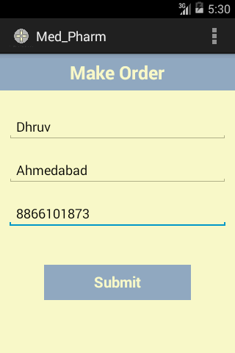 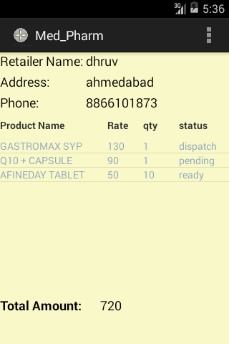

Figure 5.9 Make Order Figure 5.10 View Order

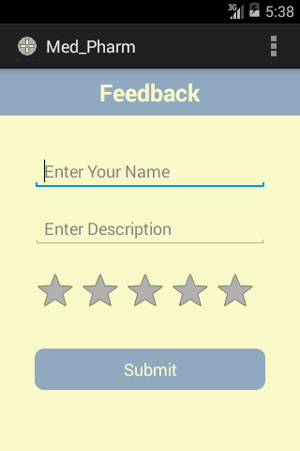 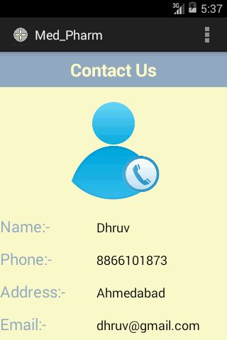

Figure 5.11 Feedback Figure 5.12 Contact Us

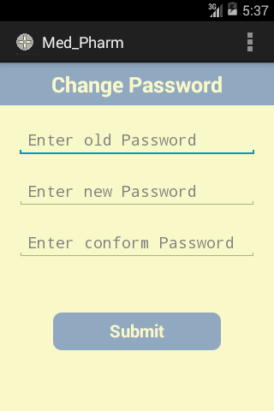

Figure 5.13 Change Password