M5-A1 – Database Management
Section A – Concept Application
Answers

Question 1 – Justify your constraint choices for at least three columns across two tables. What data integrity problems would arise if these constraints were not applied?
For a food delivery application, constraints are used to maintain data integrity and prevent invalid or inconsistent data.
1. restaurant_id – PRIMARY KEY:
The restaurant_id should be the PRIMARY KEY of the restaurants table. It uniquely identifies every restaurant. A PRIMARY KEY does not allow duplicate or NULL values. Without it, two restaurants could have the same identifier, making it difficult to identify the correct restaurant.
2. name – NOT NULL:
The restaurant name should be NOT NULL because every restaurant record should have a name. Without the NOT NULL constraint, a restaurant could be stored without a name, resulting in incomplete data.
3. restaurant_id in menu_items – FOREIGN KEY:
The restaurant_id in the menu_items table should be a FOREIGN KEY referencing restaurant_id in the restaurants table. This ensures that every menu item is linked to an existing restaurant. Without this constraint, a menu item could reference a restaurant that does not exist, creating an invalid relationship.
Therefore, PRIMARY KEY, NOT NULL and FOREIGN KEY constraints help maintain uniqueness, completeness and valid relationships between tables.

Question 2 – Explain why the WHERE clause is essential in each DML statement. What could go wrong with an UPDATE or DELETE executed without a proper WHERE condition?
The WHERE clause is important in UPDATE and DELETE because it tells the database which specific records to change or delete.
For example:
- We want to change only orders that are more than 7 days old and have status 'Pending' to 'Cancelled'.
- We want to delete only menu items that are 'Unavailable' and belong to closed restaurants.
The WHERE condition makes sure that only these required records are affected.
If we use UPDATE without WHERE, all records in the table may be updated.
If we use DELETE without WHERE, all records in the table may be deleted.
Therefore, the WHERE clause protects the database from accidentally changing or deleting unwanted data.

Question 3 – Which SQL clauses and aggregate functions would you use to produce this report? Explain why HAVING must be used here rather than WHERE to filter by aggregate results. For the revenue dashboard, aggregate functions are required to calculate information for each restaurant.
The following aggregate functions can be used:
- SUM(total_amount) – calculates total revenue for each restaurant.
- AVG(total_amount) – calculates the average order value for each restaurant.
- COUNT(order_id) – calculates the number of orders processed by each restaurant.
GROUP BY restaurant_id (or restaurant name) is used to create one result group for each restaurant.
A HAVING clause is required to filter restaurants that have processed more than 20 orders because the condition is based on an aggregate result such as COUNT(order_id).
WHERE is used to filter individual rows before grouping and aggregation. HAVING is used after GROUP BY to filter groups based on aggregate values.
Therefore, the query would conceptually use SELECT with COUNT(), SUM(), AVG(), GROUP BY and HAVING.

Question 4 – Compare INNER JOIN and LEFT JOIN for this query. Which would you use and why? Describe what each join type does to records that have no match in the other table.INNER JOIN and LEFT JOIN handle unmatched records differently.
INNER JOIN returns only the records where a matching restaurant exists in the restaurants table. If an order references a restaurant that is no longer present in the restaurants table, that order will not appear in the INNER JOIN result.
LEFT JOIN returns every record from the left table, which in this case is the orders table. If an order does not have a matching restaurant in the restaurants table, the order is still displayed, but the restaurant columns contain NULL values.
For the order history page, LEFT JOIN should be used because the requirement is to show every order, including orders that reference a restaurant no longer in the restaurants table.
In short:
• INNER JOIN → only matching records.
• LEFT JOIN → all records from the left table, plus matching records from the right table; unmatched right-side values become NULL.

Question 5 – Justify why a VIEW is preferred over direct table access here. What are two limitations the front-end developer should be aware of when working with this VIEW?A VIEW is preferred when the front-end team needs a simplified and controlled way to access database information.
A VIEW shows only the required data to the front-end, such as restaurant name, total orders, and average rating. It hides unnecessary database details.
Two limitations:
- If the original tables or columns change, the VIEW may stop working.
- A summary VIEW usually cannot be directly used to insert or update data.
Therefore, a VIEW makes data easier and safer for the front-end to use.

Question 6 – Which database mechanism should have prevented this inconsistency? Explain how COMMIT, ROLLBACK, and SAVEPOINT work together to ensure both operations succeed or neither takes effectThe payment module should use transaction control to ensure that the wallet deduction and payment record insertion are treated as one logical operation.
The transaction control mechanism should prevent this inconsistency.
- COMMIT: Saves all changes permanently when both operations are successful.
- ROLLBACK: Cancels all changes if any operation fails.
- SAVEPOINT: Creates a temporary point to which we can roll back if an error occurs.
Process: Start transaction → Deduct wallet → Insert payment → COMMIT if successful. If any step fails → ROLLBACK.
This ensures that the wallet deduction and payment record are both completed or neither is completed.

Section B — Practical Coding Tasks
-- Task 1
CREATE DATABASE foodapp_db;
CREATE TABLE restaurants (
restaurant_id INT AUTO_INCREMENT PRIMARY KEY,
name VARCHAR(100) NOT NULL,
city VARCHAR(50),
cuisine_type VARCHAR(50),
rating DECIMAL(3,1)
);
INSERT INTO restaurants (name, city, cuisine_type, rating) VALUES
('Spice Garden', 'Ahmedabad', 'Indian', 4.5),
('Pizza House', 'Mumbai', 'Italian', 4.2),
('Royal Kitchen', 'Delhi', 'North Indian', 4.7),
('Tasty Bites', 'Ahmedabad', 'Fast Food', 4.0),
('Green Leaf', 'Mumbai', 'Vegetarian', 4.3),
('Food Palace', 'Delhi', 'Chinese', 4.1);
-- Update one restaurant
UPDATE restaurants SET rating = 4.7 WHERE restaurant_id = 1;
-- Delete one restaurant
DELETE FROM restaurants WHERE restaurant_id = 6;
-- Display restaurants sorted by rating
SELECT * FROM restaurants ORDER BY rating DESC;

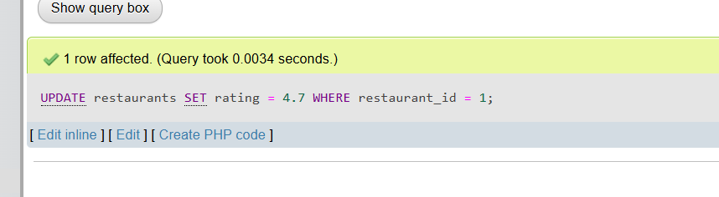
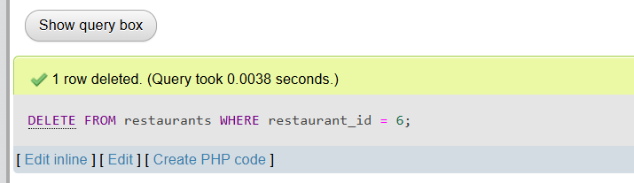
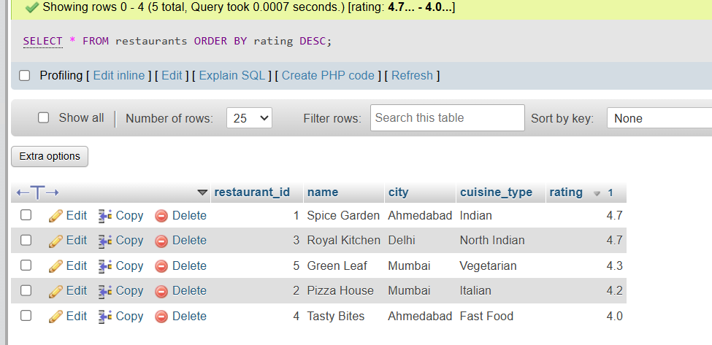
-- Task 2

CREATE TABLE orders (
order_id INT AUTO_INCREMENT PRIMARY KEY,
restaurant_id INT,
customer_name VARCHAR(100),
total_amount DECIMAL(10,2),
order_date DATE
);
INSERT INTO orders
(restaurant_id, customer_name, total_amount, order_date)
VALUES
(1, 'Rahul', 1200, '2026-09-01'),
(1, 'Priya', 1800, '2026-09-02'),
(1, 'Amit', 1500, '2026-09-03'),
(2, 'Neha', 2200, '2026-09-04'),
(2, 'Riya', 1900, '2026-09-05'),
(2, 'Karan', 1600, '2026-09-06'),
(3, 'Vishal', 2500, '2026-09-07'),
(3, 'Meera', 2100, '2026-09-08'),
(3, 'Arjun', 1800, '2026-09-09'),
SELECT
restaurant_id,
SUM(total_amount) AS total_revenue,
AVG(total_amount) AS average_order_value
FROM orders
GROUP BY restaurant_id;

SELECT
restaurant_id,
SUM(total_amount) AS total_revenue
FROM orders
GROUP BY restaurant_id
HAVING SUM(total_amount) > 5000;

SELECT * FROM orders ORDER BY order_date DESC LIMIT 5;

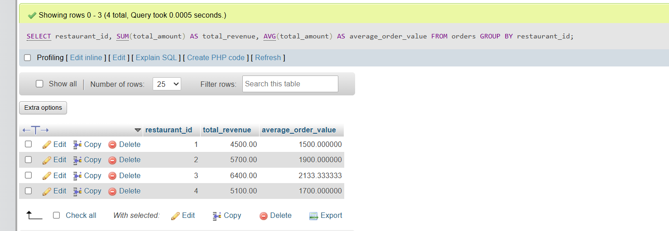
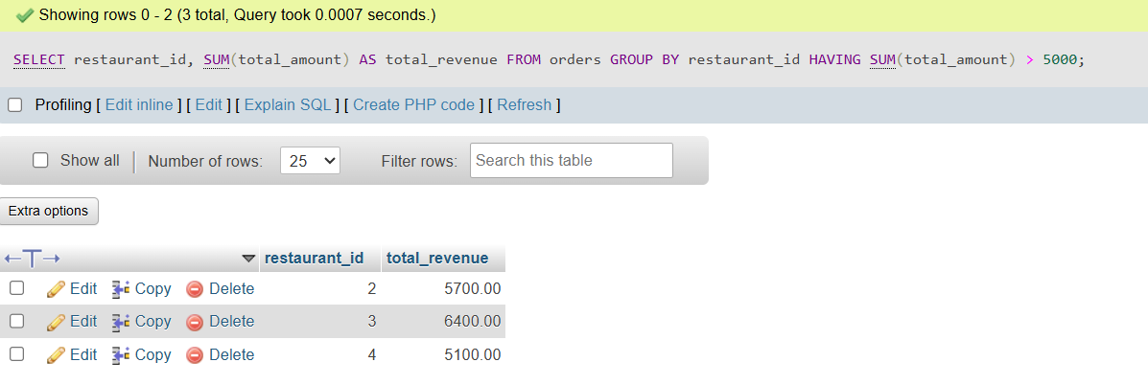
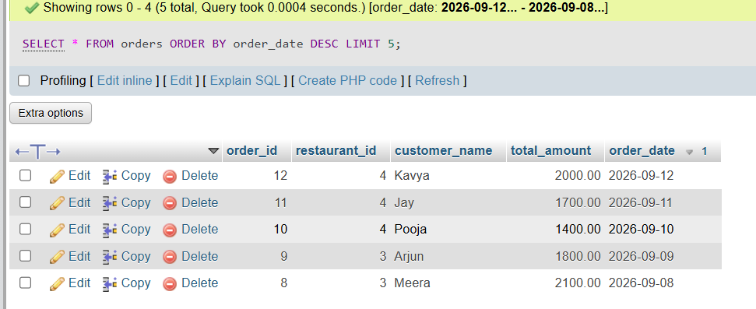

-- Task 3

CREATE TABLE menu_items (
item_id INT AUTO_INCREMENT PRIMARY KEY,
restaurant_id INT,
item_name VARCHAR(100),
price DECIMAL(10,2),
category VARCHAR(50),
FOREIGN KEY (restaurant_id)
REFERENCES restaurants(restaurant_id)
);

INSERT INTO menu_items
(restaurant_id, item_name, price, category)
VALUES
(1, 'Paneer Tikka', 250, 'Starter'),
(1, 'Butter Naan', 80, 'Bread'),
(1, 'Veg Thali', 300, 'Main Course'),
(2, 'Margherita Pizza', 350, 'Pizza'),
(2, 'Farmhouse Pizza', 450, 'Pizza'),
(2, 'Garlic Bread', 180, 'Starter'),
(3, 'Butter Chicken', 450, 'Main Course'),
(3, 'Biryani', 350, 'Rice'),
(3, 'Tandoori Chicken', 500, 'Starter'),
(4, 'Veg Burger', 180, 'Burger'),
(4, 'French Fries', 120, 'Starter'),
(4, 'Cold Coffee', 150, 'Beverage');

SELECT r.name AS restaurant_name, m.item_name,m.price
FROM restaurants r
INNER JOIN menu_items m
ON r.restaurant_id = m.restaurant_id;

SELECT r.name AS restaurant_name,m.item_name, m.price
FROM restaurants r
LEFT JOIN menu_items m
ON r.restaurant_id = m.restaurant_id;

CREATE VIEW restaurant_menu_summary AS
SELECT
r.name AS restaurant_name,
COUNT(m.item_id) AS total_menu_items,
AVG(m.price) AS average_item_price
FROM restaurants r
LEFT JOIN menu_items m
ON r.restaurant_id = m.restaurant_id
GROUP BY r.restaurant_id, r.name;
SELECT * FROM restaurant_menu_summary;
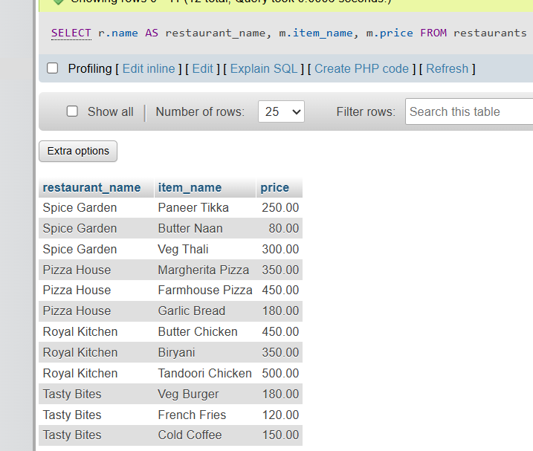
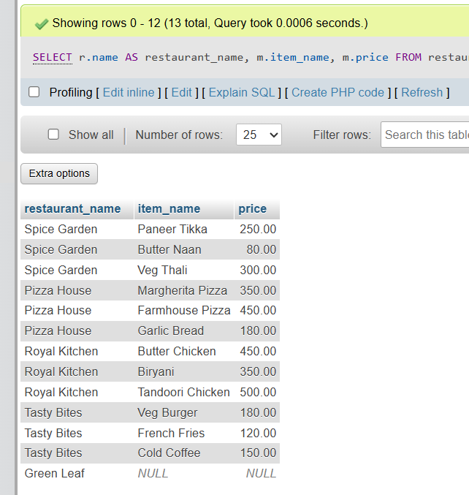
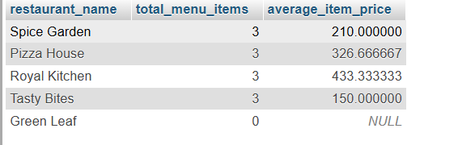

-- Task 4

CREATE TABLE customers (
customer_id INT AUTO_INCREMENT PRIMARY KEY,
customer_name VARCHAR(100) NOT NULL,
wallet_balance DECIMAL(10,2) NOT NULL
);

INSERT INTO customers (customer_name, wallet_balance)
VALUES
('Rahul', 5000),
('Priya', 3000);

DELIMITER //
CREATE PROCEDURE place_order(
IN p_customer_id INT,
IN p_restaurant_id INT,
IN p_amount DECIMAL(10,2)
)
BEGIN
DECLARE v_balance DECIMAL(10,2);
START TRANSACTION;
SELECT wallet_balance
INTO v_balance
FROM customers
WHERE customer_id = p_customer_id;
IF v_balance >= p_amount THEN
UPDATE customers
SET wallet_balance = wallet_balance - p_amount
WHERE customer_id = p_customer_id;
INSERT INTO orders
(restaurant_id, customer_name, total_amount, order_date)
SELECT
p_restaurant_id,
customer_name,
p_amount,
CURDATE()
FROM customers
WHERE customer_id = p_customer_id;
COMMIT;
SELECT 'Order placed successfully' AS message;
ELSE
ROLLBACK;
SELECT 'Insufficient wallet balance' AS message;
END IF;
END //
DELIMITER ;
CALL place_order(1, 1, 1000);
CALL place_order(2, 1, 5000);



Section C — Mini Capstone Project

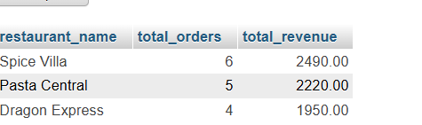


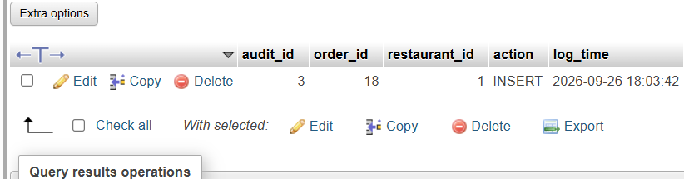
Code is in .sql file

