**Report of Lab-1 Assignment (CS-5560)**

**By Vidhi Shah**

**Student ID: 16178723**

**Report content**

* Snapshot of ER Diagrams and the Class diagram using Visio

1. ER diagram
2. Class diagram

* Snapshot of GitHub account

1. Sign in page
2. After signing in

* Snapshot of ScrumDo account

1. Overview
2. Iterations
3. Scrumboard

* Snapshot of ER Diagrams and the Class diagram using Visio

1. **ER Diagram:**

Suppose we wish to keep a genealogy. We shall have one entity set, Person. The information we wish to record about persons includes their name (an attribute) and the following relationships: mother, father, and children. Give an E/R diagram involving the Person entity set and all the relationships in which it is involved. Include relationships for mother, father, and children. Extend it with additional relationships such as husband and wife. Do not forget to indicate roles when an entity set is used more than once in a relationship.

Ans: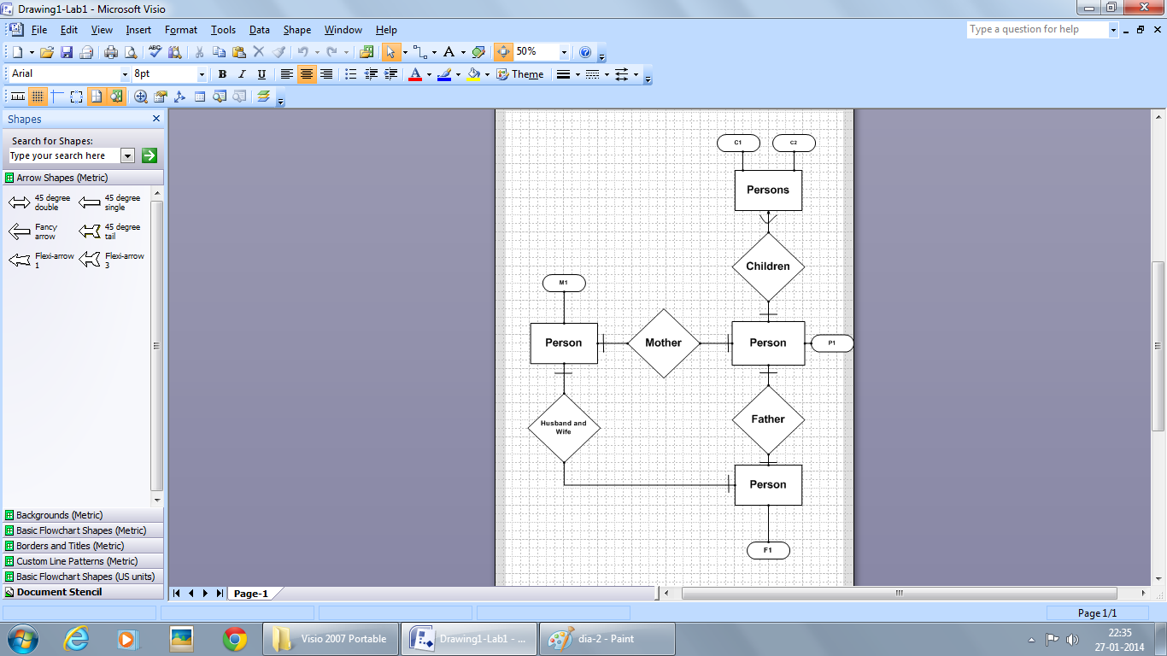

1. **Class Diagram:**

For the given domain (i.e., Family), define UML Class Diagram that specifies classes and their relationships with specific relationships such as inheritance, aggregation, composition, dependence, association, etc.

Ans:

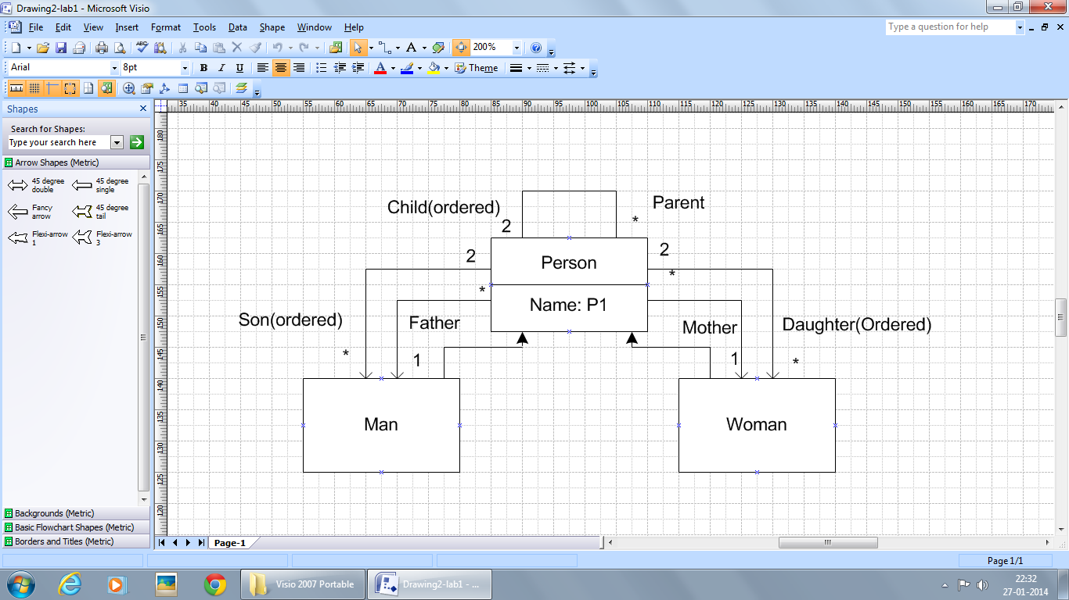

* Snapshot of GitHub account

1. **Sign in page:**

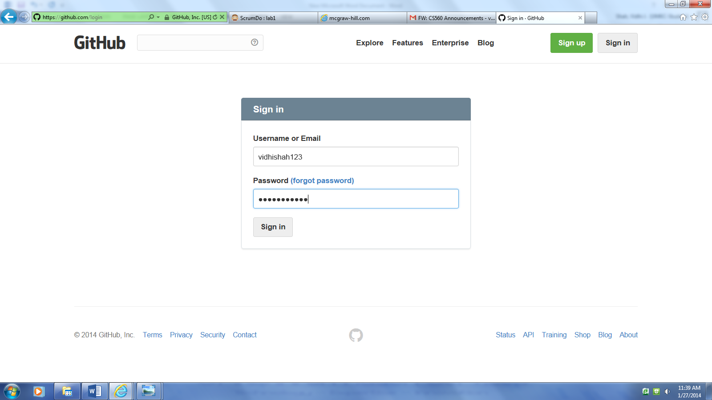

1. **After signing in:**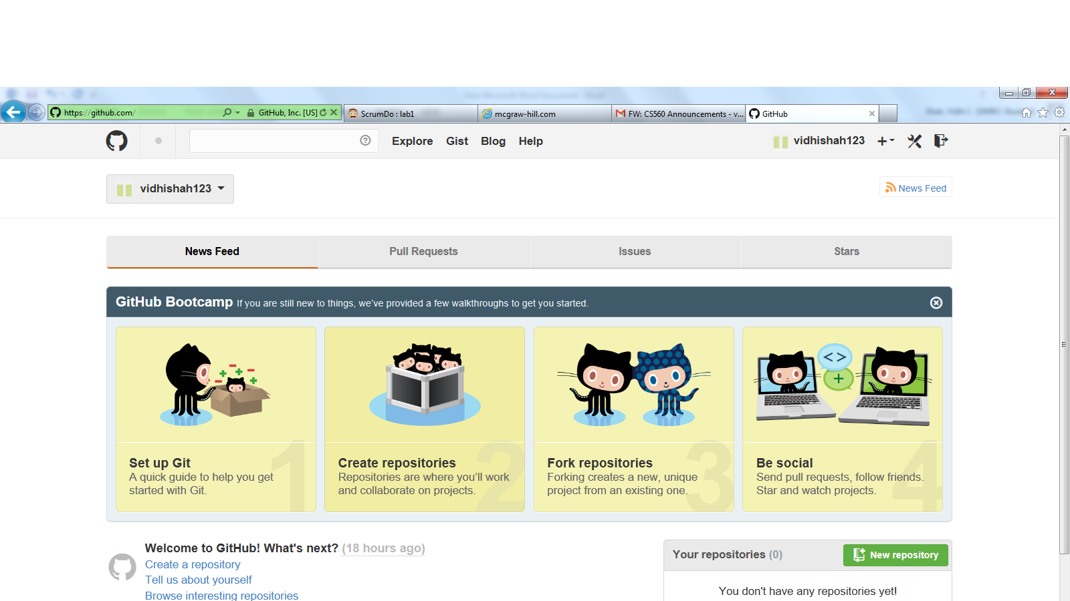

* **Snapshot of ScrumDo account**

1. **) Overview -1**:

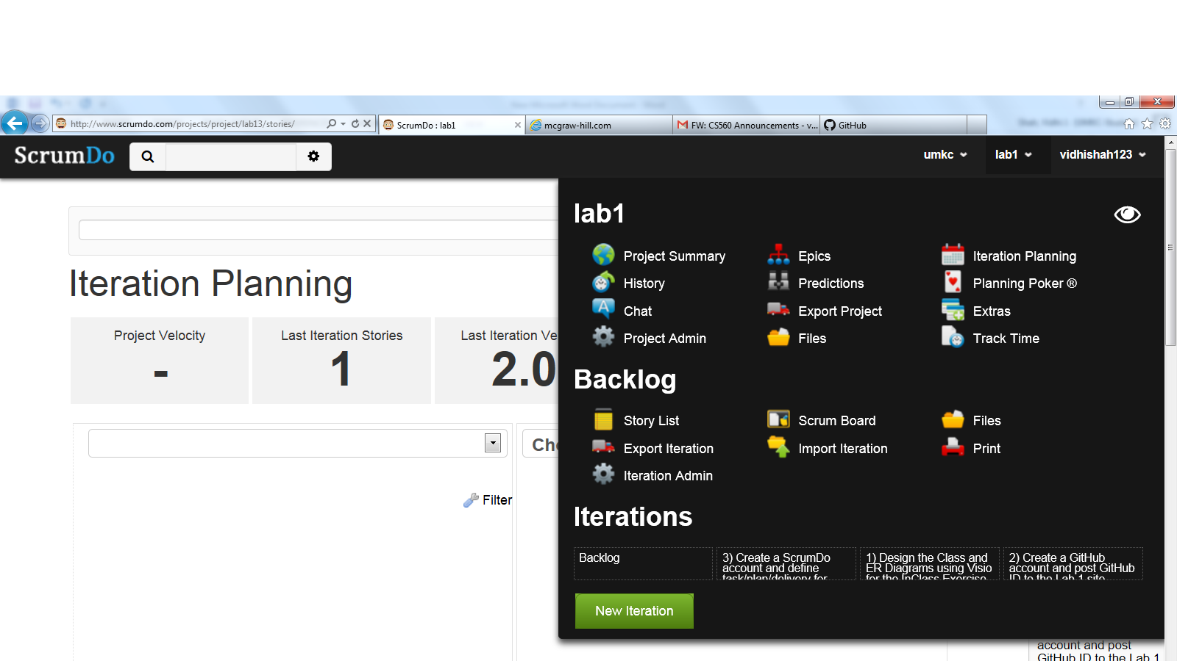

**2.) Overview – 2:**

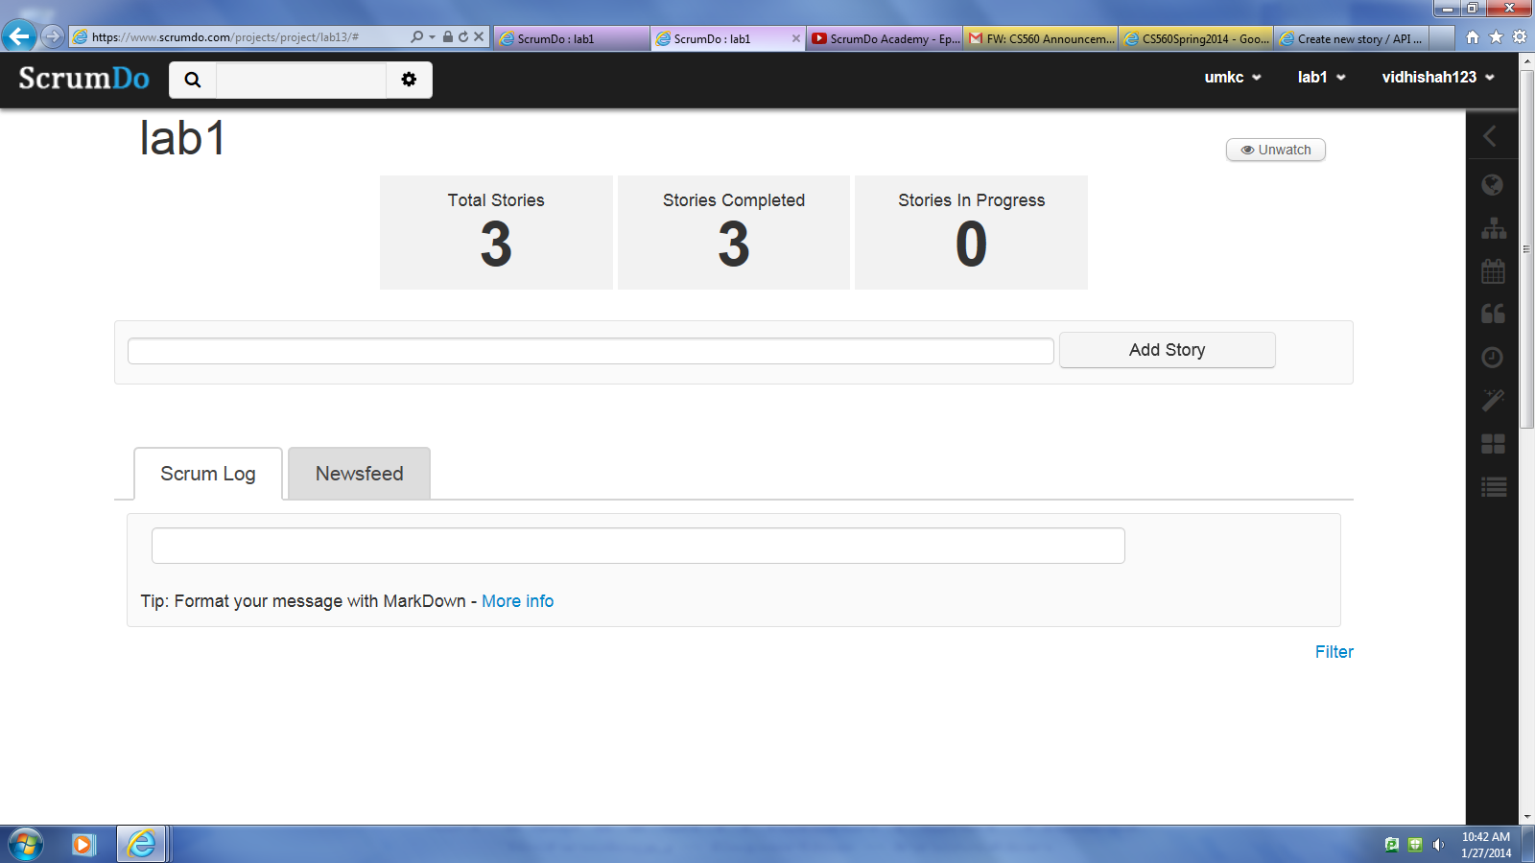

**3.) Itteration-1, 2, 3**

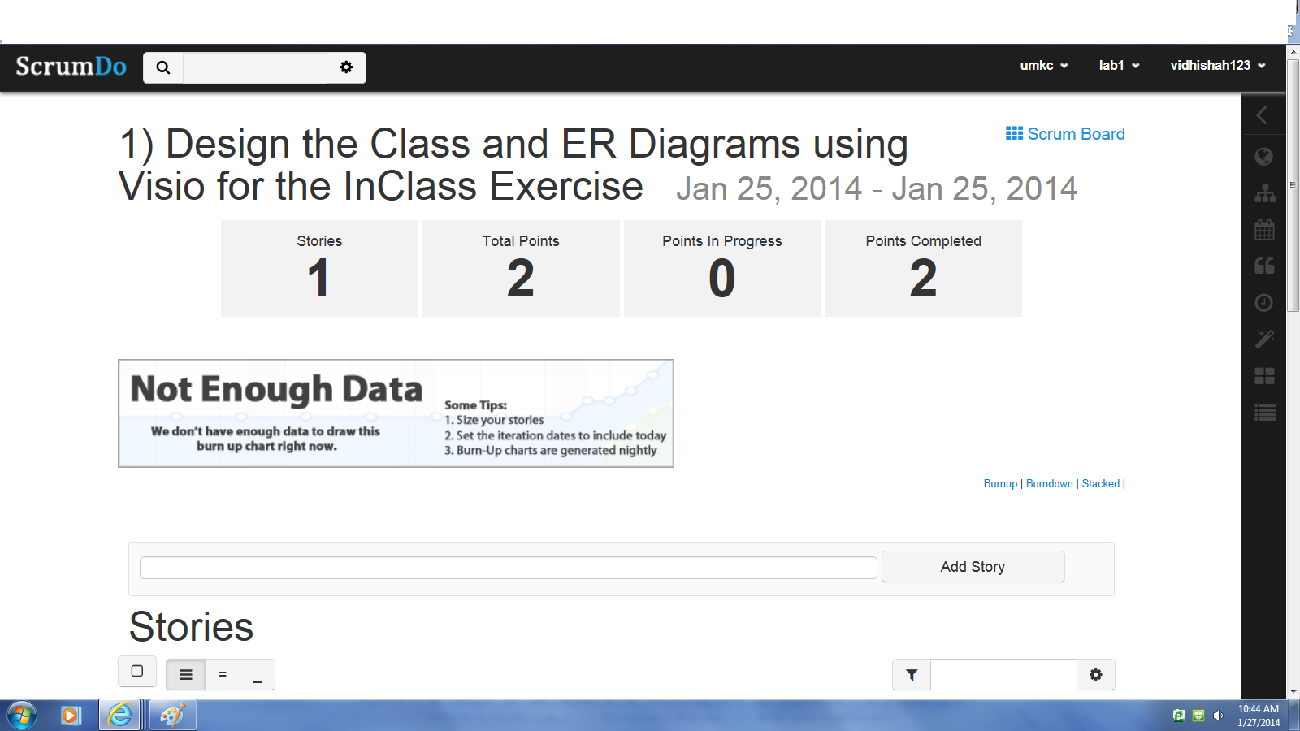

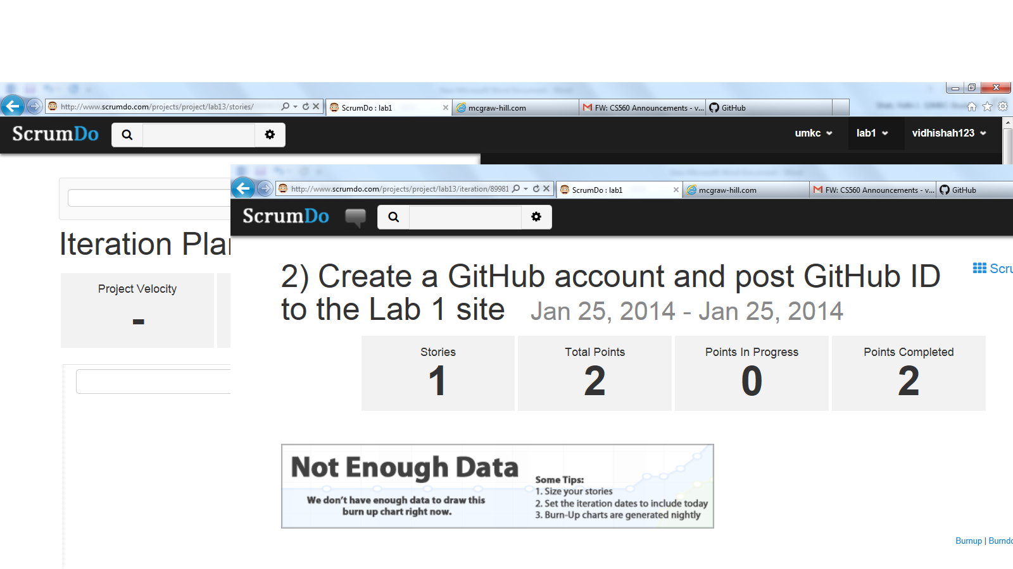

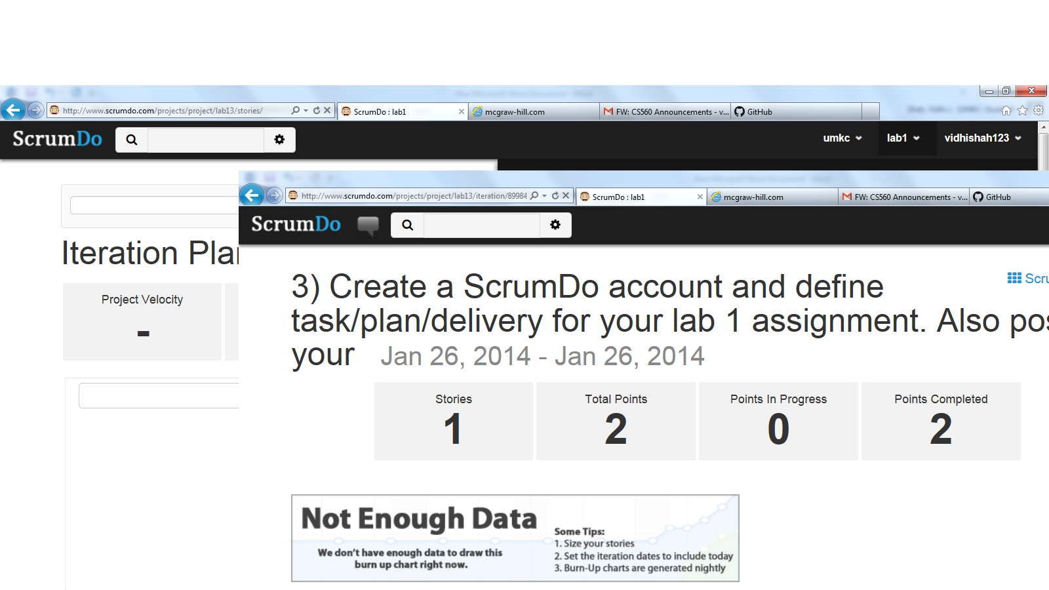

**4.) Scrum board**

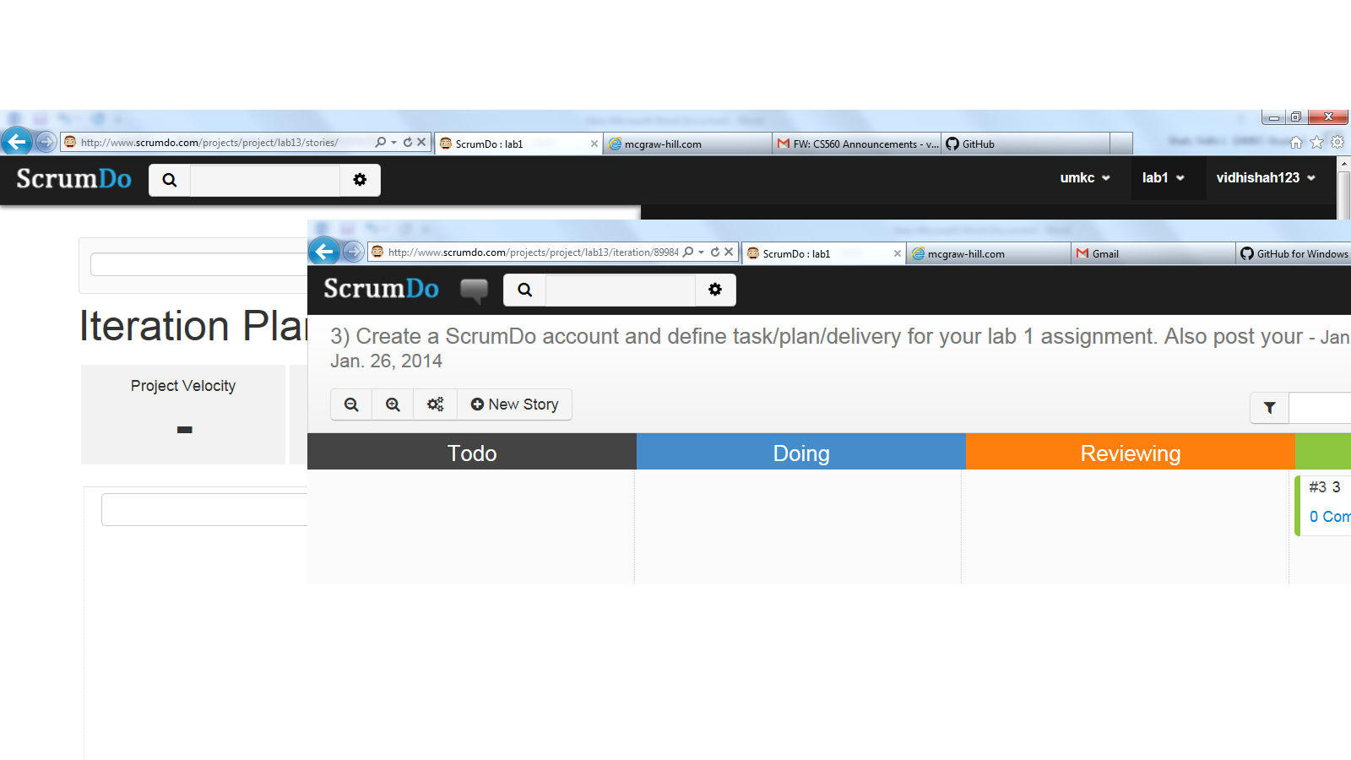

End