**Report of Lab-3 Assignment (CS-560)**

**By Vidhi Shah**

**Student ID: 16178723**

1. Make a Mashup application.

In mashup application using jsfiddle, I have used four existing web services which are

1. Google map
2. Weather forecast service map
3. Facebook
4. Twitter

With google map , one can find the existing location.

With weather forecast service map, one can find other weather information of different location of world.

Users can share that information on their facebook or twitter account.

The link is:

<http://jsfiddle.net/vidhishah123/67Lf3/6/>

Fig:1: screenshot of jsfiddle coding and output shows current location

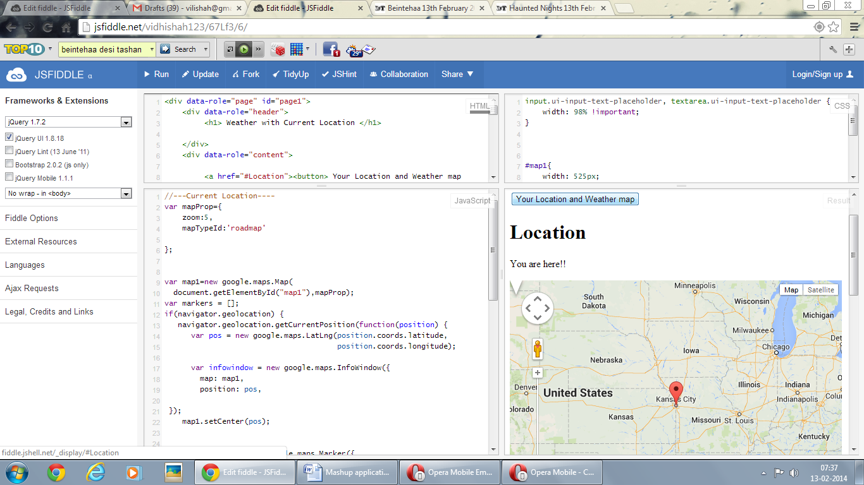

Fig:2: screenshot of jsfiddle coding and output shows weather information

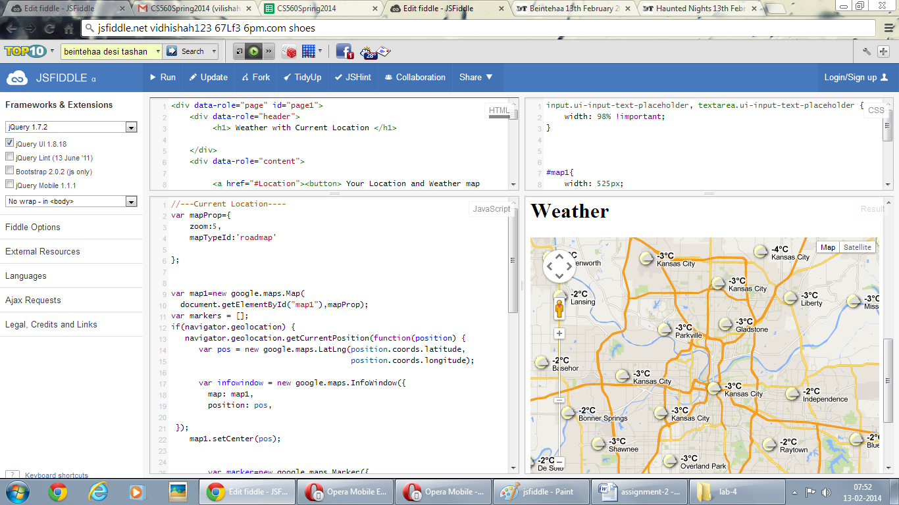

Fig:3: screenshot of jsfiddle coding and output shows hyperlink for facebook and twitter login page

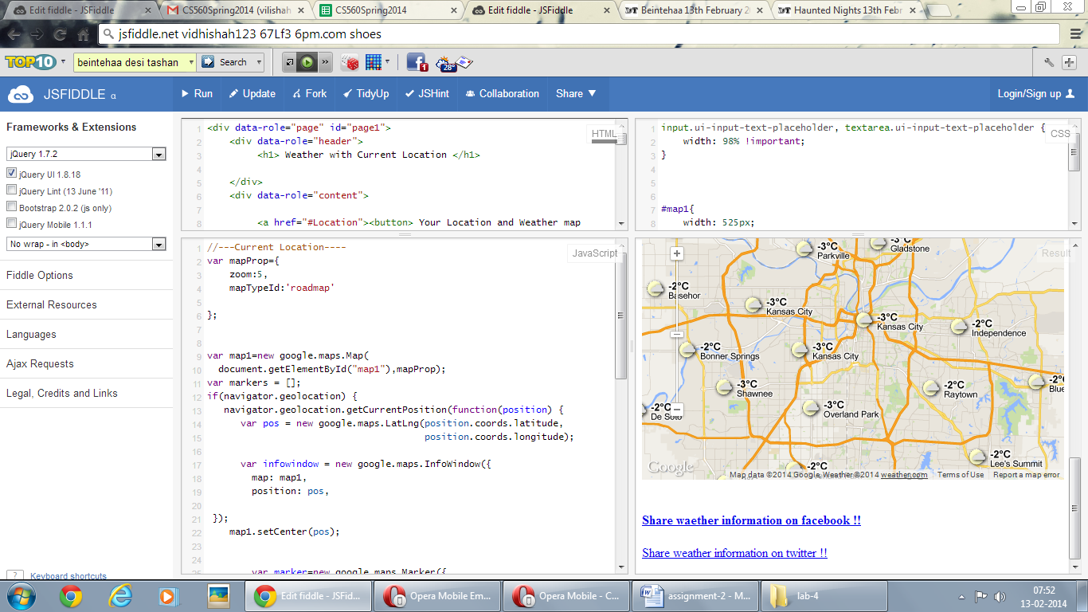

Figure:5 Use of Opera mobile emulator

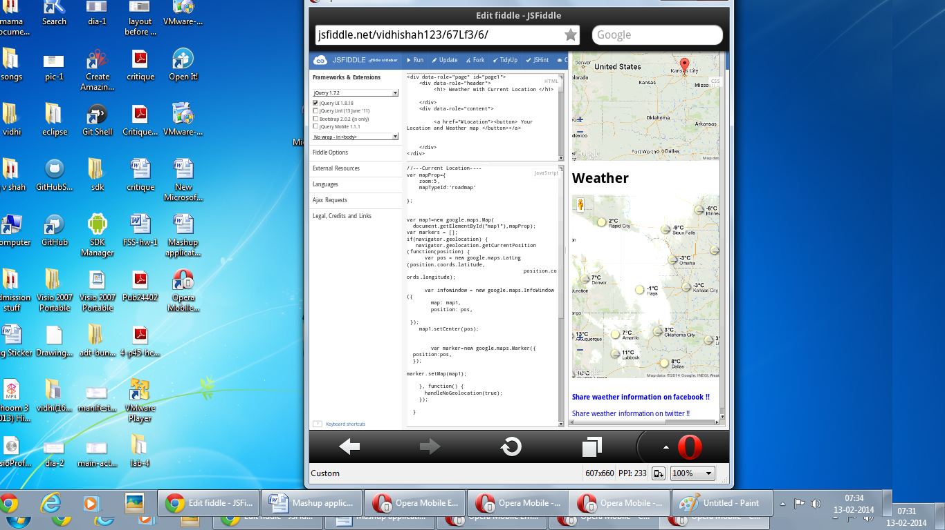

2.) Cloudera/MapReduce: Download the Cloudera Image, implement the WordCount MapReduce and run it.

Figure:1 Cloudera installation

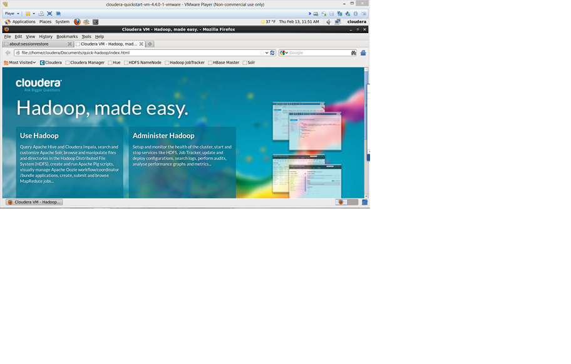

Figur:2 Successful WordCount run

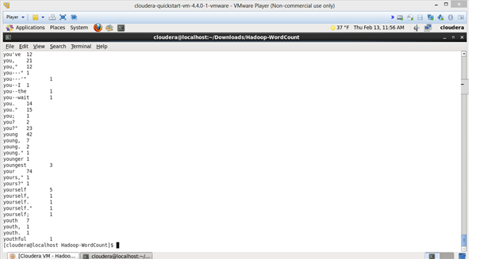

3.) Cloudera/Mahout: Configure your Cloudera with Mahout. Run Naive Bayes classifier with the input data

Figure:1 Cloudera with mahoot

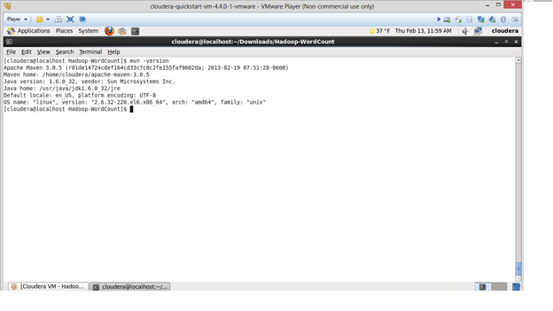

Successful run

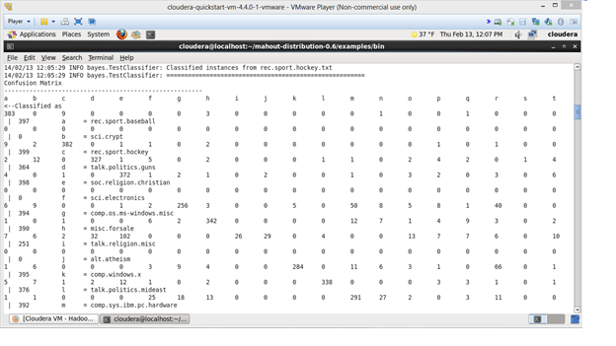

End