**CS590BD**

**BIG DATA ANALYSIS**

**LAB 4**

**By: Vidhi Shah**

Using lab-2 assignment , following files are created for three different motion:

***Training files*** *: vidhimotion1BJT.txt, Vidhi motion-2(LR) , Vidhi motion-2(Rl)*

* ***Testing file*** *: TestFile.txt*

***Copy the these files and save them on cloudera***

***/home/group4***

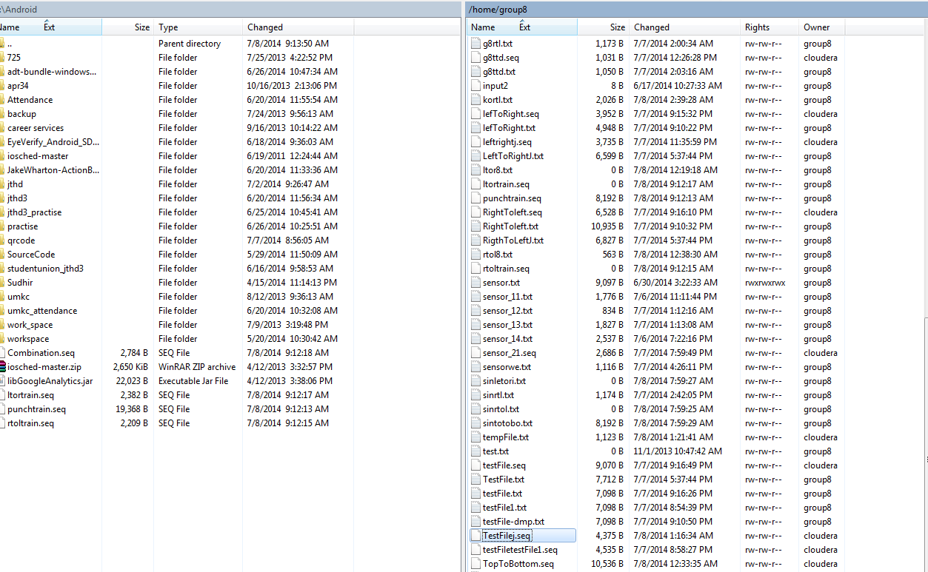

* After that we are converting txt files to sequence file by calling below servive
* [http://134.193.136.127:8080/HMMWS/jaxrs/generic/TrainFileOperation/-home-group4-LeftToRightJ.txt/-home-group4-leftrightj.seq](http://134.193.136.127:8080/HMMWS/jaxrs/generic/TrainFileOperation/-home-group4-LeftToRightJ.txt/-home-group4-leftrightj.seq%20)

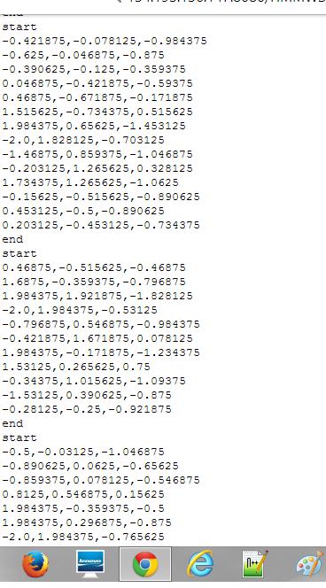

***Generating RightToLeft.seq***



* ***Generating BTPJ.seq***

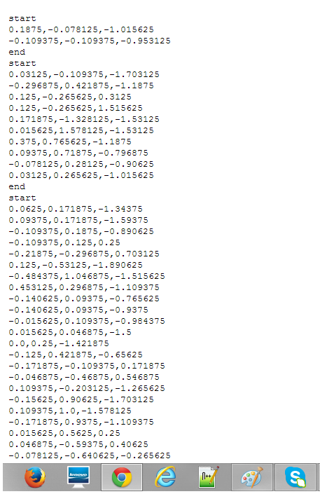

* ***Generating TestFilej.seq***

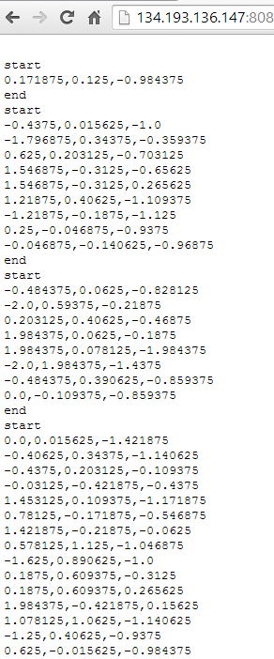

***Step 2: Training and testing for activity recognition***

*As we have set of sequence files for training and testing , now we have to run below service using our generated sequence files to identify whether training got success and generates motions.*

[http://134.193.136.127:8080/HMMWS/jaxrs/generic/HMMTrainingTest/-home-group4-leftrightj.seq/-home-group4-RightToLeft.seq/-home-group4-BTPJ.seq/-home-group4-TestFilej.seq](http://134.193.136.127:8080/HMMWS/jaxrs/generic/HMMTrainingTest/-home-group4-leftrightj.seq/-home-group4-RightToLeft.seq/-home-group4-BTPJ.seq/-home-group4-TestFilej.seq%20)