CS 590BD Big Data Analytics and Applications

Lab 1 - Task 1

June 17, 2014

|  |  |  |
| --- | --- | --- |
|  |  |  |

|  |  |  |  |
| --- | --- | --- | --- |
| Anas Katib | Gharib Gharibi | Rakesh Vistarakula | Vidhi Shah |

**Task 1.**

1.1 TI SensorTag with Android sensor app

We were able to pair the TI SensorTag with our Android device successfully. The BLE SensorTag app identified the sensor and was able to capture the motion. However, we were not able to use the app1-SensorTag to capture the device’s motion due to callback registration failure (see log output).

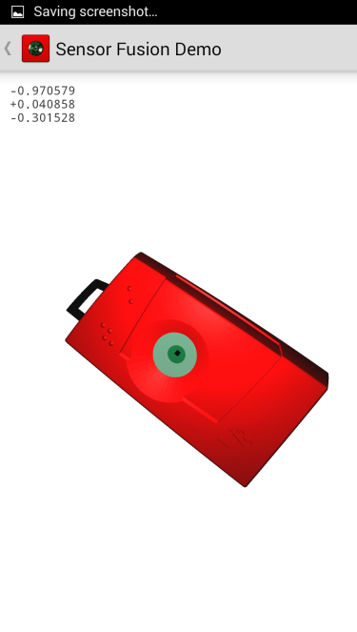

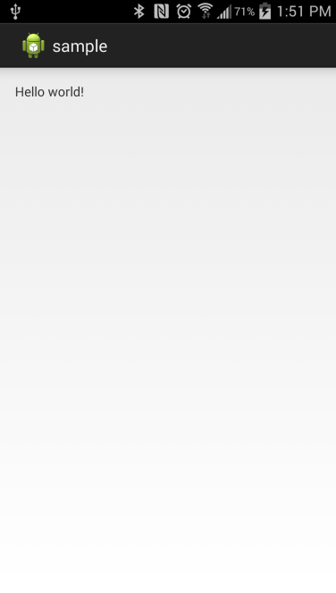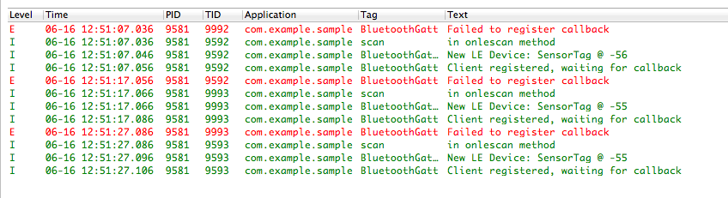

1.2 Mobile sensor with Android sensor app

The sensor app (app2-AndroidMotionSensor) detected the Android mobile device’s movement using the device’s accelerometer and changed the screen color accordingly.

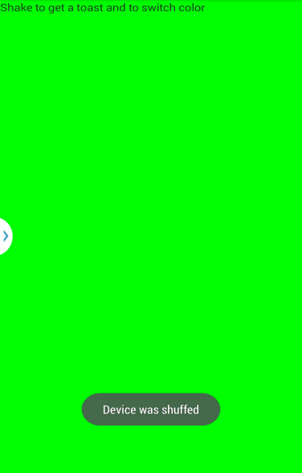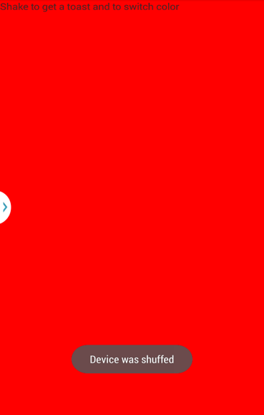

1.3 GPS feature with Android smartphone

Using app3-AndroidGPS the mobile device was able to display the GPS coordinates that were identified by the GPS sensor.

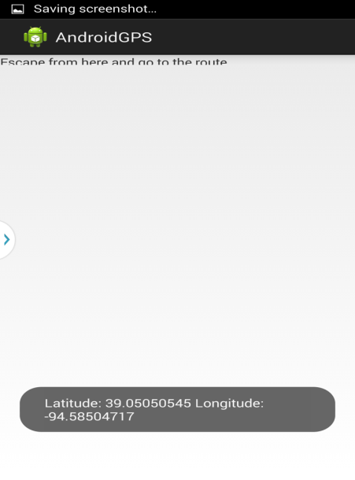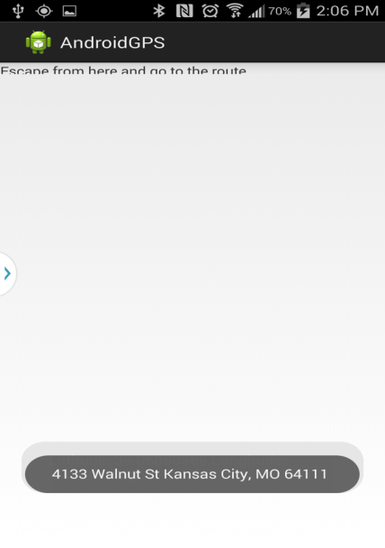

1.4 Wiigee app with Android smartphone

The app4-AndroidWiigee successfully recognized gestures with a high probability using the the mobile device’s accelerometer.

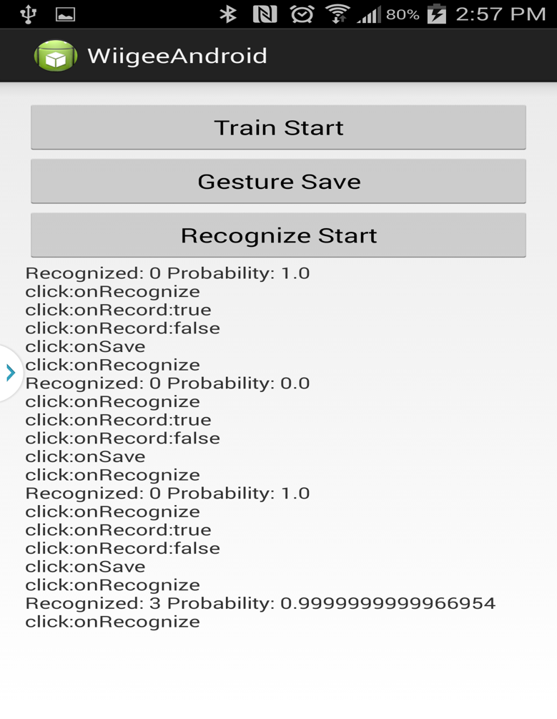

1.5 TI Chronos watch with Java app

Both the Chronos Control Center and the PunchMeterGame recognized the movements successfully using the Chronos watch’s accelerometer.

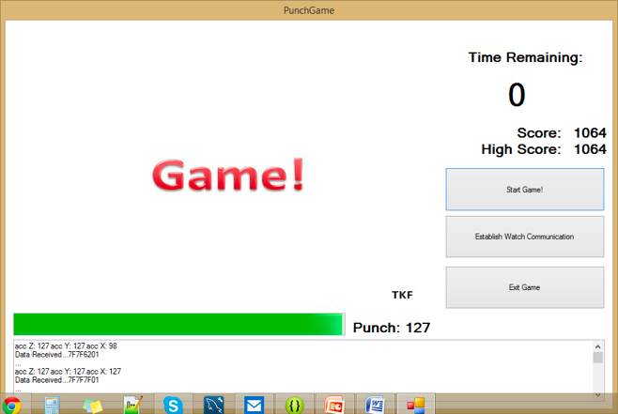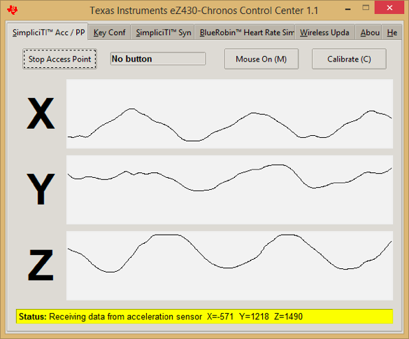

**Task 2:**

**Subtask 1:** Accessing UMKC Cloudera Individual Server

* Login to the url : <http://134.193.136.127:7180>
* Entered my SSO ID as username and password

Screenshot:1 login page

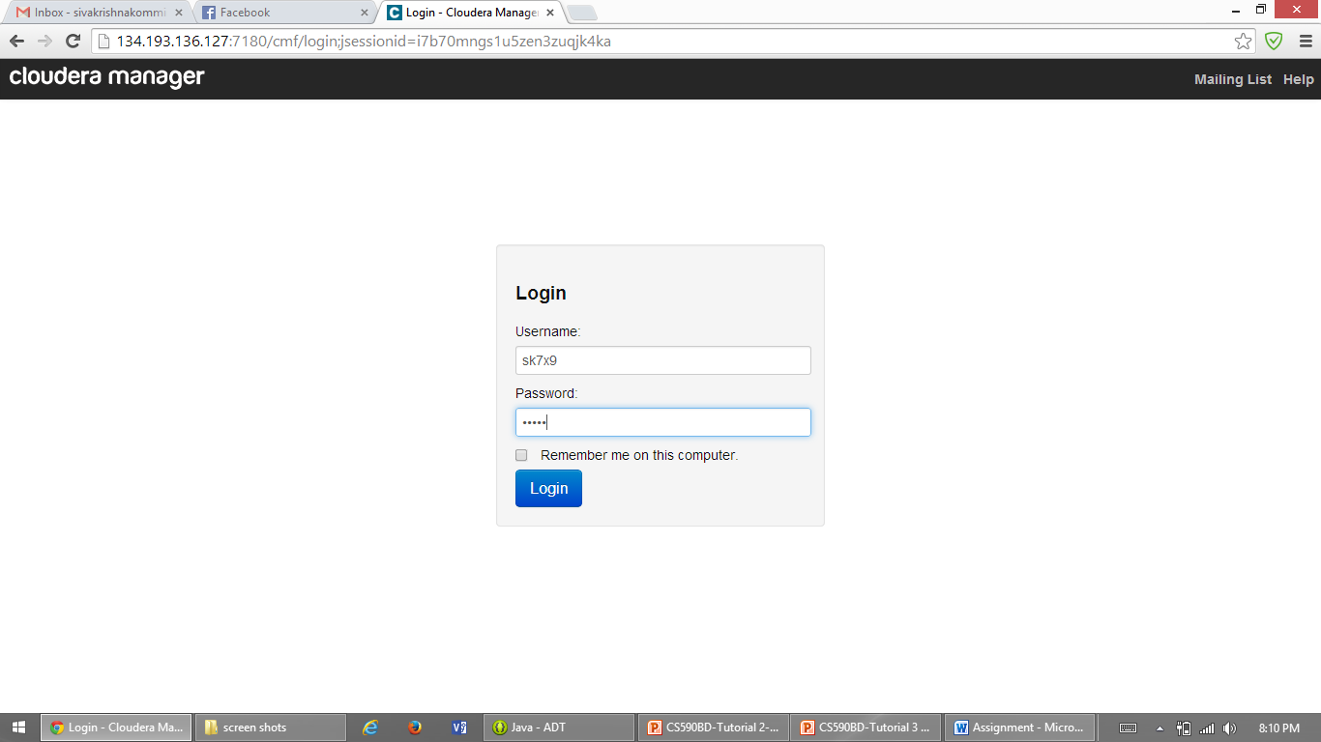

Screenshot:2 cloudera manager screen after log in which shows services

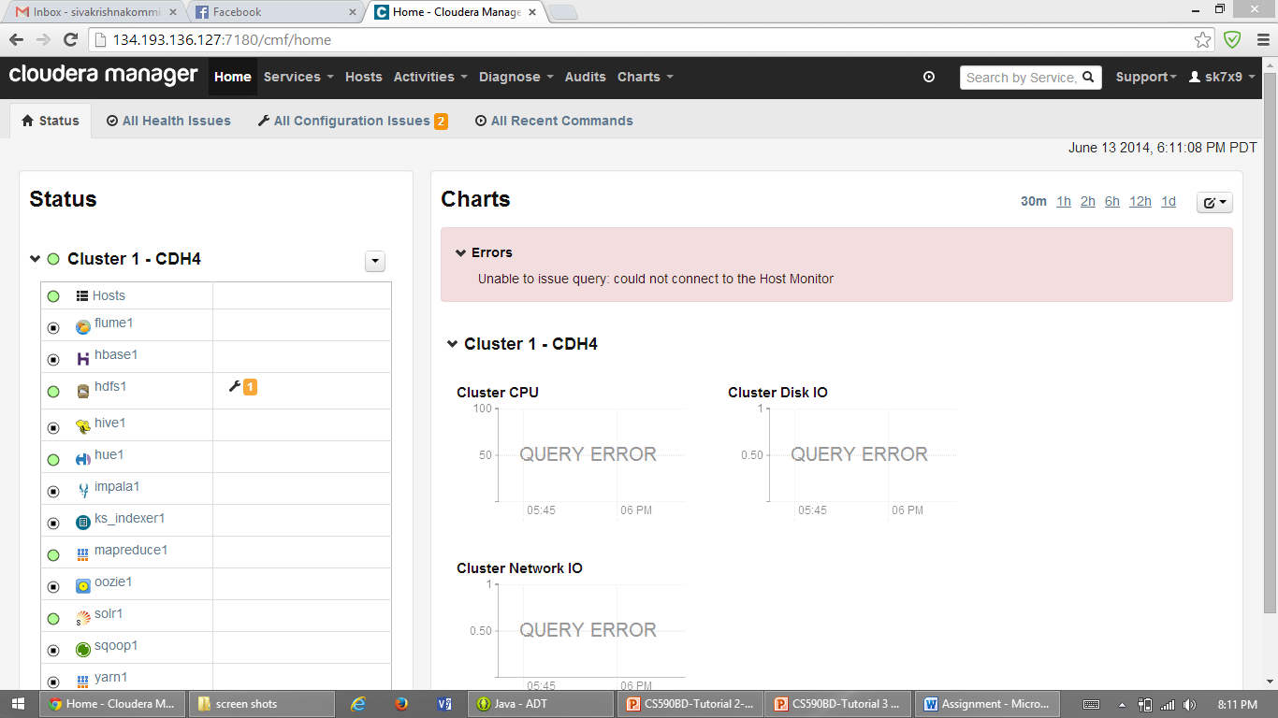

Screenshot:3 putty installation

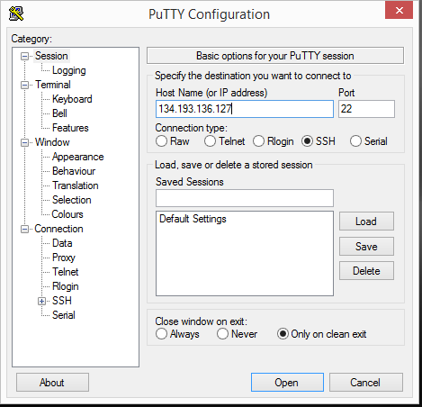

**Subtask 2:** installation of own Cloudera Server

* Download Cloudera image from the following link <http://www.cloudera.com/content/support/en/downloads/download-components/download-products.html?productID=F6mO278Rvo>
* Download Vmware player from the following link

(<http://www.vmware.com/products/player>)

Screenshot:1 VMware player

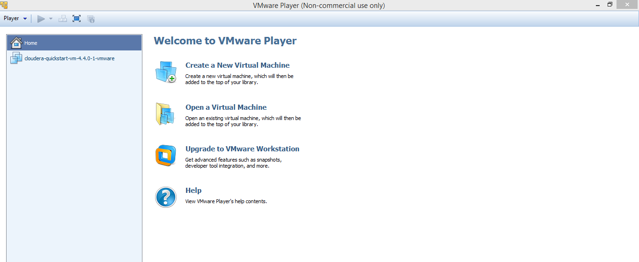

Screenshot:2 cloudera log in using username and password both as cloudera

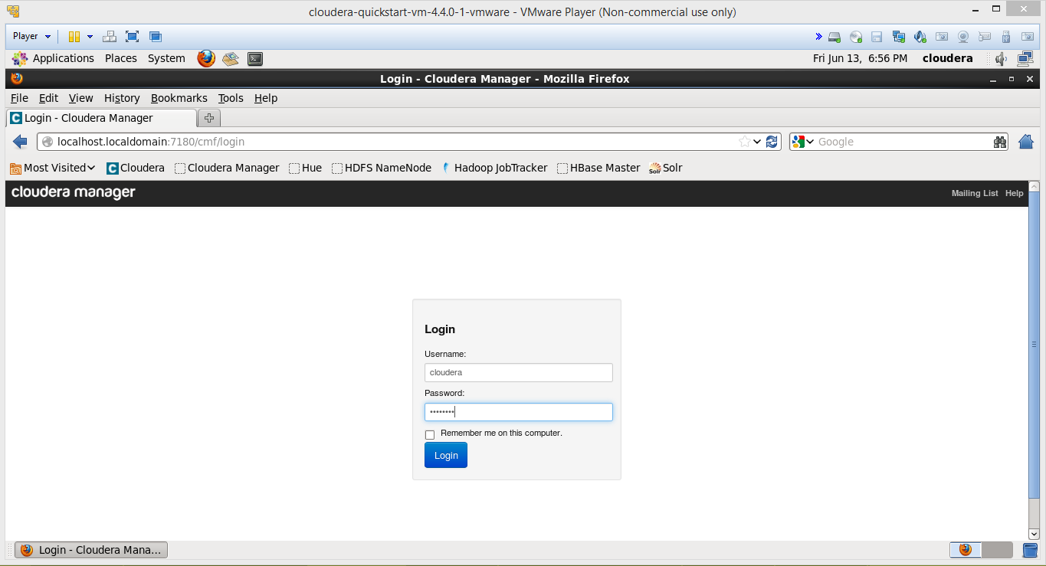

Screenshot:3 after log in cloudera manager

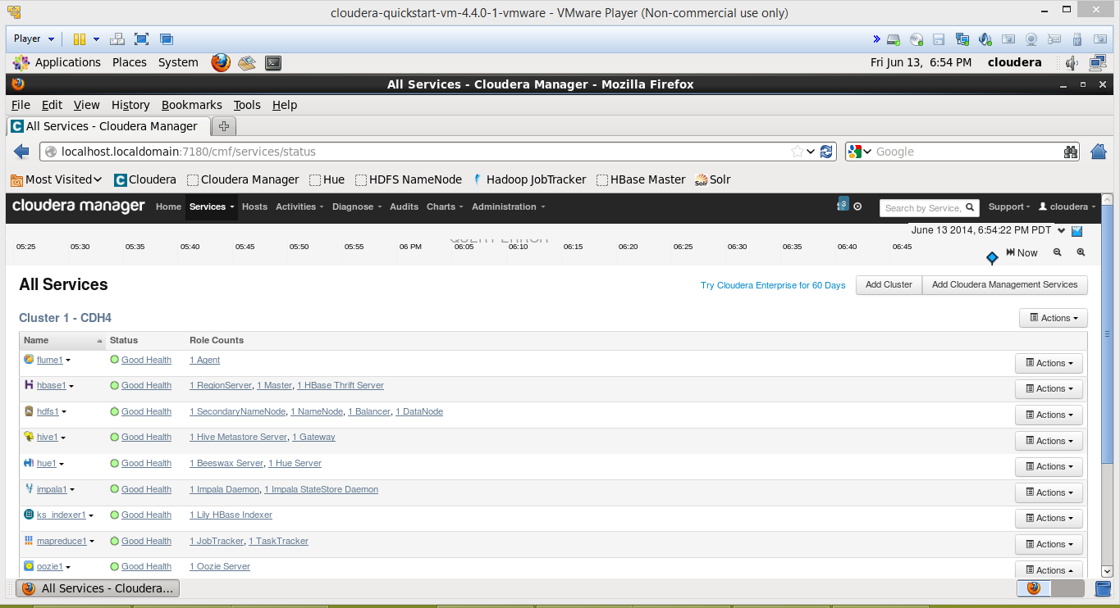

**Subtask 3:** transfering files to Cloudera

* Download WinSCP from the following link:

<http://winscp.net/eng/download.php>

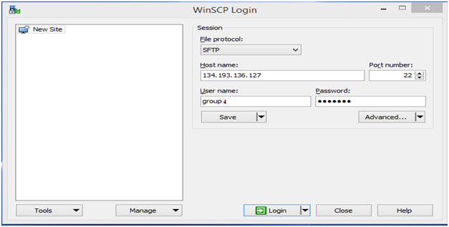

Screenshot: 1 Drag and drop the files using following window

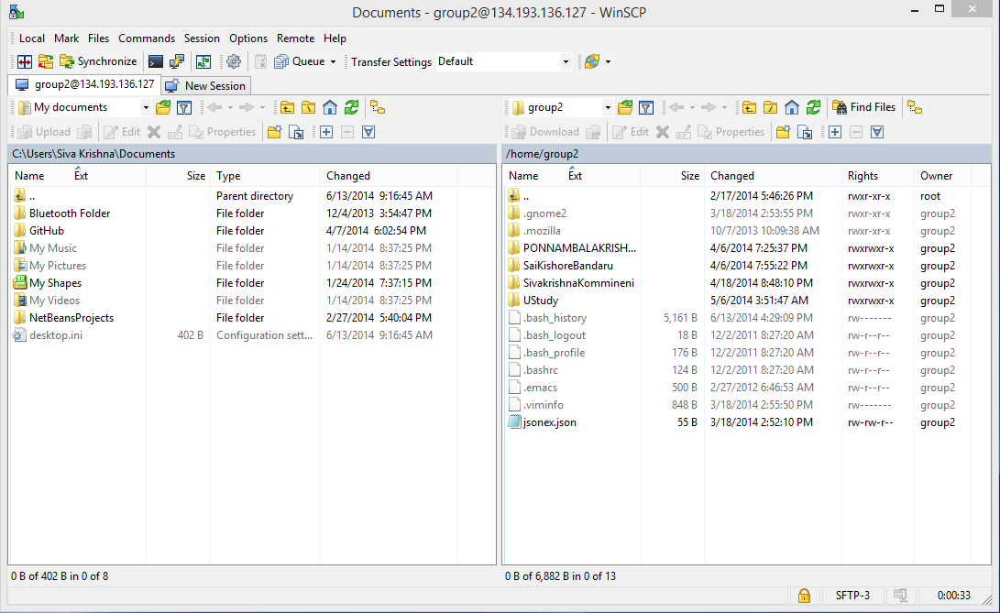

**Subtask 4:** run a Program “Word Count” on Cloudera

* Download the WordCount example from the below:

<https://portal.futuregrid.org/manual/hadoop-wordcount>

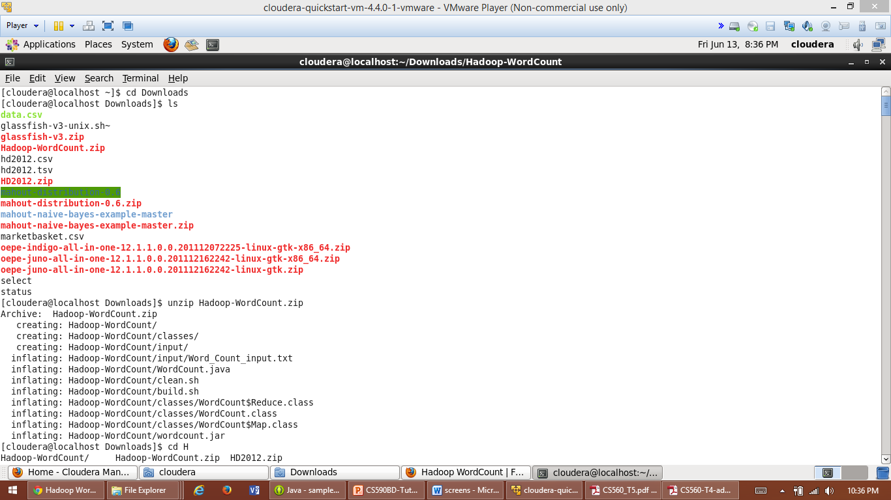

**Commands:**

* hadoop fs –put input input
* hadoop jar wordcount.jar WordCount input output3
* hadoop fs -cat output3/*

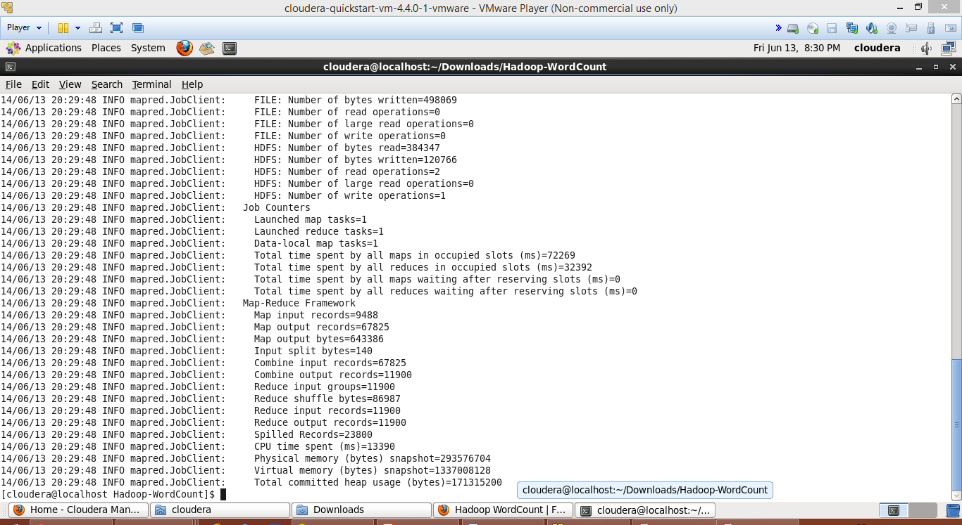

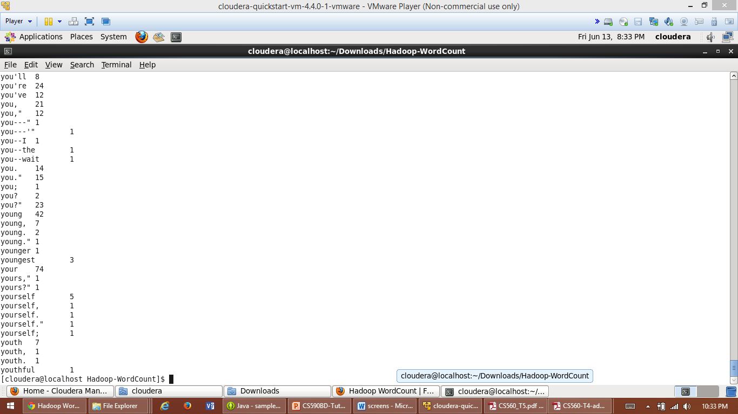

**Subtask 5:** making a hadoop jar and run it in Cloudera

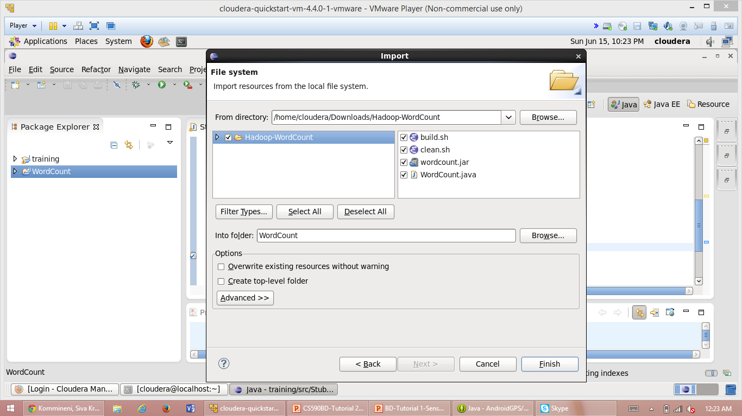

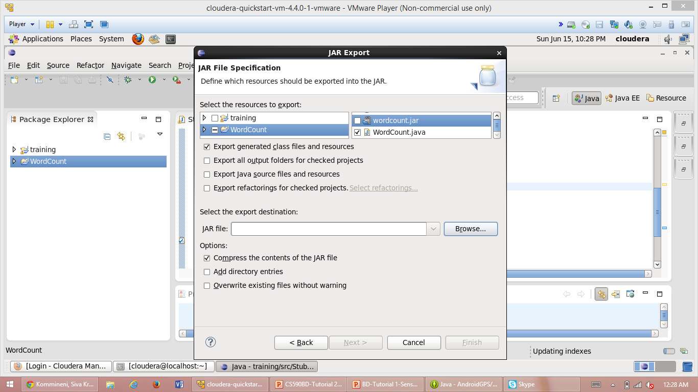

**Subtask 6:** Building a java based restful service in Cloudera

Screenshot:1 installation of glassfish server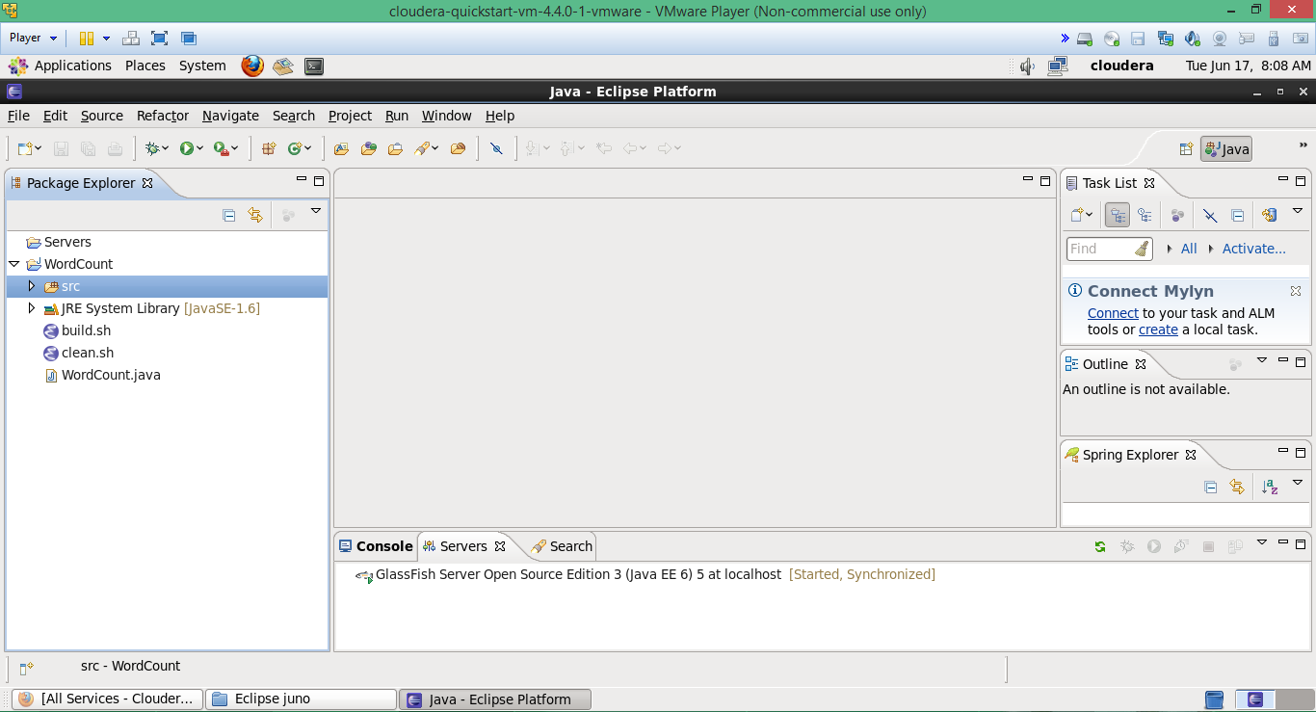

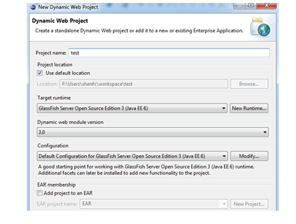

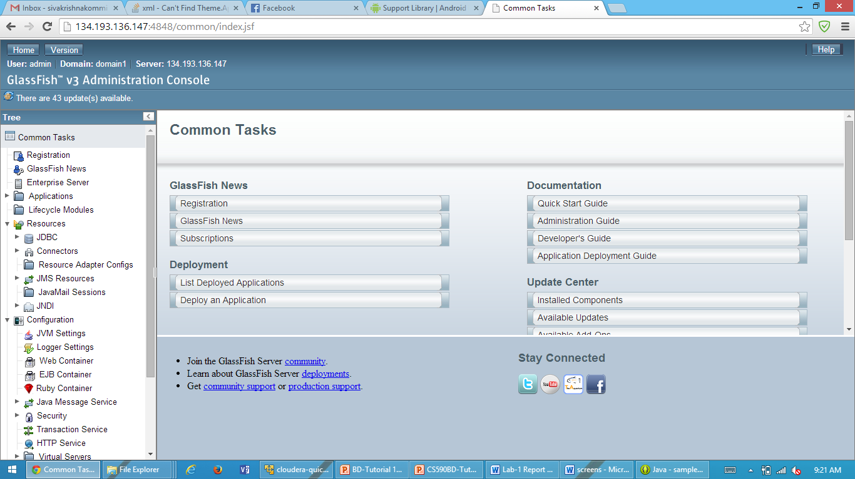

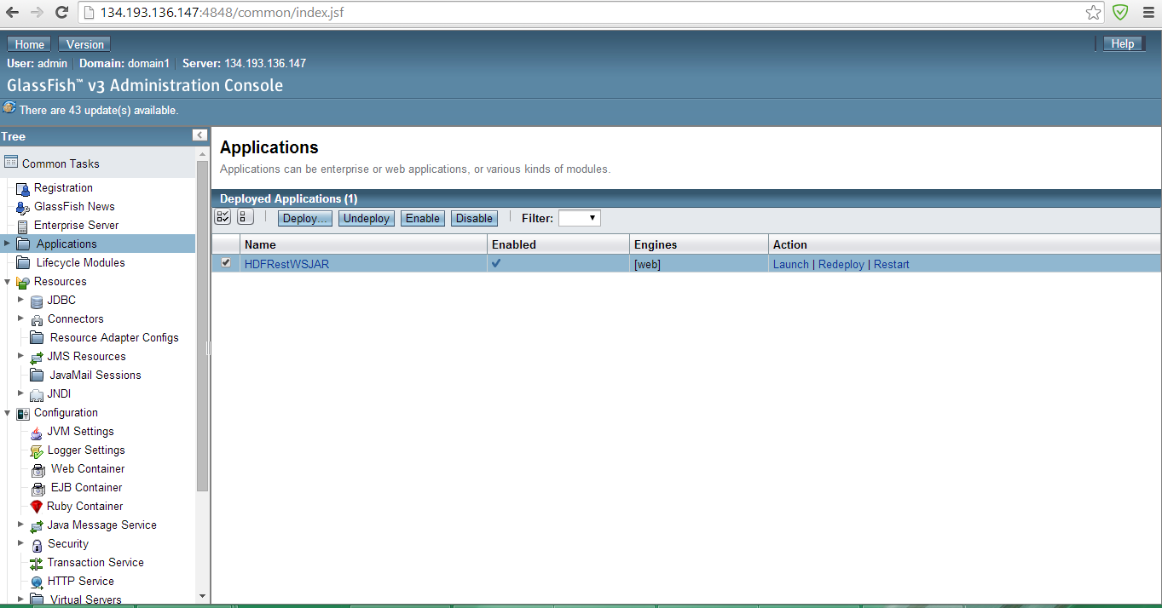

**Task 3:**

**Subtask 1:** creating an account and deploy files to Github

Screenshot:1 after sign up for GitHub using <https://github.com>

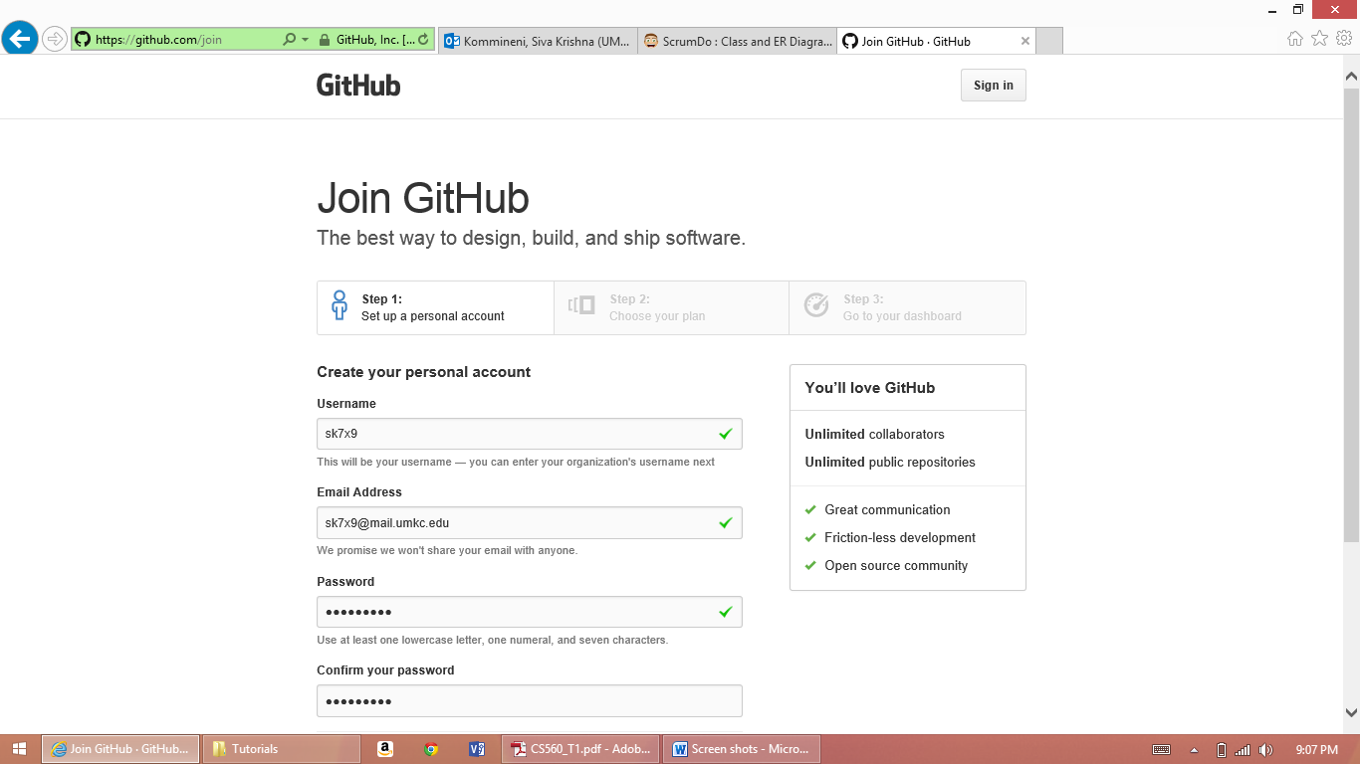

Screenshot: 2 created repository

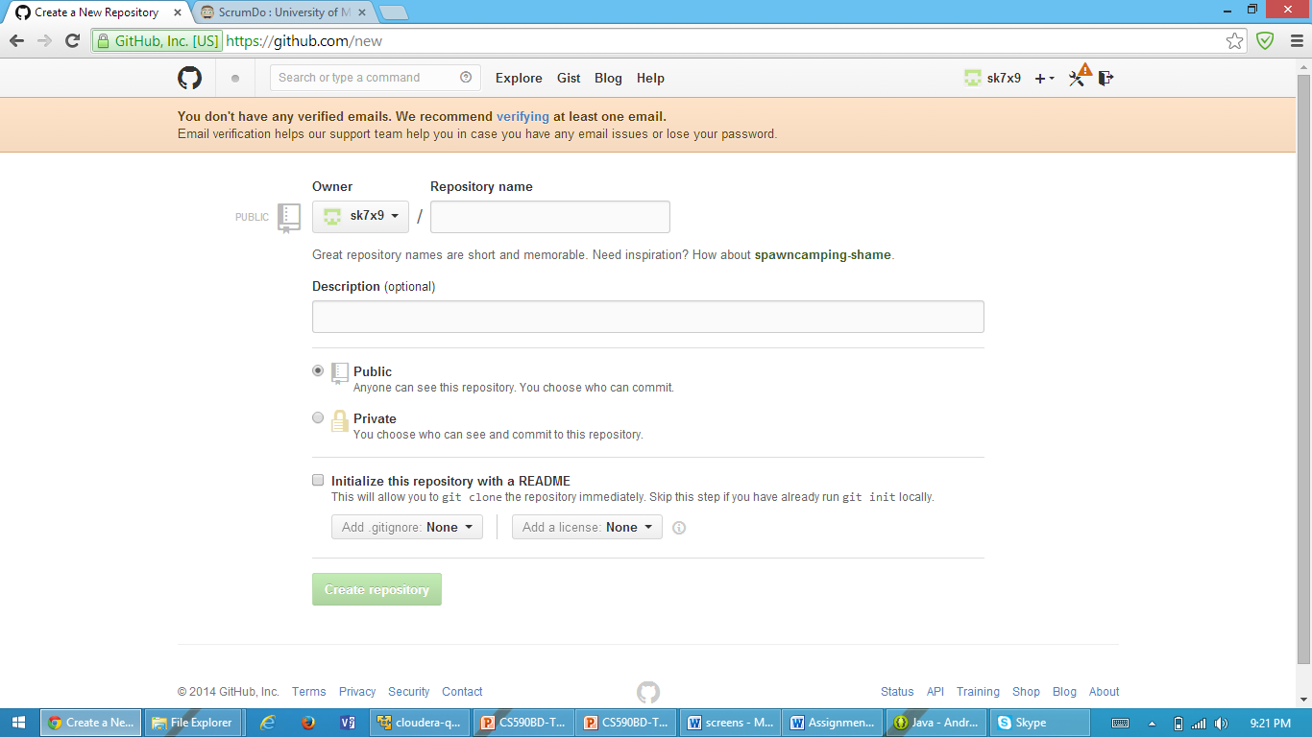

Screenshot : 3 after cloning document

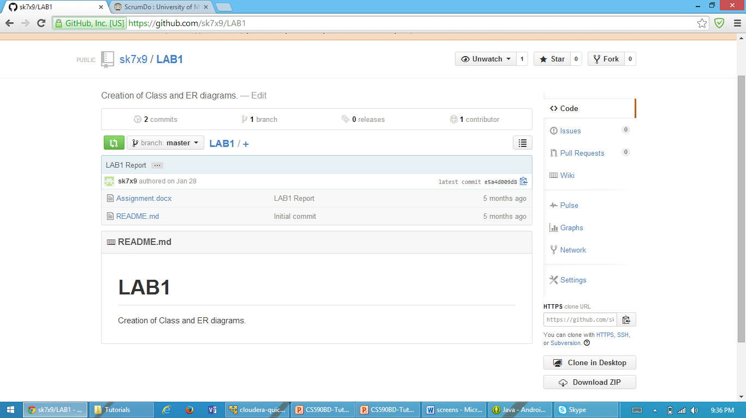

**Subtask 2:** creating an account and design projects with Scrumdo

* Used url <http://www.scrumdo.com>

Screenshot:1 log in page

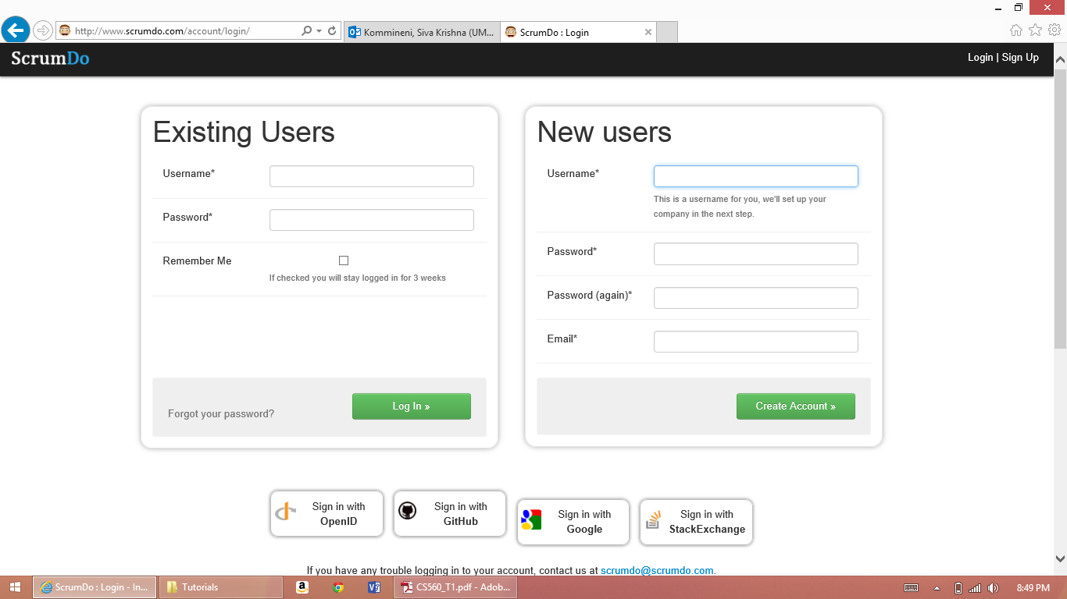

Screenshot:2 created stories and added tasks

