**Advance Software Engineering**

**Online Grocery Store**

**Date: 29th September, 2014**

By: Vidhi Shah (35) & Sai Pramodh Parimisetty (29)

Design:

Architecture diagram:

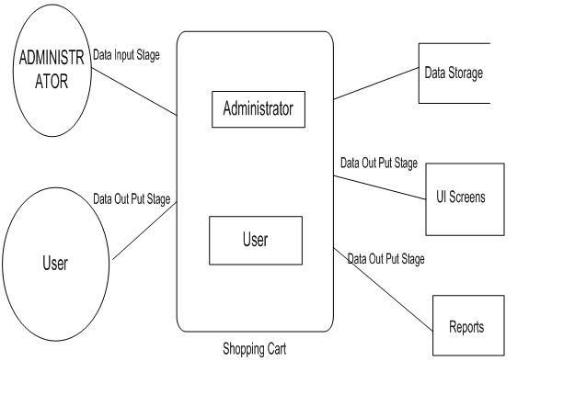

Class Diagram:

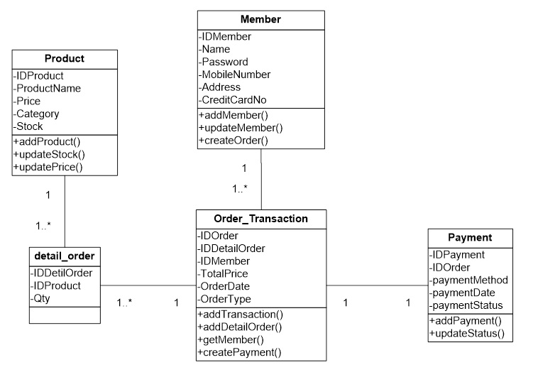

Features Implemented:

In the JQuery application created using Jsfiddle.

User has the access to optional login using their username and password.

As soon as user click on submit button, catalogue appears and from that user can select the items to buy. Here, the distance travelled by each product is shown to user. and we have used web SQL database connection for stock management.

After choosing the item user has to go to online payment. We have used Paypal APi for that.

As soon as user click save order, order will go to super market admin department.

The impact of food habit on environment for different country is shown by charts.

At the end user get some seasonal grocery suggestion with local food recipe. Again we have used local website api for recipe.

Screenshots of features:

Optional Login:

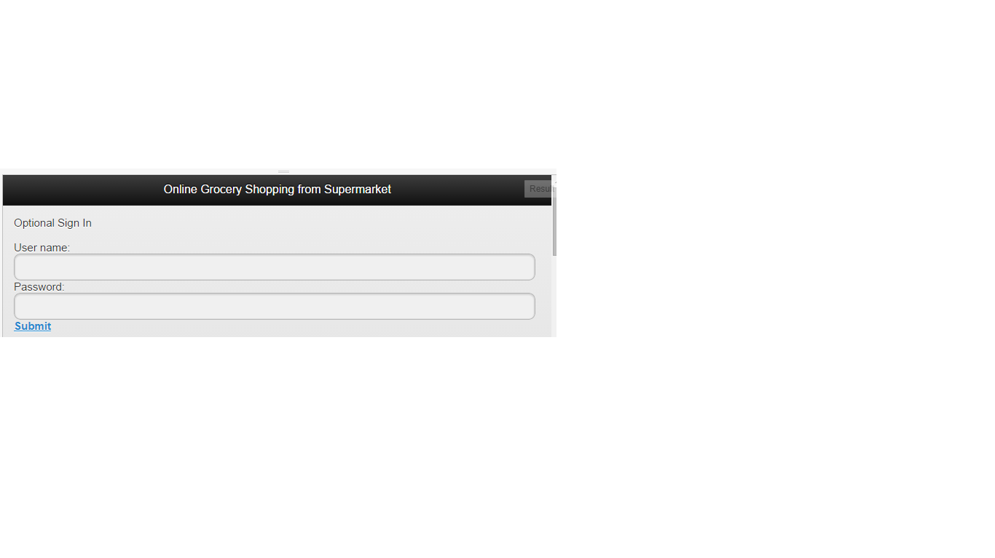

Catalog:

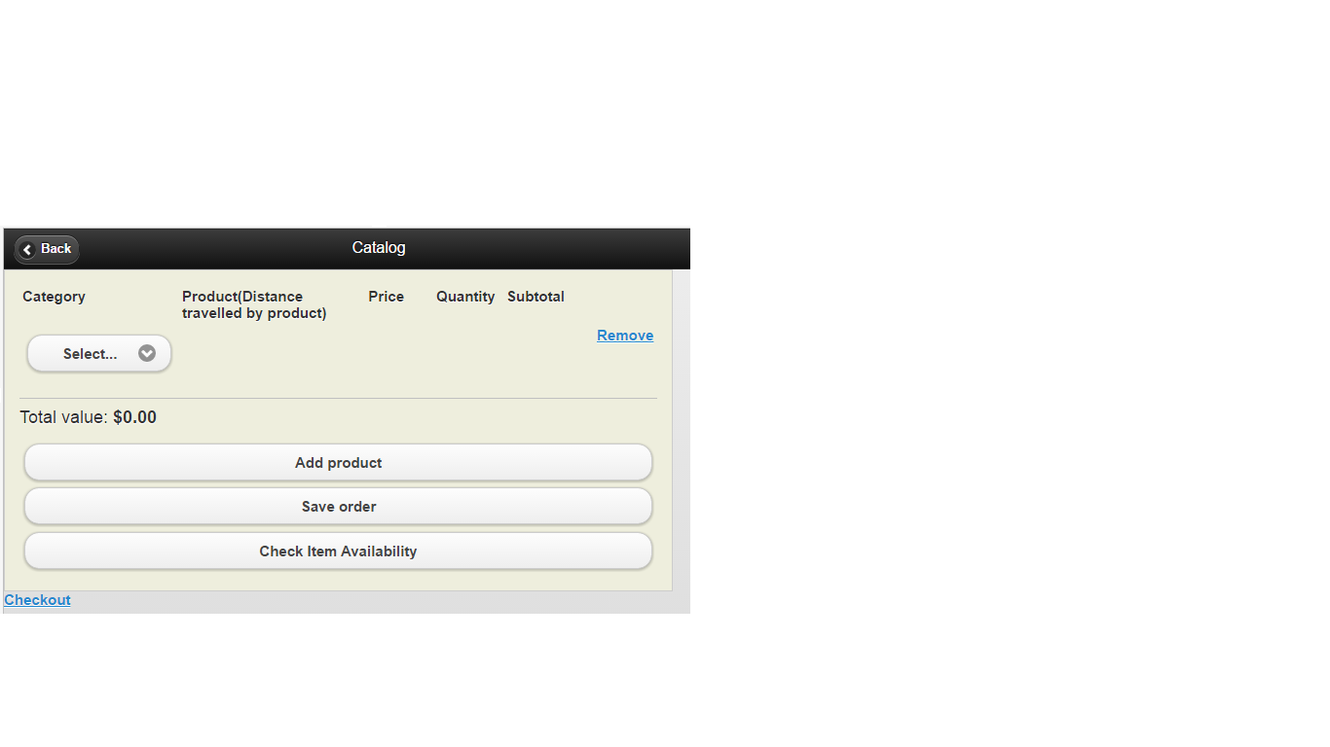

Add item in catalog and remove from catalog

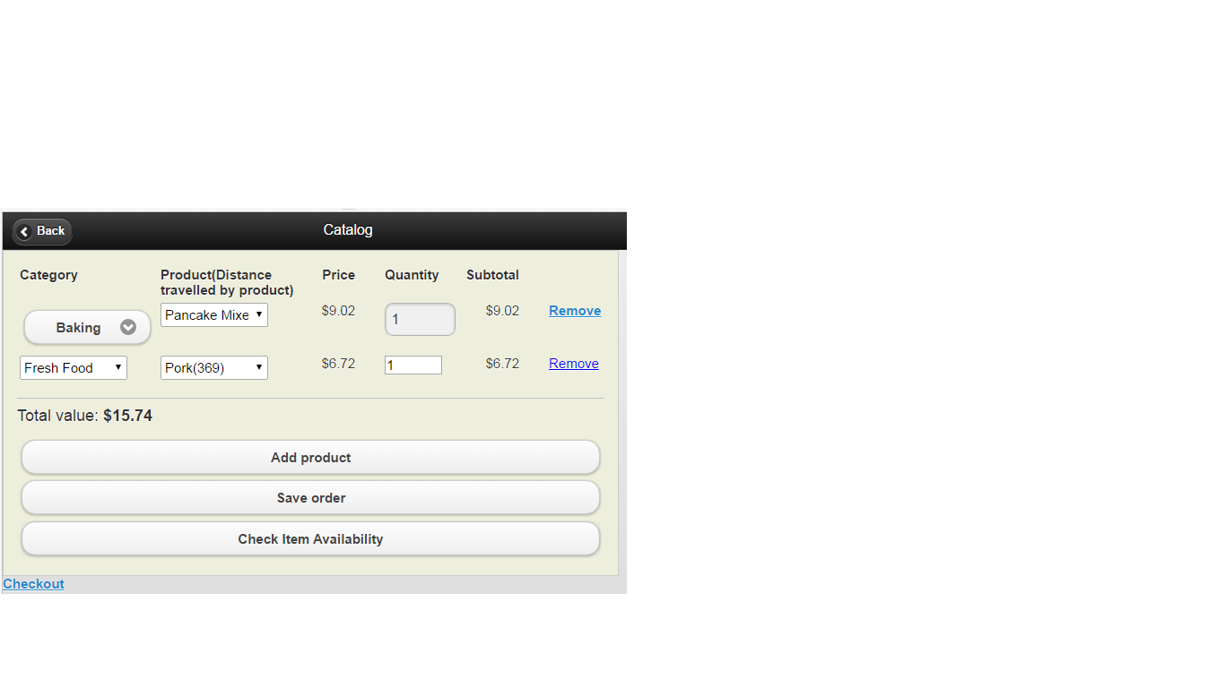

Send purchased item to store

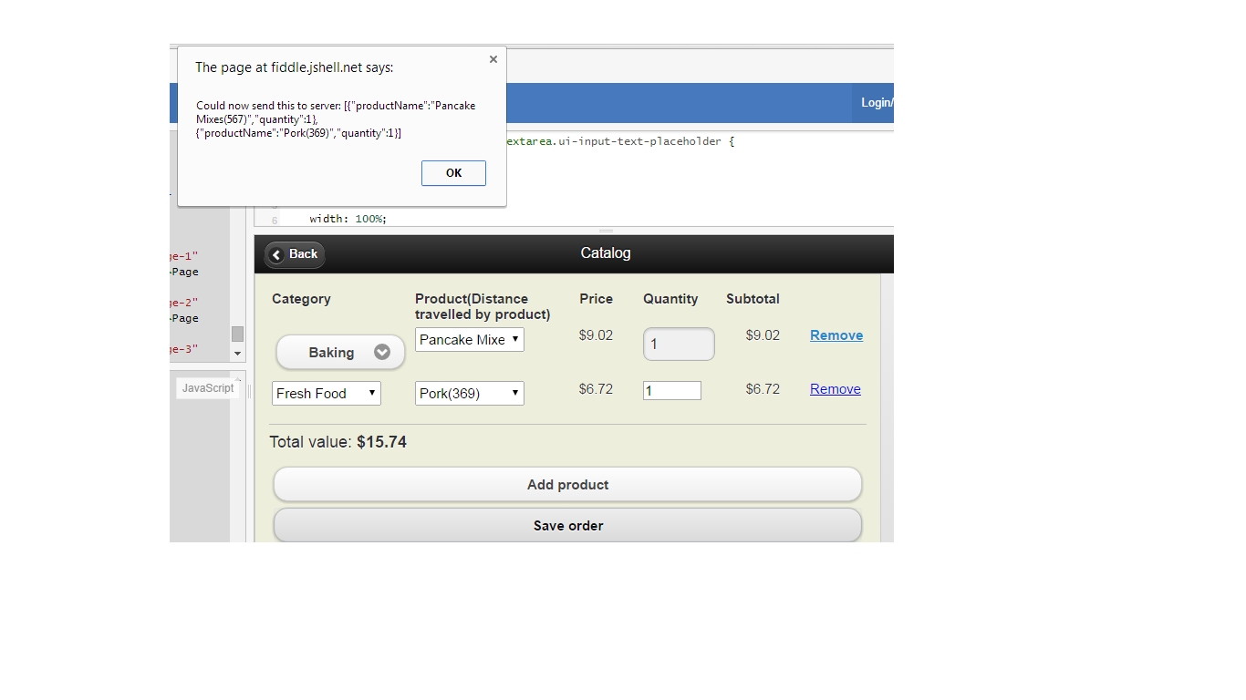

Check Item availability

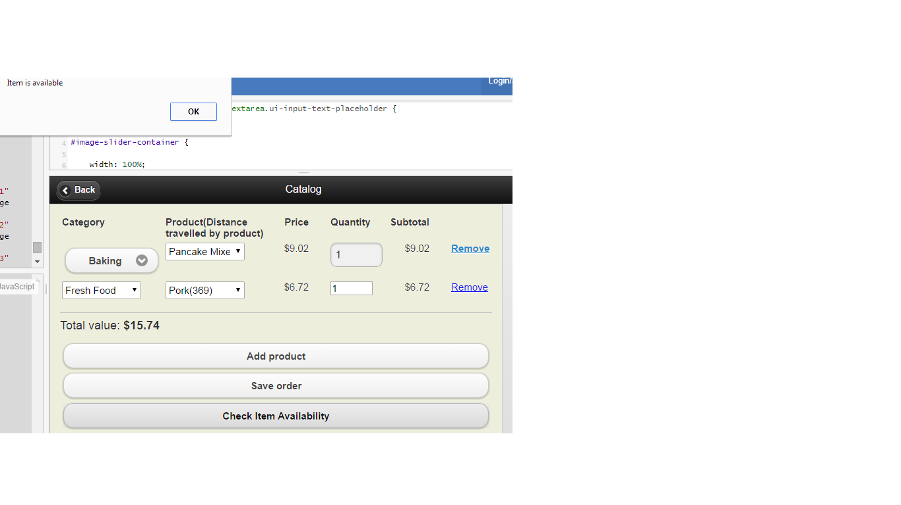

Checkout with information of food habit impacts on environment

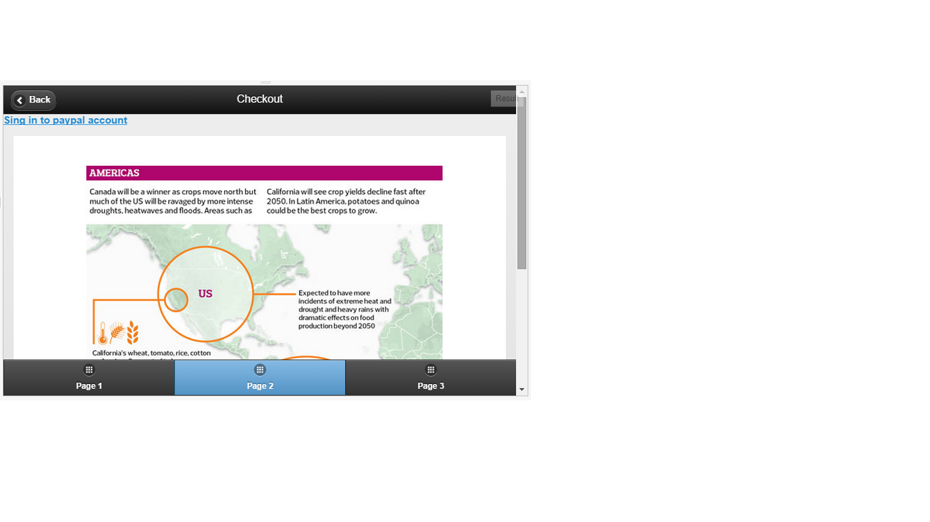

Online payment

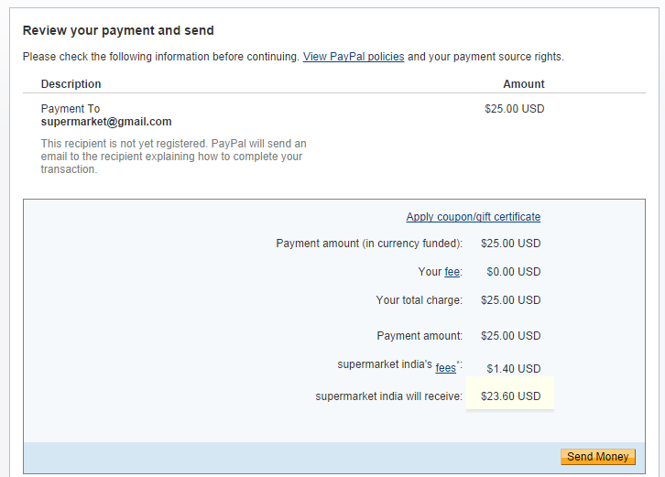

Suggested seasonal local grocery

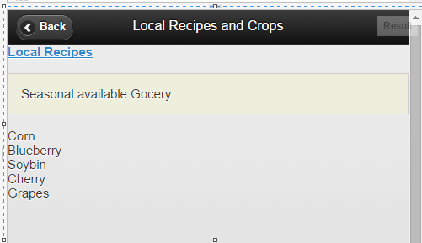

Local Food recipe

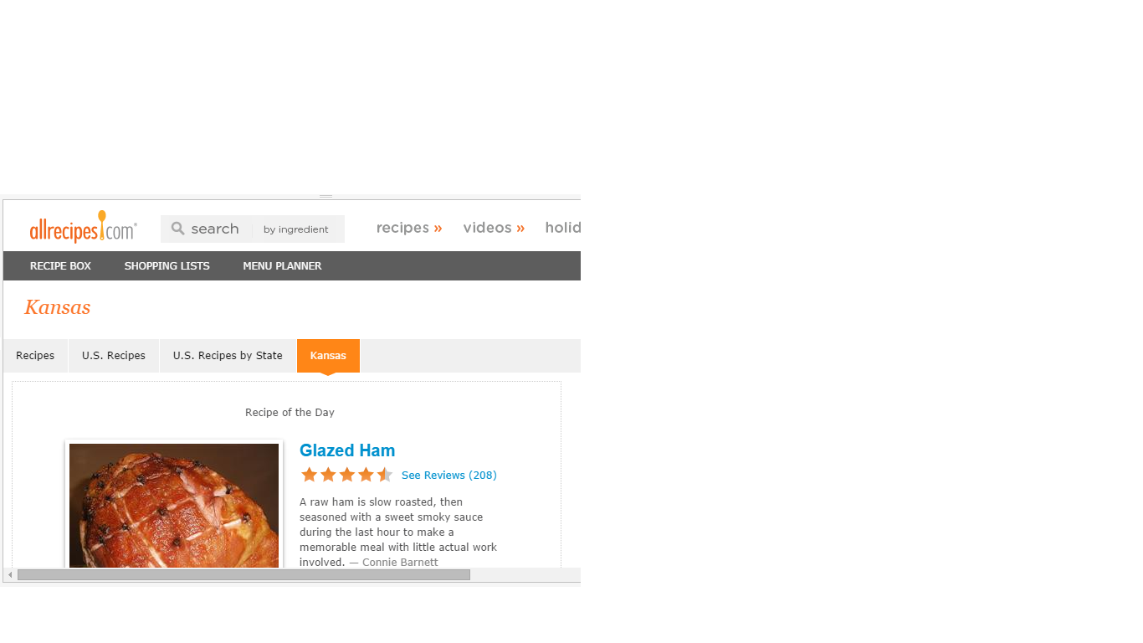

Barcode scanning

JJsfiddle link

Jsfiddle link:

<http://jsfiddle.net/adNuR/3583/>

<http://jsfiddle.net/PhilM/Bf89R/3/>

Github URL:

https://github.com/vidhishah123/challenge-1/

Web Service and Web Site URLs:

<http://allrecipes.com/recipes/us-recipes/us-recipes-by-state/kansas/>

<http://www.programmableweb.com/api/barcode-scanner>

<http://i.imgur.com/HHuCM5E.png?1>

<http://i.imgur.com/oee6Vz5.png>

<https://www.paypal.com/us/webapps/mpp/pay-online>

Limitation:

* User has to go to Paypal account to transfer money which includes its own transaction charges.

References:

[http://developer.yahoo.com/](http://developer.yahoo.com/%20)

[https://dev.twitter.com/](https://dev.twitter.com/%20)

[https://developers.facebook.com/](https://developers.facebook.com/%20)

<http://www.ksre.k-state.edu/p.aspx?tabid=18>

<https://www.paypal.com/>

<http://jsfiddle.net/bmknight/LCnt2/>

<http://www.ifr.ac.uk/waste/Reports/DEFRA-Environmental%20Impacts%20of%20Food%20Production%20%20Consumption.pdf>

<http://allrecipes.com/recipes/us-recipes/us-recipes-by-state/kansas/>