|  |
| --- |
| 1. Build an Android application that provides the following features |
| - Sensor Data Collection (you can use the application implemented for Lab 2) |
| - File Transfer (using Web Service) (Refer to Tutorial 5) |
| - HBase CRUD operations (Create, Retrieve, Update, Delete) (Using Web Services) (Refer to Lab 2 and Tutorial 5) |
| 2. Show your work to either the instructor or TA during lab evaluation sessions |
| 3. Write a short report and publish your source code and report to your GitHub Lab 3. Post the URL below before the due date. |

CS590- Big data Analytics and Application

Lab-3 Assignment

By: Vidhi Shah

Sensor data collection:

: humid

: temperature

:accelerator

: date

: Geolocation

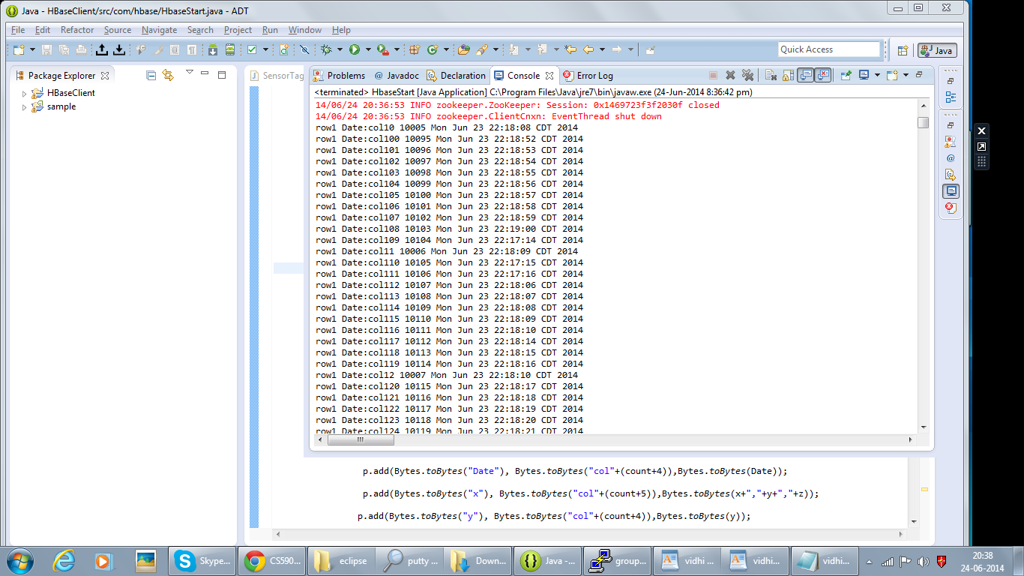

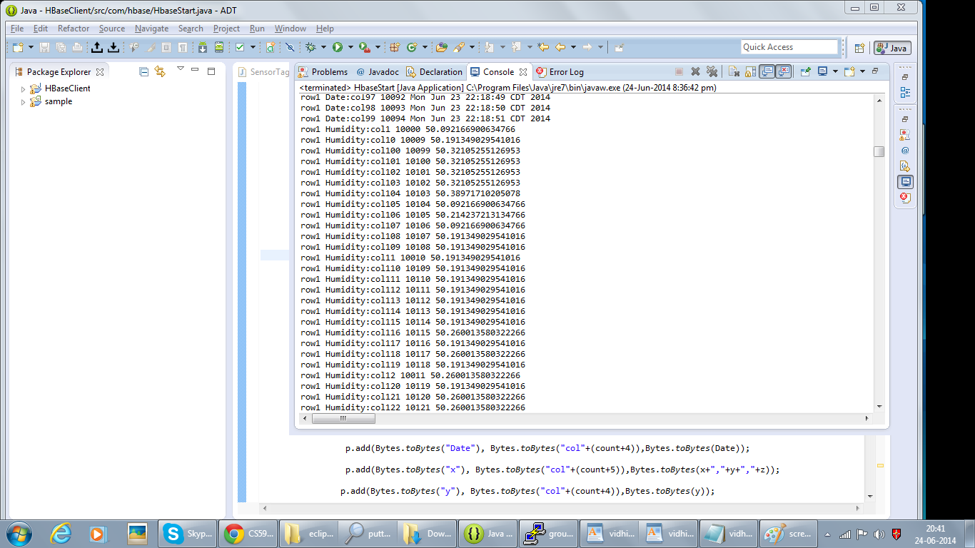

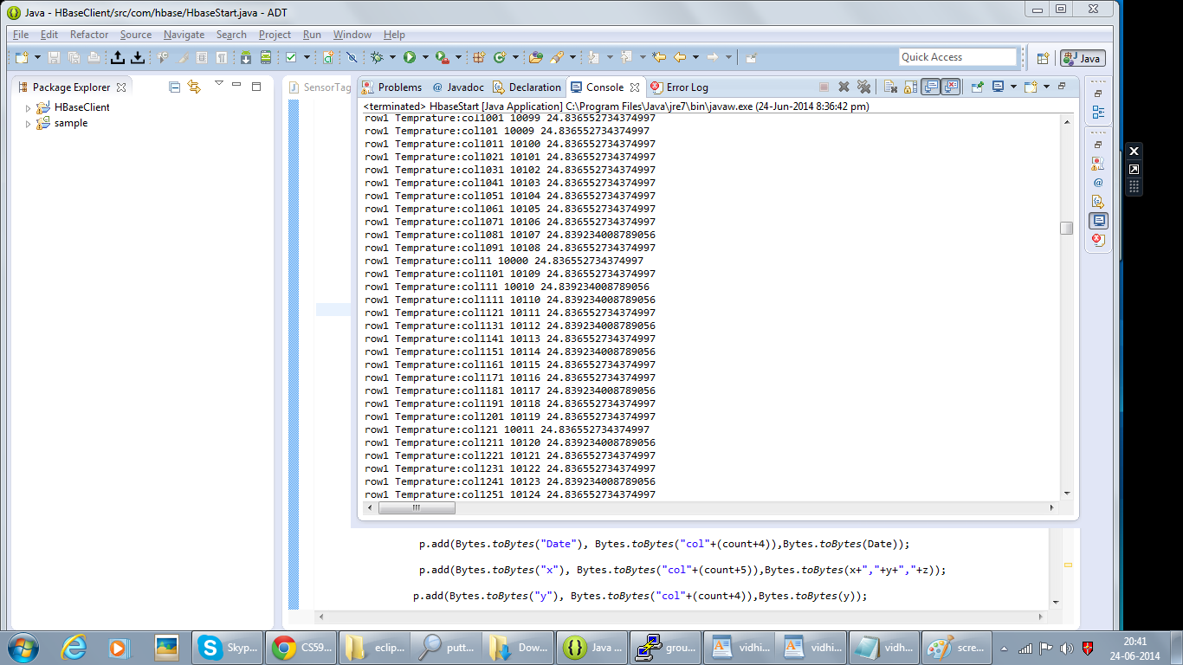

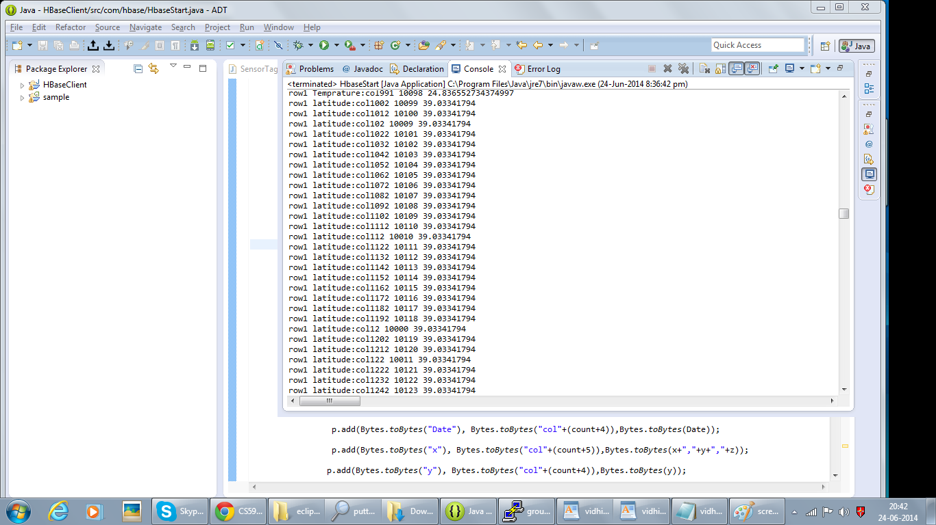

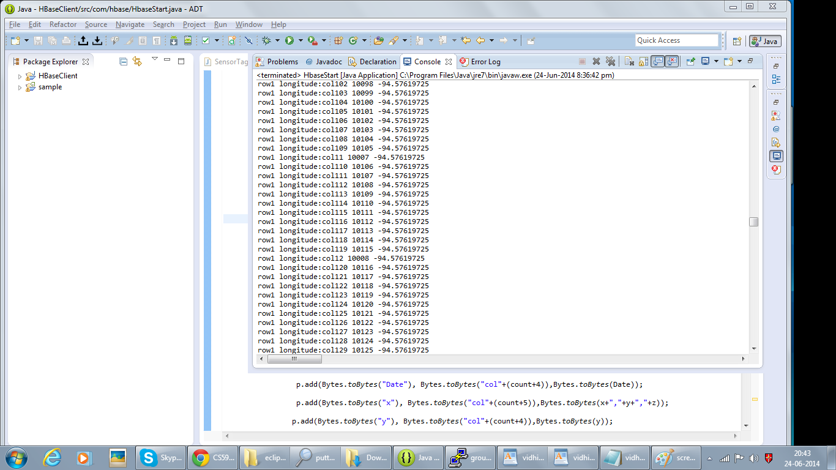

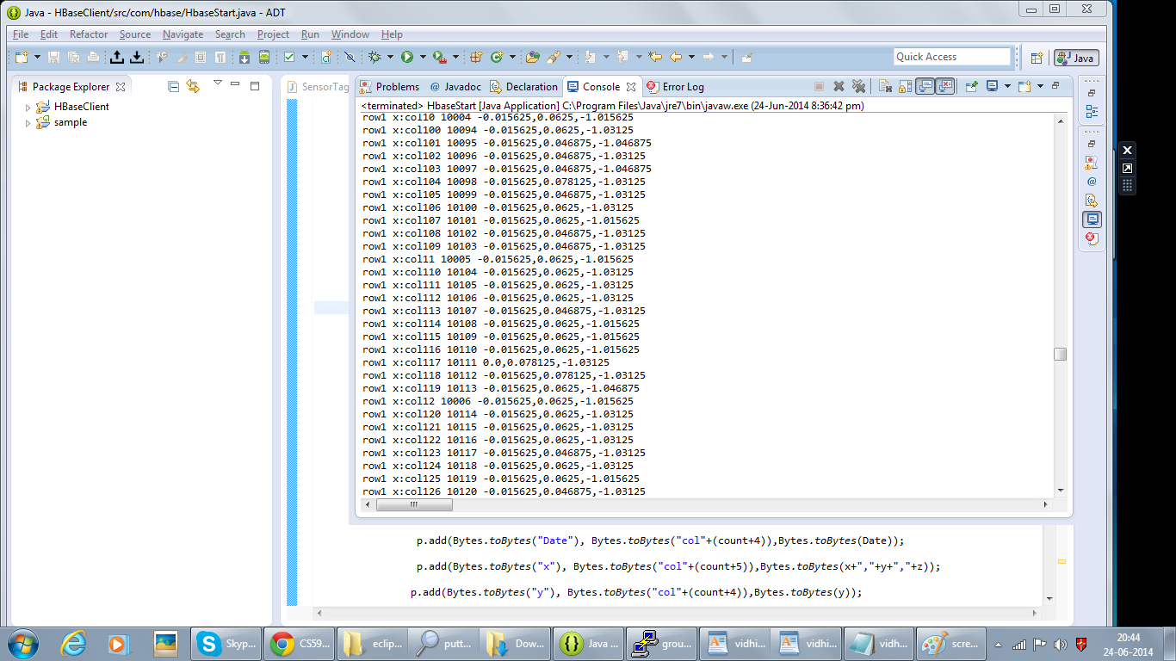

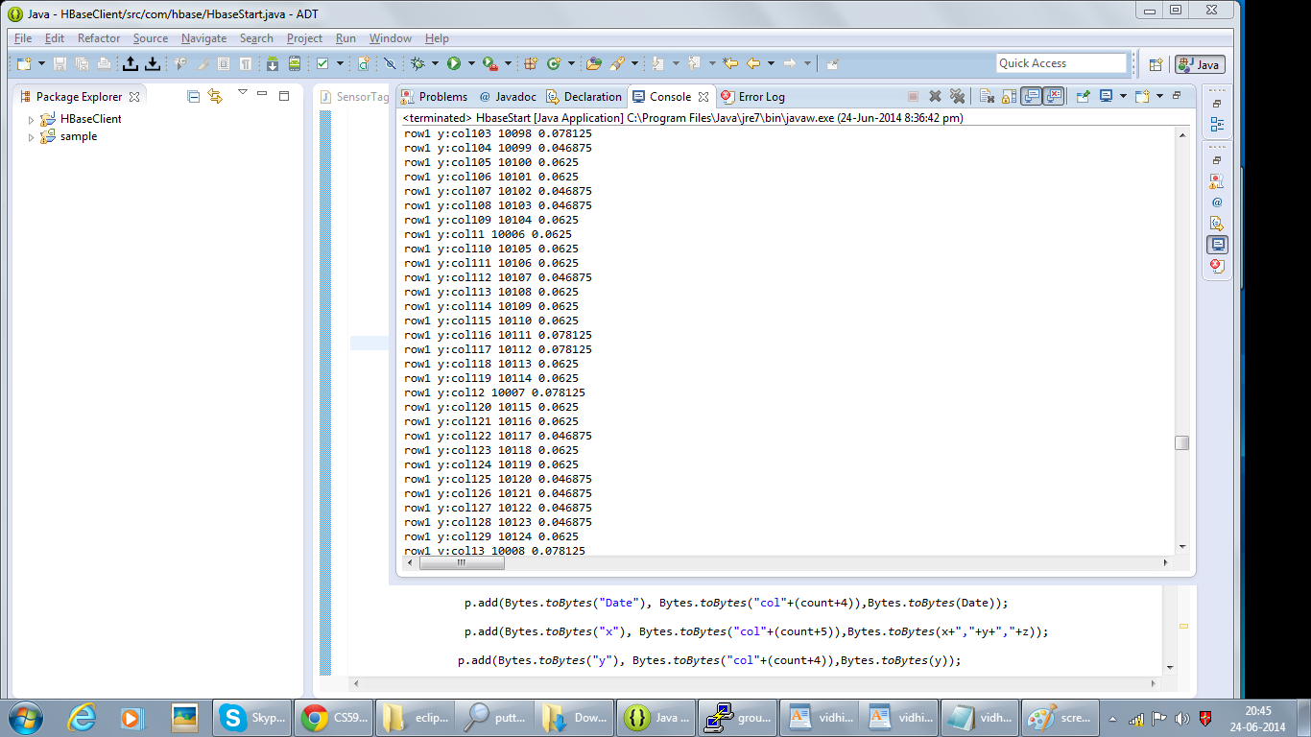



Creating Restful web service:

Screenshot:1 Exporting WAR file

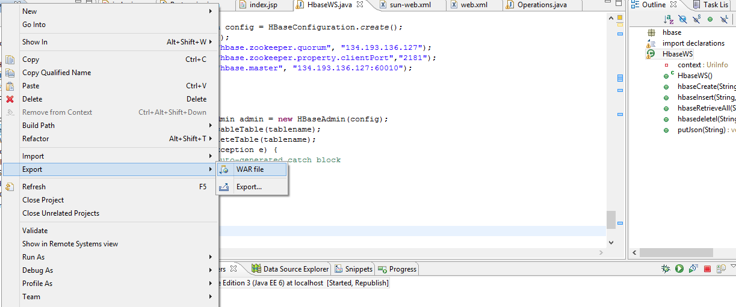

Screenshot:2 deployment in glassfish server

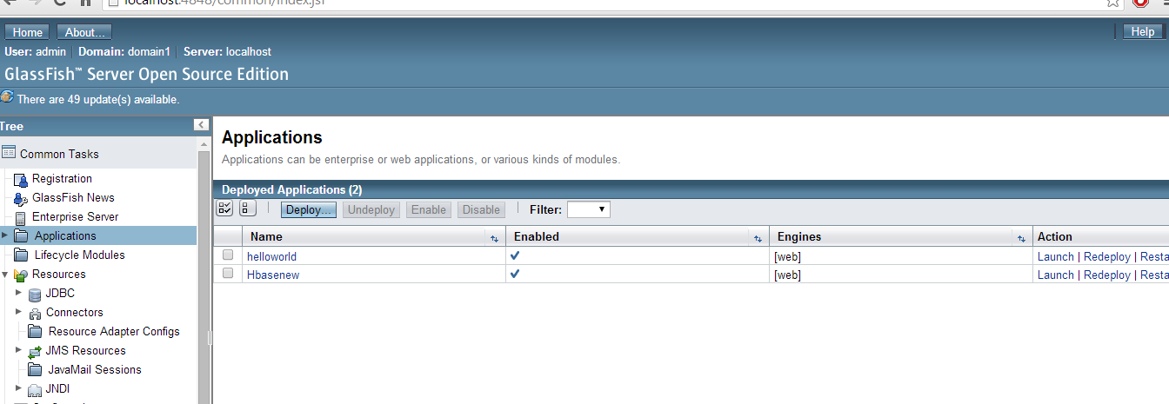

Screenshot:3 creation of table

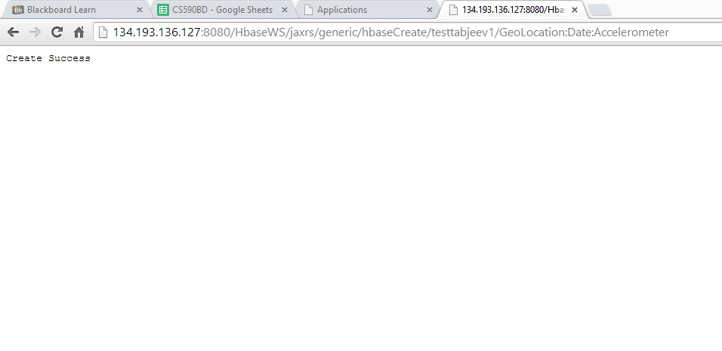

Screenshot:4 pushing data (Vidhinew.text) file

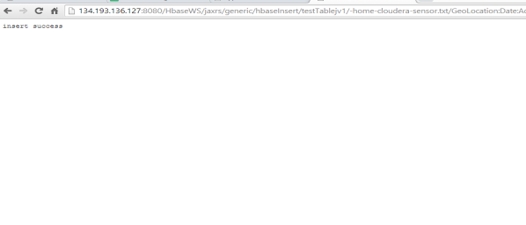

Screenshot:5 retrieving data

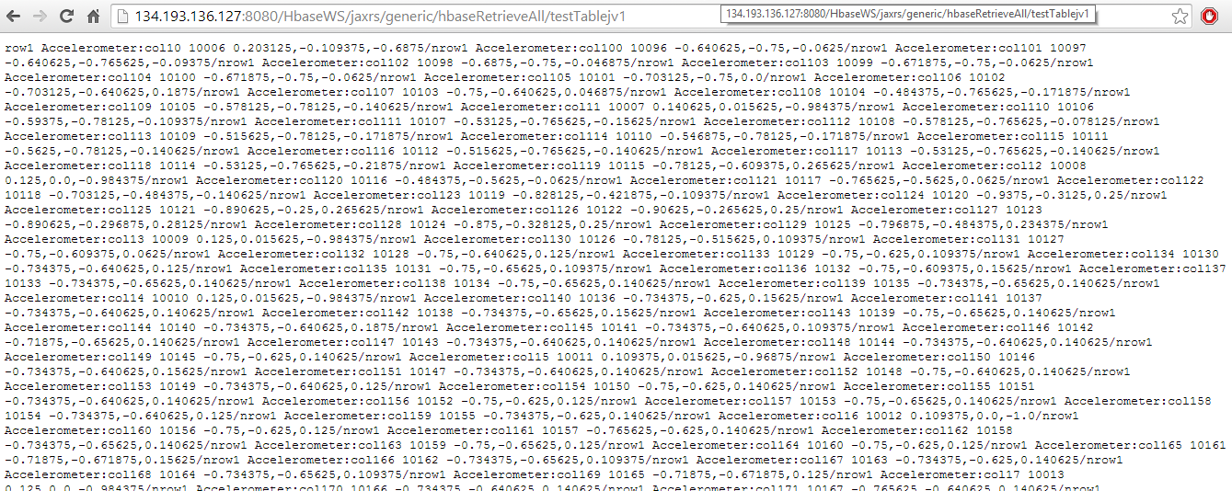

Screenshot:6 deleting table

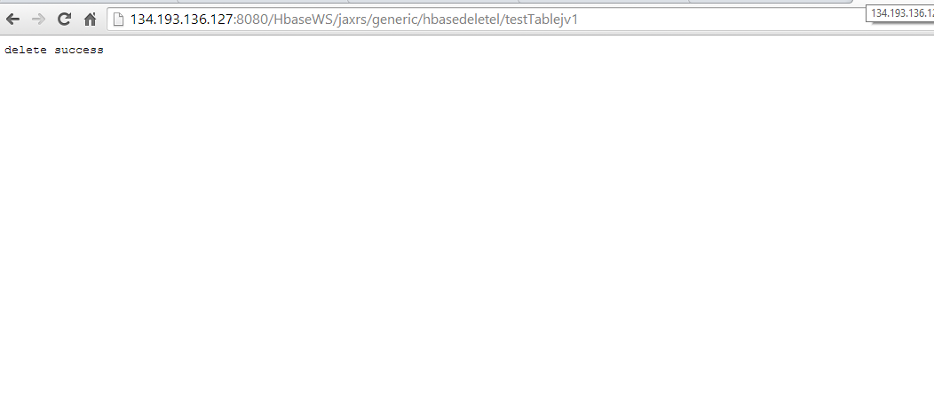

Screenshot:8 login page

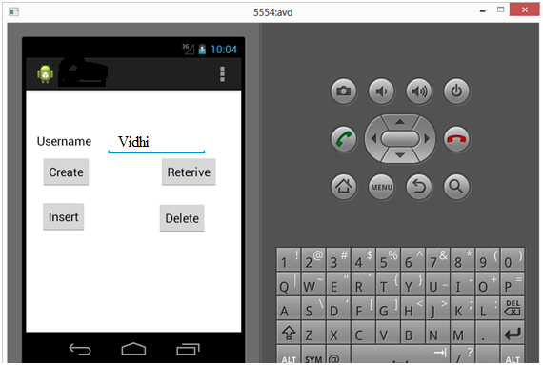

Screenshot: 9 creating table

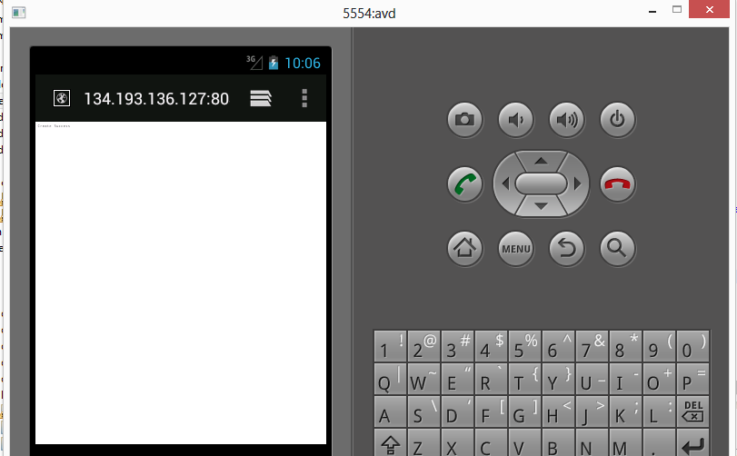

Screenshot:10 retrieving data

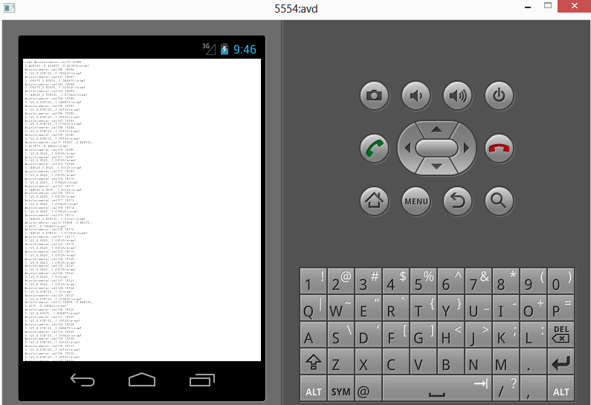

Screenshot:11 deleting data

