Knowledge discovery and Management

CS560

Report on LAB-4 tutorial

By : Vidhi Shah

16178723

Complete the following tasks:

1. Cloudera / Mahout / Solr: Implement a Mahout application (e.g., classification/Recommedation/Association Rule Mining) using your own data and store your output to Solr.

Answer:

1. Mahout Frequent Pattern Mining- Association:

Clone from github link: <https://github.com/fredang/mahout-frequent-pattern-mining-example.git>

Screenshot:1 project was built successfully

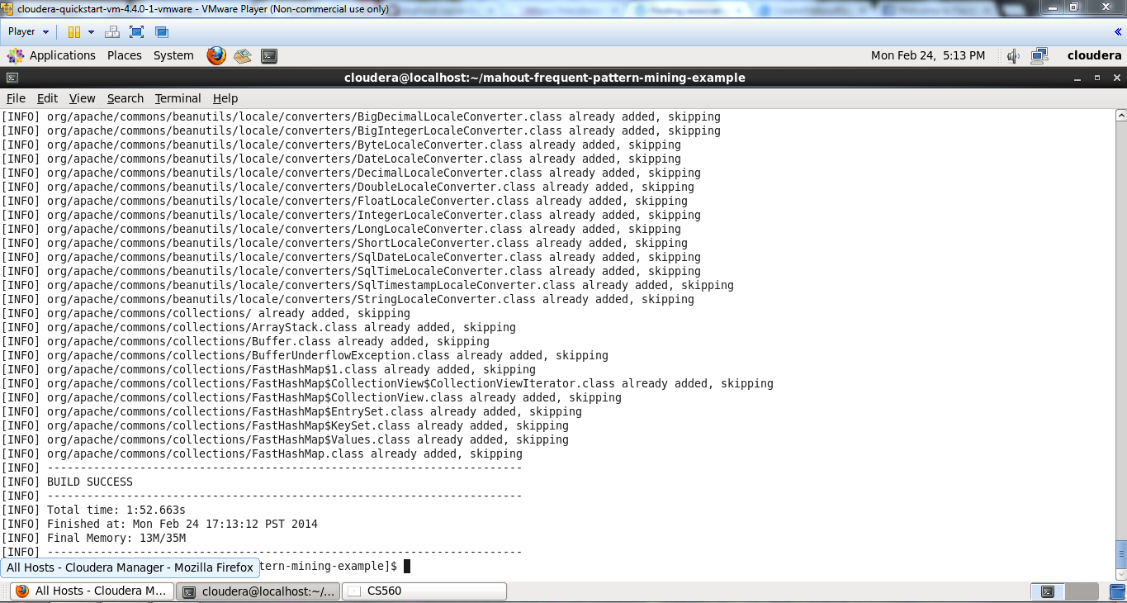

Screenshot:2 CSV input data to Dat conversion

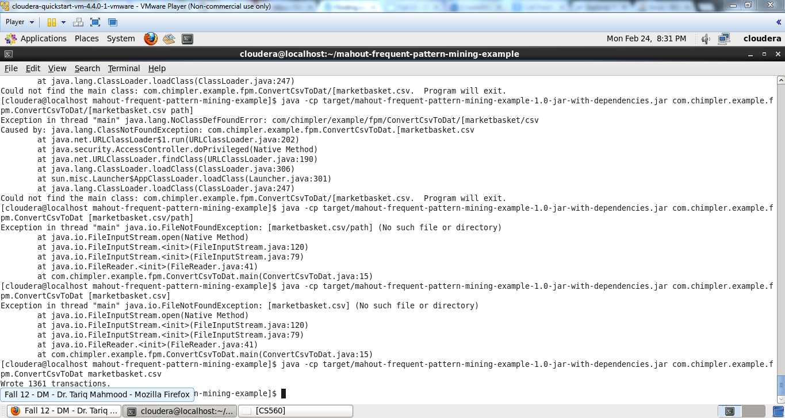

Screenshot: 3 Mahout execution

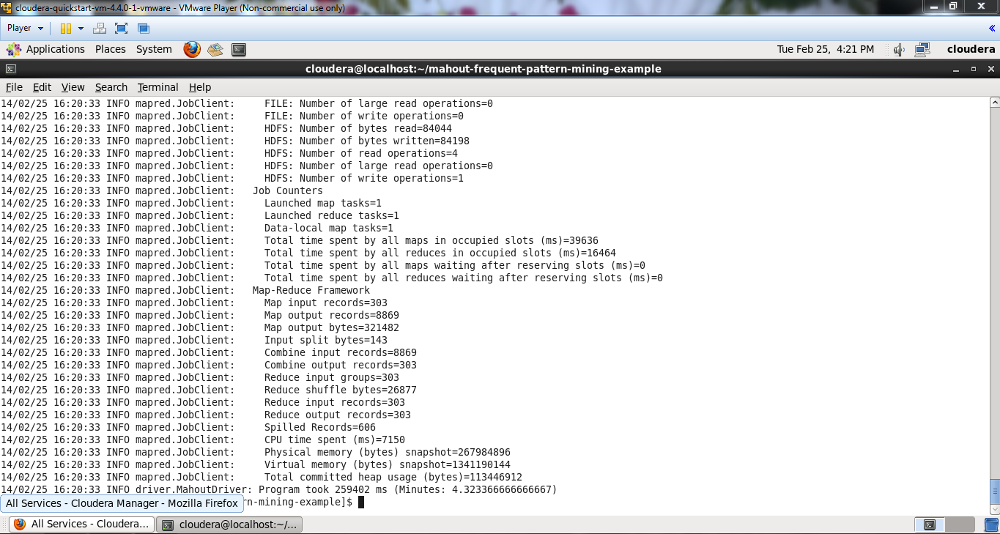

Screenshot:4 pushed data into solr

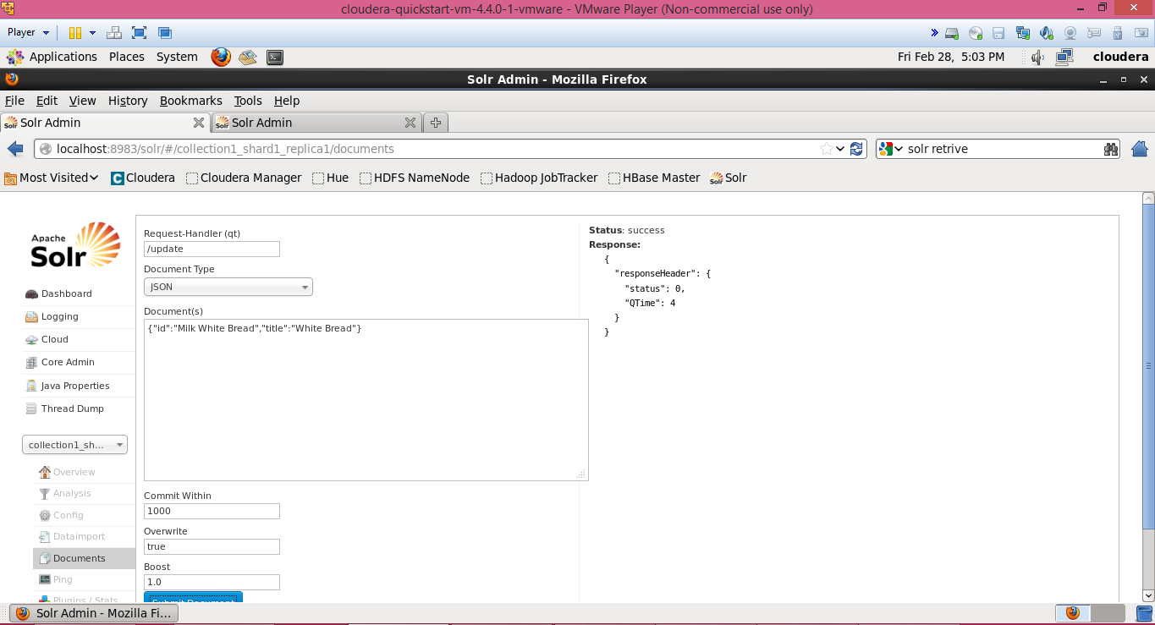

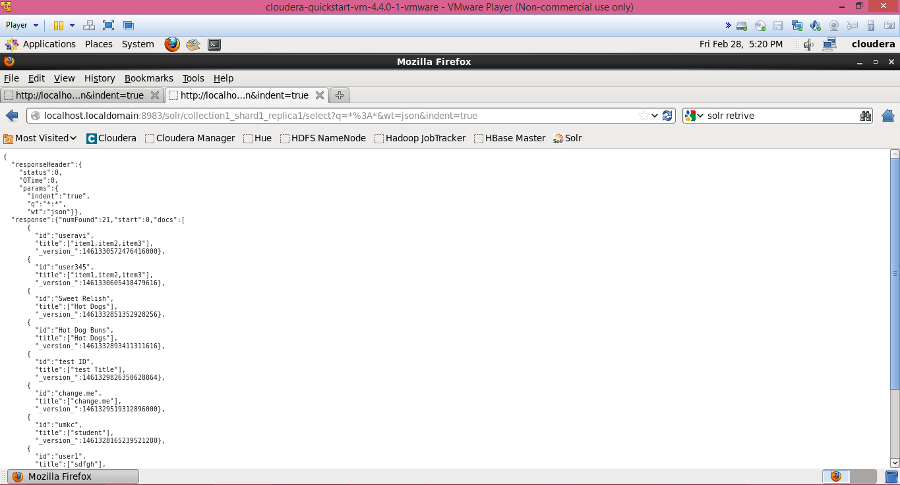

1. **Mobile Client Application :**



My solr stopped working suddenly, so I could not complete interfacing with solr.