VEHICULAR ADHOC MESSAGE PASSER
- A POSSIBLE TRACKING SYSTEM
AIM OF THE PROJECT:
To track the public transport bus and disseminate knowledge about the bus including distance and average speed to each stop in the route and keep the people updated.
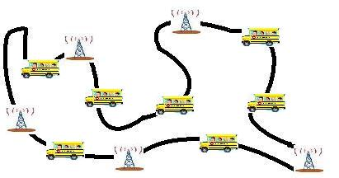
-Antenna at Bus station
- Bus (Public transport in India)

BRIEF OVERVIEW:
It would be very useful if a person has some idea of how long he should wait at the stop in order to catch the bus that would take him to the required destination. The knowledge can be in any form; here we choose distance and average speed (to indicate traffic density) as the parameters. The idea is that since the distance between bus stations (stops) are known and constant and the distance travelled by the vehicle from the starting point is measurable, it is possible at every instant of time to calculate the distance from each bus station to the vehicle of interest (bus). Average speed is a parameter dependent on the bus alone (hence the calculation is obvious). This data is passed from one station to another by vehicles travelling along the route. Security issues can be resolved to some extent by using only standard vehicles (public transport and not private vehicles) to exchange data.

MERITS IDENTIFIED:
- The person who wants to travel will have an idea if there is any bus for his required destination as soon as he reaches the stop.
- The density of buses on the same route can be balanced according to the distance travelled by each bus in a particular route.

CHALLENGES IDENTIFIED: Data accuracy, Error detection

REFERENCES:
- A. Agarwal, T.D.C Little. Prospects of Networked Vehicles of the Future, 2007
- Maxim Raya, Panos Papadimitratos, and Jean-Pierre Hubaux. Securing vehicular Communications, 2006.
- P. Basu, T.D.C Little. Networked Parking Spaces: Architecture and Applications, 2002

