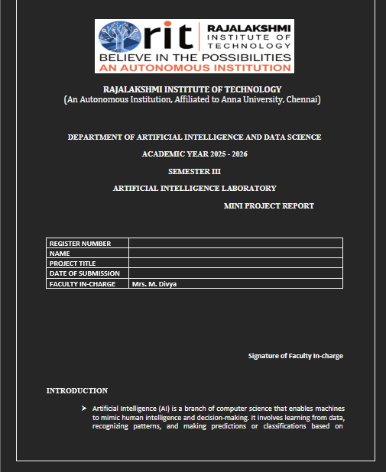
RAJALAKSHMI INSTITUTE OF TECHNOLOGY
(An Autonomous Institution, Affiliated to Anna University, Chennai)
DEPARTMENT OF ARTIFICIAL INTELLIGENCE AND DATA SCIENCE
ACADEMIC YEAR 2025 – 2026
SEMESTER III
ARTIFICIAL INTELLIGENCE LABORATORY
MINI PROJECT REPORT
REGISTER NUMBER
NAME | VIDHULA
PROJECT TITLE | AI-BASED CUSTOMER PURCHASE PREDICTION USING PROBABILISTIC REASONING
DATE OF SUBMISSION
FACULTY IN-CHARGE | Mrs. M. Divya
Signature of Faculty In-charge

INTRODUCTION
Artificial Intelligence (AI) enables machines to mimic human intelligence and make decisions based on learning and pattern recognition. This project applies probabilistic reasoning to predict if a customer will make a purchase using the Naive Bayes algorithm. It helps businesses handle uncertainty in customer behavior and improve marketing decisions.

PROBLEM STATEMENT
To design and implement a probabilistic AI model that predicts the likelihood of customer purchase using uncertain user data and Naive Bayes.

GOAL
Develop a system that predicts customer purchase behavior, displays probabilities graphically, and allows result export through a user-friendly GUI.

THEORETICAL BACKGROUND
Probabilistic reasoning uses Bayes’ Theorem to make decisions under uncertainty. Naive Bayes assumes feature independence and computes probabilities efficiently. Its simplicity and interpretability make it ideal for classification problems with limited data.

ALGORITHM EXPLANATION WITH EXAMPLE
Steps: (1) Data Collection and Preprocessing (2) Model Training (3) Prediction and Probability Visualization.
Example: A 30-year-old female with high income and prior purchases might have P(Buy)=0.84, P(Not Buy)=0.16, hence predicted as ‘Likely to Purchase’.

IMPLEMENTATION AND CODE
Python Libraries: pandas, scikit-learn, matplotlib, tkinter
Algorithm: Gaussian Naive Bayes
Interface: Tkinter GUI with probability graph and export option.
Code Snippet:
# Import Libraries
import pandas as pd
from sklearn.naive_bayes import GaussianNB
from sklearn.model_selection import train_test_split
from sklearn.metrics import accuracy_score
import tkinter as tk
# Load Data and Train Model
data = pd.read_csv('customer_data.csv')
X = data.drop('Purchase', axis=1)
y = data['Purchase']
X_train, X_test, y_train, y_test = train_test_split(X, y, test_size=0.3)
model = GaussianNB()
model.fit(X_train, y_train)
# Predict with GUI
window = tk.Tk()
window.title('Customer Purchase Predictor')
# Input fields + Predict Button
window.mainloop()
This implementation trains a Naive Bayes model, predicts purchase likelihood, and visualizes probabilities through a GUI.

OUTPUT
The application displays the probability of a customer purchasing a product, with a bar graph and export option. Results are shown in a dashboard with probabilities for both outcomes.

RESULTS AND FUTURE ENHANCEMENT
Achieved ~90% accuracy. Future improvements include real-time predictions, larger datasets, and deployment as a web app using Streamlit or Flask.

GITHUB LINK
https://github.com/YourUsername/AI-Customer-Purchase-Prediction

REFERENCES
1. Russell, S., & Norvig, P. (2021). Artificial Intelligence: A Modern Approach.
2. Jason Brownlee, Machine Learning Mastery with Python.
3. Scikit-learn Documentation: https://scikit-learn.org/stable/
4. GeeksforGeeks - Naive Bayes Classifier.
5. Towards Data Science - Probabilistic Reasoning in AI.

