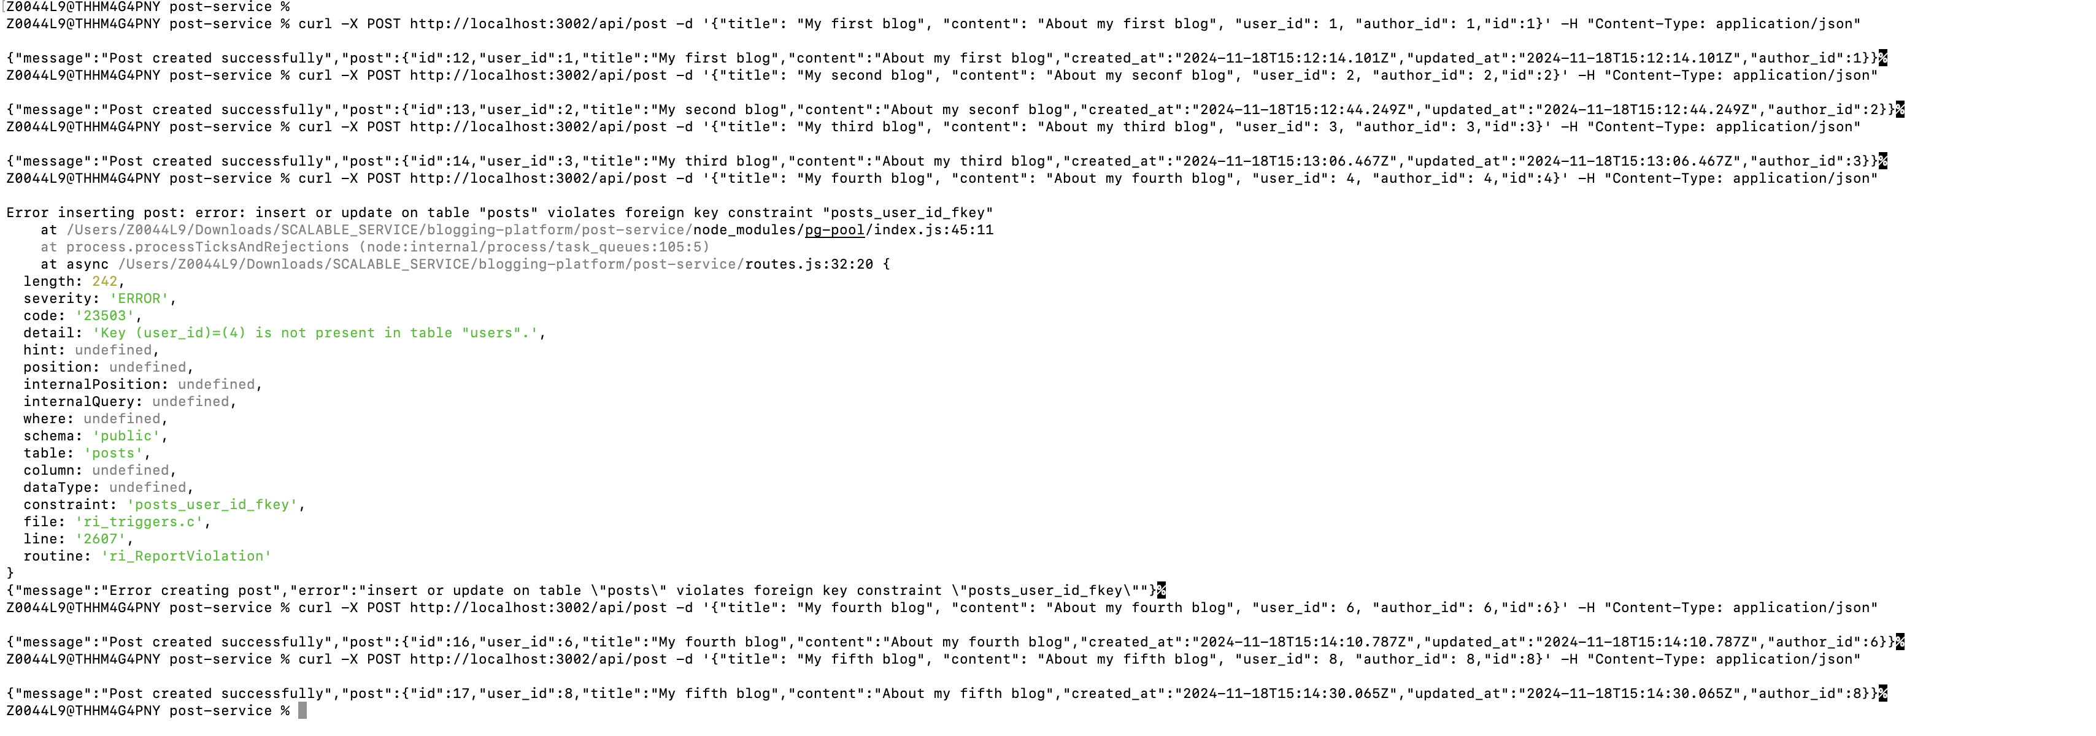

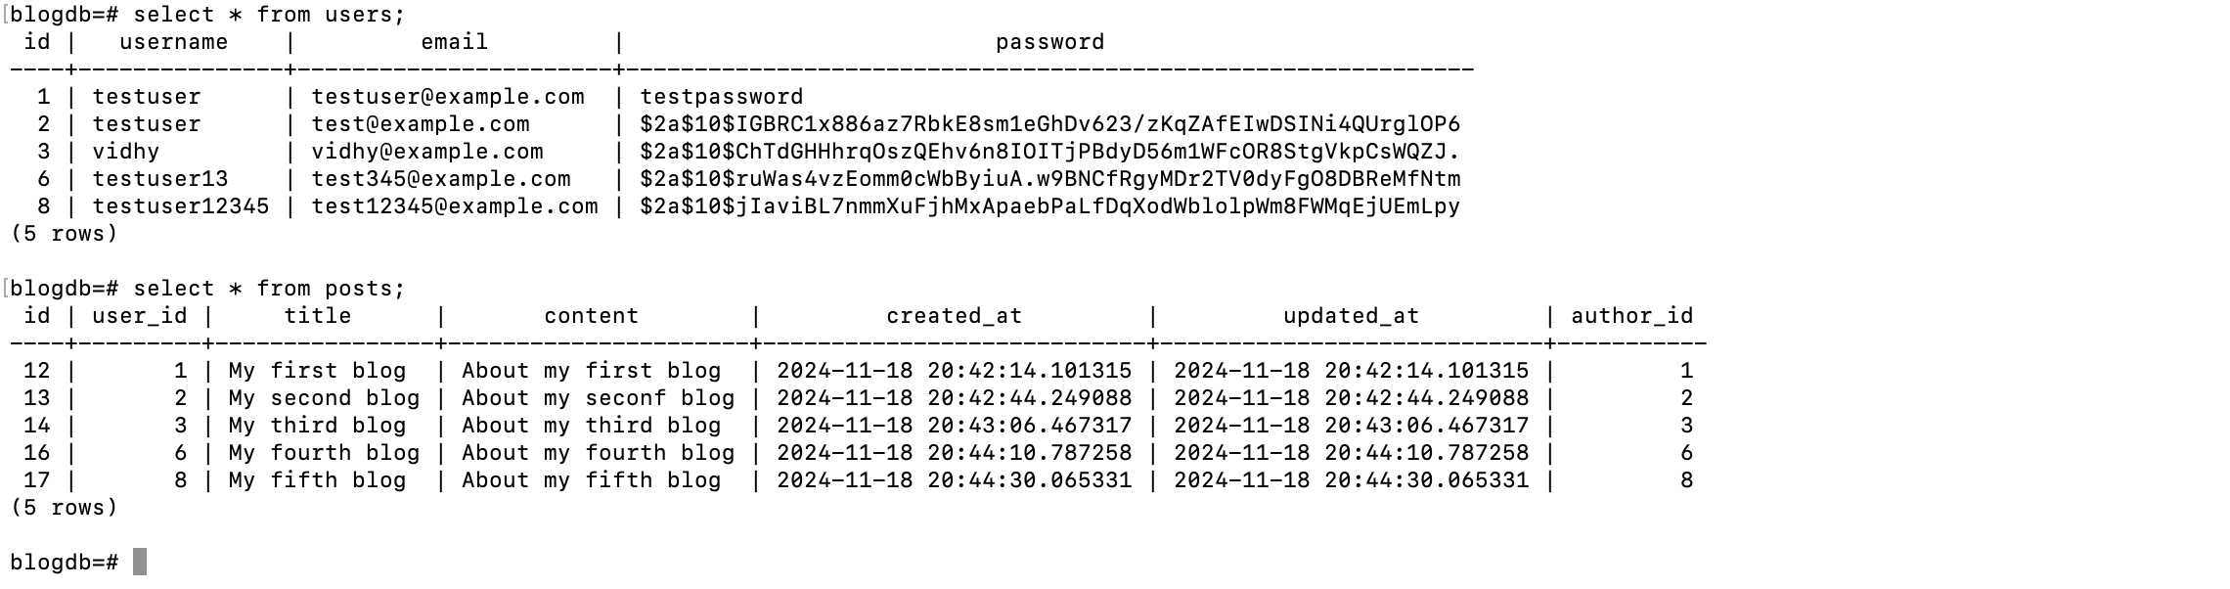

Edit Post:



ID:12 post modified & can seen in POSTS table:

Select Post by user name:



blogdb=# select \* from users;

id | username | email | password

----+---------------+-----------------------+--------------------------------------------------------------

1 | testuser | testuser@example.com | testpassword

2 | testuser | test@example.com | $2a$10$IGBRC1x886az7RbkE8sm1eGhDv623/zKqZAfEIwDSINi4QUrglOP6

3 | vidhy | vidhy@example.com | $2a$10$ChTdGHHhrqOszQEhv6n8IOITjPBdyD56m1WFcOR8StgVkpCsWQZJ.

6 | testuser13 | test345@example.com | $2a$10$ruWas4vzEomm0cWbByiuA.w9BNCfRgyMDr2TV0dyFgO8DBReMfNtm

8 | testuser12345 | test12345@example.com | $2a$10$jIaviBL7nmmXuFjhMxApaebPaLfDqXodWblolpWm8FWMqEjUEmLpy

(5 rows)

blogdb=#

Delete Post with ID:12:



Now ID 12, post deleted:

