MEDICAPS UNIVERSITY, INDORE
Department of Computer Science & Engineering
PROJECT REPORT
GLOBAL FUEL PRICES ANALYSIS
Submitted by: Vidhya Jain
Course: B.Tech – Computer Science & Engineering
University: Medicaps University, Indore
Tool: Tableau Desktop / Tableau Public
Academic Session: 2026
Enrollment no: en25cs3011044
Email id: en25cs3011044@medicaps.ac.in

TABLE OF CONTENTS
1. INTRODUCTION
1.1 Project Overview
1.2 Purpose
2. IDEATION PHASE
2.1 Problem Statement
2.2 Empathy Map Canvas
2.3 Brainstorming
3. REQUIREMENT ANALYSIS
3.1 Customer Journey Map
3.2 Solution Requirement
3.3 Data Flow Diagram
3.4 Technology Stack
4. PROJECT DESIGN
4.1 Problem Solution Fit
4.2 Proposed Solution
4.3 Solution Architecture
5. PROJECT PLANNING & SCHEDULING
5.1 Project Planning
6. FUNCTIONAL AND PERFORMANCE TESTING
6.1 Performance Testing
7. RESULTS
7.1 Output Screenshots
8. ADVANTAGES & DISADVANTAGES
9. CONCLUSION
10. FUTURE SCOPE
11. APPENDIX
Source Code (if any)
Dataset Link
GitHub & Project Demo Link
1. INTRODUCTION

1.1 Project Overview
Global Fuel Prices Analysis is a data-visualization project that explores petrol-price differences across countries and examines how fuel prices relate to factors such as fuel taxes and Brent crude oil prices. The project uses a fuel-price dataset and Tableau to turn tabular data into charts, dashboards, and a published Story. Three dashboards—Policy, Logistics, and Research—organize the analysis for different types of users.
The dashboards are intended to make comparisons easier than reading rows of raw data. Users can explore patterns across countries and categories, subject to the fields and filters available in the final workbook.

1.2 Purpose
- To present fuel-price data in a clear and visual format.
- To compare petrol prices across countries and identify broad differences.
- To explore tax bands and price categories using calculated fields.
- To examine the relationship between petrol prices and Brent crude oil prices where the dataset supports the comparison.
- To publish the dashboards as a Tableau Story and maintain supporting project files in GitHub.

2. IDEATION PHASE

2.1 Problem Statement
Fuel prices differ across countries, and the raw dataset may be difficult for a reader to interpret quickly. Comparing countries, tax levels, and crude-oil-related measures manually can take time and make patterns harder to notice. The project addresses this problem by organizing the available data into Tableau visualizations and dashboards so users can explore the information more easily.

2.2 Empathy Map Canvas
The following empathy map describes likely users of a fuel-price analysis dashboard. It is a design aid for the project, not the result of a formal interview.
Empathy area | Likely user perspective
Says | “I want to compare fuel prices between countries without reading a large spreadsheet.”
Thinks | “Which countries have higher prices, and how might tax levels relate to them?”
Does | Uses charts, compares countries or categories, and checks dashboard filters.
Feels | May feel confused by raw rows and prefers clear labels, summaries, and visual comparisons.
Needs / pains | Needs understandable charts, consistent units, clear categories, and reliable data; raw data can be time-consuming to compare.

2.3 Brainstorming
During ideation, possible ways to present the data were considered. The selected approach was to group visualizations into dashboards for policy, logistics, and research perspectives.
- Compare petrol prices by country or region.
- Group observations into low, medium, and high tax bands.
- Classify petrol prices into price categories for easier scanning.
- Explore petrol price in relation to Brent crude oil price.
- Publish a Tableau Story so viewers can navigate the project online.
- Keep the dataset, workbook, documentation, and related files organized in GitHub.

3. REQUIREMENT ANALYSIS

3.1 Customer Journey Map
This journey map represents a typical viewer exploring the published Tableau Story.
Stage | User action | Possible difficulty | Project support
Discover | Opens the shared Tableau Story link | Unsure what the project covers | Project title and overview explain the topic
Explore | Opens Policy, Logistics, or Research dashboard | Many values can be hard to compare | Charts group related information
Filter / compare | Selects available filters or compares marks | May need to interpret categories | Labels, legends, and available filters guide exploration
Understand | Reviews patterns in fuel prices and tax categories | Correlation may be mistaken for causation | Report explains that charts show relationships, not proof of cause
Share | Uses the published Story or repository files | May need source files or methodology | Tableau link and GitHub repository provide access, once links are added

3.2 Solution Requirement
Functional requirements
- The project should load the prepared CSV or Excel data into Tableau.
- It should provide visual comparisons of petrol prices across countries.
- It should include the Policy, Logistics, and Research dashboards.
- It should use calculated fields for tax bands, price categories, and the petrol-to-Brent ratio where the corresponding fields exist.
- It should publish a Story that can be opened by a viewer.
- It should provide supporting documentation and project files through GitHub.
Non-functional requirements
- Charts should have readable titles, labels, and legends.
- Visualizations should be reasonably responsive for normal browsing.
- Data fields and units should be used consistently.
- Links should be accessible to the intended audience and the published Story should open correctly.
- Findings should be based on the displayed data; no unverified numerical claims should be included.

3.3 Data Flow Diagram

DATA SOURCE
CSV FILE/ EXCEL DATASET

DATA PROCESSING
Tableau – Data Preparation & Calculated Fields

DATA VISUALIZATION
Charts and 3 Dashboards

PUBLISHING
Tableau Public Story

END USER
Views and explores the dashboards

Explanation: The dataset is the input. Tableau is used to prepare fields and create calculated measures. The resulting charts are arranged into dashboards and published as a Story for viewers. GitHub stores supporting project files and documentation; it is not the visualization engine.

3.4 Technology Stack
Technology / file type | Purpose
Tableau Desktop / Tableau Public | Create charts, dashboards, calculated fields, and publish the Story
CSV dataset | Tabular input data for analysis
Excel (.xlsx) | Spreadsheet version of the project dataset
GitHub | Versioned hosting for supporting files and README
Tableau Public | Online access to the published Story
DOCX / PDF report | Project documentation and final submission record

4. PROJECT DESIGN

4.1 Problem Solution Fit
The problem is that raw fuel-price data can be difficult to compare and interpret. Tableau charts and dashboards provide a visual interface that helps users compare countries and examine tax and crude-oil-related measures. The solution fits the problem because it changes a large table into organized views. Its usefulness depends on data quality, appropriate chart selection, readable labels, and correct interpretation.

4.2 Proposed Solution
The proposed solution is an interactive Tableau Story named Global Fuel Prices Analysis. It contains three dashboards: Policy, Logistics, and Research. The project uses calculated fields such as Tax Band and Price Category to group observations, and Price Brent Ratio to compare average petrol price with average Brent crude price. The final published workbook should be treated as the source of truth for exact chart titles, filters, and formulas.

4.3 Solution Architecture
1. Data input: prepared CSV and Excel files.
2. Data connection: load the dataset into Tableau and verify field types.
3. Analysis: create calculated fields and build charts.
4. Presentation: arrange charts into Policy, Logistics, and Research dashboards.
5. Publishing: publish the Story to Tableau Public.
6. Documentation: keep the workbook, dataset where permitted, README, and report in GitHub.

5. PROJECT PLANNING & SCHEDULING

5.1 Project Planning
Phase | Main tasks | Output
1. Define the problem | Identify the need for comparing fuel prices | Problem statement
2. Prepare data | Review the CSV/Excel files and check fields | Dataset ready for Tableau
3. Analyze data | Create calculated fields and explore the measures | Calculated fields and analysis
4. Build visualizations | Create charts and organize three dashboards | Policy, Logistics, Research dashboards
5. Publish | Publish the Story and check the public link | Tableau Public Story
6. Document and submit | Prepare report, organize files, and add repository/demo links | Final submission package
Note: This is a phase-based plan. Add actual dates or duration only if required by the project supervisor and based on the work completed.

6. FUNCTIONAL AND PERFORMANCE TESTING

6.1 Performance Testing
The following checklist can be used to validate the final workbook. Mark each test as Pass or Fail after checking the published Story and local workbook.
Test | How to check | Status
Data connection | Open the workbook and confirm the data source loads without an error | Pass
Calculated fields | Check formulas and category thresholds against the workbook | Pass
Dashboard display | Open all three dashboards and confirm charts render | Pass
Filters / interactions | Try each configured filter and confirm charts respond correctly | Pass
Labels and units | Check titles, legends, labels, and units for readability | Pass
Published link | Open the Tableau Public Story link in a browser | Pass
Responsiveness | Navigate between dashboards and observe whether they load smoothly | Pass
No measured load-time or benchmark result is claimed in this report. Record actual observations if formal performance measurements are required.

7. RESULTS
The project produces a published Tableau Story with three dashboards—Policy, Logistics, and Research—and visualizations intended to support comparisons of fuel prices, tax categories, and related measures. The exact conclusions should be taken from the final published workbook after checking the charts.

7.1 Output Screenshots
Insert screenshots from the final Tableau workbook in the spaces below. Use screenshots of the actual published dashboards; do not use placeholder images as final evidence.
Figure 1: Policy Dashboard
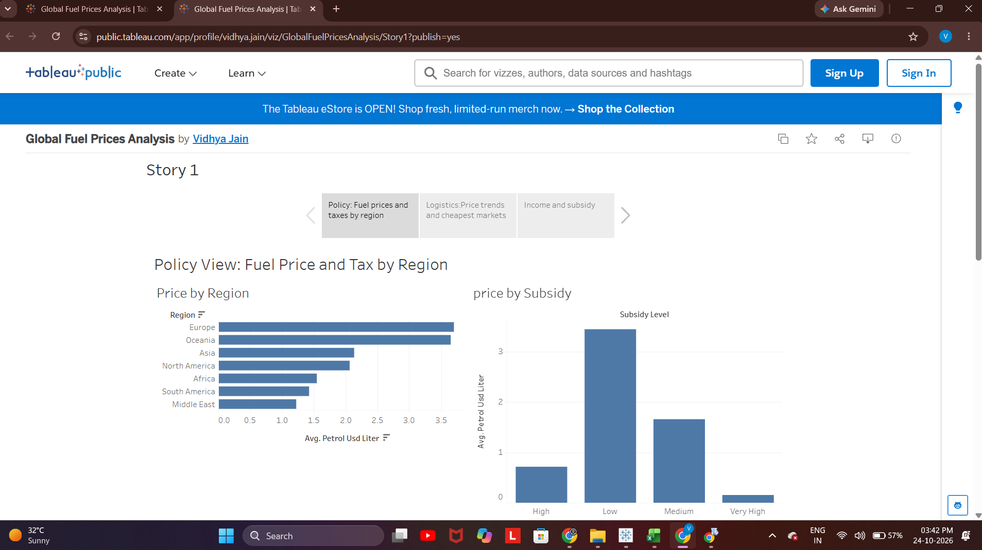
Figure 2: Logistics Dashboard
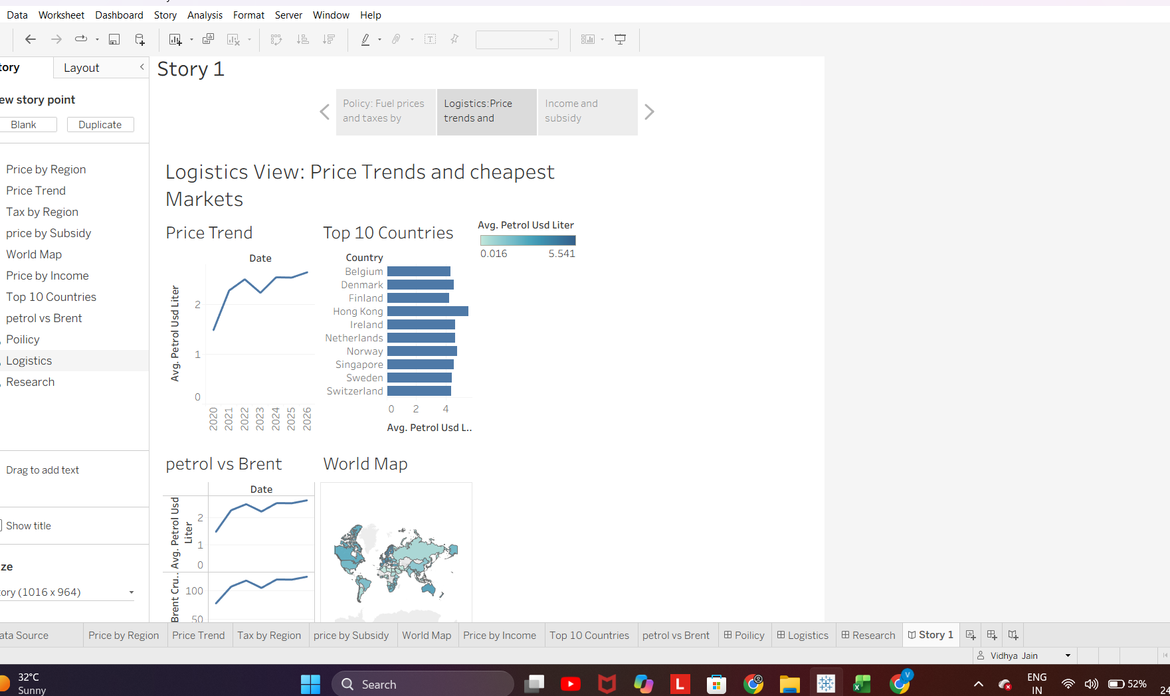
Figure 3: Research Dashboard
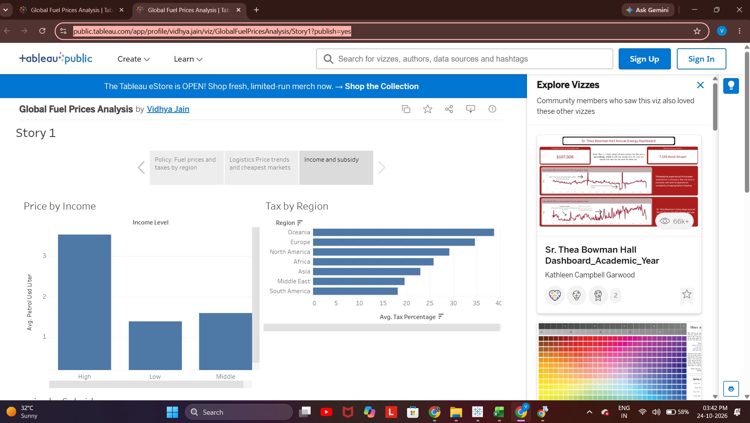

8. ADVANTAGES & DISADVANTAGES

Advantages
- Visual comparison is easier than reviewing raw spreadsheet rows.
- Dashboards organize the analysis into different perspectives.
- Calculated categories can help viewers scan patterns quickly.
- The published Story can be shared through a web link.
- Supporting files can be organized in a GitHub repository.

Disadvantages / Limitations
- The analysis is limited by the completeness, accuracy, and coverage of the available dataset.
- Charts show patterns and associations; they do not by themselves prove that one factor causes another.
- Interpretation depends on correct units, field definitions, and calculated-field thresholds.
- Viewers may need an internet connection to open the published Tableau Story.
- Specific numerical findings must be verified against the final workbook before being reported.

9. CONCLUSION
Global Fuel Prices Analysis demonstrates how Tableau can be used to transform a fuel-price dataset into visual dashboards and a shareable Story. The Policy, Logistics, and Research dashboards provide structured views for exploring country-level price differences and related measures. The project also demonstrates the use of calculated fields and online publication. Before final submission, the dataset source, actual dashboard screenshots, verified findings, GitHub repository URL, and any required demonstration video should be added and checked.

10. FUTURE SCOPE
- Add more recent and reliable fuel-price observations when available.
- Document the original dataset source, data definitions, units, and update frequency.
- Add more countries or historical comparisons if suitable data is available.
- Improve dashboard tooltips, filter controls, accessibility, and mobile readability.
- Include verified key findings and clearly explain limitations.
- Automate data refresh if the source and Tableau setup support it.
- Add a short demonstration video explaining the dashboards and their use.

11. APPENDIX

A. Source Code / Calculated Fields
This is a Tableau visualization project rather than a conventional software application, so there may be no separate source-code file. The calculated fields used during development are listed below; verify their exact names and formulas in the final workbook before submission.
Tax Band — intended grouping: High for tax percentage ≥ 35; Medium for tax percentage ≥ 20 and < 35; Low for tax percentage < 20.
Formula: IF [Tax Percentage] >= 35 THEN "High"
ELSEIF [Tax Percentage] >= 20 THEN "Medium"
ELSE "Low"
END
Price Category — intended grouping: Expensive for Petrol Usd Liter ≥ 3; Medium for Petrol Usd Liter ≥ 1 and < 3; Cheap for Petrol Usd Liter < 1.
Formula : IF [Petrol Usd Liter] >= 3 THEN "Expensive"
ELSEIF [Petrol Usd Liter] >= 1 THEN "Medium"
ELSE "Cheap"
END
Price Brent Ratio — AVG([Petrol Usd Liter]) / AVG([Brent Crude Usd]) * 100.

B. Dataset Link
Dataset file names used during development: fuel_prices_clean.csv and global_fuel_prices_Dataset.xlsx.
Original dataset source URL: [https://drive.google.com/file/d/13k0qQW8OqvyIrE3yCzAym5SUTmQNd0qu/view?pli=1].

C. GitHub & Project Demo Link
Tableau Public Story: https://public.tableau.com/app/profile/vidhya.jain/viz/GlobalFuelPricesAnalysis/Story1?publish=yes
GitHub repository: [https://github.com/vidhya-jain/fuel-prices-project].
Demo / explanation video: [https://drive.google.com/file/d/1OFsIwGC01hxrHGgM_6wzWetBCvSMjlsk/view?usp=sharing].

D. Final Submission Checklist
- Verify all three dashboards and insert actual screenshots.
- Add the original dataset source URL.
- Verify calculated-field names, formulas, and thresholds in Tableau.
- Add two or three findings that are directly visible in the final charts.
- Paste the exact public GitHub repository URL.
- Add the demo video link if the assignment requires a video.
- Open the Tableau Story link and confirm it is accessible.

