Output:

1. Requests to make 3 http calls:

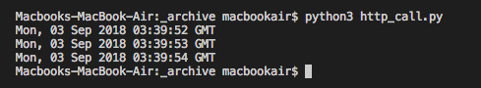

1. Asynchronous calls to http

