Introduction to Database and SQL (BIA 5002) Assignment 2 (Weightage: 20%)

**Submission Instructions**

1. Please submit the completed assignment as a word or pdf document on Blackboard.
2. Follow the format ‘*Assignment2-Group Number*’ to rename the submission document.
3. Mention the student numbers and full names of all the group members in the submission document.
4. Late penalty is 10% for each day you submit after the deadline.
5. Define 10 business rules for Supply Chain Management in any business of your choice. (2 Points)

Business – **Quick Service Restaurants (QSRs)**

Supply Chain Management Process – Critical Components for QSRs Business

* **Sourcing**: - Identifying and procuring raw materials and supplies
* **Production**: - Manufacturing or processing finished products
* **Distribution**: - Getting products to customers on time
* **Inventory Management**: - Keeping track of raw materials, supplies, and [finished goods](https://www.bluecart.com/blog/finished-goods-inventory)
* **Transportation**: - Moving products from one location to another
* **Customer Service**: - Providing excellent service to restaurants and their customers.

Reference: - <https://www.revolutionordering.com/blog/restaurant-supply-chain-management>

Based on the above process here are the business rules for the QSR Business: -

1. **Find suppliers that offer the best deals -** The first step to ensuring an efficient and cost-effective restaurant supply chain is to find vendors that offer the best deals. This may require some research, but it will be well worth it in the long run.

* **Business Rules** - Each supplier can provide multiple products or services, but each product or service is provided by only one Supplier.
* **Entity** – Supplier and Restaurant
* **Relationship** – One to Many

1. **Review vendors’ pricing and value regularly -** It’s important to review your vendors’ pricing and value regularly to ensure that you are getting the best possible deal. You can do this by requesting quotes from multiple suppliers or using a software program that tracks supplier prices. Either way, this will help you keep your costs down and your profits up.

* **Business Rules** - Multiple vendor pricing entries can pertain to the same supplier, but each vendor pricing entry pertains to only one supplier.
* **Entity** - Vendor Pricing and Supplier
* **Relationship** - One to Many

1. **Consider joining a Group Purchasing Organization (GPO)-** This can be a great way to access bulk discounts and other cost-saving benefits. In addition, it can also help you build relationships with other restaurants that may be able to offer helpful advice or resources.

* **Business Rule –** Multiple restaurants can be affiliated with multiple GPOs, and each GPO can have multiple affiliated restaurants.
* **Entity –** Group Purchasing Organization (GPO) and Restaurant
* **Relationship -** Many-to-Many

1. **Streamline your supply chain-** This may involve consolidating orders, using Just-In-Time ([JIT](https://www.bluecart.com/blog/just-in-time-inventory-system)) delivery methods, or investing in inventory management software. Whatever steps you take, the goal should be to minimize waste and maximize efficiency.

* **Business Rule –**

One order can consolidate multiple other orders.

Each delivery method is associated with one JIT delivery Approach.

Each inventory management software is associated with one restaurant.

* **Entity –** Order, Delivery, Inventory Management Software and Restaurant
* **Relationship -** Order and Delivery (One to One),Inventory Management Software and Restaurant (One to One), Order and Restaurant (One to Many)

1. **Food Safety Compliance**- Adhere strictly to food safety regulations and industry standards, implementing robust procedures for handling, storing, and transporting perishable goods to prevent contamination and ensure consumer safety.

* **Business Rule** - Multiple procedures may adhere to multiple regulations and standards, and multiple regulations and standards may apply to multiple procedures.
* **Entity** - Food Safety Regulation, Industry Standard, Procedure, Perishable Goods
* **Relationship** - Procedure, food safety regulation and Industry Standard (Many-to-Many)

1. **Review the benefits and drawbacks of doing tasks yourself-** One of the most important things to consider when streamlining your restaurant supply chain is whether you should outsource specific tasks. For example, you may be tempted to save money by going to the market rather than ordering it from a supplier. However, this could cost you more in the long run if you don’t know vendors.

* **Business Rule** - Multiple tasks may involve evaluating the same benefits and drawbacks, but each task is evaluated for internal execution or outsourcing.
* **Entity** – Task and Restaurant
* **Relationship –** One to Many

1. **Ensure you have sufficient supplies before promotions-** If you’re planning on running a promotion or special event at your restaurant, it’s important to ensure that you have enough supplies beforehand.

* **Business Rule** - Multiple supplies may support the same promotion/event, but each supply is associated with only one promotion.
* **Entity** – Supply and Promotion
* **Relationship –** One to Many

1. **Boost restaurant**[**operational efficiency**](https://revolutionordering.com/operational-efficiency/)**with**[**restaurant technology**](https://revolutionordering.com/restaurant-technology/)**-** In today’s high-tech world, many software programs and online tools can help streamline your restaurant supply chain. For example, [restaurant online ordering systems](https://revolutionordering.com/online-ordering-platform-for-restaurants/) can save you time and money by automating the ordering process.

* Business Rule - One restaurant may utilize multiple software programs or online tools, but each software program or online tool is utilized by only one restaurant.
* Entity – Software and Restaurant
* Relationship – One to Many

1. **Keep track of the origin of your supplies -**Today, more than ever, it’s important to know where your restaurant’s food comes from. That means tracking your supplies’ origin and the products’ safety status.

* **Business Rule** - One restaurant may track multiple supply origins, but each supply origin is tracked by only one restaurant.
* **Entity** – Supplier and Supply Origin
* **Relationship** - One-to-Many

1. **Build strong relationships with your suppliers-** One of the best ways to optimize your restaurant supply chain is to build strong relationships with your suppliers. You can do this by maintaining open communication, being fair and honest in negotiations, and paying invoices on time.

* **Business Rule** - Multiple suppliers can collaborate with multiple restaurants, and each restaurant can collaborate with multiple suppliers.
* **Entity** – Restaurant and Supplier
* **Relationship** - Many-to-Many

*Note: Ensure that you explain the business rules and provide reference to each of the business rules explained.*

1. With the business rules defined in Part A, create a Conceptual Entity Relationship Diagram (2 Points)

*Note: Any convenient tool can be used to create your Entity Relationship Diagram.*

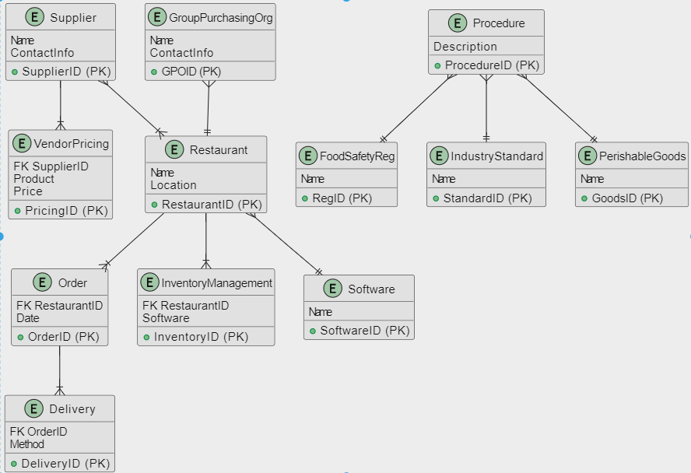

1. With reference to the Conceptual Entity Relationship Diagram in Part B, create a Logical Entity Relationship Diagram (2 Points)

*Note: Any convenient tool can be used to create your detailed Entity Relationship Diagram.*

1. With reference to the Logical Entity Relationship Diagram in Part C, create a Physical Entity Relationship Diagram (2 Points)

*Note: Any convenient tool can be used to create your detailed Entity Relationship Diagram.*

1. With reference to the detailed entity relationship diagram in Part D, complete the below tasks. (3 Points)

* Create a database in SQL Server (with SQL).
* Create the tables identified, in the SQL Server database with respective constraints (with SQL).
* Populate each table with dummy data (with SQL).

*Note: All the SQL Statements/Scripts executed should be given in the submission document along with the screenshots of the execution.*

1. With reference to the database created with populated tables in Part E, query the tables and provide meaningful analytical findings. (3 Points)

*Note: All the SQL queries executed should be given in the submission document along with the screenshots of the execution. A description of each analytical finding should be given as well.*

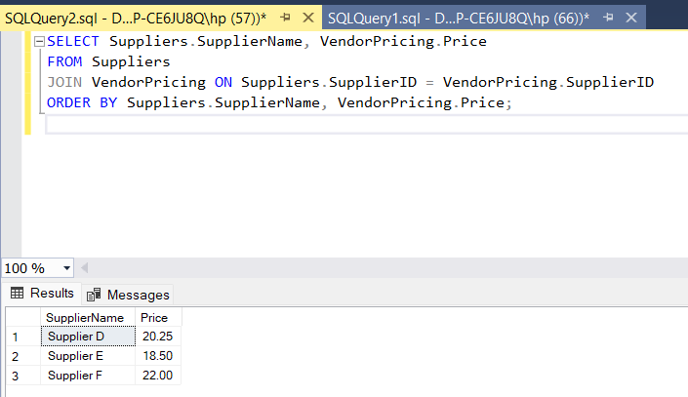

1. With reference to the detailed entity relationship diagram in Part D, complete the below tasks. (3 Points)

* Create a database in MongoDB (with MongoDB Shell)
* Create at least 5 tables identified as collections, in the MongoDB database (with MongoDB Shell)
* Populate each collection with dummy data (with MongoDB Shell)

*Note: All the MongoDB Commands/Scripts executed should be given in the submission document along with the screenshots of the execution.*

1. With reference to the database created with populated tables in Part G, query the tables to inspect the data (3 Points)

*Note: All the MongoDB Commands/Scripts executed should be given in the submission document along with the screenshots of the execution.*

