Document and window object

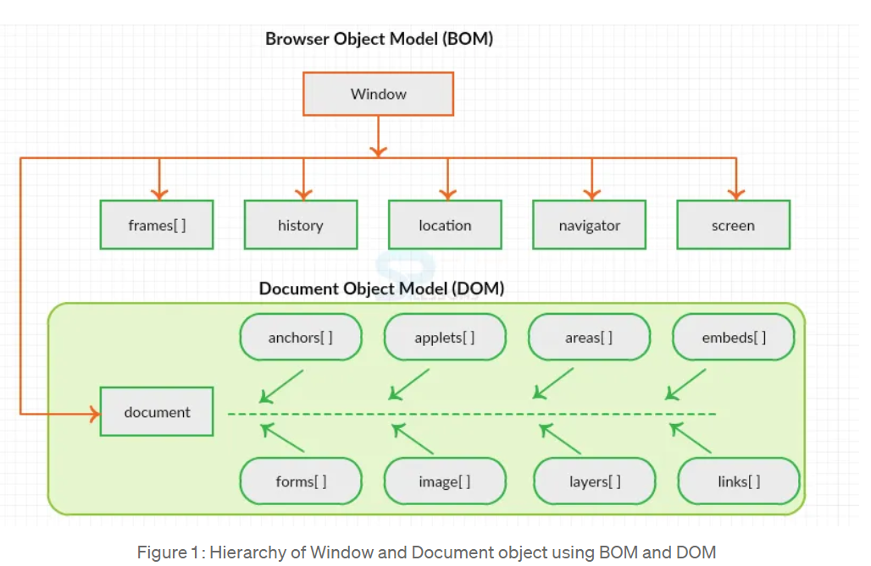

**Window:**

* The window object represents a window/tab containing a DOM document .
* The document object is property of window object that points to the DOM document loaded in that window.

**Document:**

* When a web page is loaded, the browser creates a Document Object Model of the page.
* The document object represents the whole html document as a tree of Objects(HTML, HEAD, BODY, and other HTML tags).
* It is the root element that represents the html document.
* Each HTML document that gets loaded into a window becomes a document object.
* The document contains the contents of the page. Using document object, JavaScript can modify, add and delete the HTML elements, attributes CSS styles in the page.
* access a document object either using window.document property or document object directly as window is global object.

**window.open() opens a new tab or window and document.open() creates a blank document within the window.**