A

Project on

Bureau of Labor Statistics Data Federation

By

Archana Jadala

Vidhya Moorthy

Vamshidhar Reddy vemula

Cyriacus Onuigbo

**Project Specification**

**Purpose**:To integrate current BLS data into the Systemic Reporting and Analytics Local server utilizing the BLS Application Programming Interface(API) version 2.0

**Preferred development language**: Any one of C++, Java, PHP. A final product must result in a compiled executable file.

**ODS Database authentication:** Users should authenticate via their Windows logon (DCCCD network login)

**API Authentication:** The programmer will need to acquire an API authentication from the service.

**Desired BLS Series ID's:**

Some of the data desired is still subject to discovery. Final information will be provided by 5/20/2018 to include complete Series ID's.

The first iteration of this project will address Local Area Unemployment Statistics in the Dallas-Fort Worth-Arlington MSA.

See [https://www.bls.govnielp/hIpfonna.htm#LA](https://www.b1s.govnielp/hIpfonna.htm#LA) to build Series ID's for this.

Seasonally Adjusted Data is desired. The following Measures are desired:

**Measure**

Indicates the unit of measurement:

· 06 Labor force,

· 05 Employment,

· 04 Unemployment, and

· 03 Unemployment rate.

**Deliverables:** A Windows application that allows any user (with appropriate database credentials) to select from amongst predetermined data sets (identified by a 'Series ID' and Year), receive a file from the API in JSON format and refresh tables within the Azure SQL ODS. The application should authenticate to the BLS API, retrieve the data requested and place it in a table in the BSDW 2 database. Both Source Code, and an executable file will be included. Code should be commented for clarity. The API authentication information should also be submitted.

**Due Date:** Due date is subject to negotiation and agreement. It is acknowledged that commencement of work is contingent on some need to learn API/REST programming.

The Project is all about occupation data from the Bureau of Labour Statistics or BLS. In this Project we’re going to deal specifically about occupation employment statistics. You can get to the BLS website a couple of different ways using Google. The first iteration of this project will address Local Area Unemployment Statistics in the Dallas-Fort Worth-Arlington MSA. This link([https://www.bls.govnielp/hIpfonna.htm#LA](https://www.b1s.govnielp/hIpfonna.htm#LA) ) is a sample format description of the Local Area Unemployment Statistics series. The following is the screenshot of the link where there is the description of Series ID, list of codes and their corresponding titles.

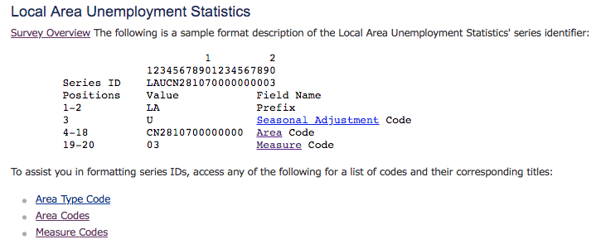

The following measures are used in the project : 06 Labor force, 05 Employment, 04 Unemployment, and 03 Unemployment rate.

**Software Requirements:**

**Programming Language**: Java, SQL

**Tools**: NetBeans IDE 8.2, MySQL Workbench 8.0.11 (<https://dev.mysql.com/downloads/mysql/>)

**Libraries used:**

1. Commons-logging-1.2.jar (<https://commons.apache.org/proper/commons-logging/download_logging.cgi>)
2. Httpclient-4.5.5.jar (<https://mvnrepository.com/artifact/org.apache.httpcomponents/httpclient/4.5.5>)
3. Httpcore-4.4.9.jar (<https://mvnrepository.com/artifact/org.apache.httpcomponents/httpclient/4.5.5>)
4. Json-simple-1.1.jar ( <https://mvnrepository.com/artifact/com.googlecode.json-simple/json-simple/1.1.1>)
5. Mysql-connector-java-8.0.12.jar (<https://dev.mysql.com/downloads/connector/j/>)

Our Project is a Windows application that allows any user (with appropriate database credentials) to select from amongst predetermined data sets (identified by a 'Series ID' and Year), receive a file from the API in JSON format and refresh tables within the MySQL Workbench.

**Programming:** The code is divided into three parts as follows

1. BLS Data Extractor
2. BLS Data Parser
3. Establishing connection to MYSQL Workbench

**Part 1**: **BLS Data Extractor** - Implemented using java where the data is extracted from the BLS content provider for predetermined Series ID’s using the following code and a file is created (BLSoutput.json) and the extracted data is stored in this JSON file.

**Code:**

System.out.println("- Data Extraction Started from https://api.bls.gov/publicAPI/v2/timeseries/data/ at " +startCalendar.getTime() );

HttpClient httpClient = new DefaultHttpClient();

HttpPost httpPost = new HttpPost("https://api.bls.gov/publicAPI/v2/timeseries/data/");

String SeriesID1 = "LAUMT481910000000006";

String SeriesID2 = "LAUMT481910000000005";

String SeriesID3 = "LAUMT481910000000004";

String SeriesID4 = "LAUMT481910000000003";

StringEntity input = new StringEntity

("{\"seriesid\":[\"LAUMT481910000000006\",\"LAUMT481910000000005\",\"LAUMT481910000000004\",\"LAUMT481910000000003\"]}");

input.setContentType("application/json");

httpPost.setEntity(input);

HttpResponse response = httpClient.execute(httpPost);

HttpEntity entity = response.getEntity();

String responseString = EntityUtils.toString(entity, "UTF-8");

PrintWriter outputfile = new PrintWriter("BLSoutput.json");

outputfile.print(responseString);

outputfile.close();

**Extracted Data is in this format:**

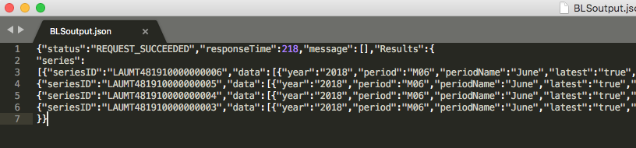

**Part 2: BLS Data Parser:** The extracted data from the BLS content provider is stored in json file and this file is given as input to the BLS Data Parser where the extracted data is parsed according to the category. A file reader is used to read the input file and an object is created using a constructor (parse) of JSONParser class named obj.

**JSON** (JavaScript Object Notation) is a lightweight, text-based, language-independent data exchange format that is easy for humans and machines to read and write. JSON can represent two structured types: **objects and arrays**. An object is an unordered collection of zero or more name/value pairs. An array is an ordered sequence of zero or more values. The values can be strings, numbers, booleans, null, and these two structured types.

**JSON Processing in Java** : The Java API for JSON Processing JSON.simple is a simple Java library that allow parse, generate, transform, and query JSON. You need to download the json-simple-1.1 jar and put it in your CLASSPATH before compiling and running the code.

**JSON-Simple API** : It provides object models for JSON object and array structures. These JSON structures are represented as object models using types JSONObject and JSONArray. JSONObject provides a Map view to access the unordered collection of zero or more name/value pairs from the model. Similarly, JSONArray provides a List view to access the ordered sequence of zero or more values from the model.

JSON Array: [{"seriesID":"LAUMT481910000000006"}, {"year":"2018"}]

JSON Object: {"status":"REQUEST_SUCCEEDED"}

Thus we created two different JSON objects for parsing the data JSON Array and JSON Object. The parsed data is stored in a text file named “BLSparser.txt”.

**Code:**

Object obj = new JSONParser().parse(new FileReader("BLSoutput.json"));

PrintWriter outputfile = new PrintWriter("BLSparser.txt");

// typecasting obj to JSONObject

JSONObject jo = (JSONObject) obj;

// getting status

//System.out.println("BLS Data Parsed Output");

String status = (String) jo.get("status");

System.out.println("-- Request status:" + status);

// getting responseTime

long responseTime = (long) jo.get("responseTime");

System.out.println("-- Request responseTime:"+ responseTime);

// getting message

JSONArray message = (JSONArray)jo.get("message");

//System.out.println("-- Message:"+ message.get(0));

// Creating JSON object for Results

JSONObject Results = (JSONObject)jo.get("Results");

// Creating JSON array object for Series

JSONArray series = (JSONArray) Results.get("series");

Iterator itr = series.iterator();

while (itr.hasNext())

{

Object ItrSeriesObject = itr.next();

JSONObject jsonObject2 = (JSONObject) ItrSeriesObject;

String seriesID = (String)jsonObject2.get("seriesID");

System.out.println("\t\tseriesID:" + seriesID);

String level0 = "'"+seriesID+"'";

JSONArray data = (JSONArray)jsonObject2.get("data");

Iterator itrData = data.iterator();

while (itrData.hasNext())

{

Object dataIterObject = itrData.next();

JSONObject jsonObject3 = (JSONObject) dataIterObject;

String period = (String)jsonObject3.get("period");

//System.out.println("\t\tperiod:" + period);

String year = (String)jsonObject3.get("year");

//System.out.println("\t\tyear:" + year);

String periodName = (String)jsonObject3.get("periodName");

//System.out.println("\t\tperiodName:" + periodName);

String value = (String)jsonObject3.get("value");

//System.out.println("\t\tvalue:" + value);

JSONArray footnotes = (JSONArray)jsonObject3.get("footnotes");

//System.out.println("data:" + footnotes);

String latest = (String)jsonObject3.get("latest");

//System.out.println("\t\tlatest:" + latest);

String level1 = "'"+period+"',"+year+",'"+periodName+"',"+value+","+latest;

Iterator itrFootNotes = footnotes.iterator();

while(itrFootNotes.hasNext())

{

Object footNotesIterObject = itrFootNotes.next();

JSONObject jsonObject4 = (JSONObject)footNotesIterObject;

String code = (String)jsonObject4.get("code");

//System.out.println("\t\t\tcode:" + code);

String text = (String)jsonObject4.get("text");

//System.out.println("\t\t\ttext:" + text);

String level2 = (level0+","+level1+",'"+code+"','"+text+"'");

outputfile.println(level2);

String sql = "INSERT INTO seriesData VALUES " + "(" + level2 + ")";

stmt.executeUpdate(sql);

}

}

**BLS Parsed Data:**

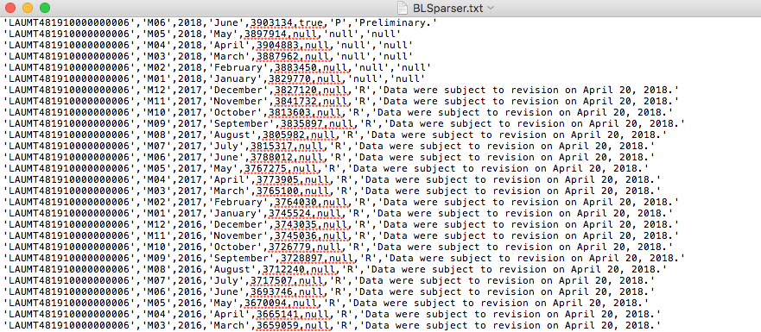

**Part 3: Establishing Connection to MYSQL Workbench:**

Go to <https://dev.mysql.com/downloads/windows/installer/8.0.html> and download mysql (mysql-installer-community-8.0.11.0.msi) skip the signup and just download and save file to desktop. Then double click the installer and install. Choose Custom setup type, in Select Product and features select MySQL Servers and for further instructions follow this Youtube link and easy installation **(**<https://youtu.be/Ddx13KlW8yQ?t=67>) or (<https://youtu.be/aY6LiTbfckA?t=119>) Use the code below to create a user in your local database, then create tables to store the data. Connect to the local database with with previously created Username and password in Java code. Below are the screenshot of code in database and in java.

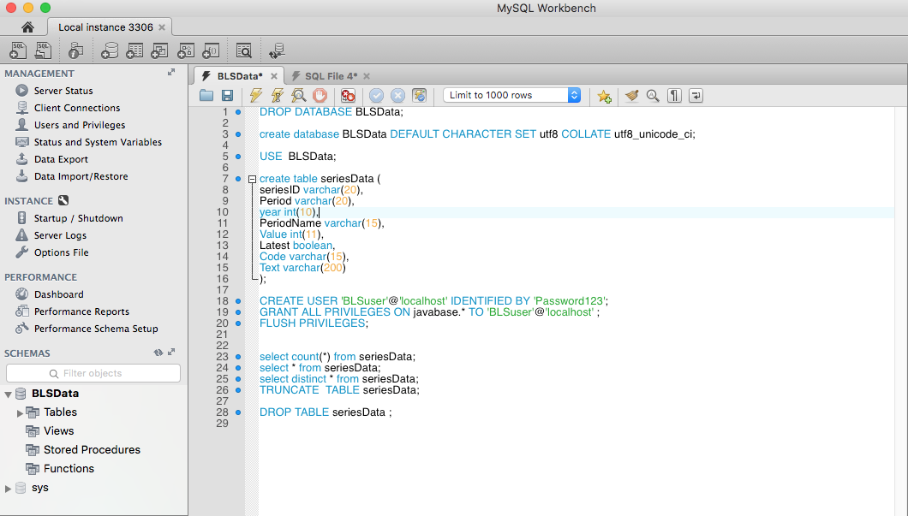

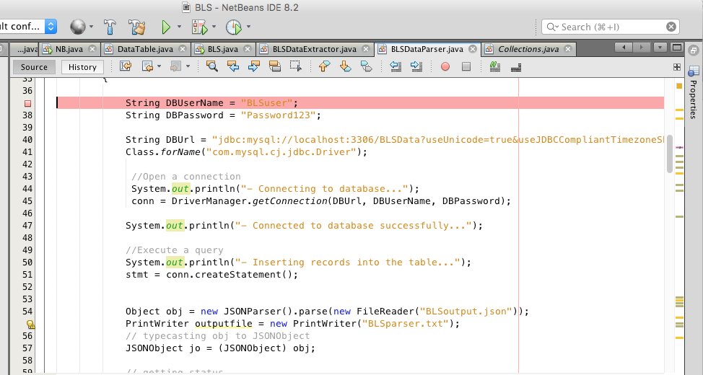

**Code:**

DROP DATABASE BLSData;//Drops Previous Database

create database BLSData DEFAULT CHARACTER SET utf8 COLLATE utf8_unicode_ci;

USE BLSData;

create table seriesData (

seriesID varchar(20),

Period varchar(20),

year int(10),

PeriodName varchar(15),

Value int(11),

Latest boolean,

Code varchar(15),

Text varchar(200)

);

CREATE USER 'BLSuser'@'localhost' IDENTIFIED BY 'Password123';//Creates BLSuser with password 'Password123'

GRANT ALL PRIVILEGES ON javabase.* TO 'BLSuser'@'localhost' ;

FLUSH PRIVILEGES;

select count(*) from seriesData;

select * from seriesData;

select distinct * from seriesData;

TRUNCATE TABLE seriesData;

DROP TABLE seriesData ;

**OutPut:**

After java code execution

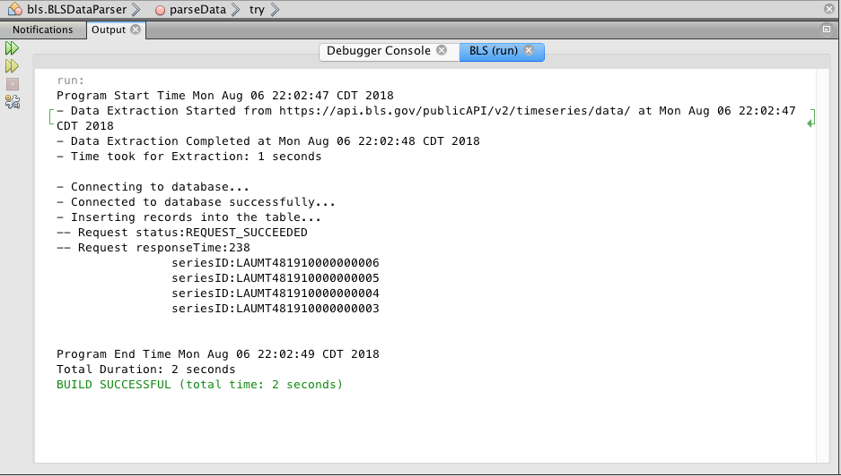

and two files will be created in project folder "BLSoutput.json", "BLSparser.txt" on the other side in Database the final records are shown as

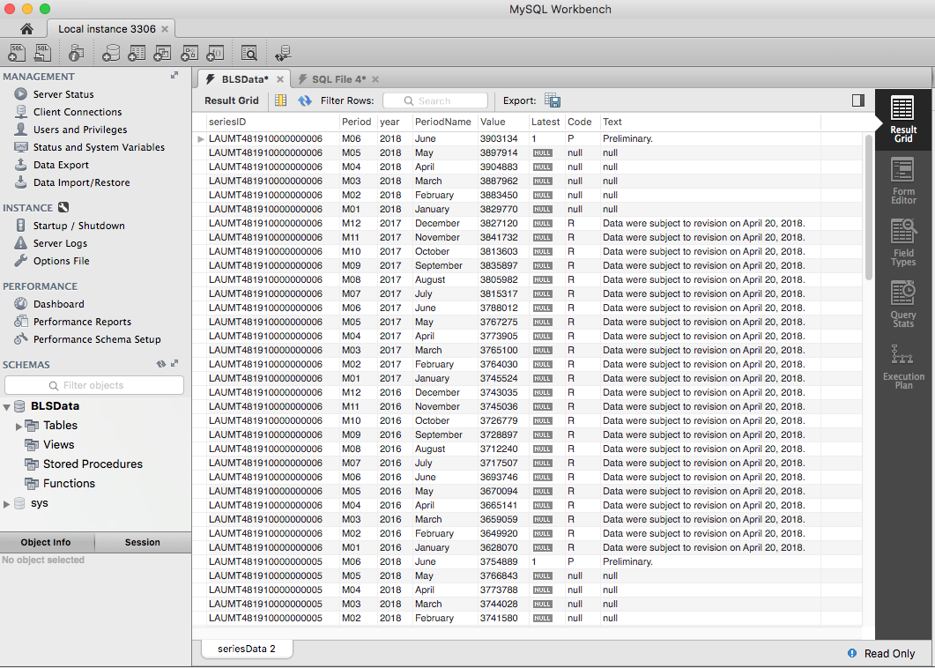

**References:**

1. <https://dev.mysql.com/downloads/installer/>
2. <https://mvnrepository.com/artifact/org.apache.httpcomponents/httpclient/4.5.5>
3. <https://www.youtube.com/watch?v=aY6LiTbfckA>
4. <https://www.geeksforgeeks.org/parse-json-java/>
5. <https://www.bls.gov/help/hlpforma.htm#LA>
6. <https://www.bls.gov/developers/api_java.htm#java2>
7. <https://stackoverflow.com>