**APPLICATION LOAD BALANCER**

**Launch two EC2 instances or start your existing EC2 instances**

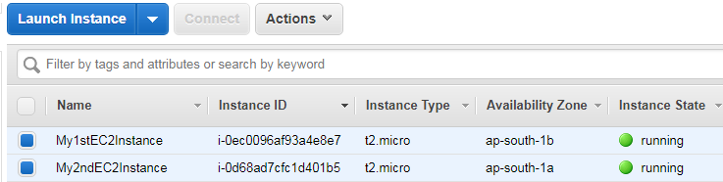

**Under EC2 Dashboard click on Target Groups that comes under Load Balancing and Create Target Group**

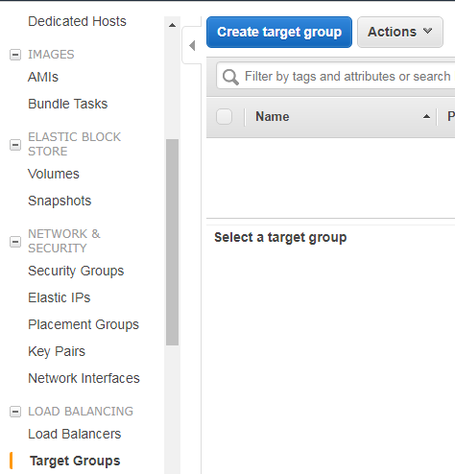

**Give Target group name, Protocol – HTTP, Port – 80, Type – Instance, Default VPC and path – index.html**

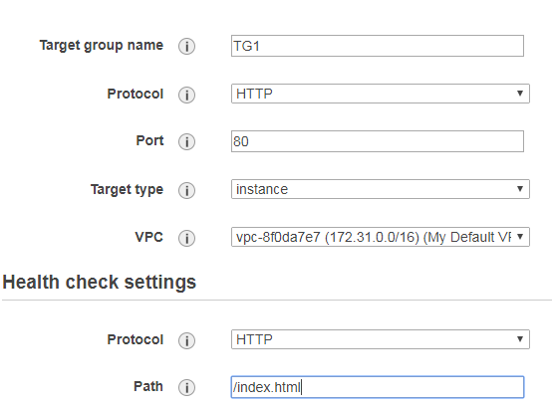

**Your target group is now successfully created. Click on TG1 link to view your target group.**

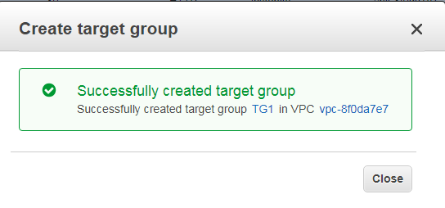

**This is your target group TG1**

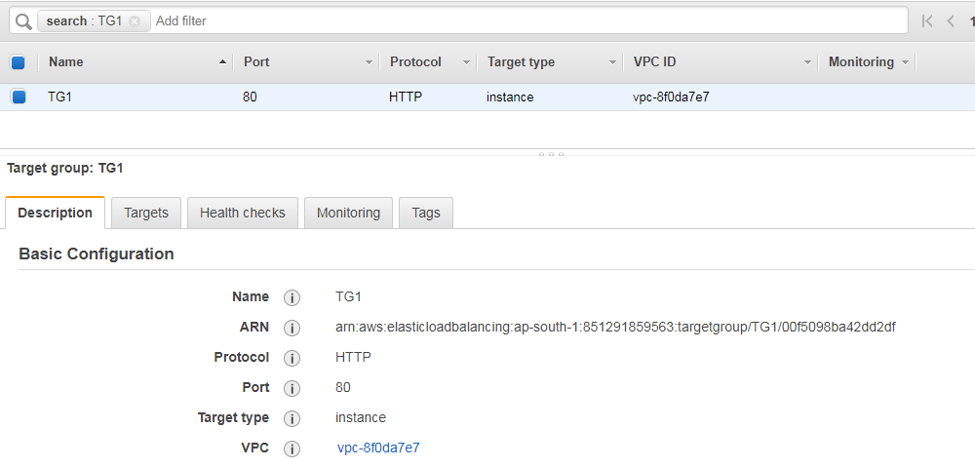

**Create one more target group TG2**

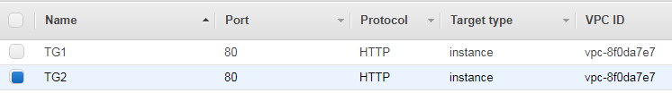

**In EC2 dashboard click on Load Balancer and create new load balancer**

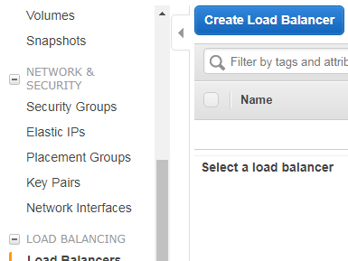

**Select Application load balancer and click create**

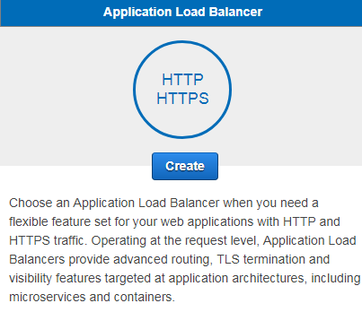

**Configure your load balancer: Give name for your load balancer, Scheme – internet facing, IP address** **type - ipv4, listener – HTTP port 80**

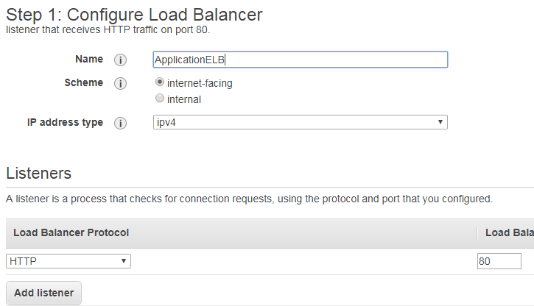

**Select default VPC with both availability zones in your region**

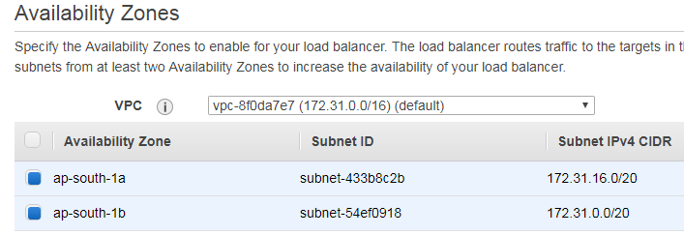

**Create new security group of type HTTP with port no 80**

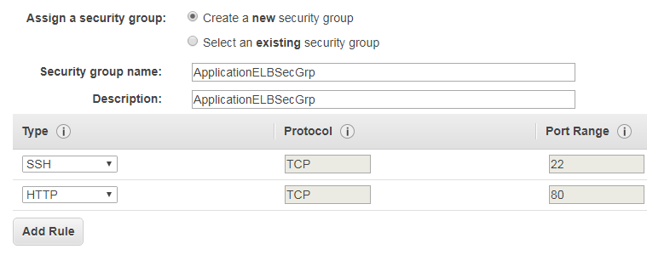

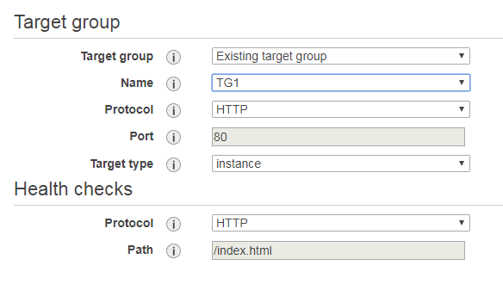

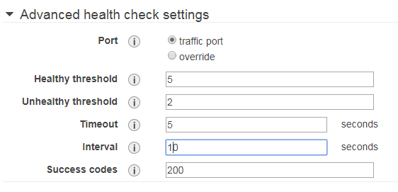

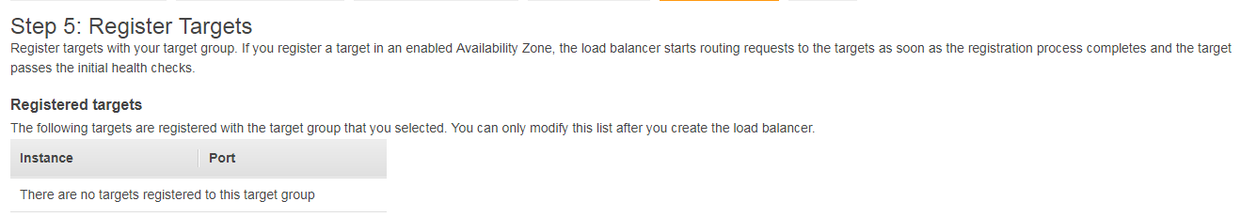

**Review your load balancer and create it.**

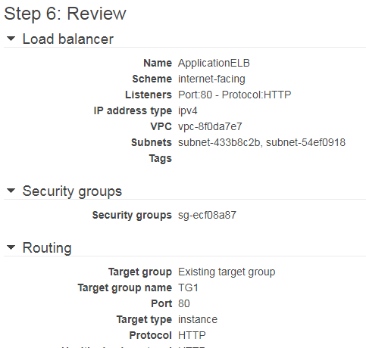

**Your load balancer has now been successfully created. Click on the link to view your load balancer**

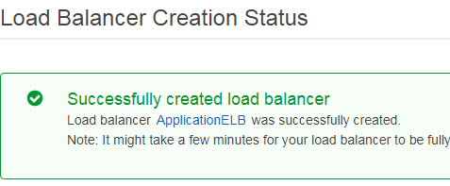

**Select any one of your target groups (TG1). Under targets tab click on Edit**

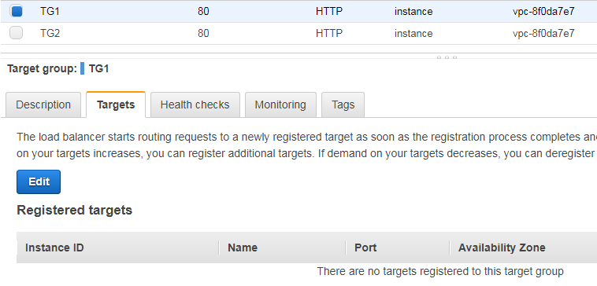

**Select any one of your instance and click add to registered on port 80**

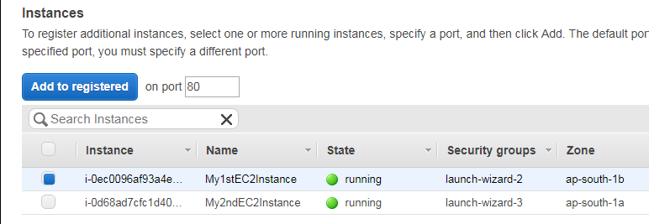

**Your instance is now registered with TG1**

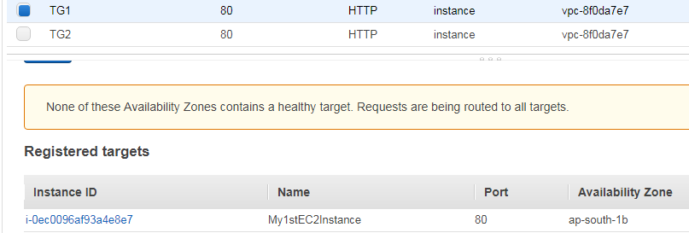

**Select your TG2 , under targets tab click on edit**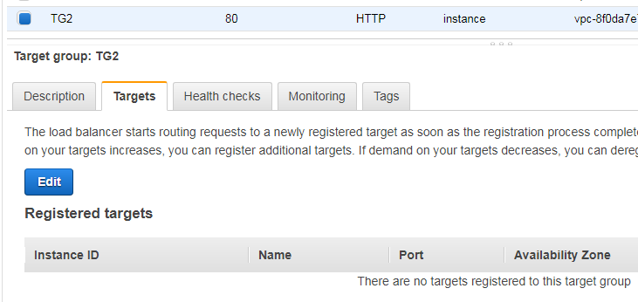

**Select your second running instance and add to registered on port 80**

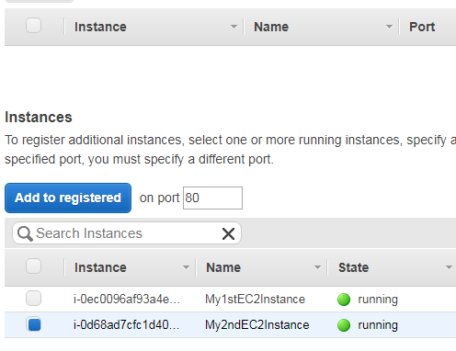

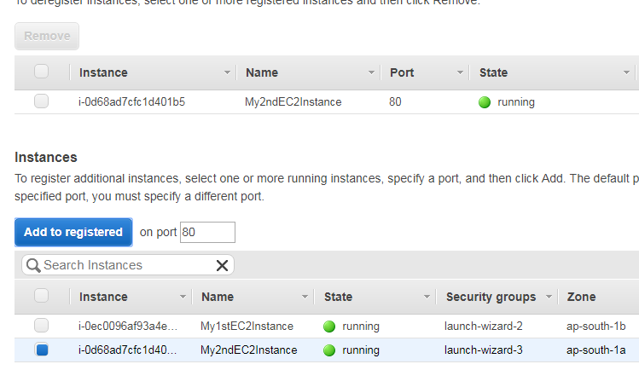

**Your second instance is now registered with TG2**

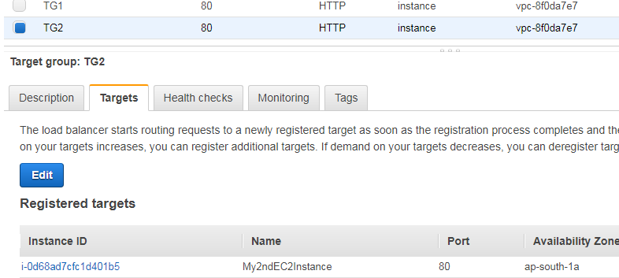

**Select the Load balancer you have created. Under listeners tab of your load balancer click on add** **listener**

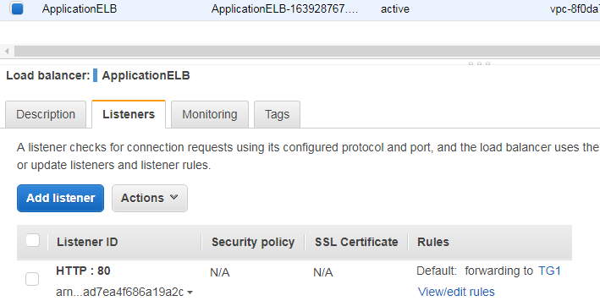

**Create listener: Protocol- HTTP, Port-8000, Target Group-TG2 .**

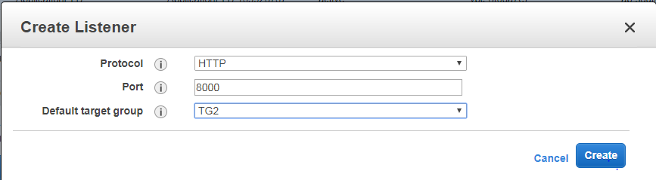

**Your listener is created with a warning message. Click on security group link to edit the security settings**

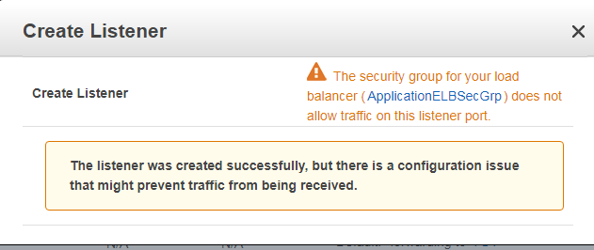

**Click on Edit inbound rules under Actions dropdown of your security group**

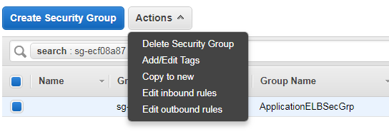

**Add custom TCP type with port range 8000 and save it**

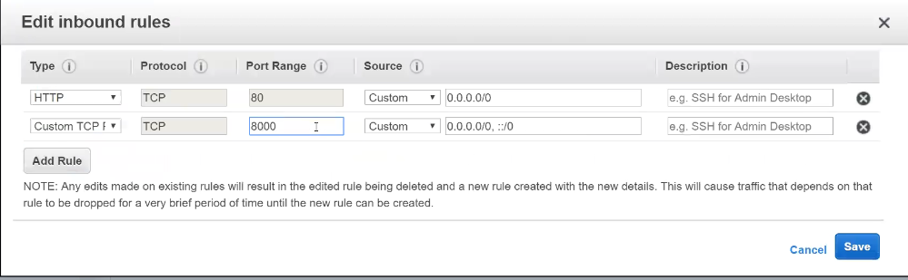

**You can view the listeners of your application load balancer with HTTP ports 80 and 8000.**

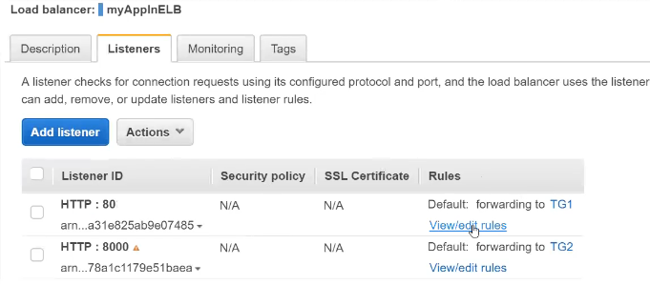

**You can even add your own custom rules by clicking on View/edit rules**

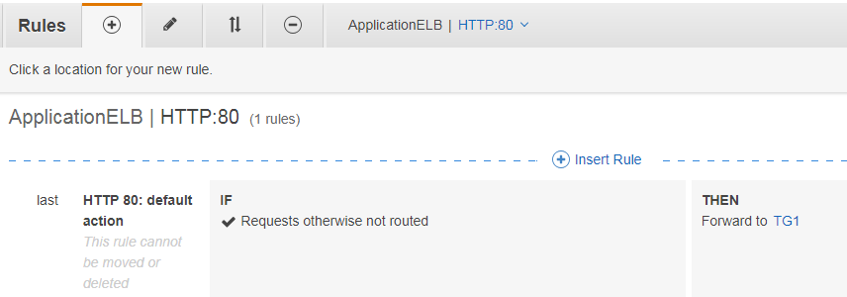

**Insert Rule: Give path as /img-*.html and forward it to target group (TG2)**

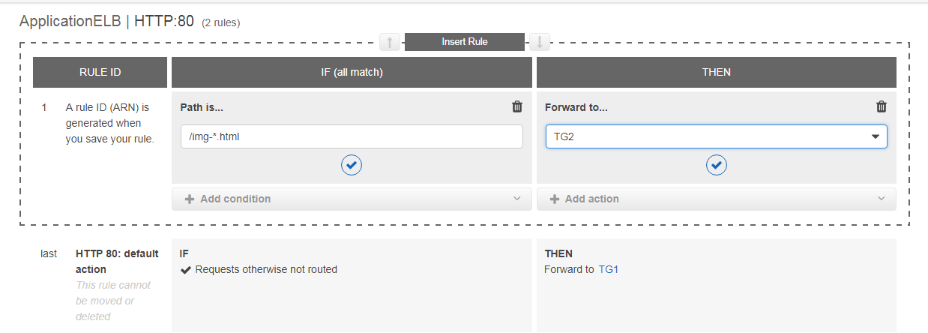

**Insert one more rule: Host – mobile.google.com and forward it to target group (TG2)**

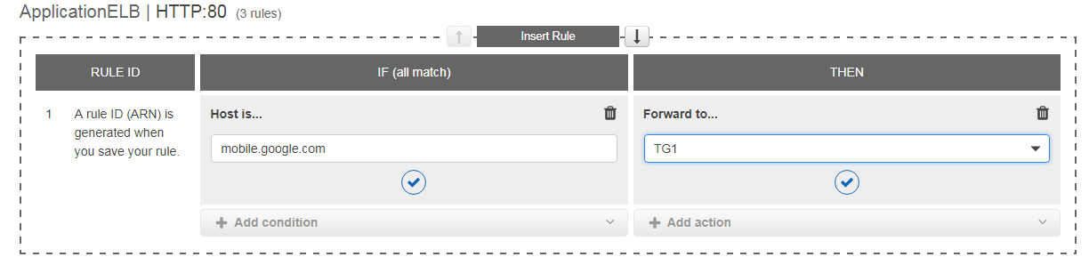

**You can view those rules under listeners tab of your load balancer**

