**Auto Scaling Group**

**In EC2 Dashboard under Auto scaling click on Auto Scaling Groups and create auto scaling group**

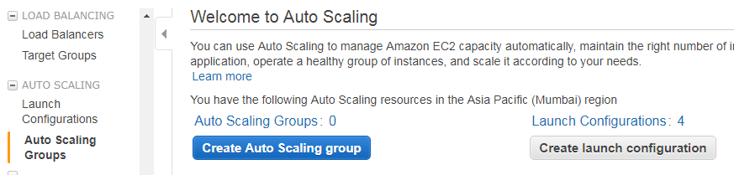

**Select a new launch configuration**

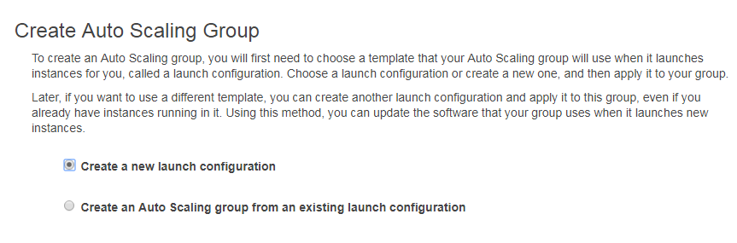

**Select amazon linux AMI**



**Select instance type t2.micro**

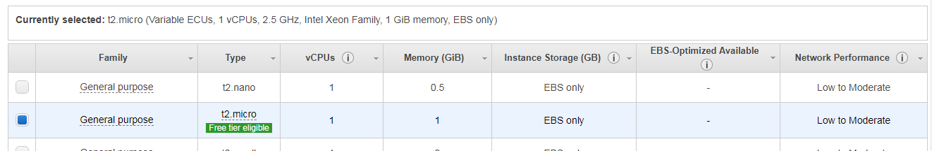

**Under create launch configuration leave default values and click on advanced settings**

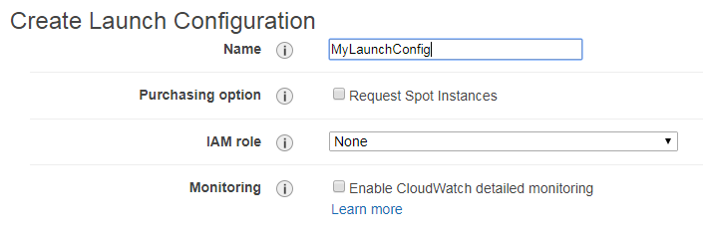

**Leave default kernel ID and Ram Disk ID. Write the following bash script in user data.**

**#!/bash/bin**

**sudo su**

**yum update -y**

**yum install httpd -y**

**service httpd start**

**echo "<html><body><h1>Hello from web server</h1></body></html>"** **>/var/www/html/index.html**

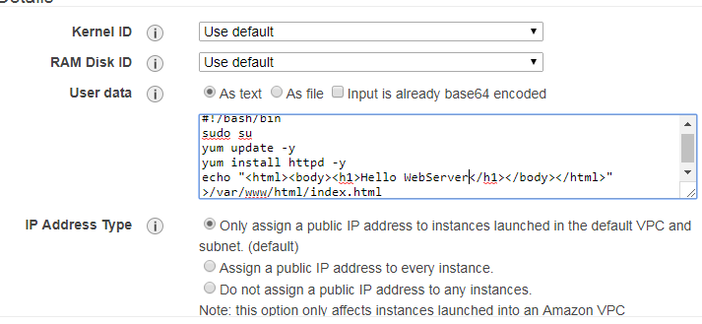

**Add the default root volume**

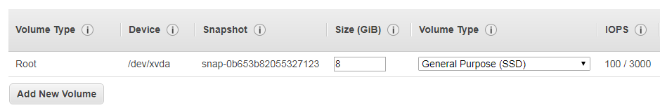

**Create new security group of type SSH and HTTP. Your source should be anywhere**

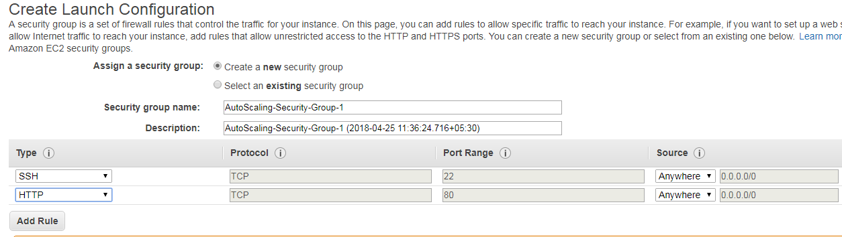

**Review your configuration details and create it**

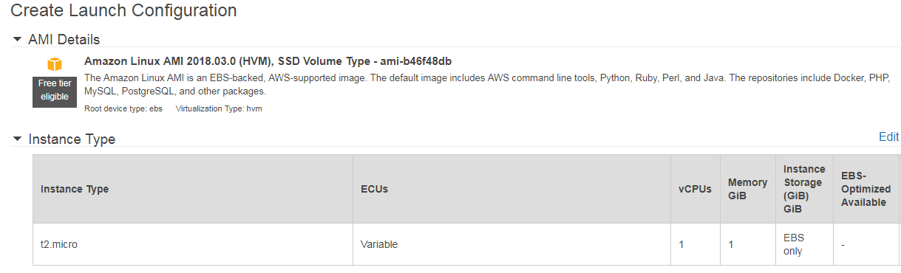

**Select an existing key pair and create launch configuration**

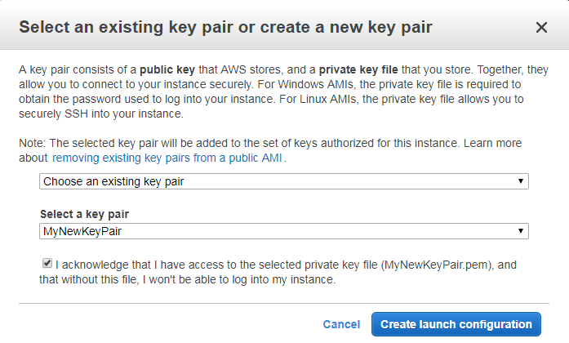

**Under create auto scaling group give group name, group size (start with 3 instances), your default VPC,** **select both subnets in availability zone**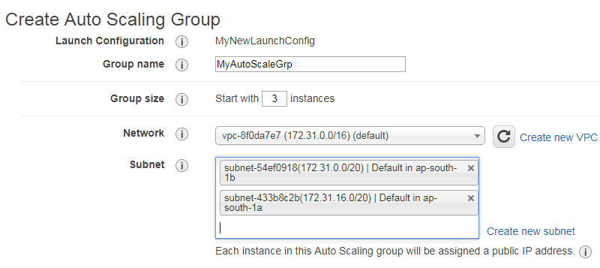

**Select use scaling policies and scale between 1 and 5 instances. Click on add new alarm**

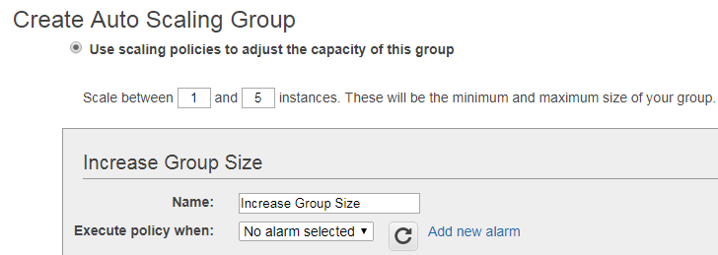

**Create an alarm whenever average CPU utilization reaches >=80% for atleast 1 consecutive periods of 5** **minutes. Click on create alarm.**

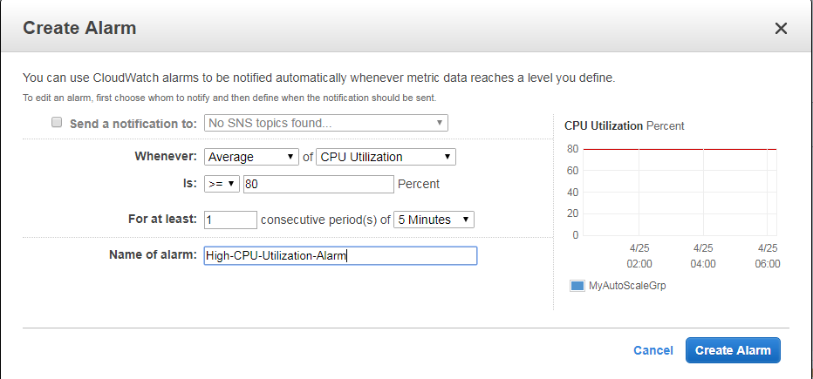

**Add 1 instance when CPU Utilization is <=80 % and > 90%. Add 2 instances when CPU Utilization is <=90** **% and greater than infinity.**

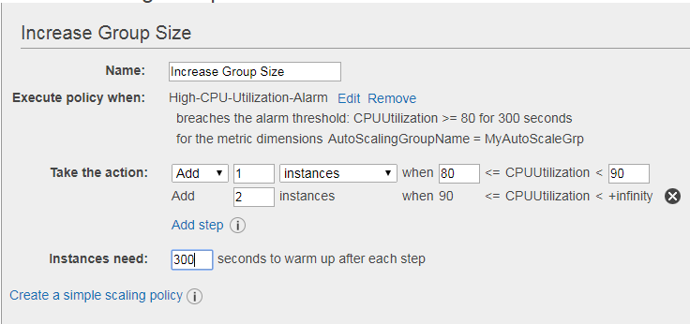

**Under decrease size group create an alarm whenever average CPU Utilization reaches <=5 % for atleast** **1 consecutive periods of 5 minutes** 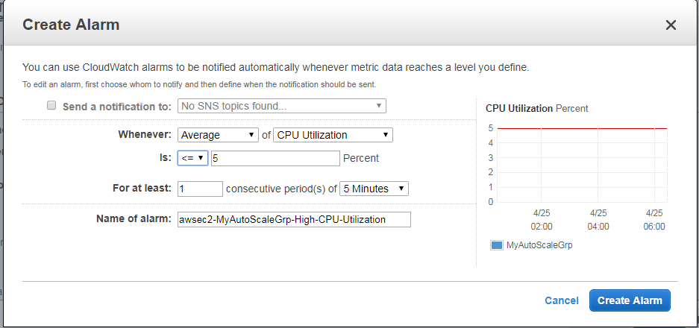

**Remove 1 instance when CPU utilization is <=5%**

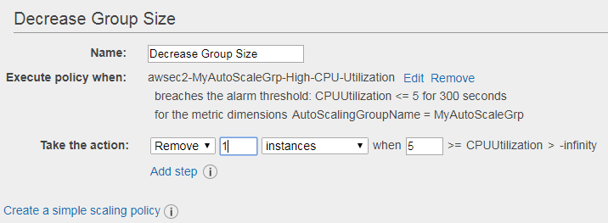

**Give name for the instances created under your auto scaling group**

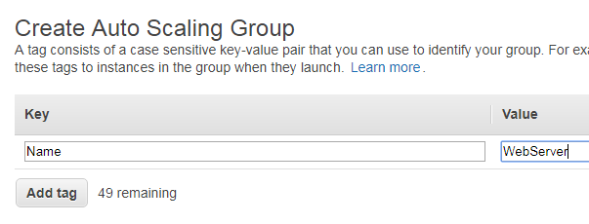

**Review the details and create it.**

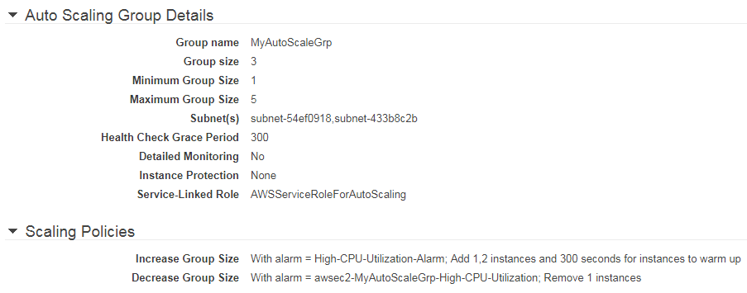

**Auto scaling group has been successfully created.**

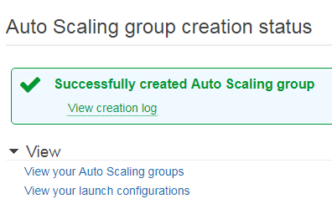

**Three instances are now up and running since your desired number of instances is 3.**

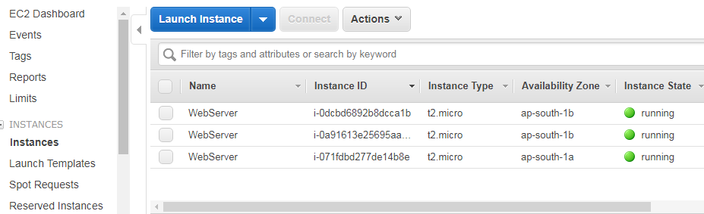

**One of your instance is shutting down due to low CPU Utilization**

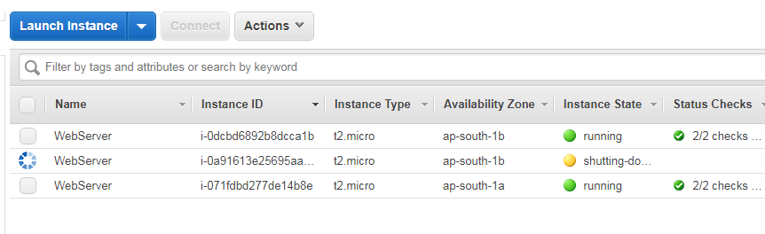

**We can track the progress of instances under Activity history .**

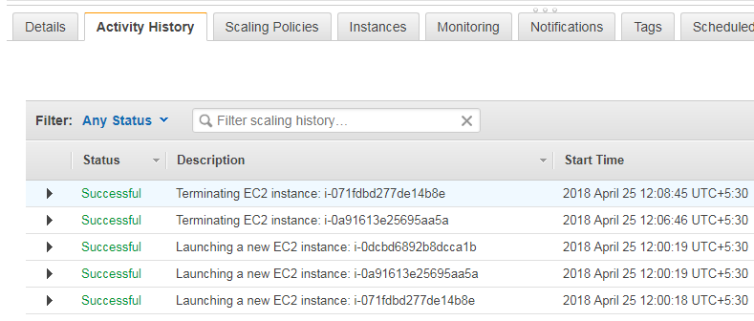

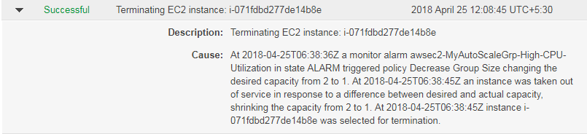

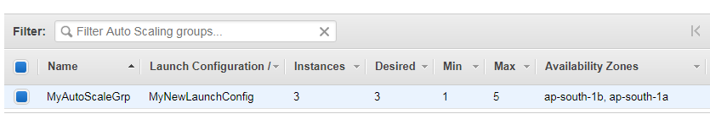

**Since the desired no of instances is 3, 3 of our instances would be running if even one instance got** **terminated due to low CPU utilization or high CPU utilization.**

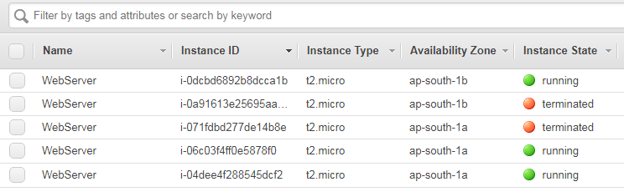

**Select the IPV4 Public IP of any of the running instances.**

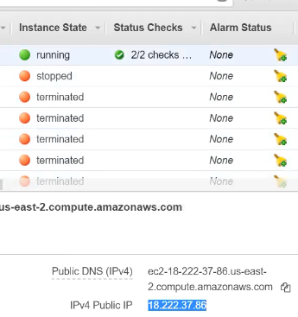

**Give your IP on the browser and check your web page.**

