**CLOUD FRONT**

**Create S3 bucket and grant public access for that bucket**

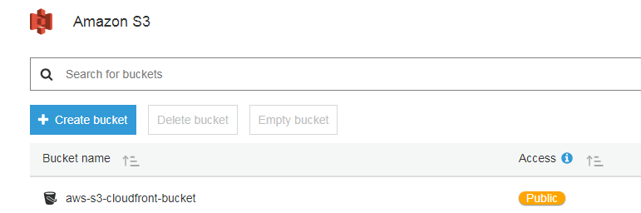

**Upload an image and grant public access for that image**

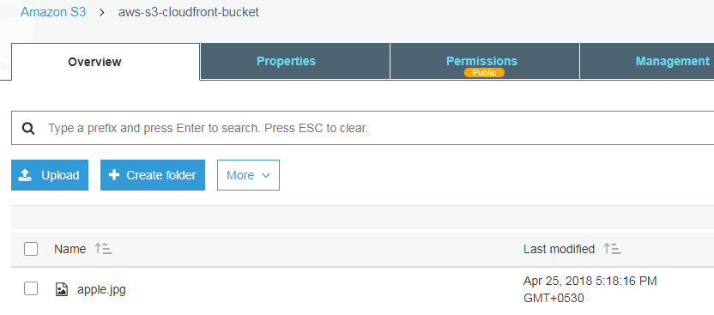

**After uploading click on the below link to view the uploaded image in browser**



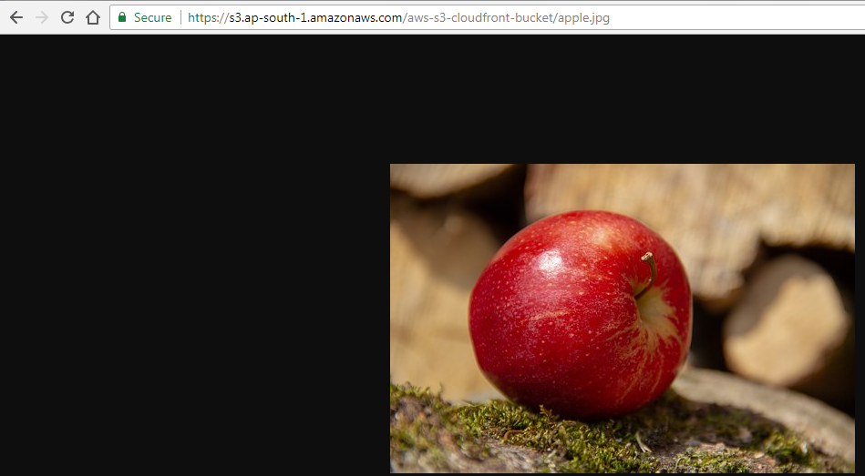

**Under Network and Content Delivery click on CloudFront**

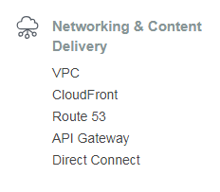

**Click on Create Distribution**

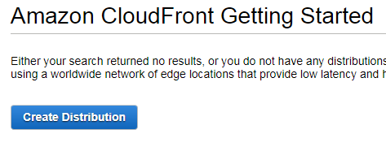

**Click on Get Started under Web**

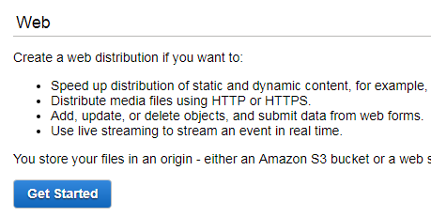

**In Origin Domain Name select the bucket which you had created**

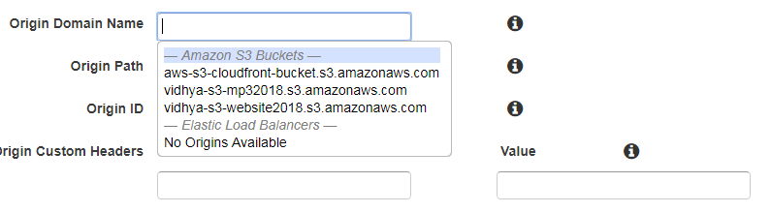

**Leave default values for rest of the settings**

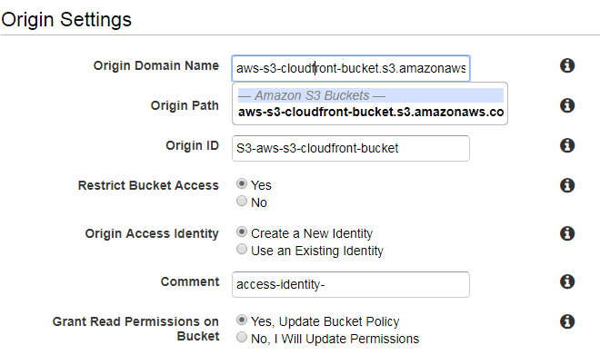

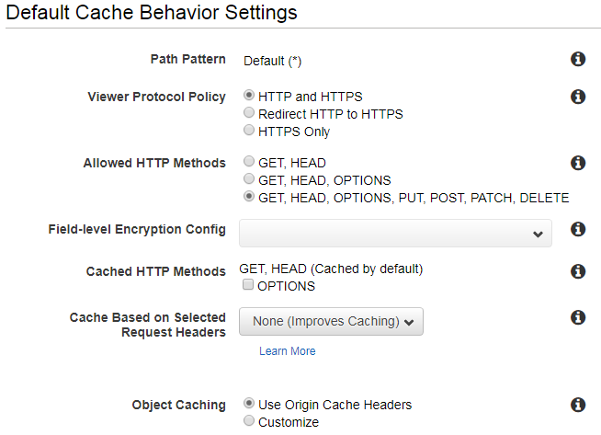

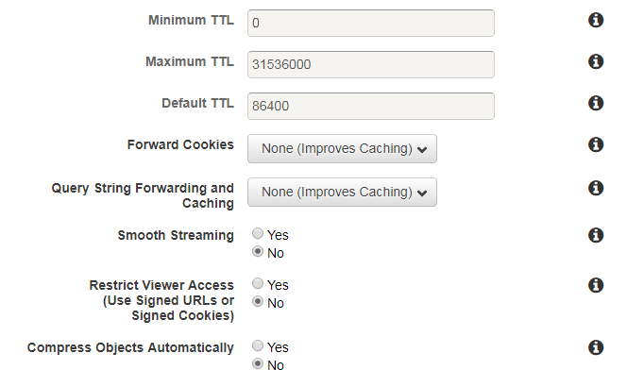

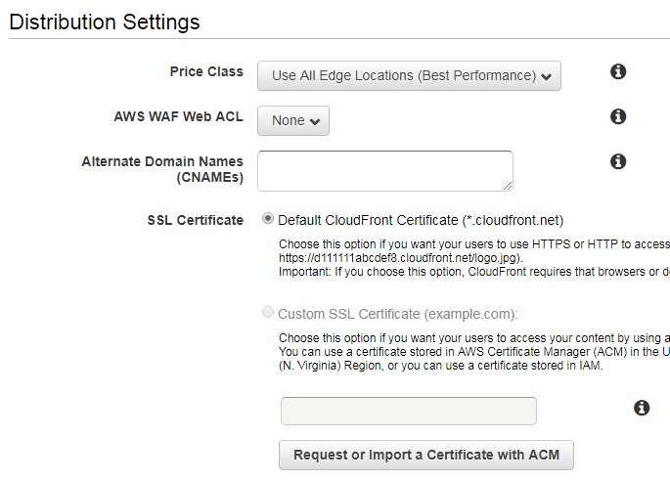

**Click on Create Distribution**

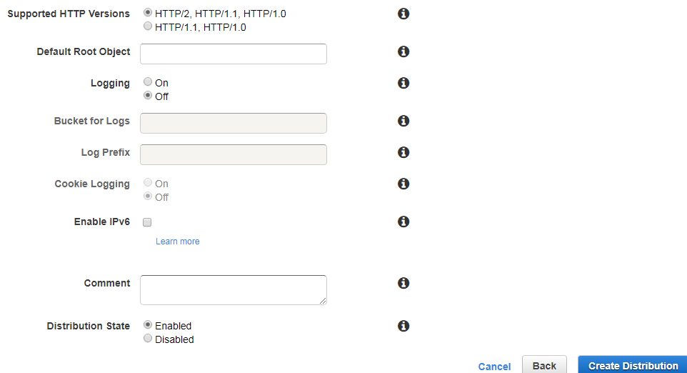

**Cloud Front Private content is getting started. Click on Distribution**

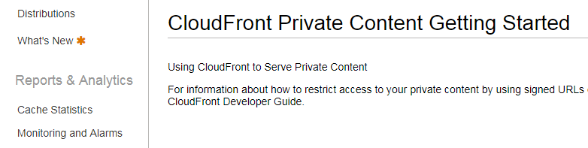

**Copy the domain name and give it as url for the image. Your image will be loaded from the edge location**

