**IAM User (S3 Read Only Access) Bucket Creation**

**Create a New Group in Identity Access Management**

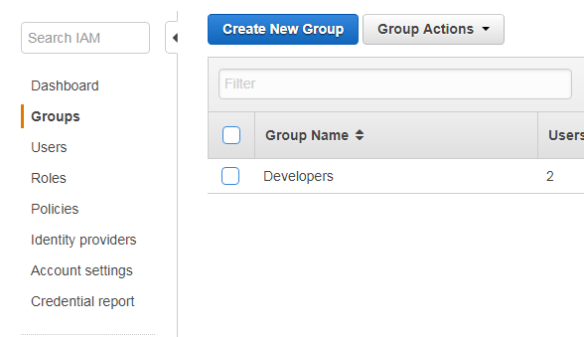

**Give the group name as Testers**

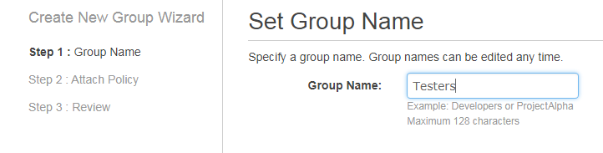

**Attach a policy – AmazonS3ReadOnlyAccess to it.**

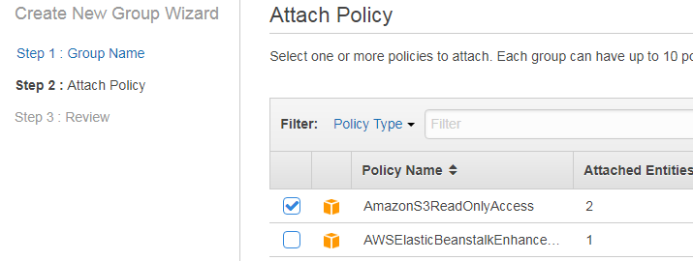

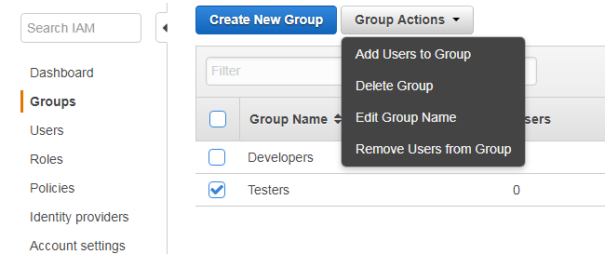

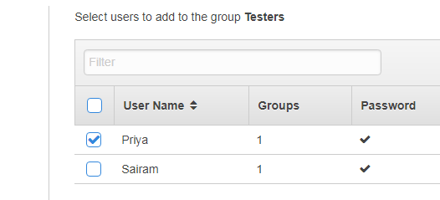

**Create a new user – Tester1 and give custom password for the user**

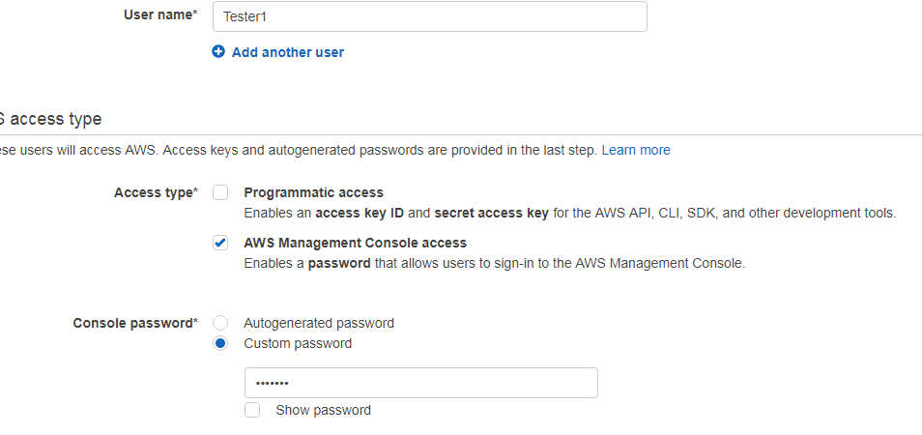

**Add Tester1 to the group Testers**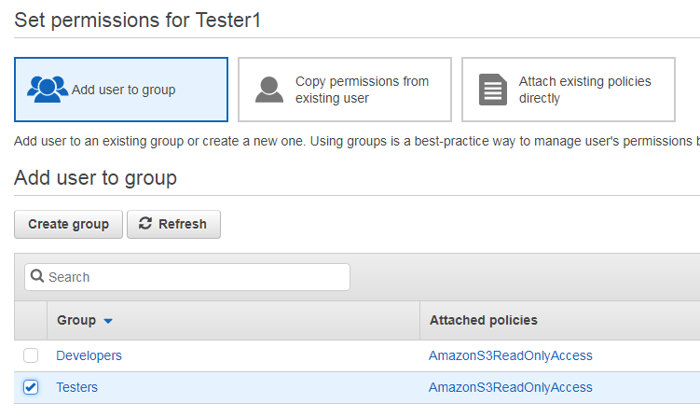

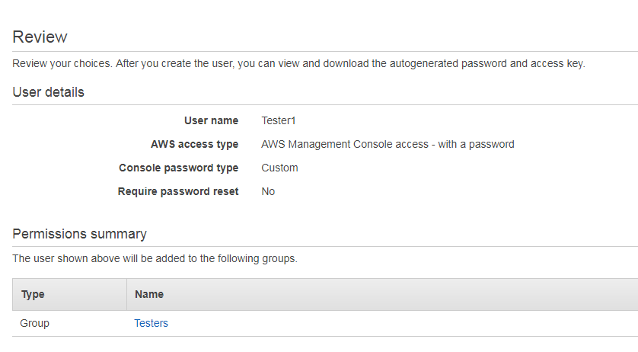

**After creating the user and adding it to the group you will receive success page. Click on AWS Management console**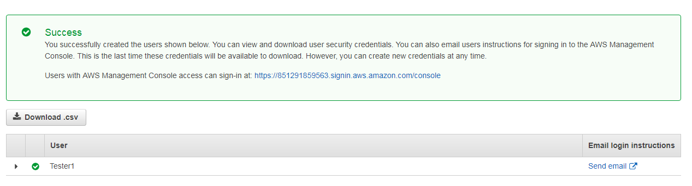

**You will be directed to login page of Tester1. Give your password and sign in to the console.**

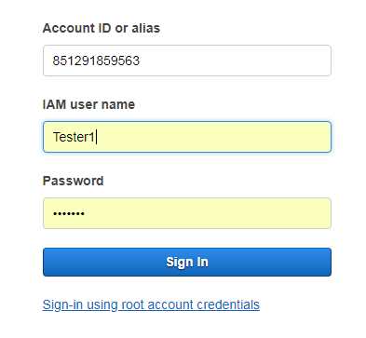

**Go to IAM services and click on create bucket. You would be redirected to property window. Give the bucket name, region and click next.**

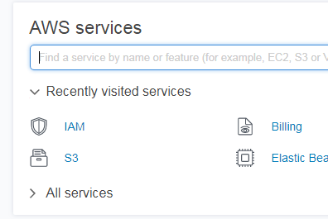

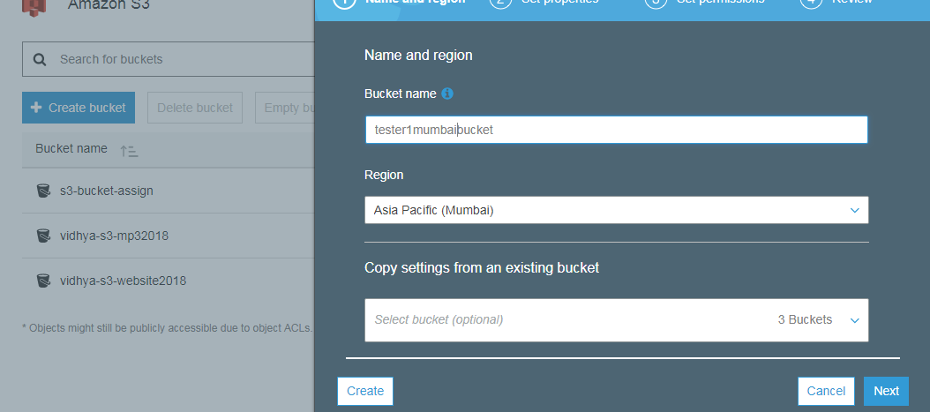

**While trying to create a bucket it will Access denied error since you have give S3ReadOnlyAccess to Tester1.**

