**Generate PPK file and** **Launch an EC2 Instance**

Click On EC2 Instance on Services pane

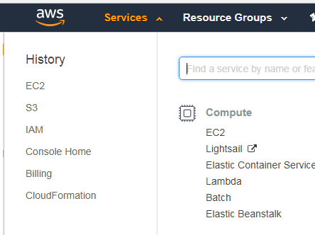

Under create instance click on Launch Instance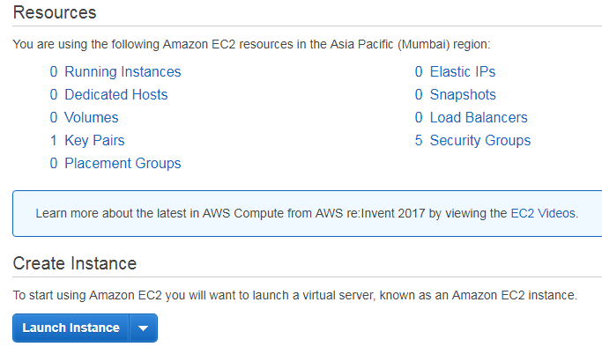

Select Amazon Linux AMI which comes under Free Tier

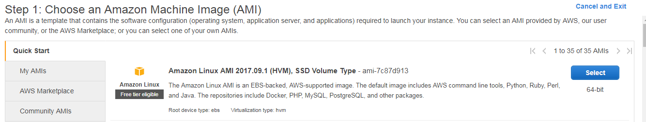

Choose Instance Type t2.micro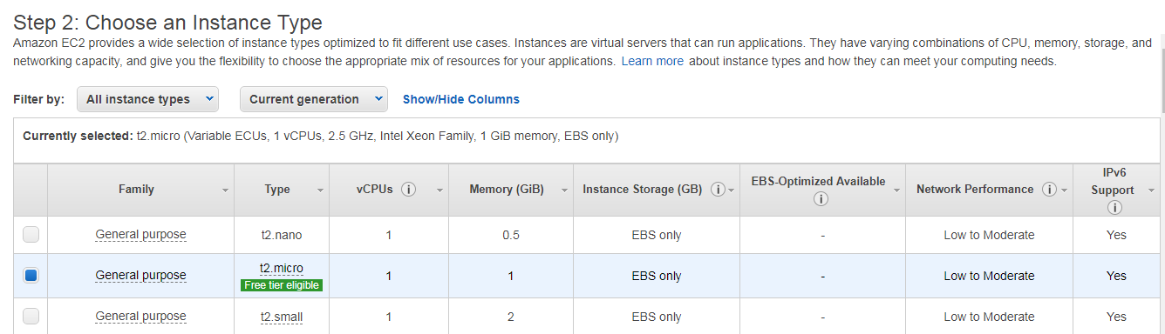

Review and launch your instance

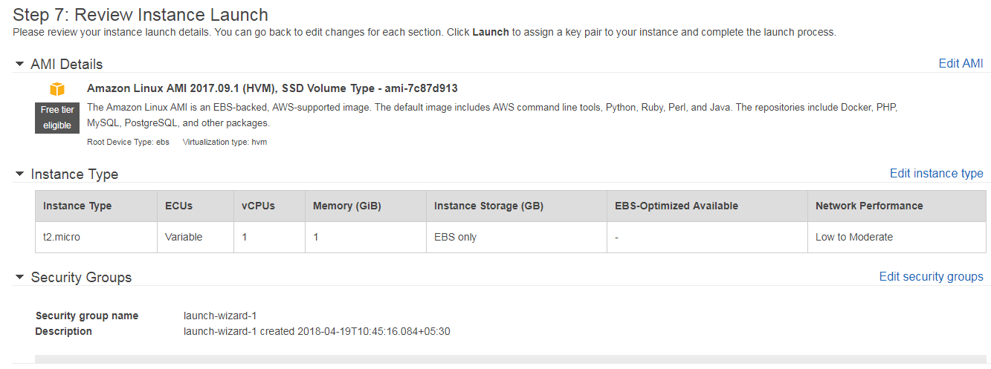

Create a new key pair value. Give a name to your key pair and download it

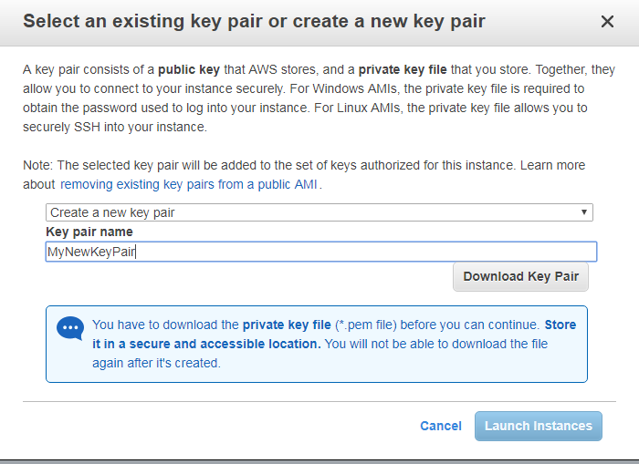

Click on the link under Your instances are launching now and you will be redirected to the instance page.

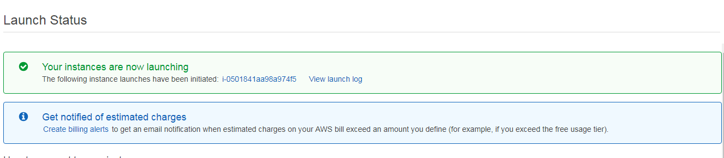

Your instance has now been launched

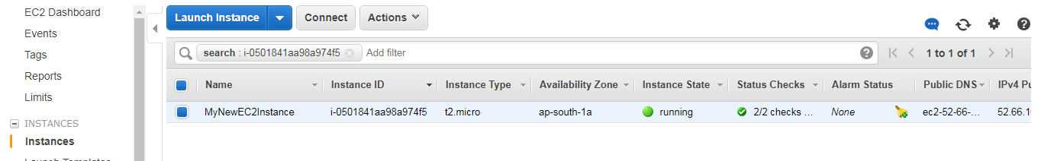

Download PuttyKeyGen software and install it in your system. Now open your Putty key Generator and click Load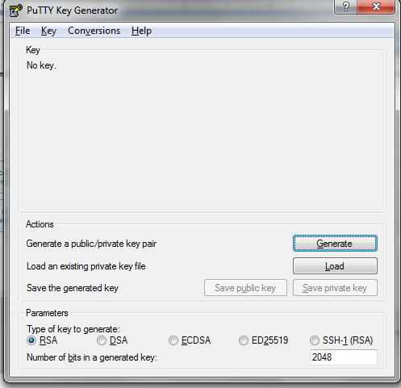

Browse and open your MyNewKeyPair.pem file which you have downloaded earlier

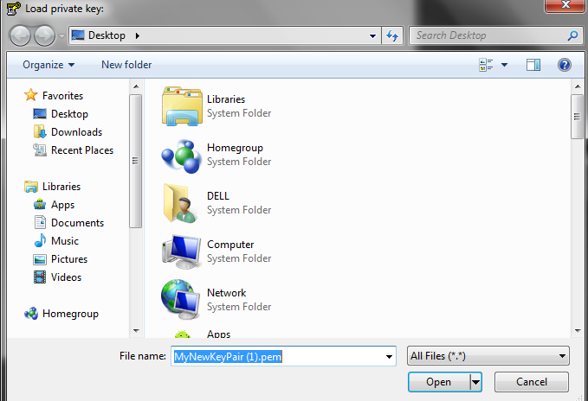

Save it as private key. MyNewKeyPair.pem file will now be converted as MyNewKeyPair.ppk . Save your .ppk file

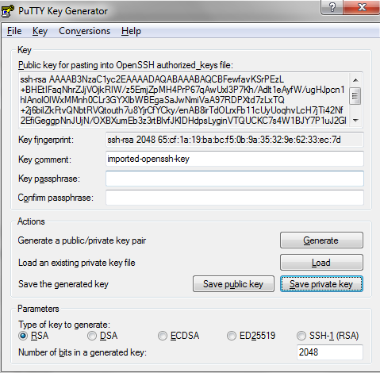

Select the instance which you have created earlier and launch instance

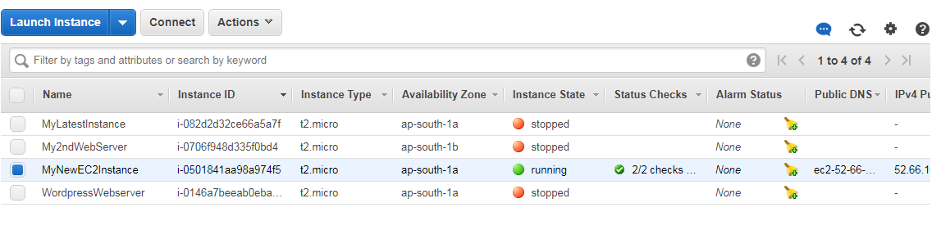

Select Amazon Linux AMI

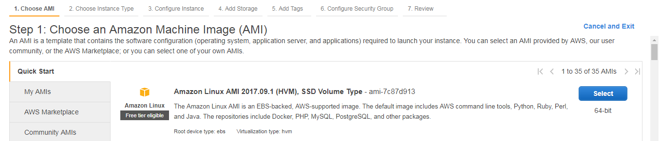

Configure the instance details (Number of instances - 1, Network – Default VPC, Subnet – default, Enable Auto-assign Public IP, Protect against accidental termination, Tenancy – shared) Click Next

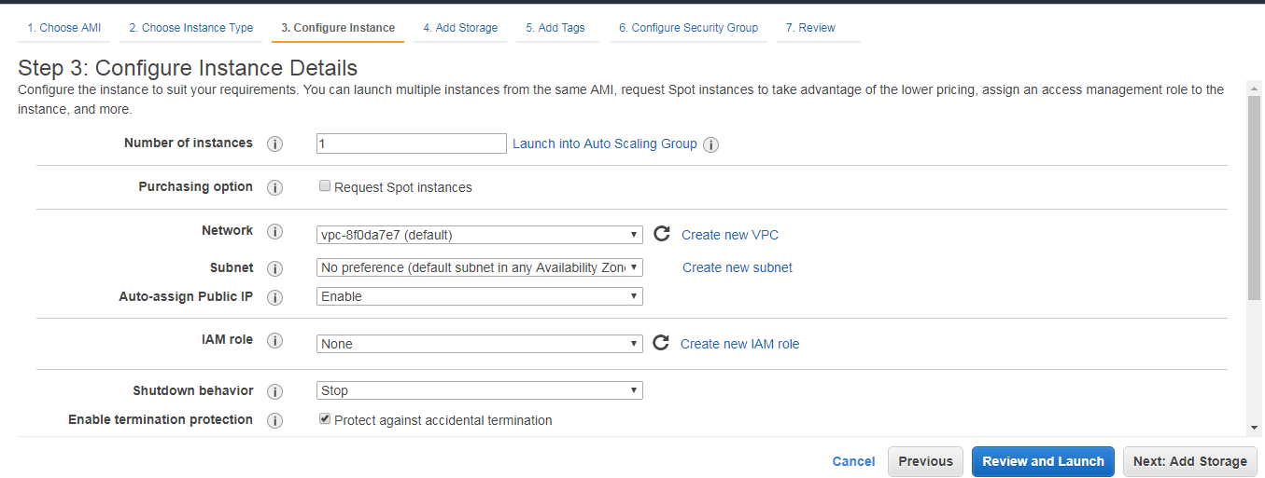

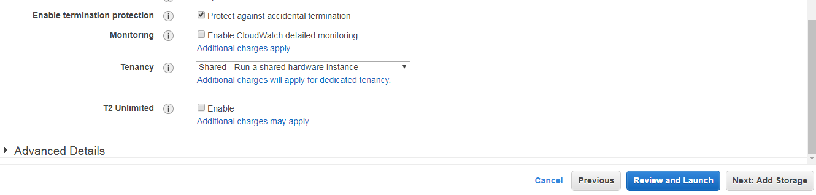

Add Storage to your Root Volume and click next

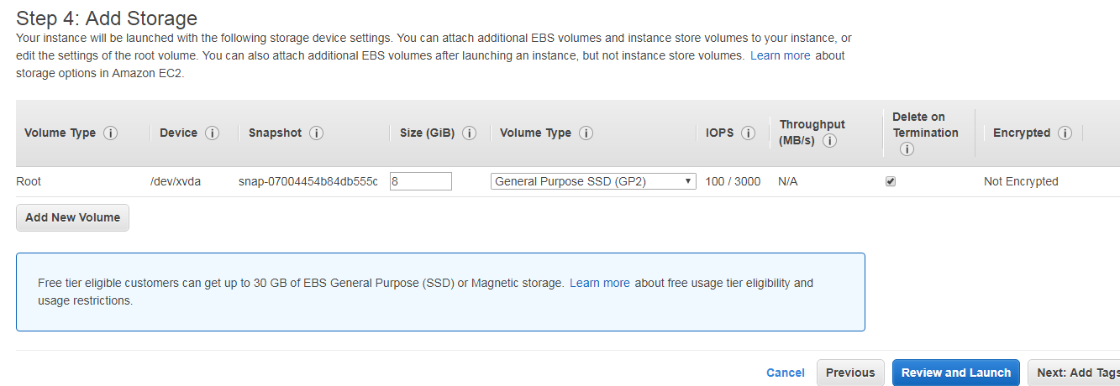

Add Tag and give name for your EC2 WebServer

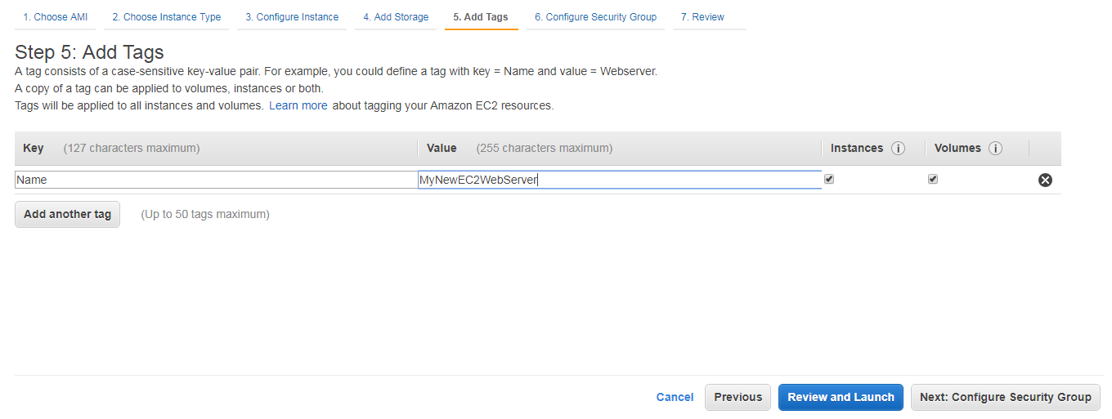

Configure your security group of type SSH and HTTP

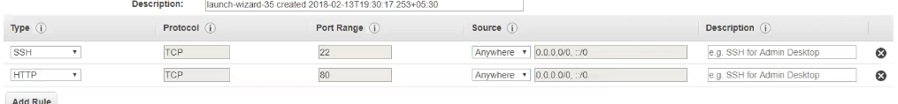

Review and launch your instance

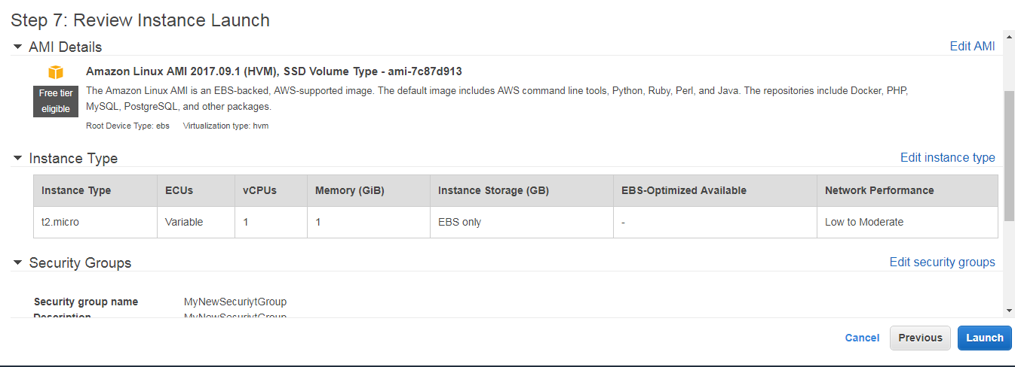

When you launch your instance you will be redirected to select a key pair. Select MyNewKeyPair.ppk

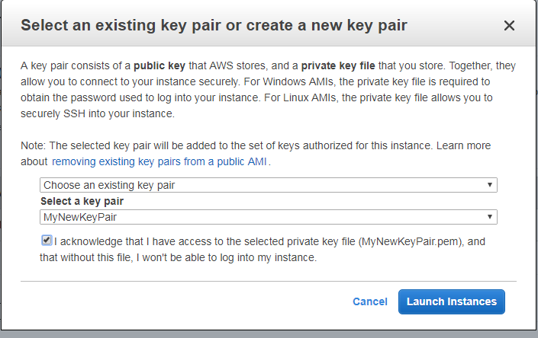

Click on the link given under your instances are launching now

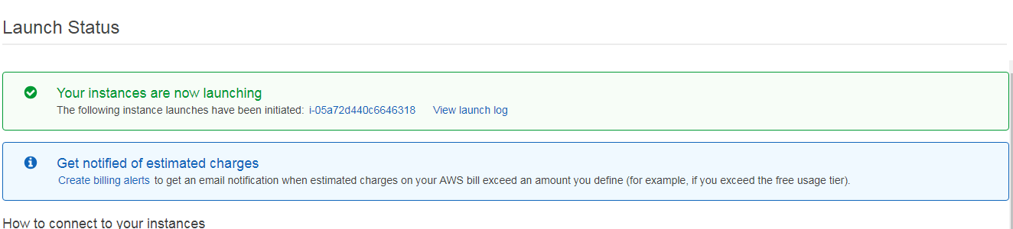

Your instances are up and running

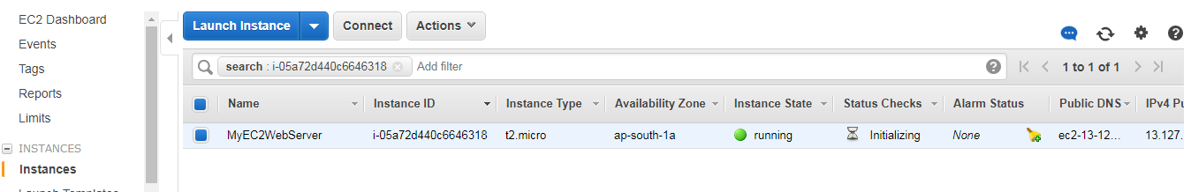

Under description tab of your launched instance select your IPV4 Public IP

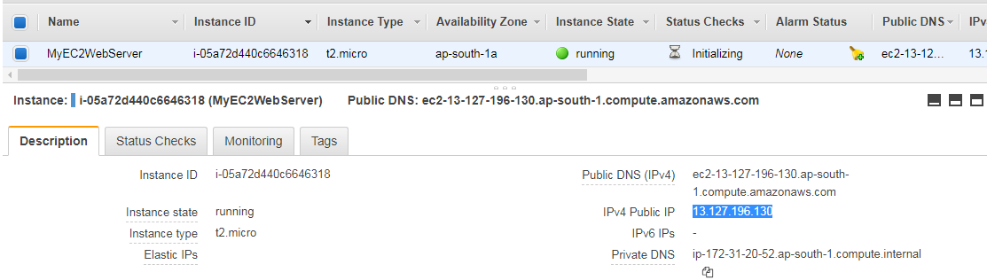

Open your putty and under your host name give ec2-user@your IPV4 Public IP

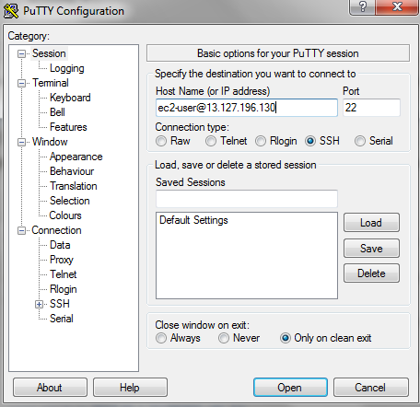

Select Auth under your SSh and browse your ppk file

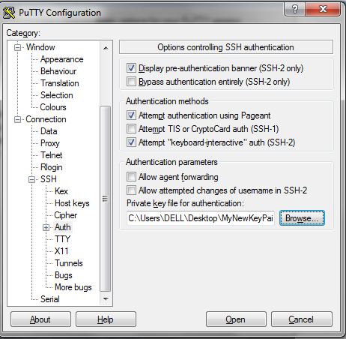

Click Yes on prompt window

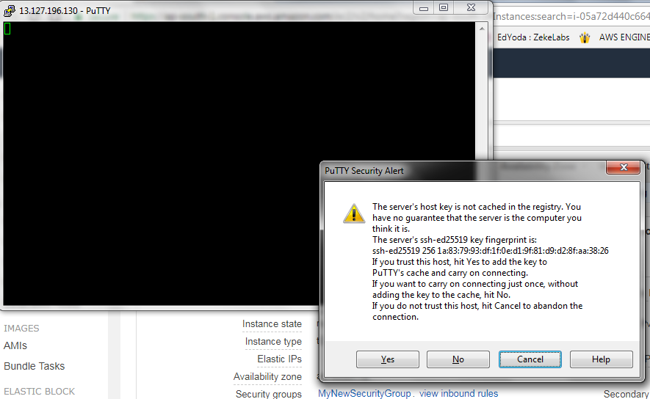

Now your Amazon Linux AMI is ready for use

