**CLASSIC LOAD BALANCER**

**On the navigation bar, choose a region for your load balancer. Be sure to select the same region that you selected for your EC2 instances. Under EC2 Service click on Load Balancer and Create Load Balancer.**

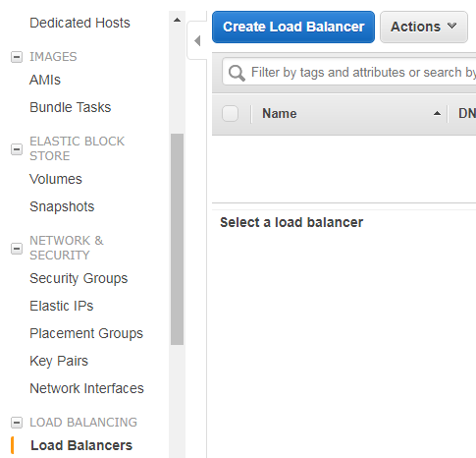

**Select a load balancer type – For Classic Load Balancer, choose Create**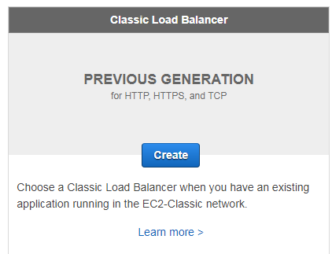

**For Load Balancer name, type a name for your load balancer. For Create LB inside, select the same network that you selected for your instances: EC2-Classic or a specific VPC. Leave the default listener configuration.**

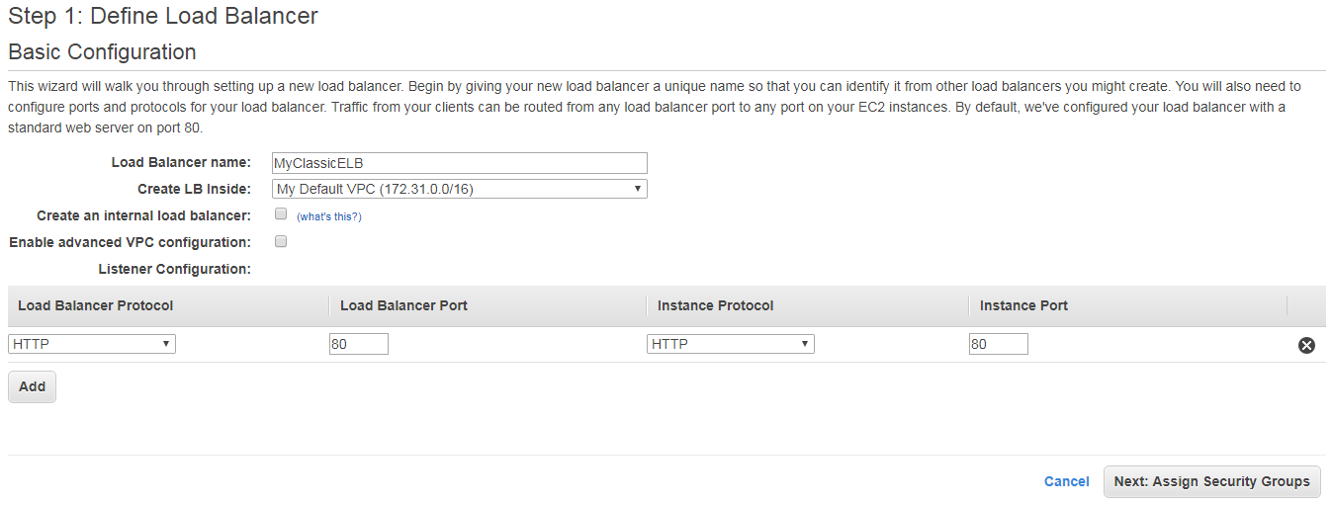

**On the Assign Security Groups page, select Create a new security group. Type a name and description for your security group, or leave the default name and description. This new security group contains a rule that allows traffic to the port that you configured your load balancer to use.**

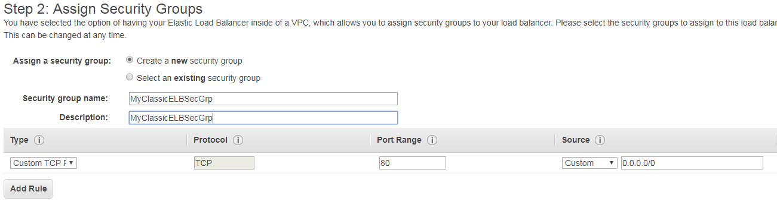

**On the Configure Health Check page, leave Ping Protocol set to HTTP and Ping Port set to 80. For Ping Path give your default home page as index.html. For Advanced Details, leave the default values.**

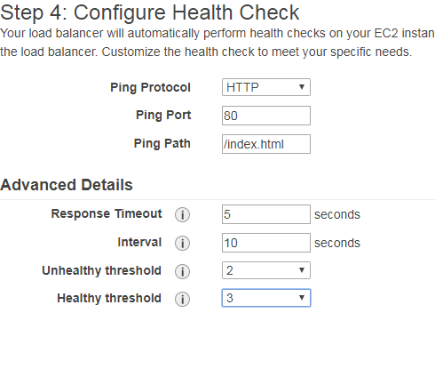

**Your load balancer distributes traffic between the instances that are registered to it. On the Add EC2 Instances page, select the instances to register with your load balancer.**

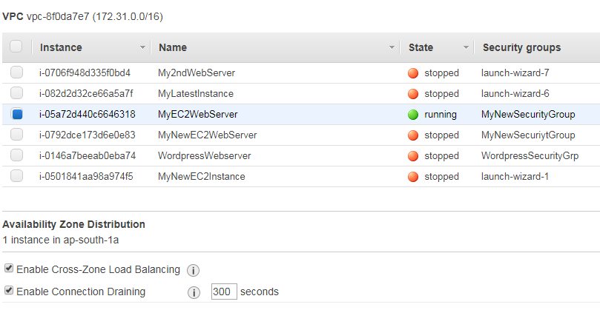

**Add Tags to your load balancer to identify them**

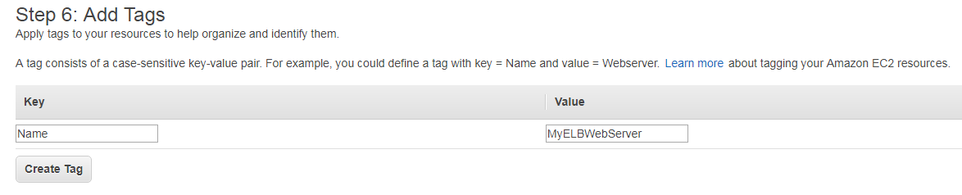

**Review your load balancer and Create it**

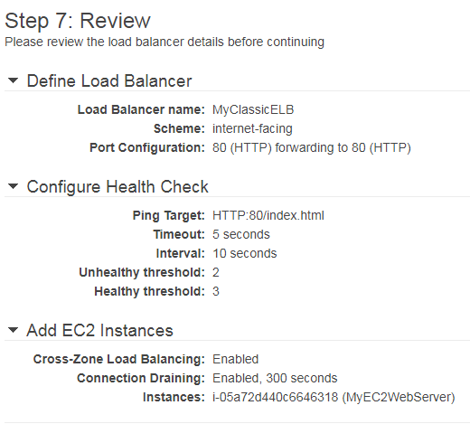

**Now your load balancer has been successfully created. Click on MyClassicELB link to get redirected to your Elastic Load Balancer**

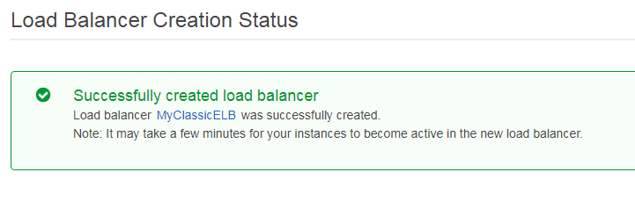

**Your load balancer is now started at the availability zone you have selected**

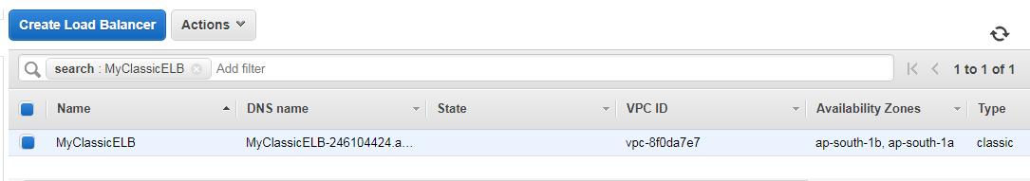

**On the instance pane of your EC2 service click on your running EC2 instance and select your IPv4 Public IP**

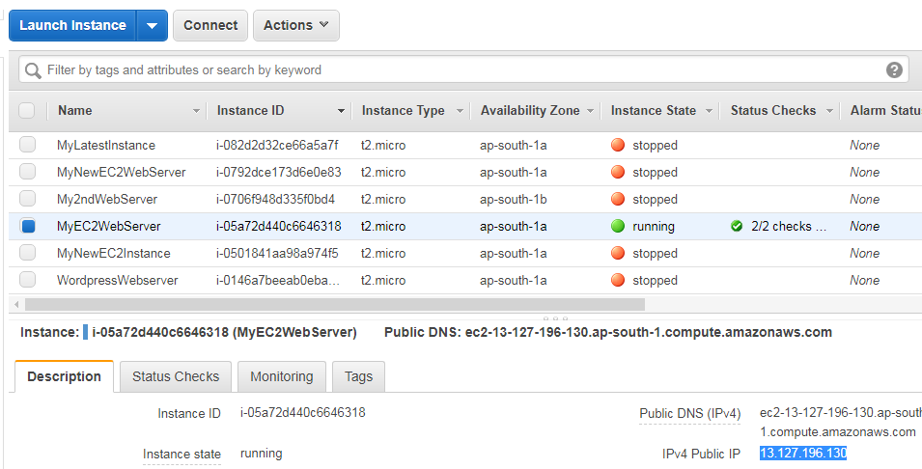

**Go to your putty configuration and give your IPV4 Public IP**

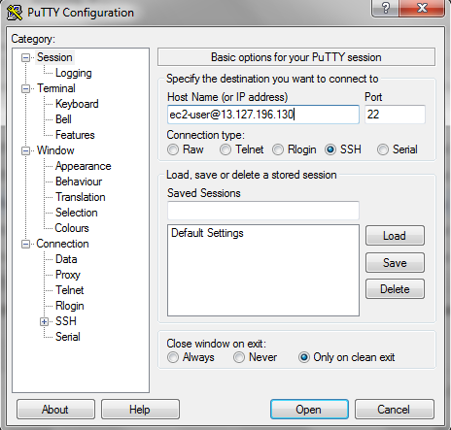

**Select Auth under SSH and browse your key**

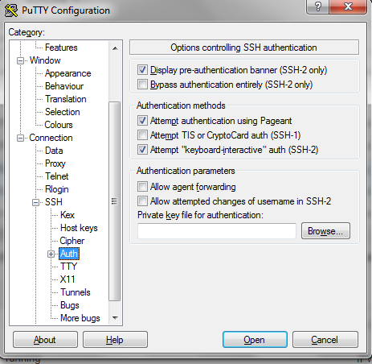

**Your Amazon machine is now up and running. Go to your root directory by giving the command   
“sudo su” and start your apache service using the command “service httpd start”**

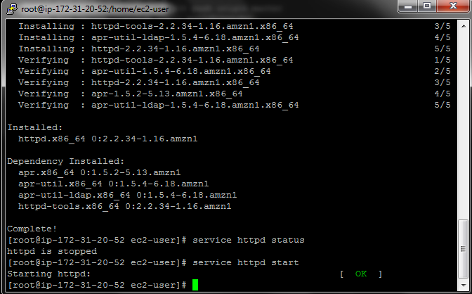

**Go to the path “cd /var/www/html” and create your index.html page using the command “vi index.html”**

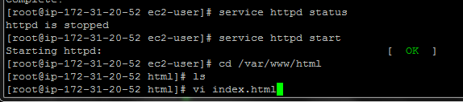

**Create your data in Index.html**

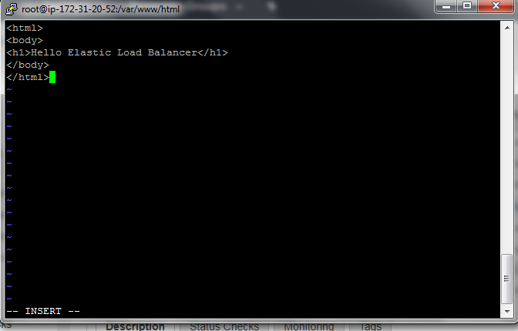

**Your index.html page is now created**

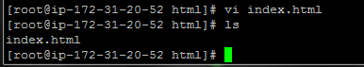

**Under Description pane of your running EC2 instance select your IPV4 Public**

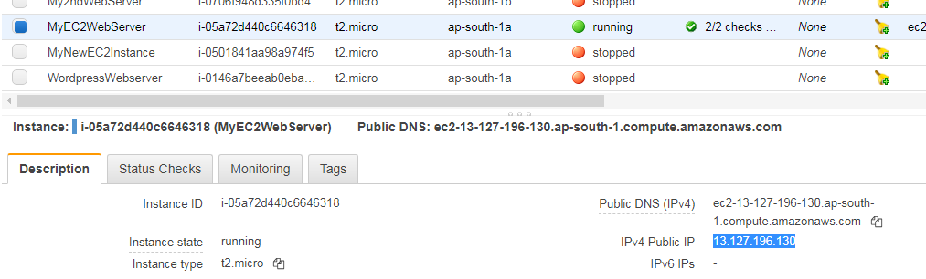

**Give your public IP address on your browser to check if your site is up and running.**

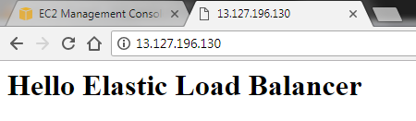

**Under the instances pane of your load balancer the status of your instance is InService**

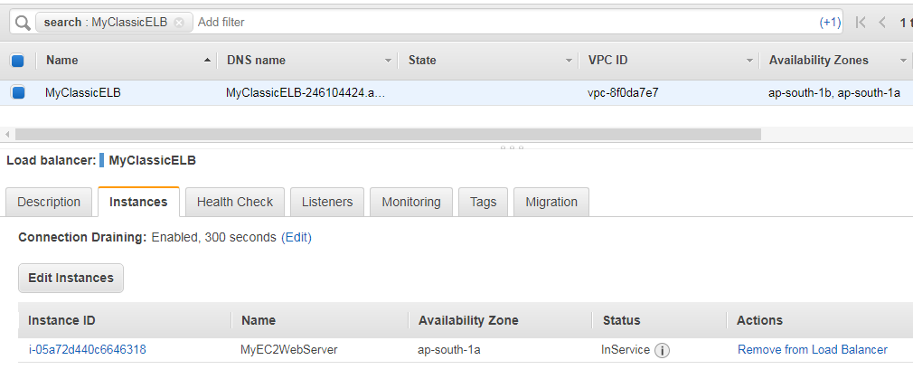

**Select the DNS name from the description pane of your load balancer**

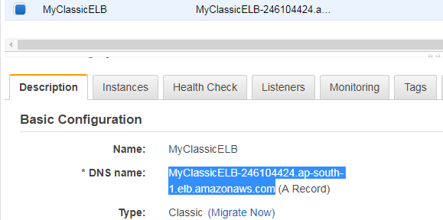

**Give your DNS name on the browser and the content given on your index.html file will be displayed**

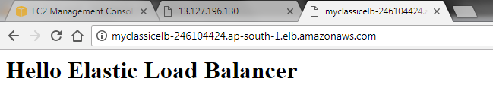

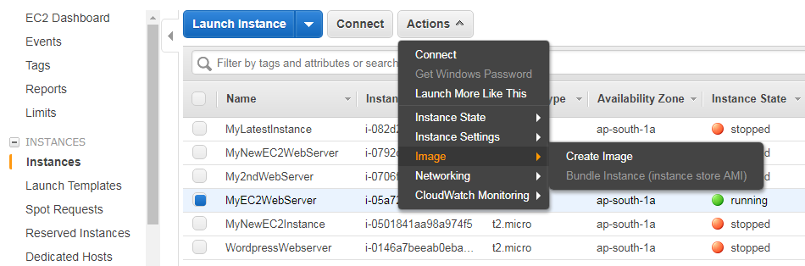

**Now you need to run your second instance. Click on AMI pane under your EC2 dashboard and create Image. Give image name, image description, leave the default instance volume and create image.**

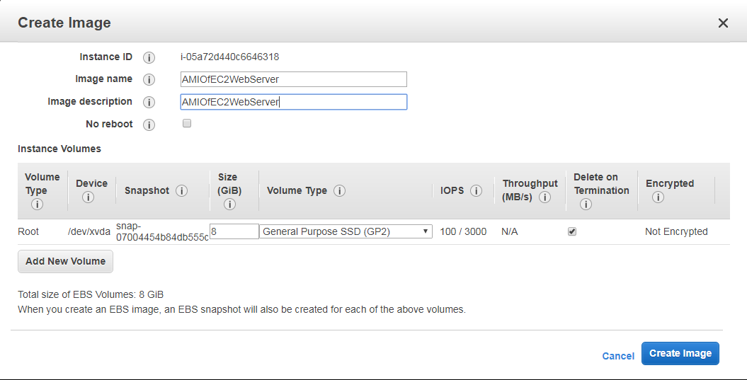

**Your Image has now been successfully created. Click on the link to view your AMI.**

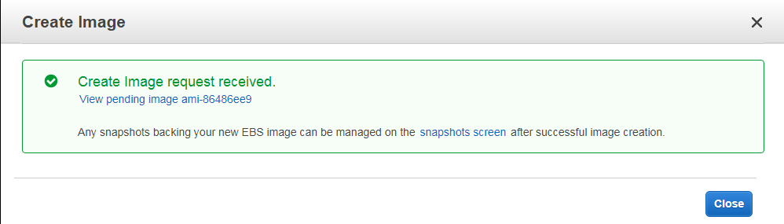

**Launch the AMI which you have created.**

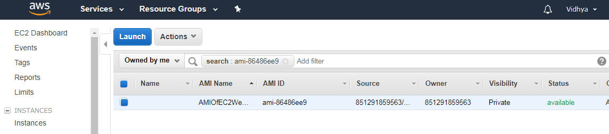

**Choose your instance type t2.micro**

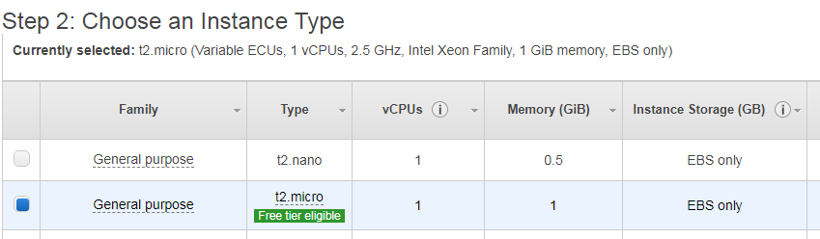

**Configure your instance details. Leave the default values and enable your Auto-assign public IP. Review and launch your instance**

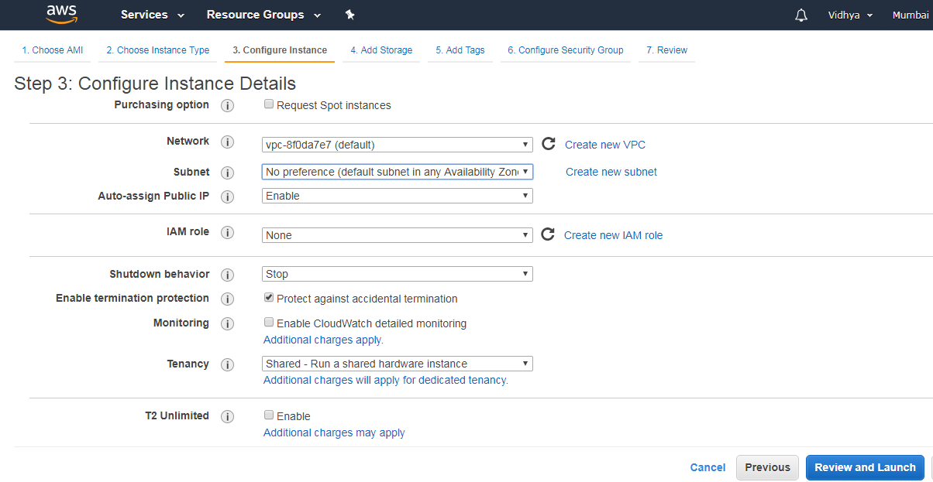

**Add tags to your EC2 instance to identify them**

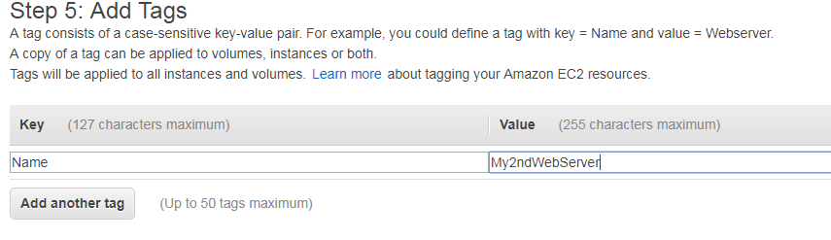

**Review and launch your instance**

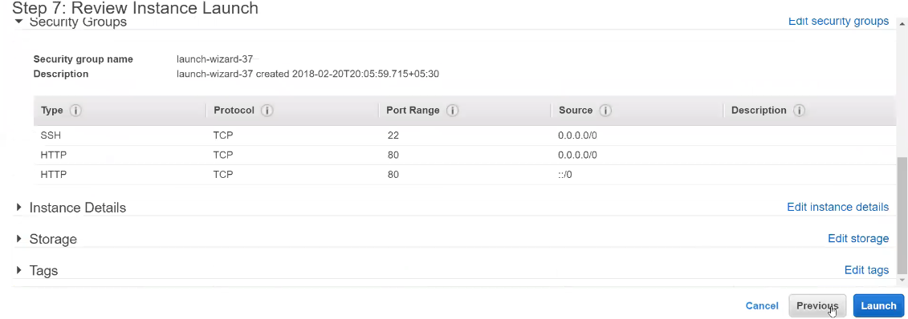

**Select an existing key pair which you have created already (.ppk) and launch instances**

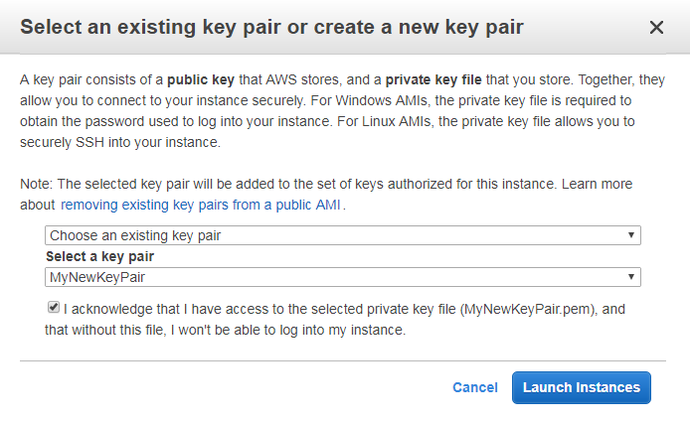

**Copy your IPv4 Public IP of your second running instance under the description pane of your selected instance**.

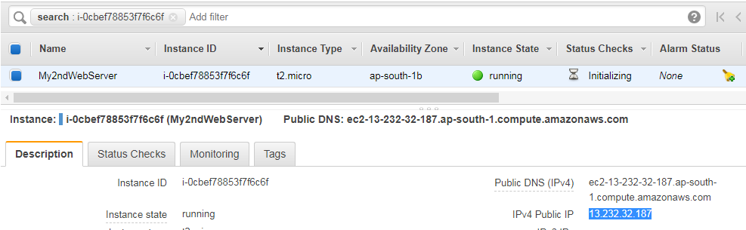

**Configure your putty by giving IPv4 Public IP under the Host Name of your putty window**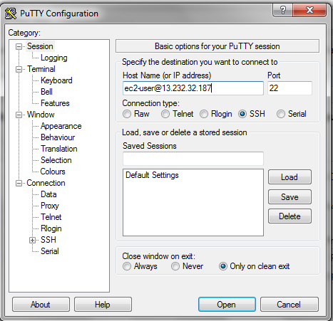

**Select Auth under SSH and browser your key (.ppk file)**

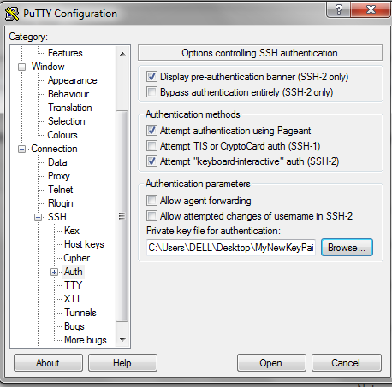

**Your second instance is now up and running. Give the following commands**

**“sudo su” - Goes to your root directory**

**“cd / var/www/html” – Goes to your html directory**

**“ls” – Lists the html pages**

**“service httpd start” – starts your apache service**

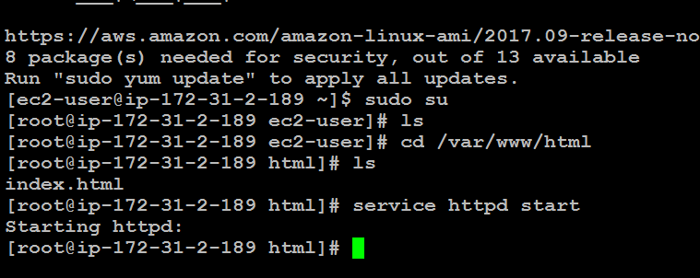

**Open your index.html using the command – “vi index.html”**

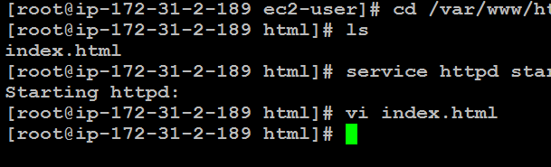

**Modify your content in index.html**

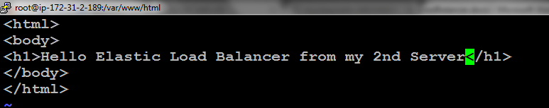

**Copy IPv4 Public IP of second EC2 instance.**

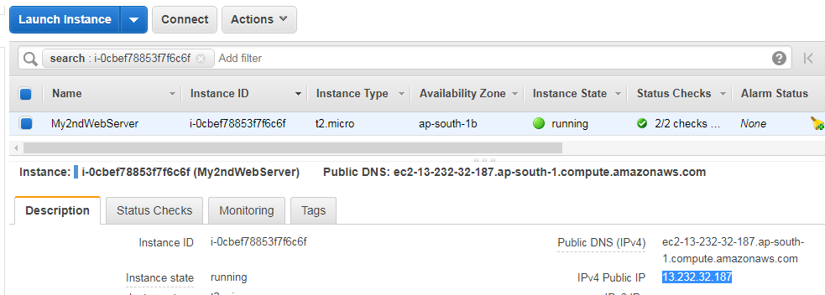

**Paste your Public IP on the browser and check if your page is up and running with your updated content in your index.html file**

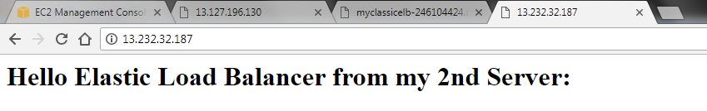

**Under Actions dropdown of the selected load balancer click on edit instances**

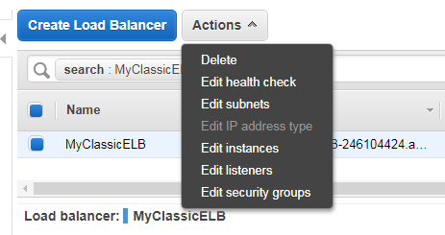

**Select the instances you need to connect to your load balancer**

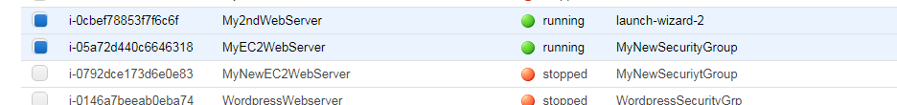

**Under instances tab of your load balancer, the status of both the instances are InService.**

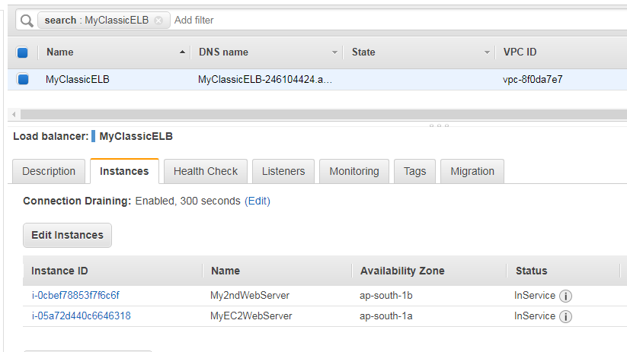

**Click on load balancer in EC2 dashboard, select your load balancer and copy DNS name of your load balancer under basic configuration.**

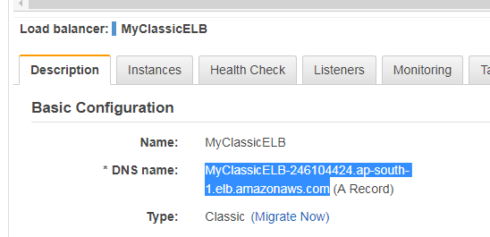

**Give the DNS name on the browser to check the content of your index.html page is loading**.

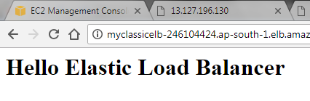

**Refresh your browser to check the content of your updated index.html page.**

