**Relational Database Services**

**Under Databases Services select RDS and click on Get started now**

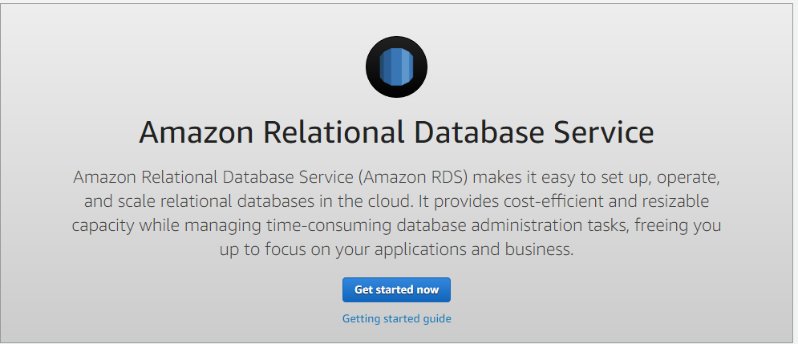

**Select MySQL, enable your free tier usage and click next**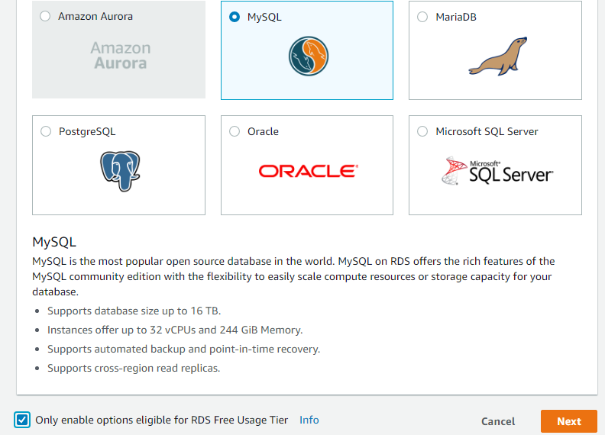

**Under instance specifications give license model and DB engine version**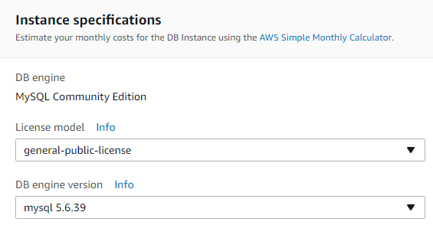

**Under settings give db instance identifier, master username and password**

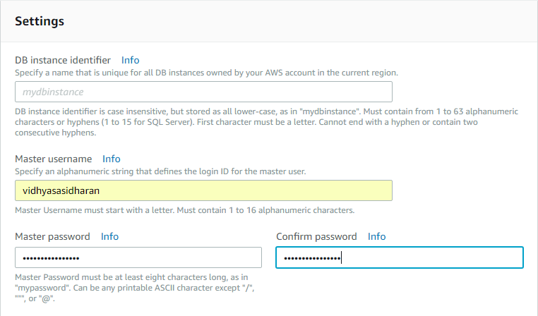

**Give default VPC, subnet group, public accessibility – yes, select any availability zone and create new** **security group**

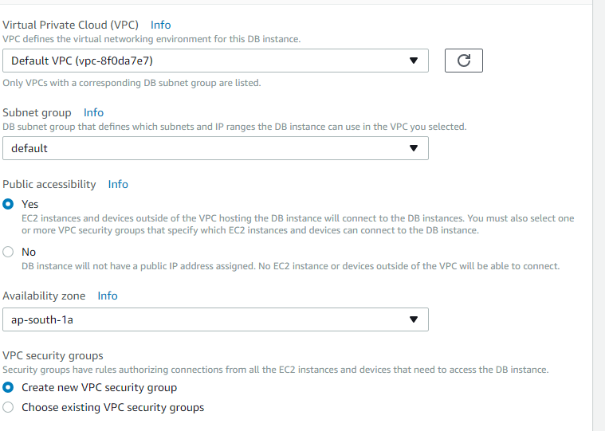

**Give Database name, port no- 3306, db parameter group – default, option group – default, disable IAM** **db authentication**

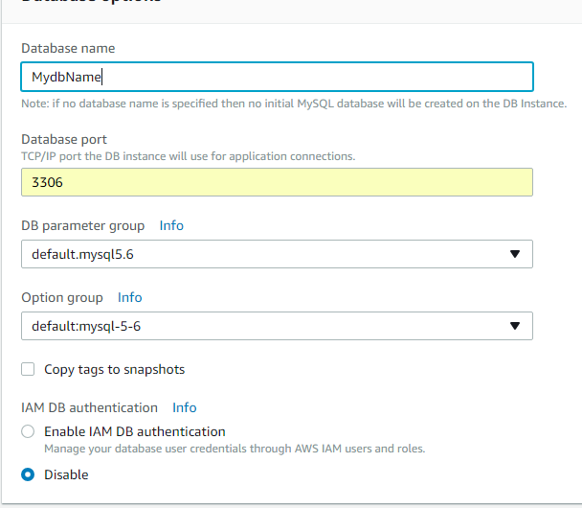

**Select your backup and retention period from dropdown**

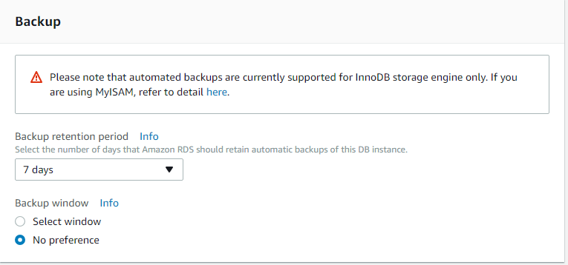

**Disable enhanced monitoring**

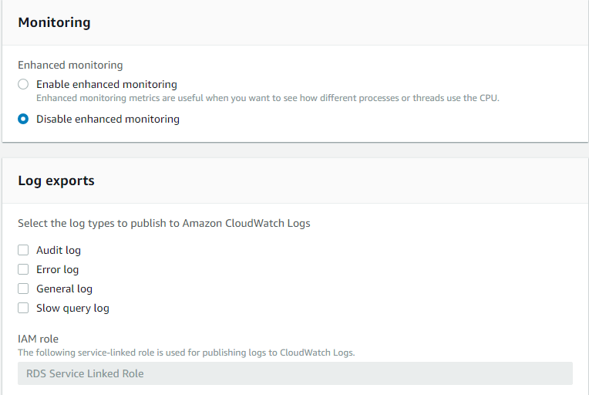

**Disable auto minor version upgrade and launch DB instance**

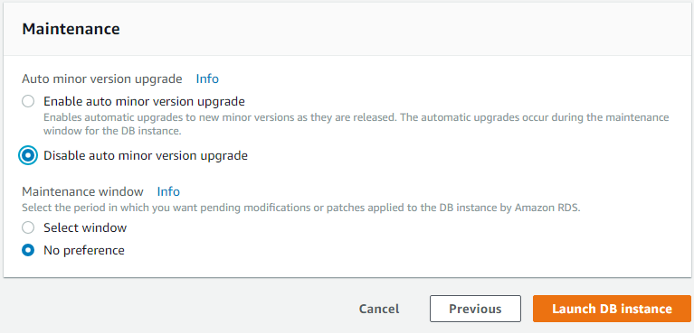

**Your db instance is launched and the status will be changed to available state after 5 mins**

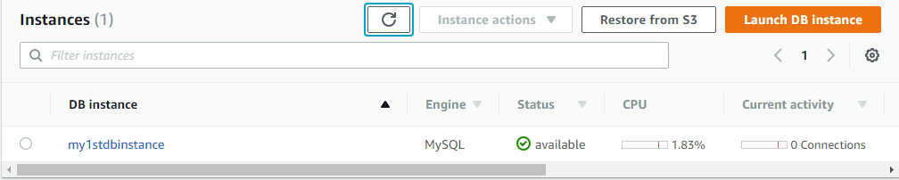

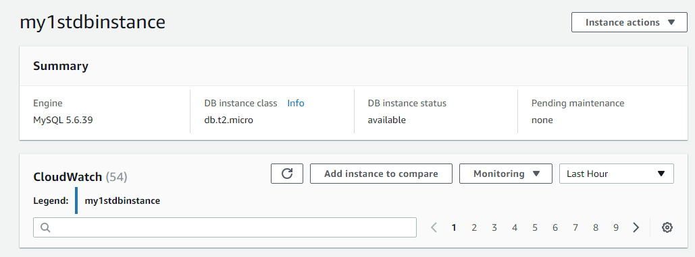

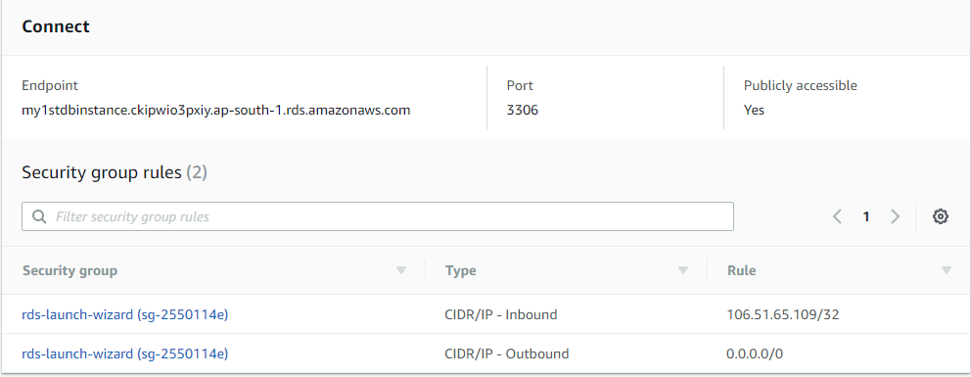

**Launch an EC2 Instance or start an existing EC2 instance**

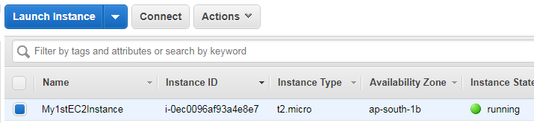

**SSH your EC2 instance via putty window**

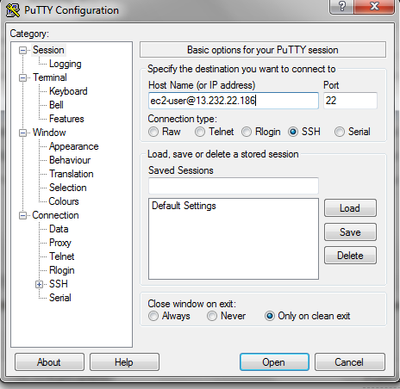

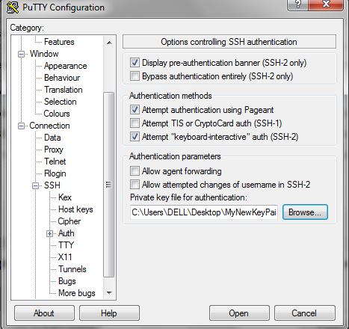

**Once your Amazon linux machine is up go to the root folder by giving the command “sudo su”**

**Install mysql using command “yum install mysql –y”**

**You’re my sql is now installed. Give the command “mysql –h endpointlink –P 3306 –u username –p** **password”**



**Under security group rules of your RDS instance click on rds-launch-wizard of inbound type**

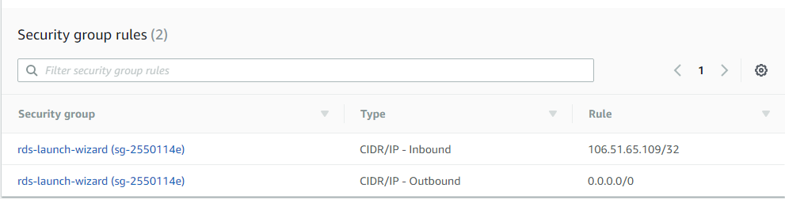

**Edit inbound rule**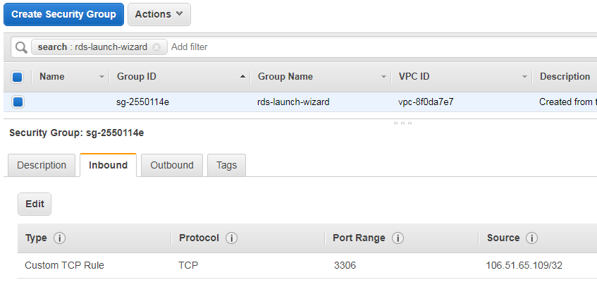

**Add a rule select Custom TCP from dropdown, port- 3306, source - anywhere**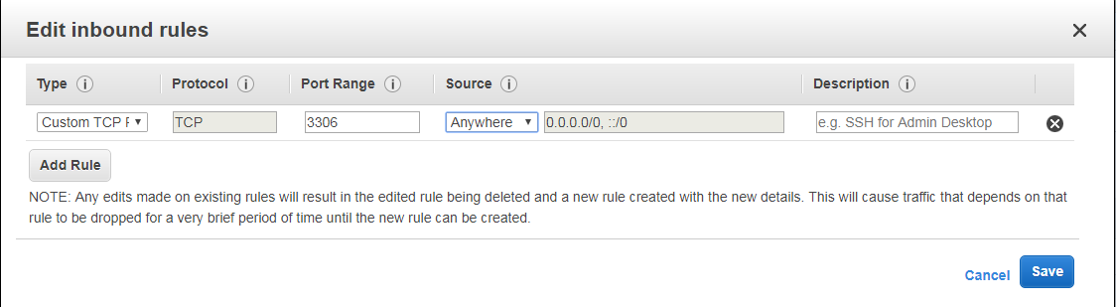

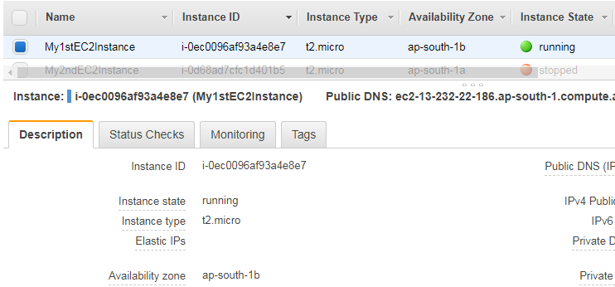

**Under security group of your running EC2 instance edit inbound rule**

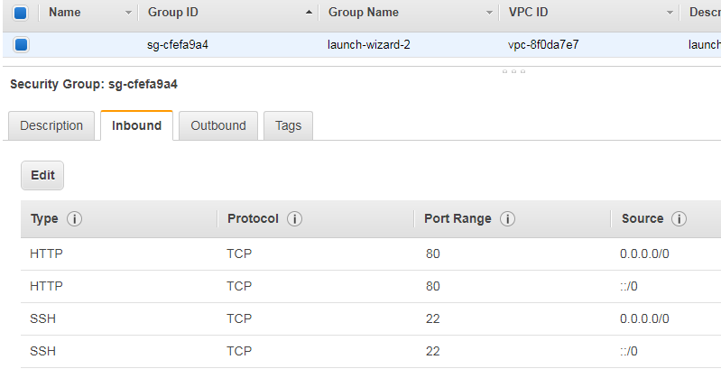

**Add rule of type MySQL/Aurora with port range 3306 and source anywhere. Save your settings.**

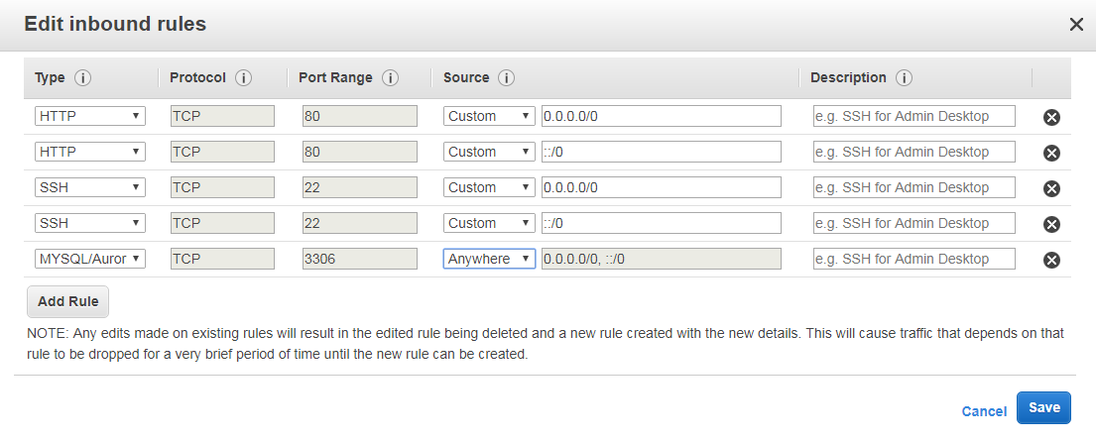

**In your putty window try connecting to your mysql again using the command “command “mysql –h** **endpointlink –P 3306 –u username –p password”. Now mysql is ready for use.**



**“show databases” – lists all your db’s in mysql**

**“use MydbName” – Allows to create tables inside your db**

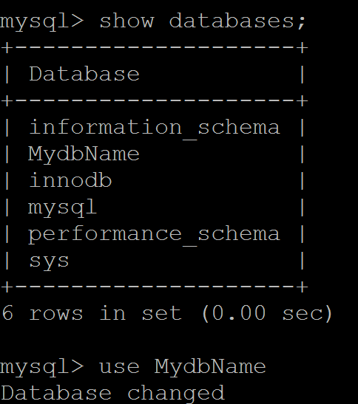

**Create a table using query–“create table table_name(column_name datatype());**

**Insert values using query - “insert into table_name values(‘value1’);**

**Show your table using query – “select * from table_name”;**

