***Snapshot***

**Open the Amazon EC2 console at**[**https://console.aws.amazon.com/ec2/**](https://console.aws.amazon.com/ec2/)**.**

**Choose snapshots in the navigation pane and click Create Snapshot**

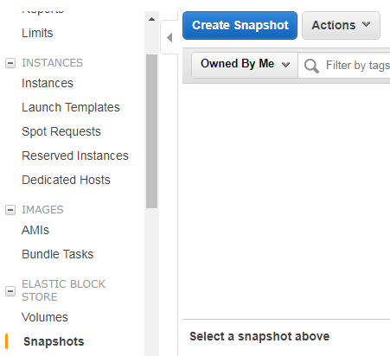

**On the Create Snapshot page, select the volume to create a snapshot for.**

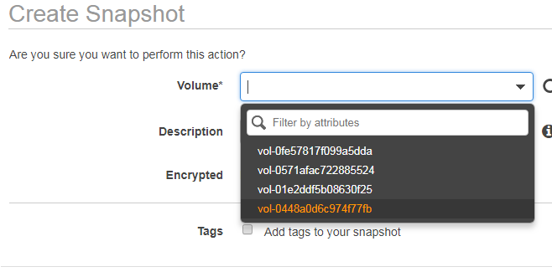

**Choose Add tags to your snapshot. For each tag, provide a tag key and a tag value. Choose Create Snapshot.**

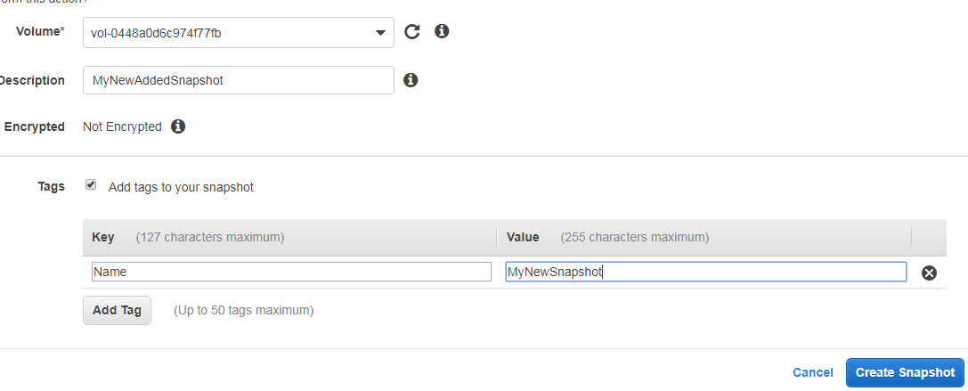

**Your snapshot is now created. Click on the link to view your snapshot created**

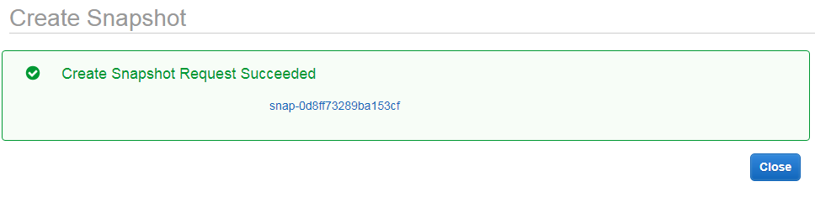

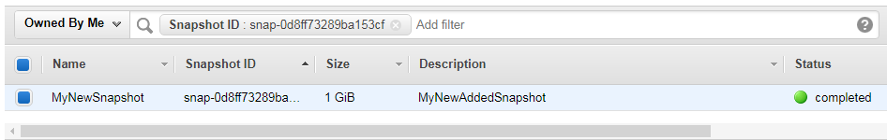

**Details of your snapshot can be viewed here**

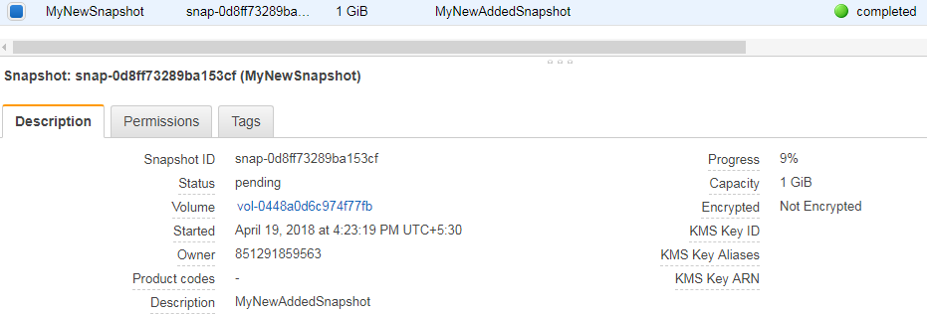

**Delete Your Snapshot by clicking on the Actions in Snapshot pane**

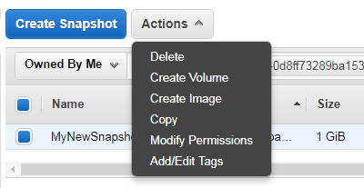

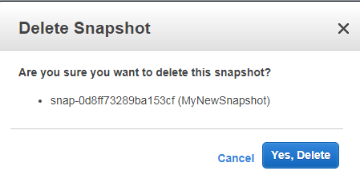

**Your snapshot is now deleted**

