**Version Control**

**Create a index.html file**

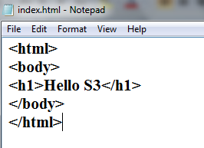

**Go to Overview pane and upload your index.html file**

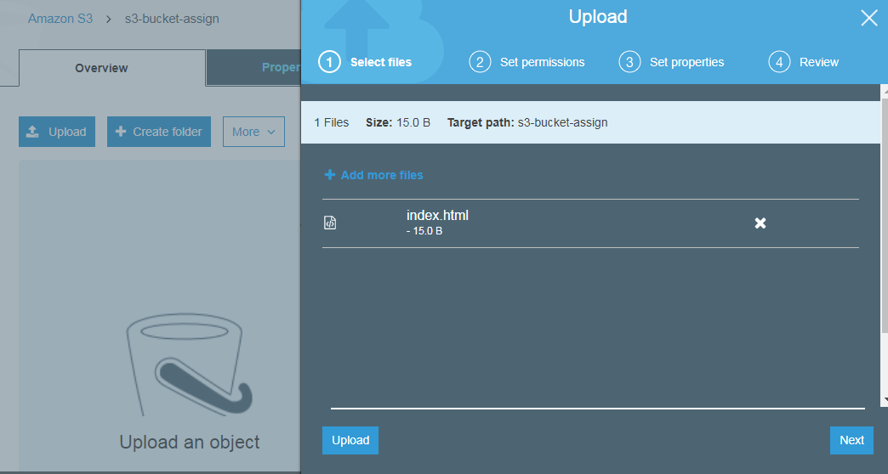

**Grant public read access to this object**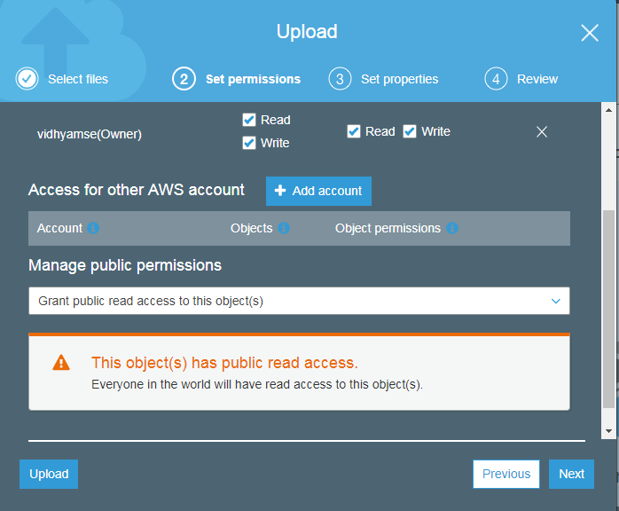

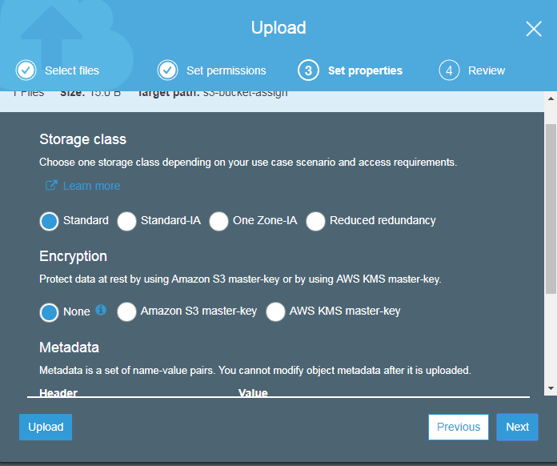

**Review and upload your file**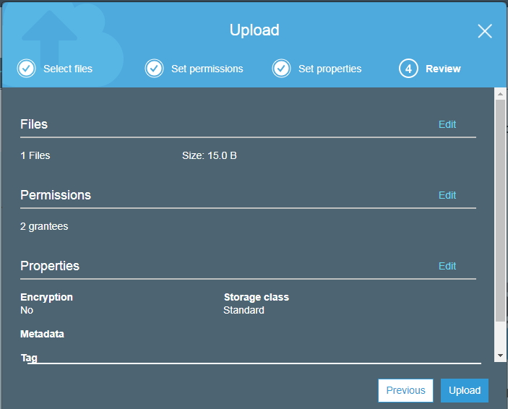

**Your index.html file is now uploaded. Click on the file**

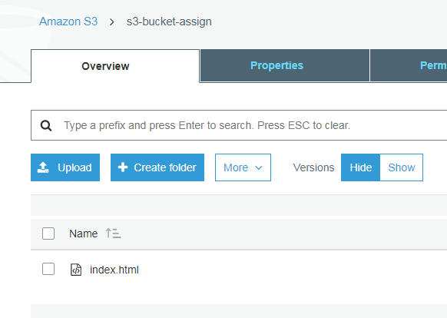

**Click on the link**

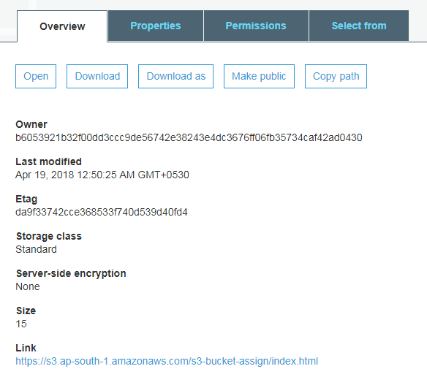

**You will be redirected to your web page.**

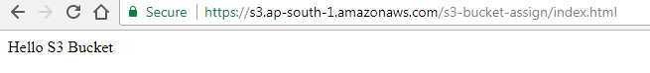

**Modify your index.html file**

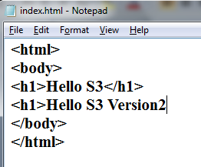

**Upload your modified index.html file**

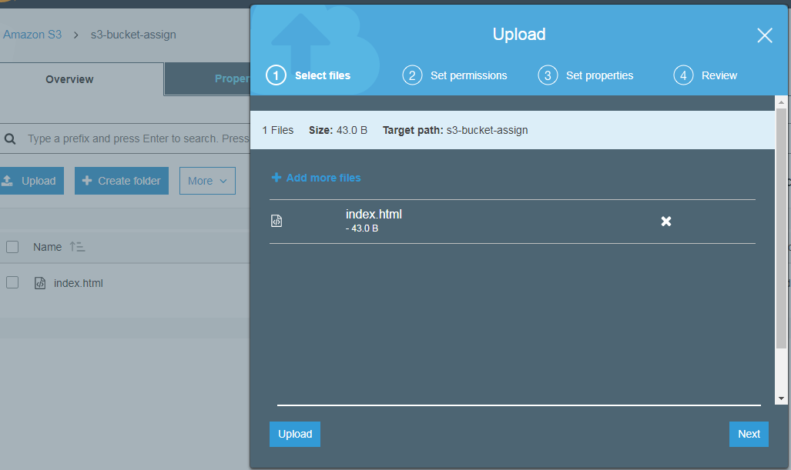

**Grant public read access to this object and upload the file**



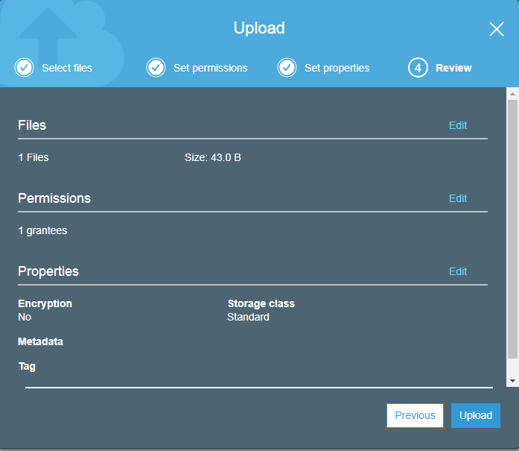

**Click on index.html**

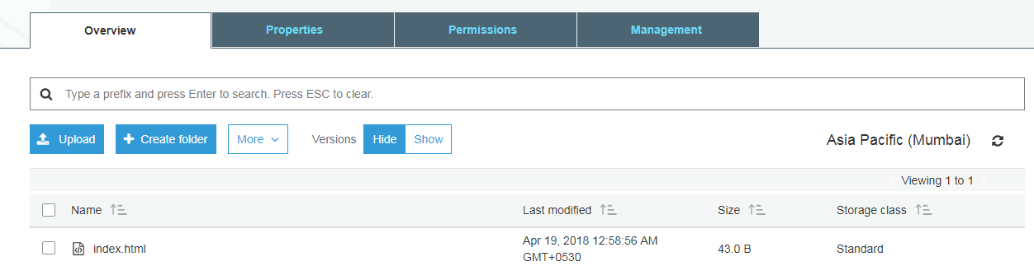

**Click on the link**



**You will be redirected to the webpage with updated content**

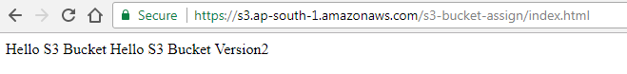

**If you click on index.html and check the property window you will find the two versions of that file**

