VIDHYA R
192572153
EXPERIMENT NO: 16

Aim:
To implement a Python program for a Feed Forward Neural Network using TensorFlow/Keras.

Algorithm:
Step 1: Start.
Step 2: Import the required libraries.
Step 3: Create a Sequential Neural Network model.
Step 4: Add input, hidden, and output layers.
Step 5: Compile the model.
Step 6: Train the model using the training dataset.
Step 7: Evaluate the model.
Step 8: Display the accuracy.
Step 9: Stop.

PROGRAM:
from tensorflow.keras.models import Sequential
from tensorflow.keras.layers import Dense
import numpy as np

X = np.array([[0,0],[0,1],[1,0],[1,1]])
Y = np.array([[0],[1],[1],[0]])

model = Sequential()
model.add(Dense(4, input_dim=2, activation='relu'))
model.add(Dense(1, activation='sigmoid'))

model.compile(loss='binary_crossentropy',
optimizer='adam',
metrics=['accuracy'])

model.fit(X, Y, epochs=100, verbose=0)

loss, accuracy = model.evaluate(X, Y, verbose=0)
print("Accuracy:", accuracy)

OUTPUT:

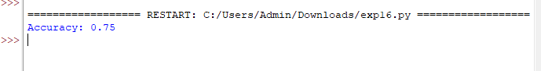

RESULT:
Thus, the Python program for the Feed Forward Neural Network was implemented successfully.

