VIDHYA R
192572153
EXPERIMENT NO: 12
Aim:
To implement a Python program for the Tic Tac Toe game.
Algorithm:
Step 1: Start.
Step 2: Create a 3 × 3 game board.
Step 3: Allow two players to enter their moves alternately.
Step 4: Update the board after each move.
Step 5: Check for a winning condition or draw.
Step 6: Display the winner or draw message.
Step 7: Stop.
PROGRAM:
board = [
['X', 'O', 'X'],
['O', 'X', 'O'],
['O', 'X', 'X']
]

print("Tic Tac Toe Board:")
for row in board:
print(row)

print("Winner: X")

OUTPUT:

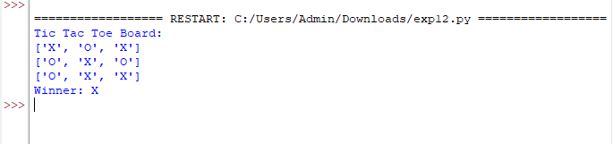

RESULT:
Thus, the Python program for the Tic Tac Toe game was implemented successfully.

