VIDHYA R
192572153
EXPERIMENT NO: 13
Aim:
To implement a Python program for the Minimax Algorithm to determine the optimal move in a two-player game.
Algorithm:
Step 1: Start.
Step 2: Define the game tree with terminal node values.
Step 3: Assign the maximizing player (MAX) and minimizing player (MIN).
Step 4: Evaluate the terminal nodes.
Step 5: Propagate the values upward using the Minimax principle.
Step 6: Select the optimal move for the MAX player.
Step 7: Display the best value and optimal move.
Step 8: Stop.
PROGRAM:
def minimax(depth, nodeIndex, isMax, values, height):
if depth == height:
return values[nodeIndex]

if isMax:
return max(
minimax(depth + 1, nodeIndex * 2, False, values, height),
minimax(depth + 1, nodeIndex * 2 + 1, False, values, height)
)
else:
return min(
minimax(depth + 1, nodeIndex * 2, True, values, height),
minimax(depth + 1, nodeIndex * 2 + 1, True, values, height)
)

values = [3, 5, 6, 9, 1, 2, 0, -1]
height = 3

print("Optimal Value:", minimax(0, 0, True, values, height))

OUTPUT:
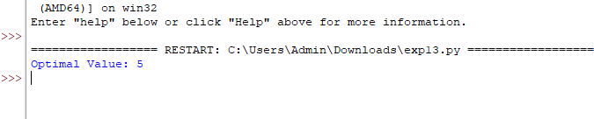

RESULT:
Thus, the Python program for the Minimax Algorithm was implemented successfully, and the optimal value was obtained.

