VIDHYA R
192572153
EXPERIMENT 11:
Aim:
To implement a Python program to solve the Map Coloring Problem using the Constraint Satisfaction Problem (CSP) approach.
Algorithm:
Step 1: Start.
Step 2: Define the map regions and their neighboring regions.
Step 3: Assign a set of colors to each region.
Step 4: Check that no two adjacent regions have the same color.
Step 5: Assign valid colors to all regions.
Step 6: Display the color assigned to each region.
Step 7: Stop.
PROGRAM:
states = ['A', 'B', 'C', 'D']
colors = ['Red', 'Green', 'Blue']

solution = {
'A': 'Red',
'B': 'Green',
'C': 'Blue',
'D': 'Red'
}

print("Map Coloring Solution:")
for state in states:
print(state, "->", solution[state])

OUTPUT:
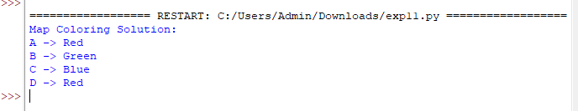

RESULT:
Thus, the Python program to solve the Map Coloring Problem using the CSP approach was implemented successfully.

