Documentation for WEB Server using Python, C++ and Qt

Step 1: Download and Install VirtualBox (Linux Version)
- Open the VirtualBox Downloads Page:
VirtualBox Downloads
- Select the Linux Hosts version appropriate for your distribution. For example, if you're using Ubuntu, download the Linux distributions version.
- Follow the installation instructions for your Linux distribution.

Step 2: Download and Install Ubuntu
- Visit the Ubuntu Downloads Page:
Ubuntu Desktop Download
- Download the Ubuntu version you want to use (e.g., 20.04 LTS or 22.04 LTS).
- Once downloaded, create a virtual machine in VirtualBox and install Ubuntu by following the installation guide on the Ubuntu website.

Step 3: Install Python (Python3)
- Open a terminal window in your Ubuntu environment.
- To install Python 3 using pip, run the following command:
sudo apt update
sudo apt install python3-pip

Step 4: Install Qt Creator
- Download the Qt Creator installer from the official website:
Qt Creator Installer
- Once the download is complete, make the installer executable with the following command:

chmod +x qt-online-installer-linux-x64-4.9.0.run
- Start the installation process by running:

sudo ./qt-online-installer-linux-x64-4.9.0.run
- Follow the on-screen instructions to complete the installation of Qt Creator.

Step 5: Install curl
- To install curl, run the following command in your terminal:

sudo apt install curl

Step 6: Set Up Python Virtual Environment and Install Flask
- Create a new directory for your project:

mkdir my_project
cd my_project
- Create a virtual environment with Python 3:

python3 -m venv venv
- Activate the virtual environment:

source venv/bin/activate
- Install Flask (used to create a web server):

pip3 install flask
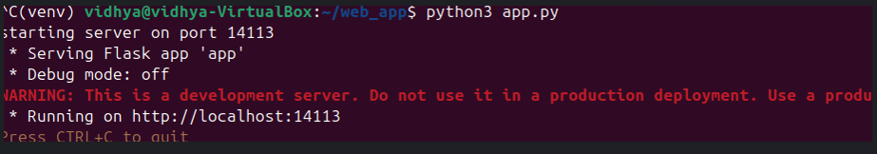

Step 7: Create a QtQuick Application
- Open Qt Creator.
- Click on New Project and select Qt Quick Application.
- Follow the prompts to configure the project (e.g., name, location, build kits).
- Once the project is created, add your C++ code and QML files:
  - C++ Code: Add the necessary logic to interact with the QML files.
  - QML Code: Create a web.qml file with the desired UI structure.

Step 8: Build and Run the QtQuick Application
- Click Build in Qt Creator to compile the project.
2. Run the application to check if the UI is visible and functioning properly.

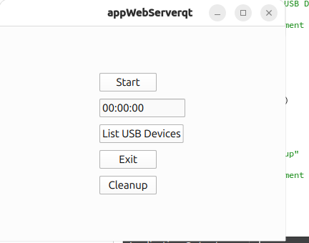

Step 9: Connect the Python Server with the Qt Application
In your terminal, test the server connection using curl:

curl -X POST http://localhost:14113/api/v1/getQML -H "Content-Type: application/json" -d '{"filename": "/path/to/web.qml"}'
Replace /path/to/web.qml with the correct path to the QML file.
- If everything is set up correctly, you should receive a 200 OK response indicating the connection was successful.

