Q1).
Create a table called Playlist with columns: id, song_name, artist, genre, and play_count. Insert at least 5 sample records representing your favorite songs from Spotify.
Query:-
create table palylist (id int primary key auto_increment , song_name varchar(30),artist varchar(30),gener varchar(30),play_cout int);

insert into palylist(song_name,artist,gener,play_cout) values ('Arz Kiya Hai','Anuv Jain','Pop',1100000),
('Bairan Banjaare','Mitta Ror & Swara Verma','Pop',889500),
('Faded', 'Alan Walker', 'EDM', 1700000000),
('Tum Hi Ho', 'Arijit Singh', 'Bollywood', 1500000000),
('Hotel California', 'Eagles', 'Classic Rock', 1200000000),
('Brown Munde','AP Dhillon','HipHop',10000000),
('Excuses','AP Dhillon','HipHop',8000000),
('295','Sidhu Moose Wala','HipHop',15000000);
Output:-
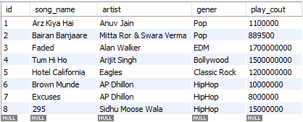
Q2).
Write a SELECT query to display only the song_name and artist from the Playlist table, but show the artist column as 'Singer' using an alias.
SELECT song_name,artist as singer FROM instaclone.palylist
Output:-

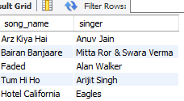
Q3).
Write a SELECT query to find all songs in the Playlist table where the genre is 'Pop' and play_count is greater than 100. Sort the results by play_count in descending order.
Query:-
SELECT * FROM instaclone.palylist where gener='pop';
Output:-
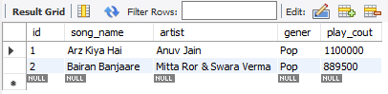
Q4).
Use the COUNT aggregate function to find out how many songs in your Playlist table belong to the genre 'Hip-Hop'.
Query:-
select count(gener) as totalgenrehiphop from instaclone.palylist where gener='HipHop';
Output:-
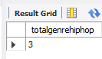

Q5).
Write a SELECT query that shows the total number of plays (SUM of play_count) for each genre in your Playlist table, grouped by genre.<br><br><em><strong>Hint:</strong> Use GROUP BY with the SUM function to aggregate play counts by genre.</em>
Query:-
select sum(play_cout),gener as total from instaclone.palylist group by gener;
Output:-
