CREATE TABLE restaurants (
id INT PRIMARY KEY AUTO_INCREMENT,
name VARCHAR(100),
location VARCHAR(100),
rating DECIMAL(2,1)
);

ALTER TABLE restaurants
ADD COLUMN average_cost INT;
SELECT * FROM hotel.restaurants;
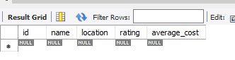
DROP TABLE restaurants;
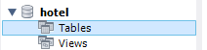
CREATE TABLE playlists (
playlist_id INT PRIMARY KEY AUTO_INCREMENT,
title VARCHAR(50),
created_by VARCHAR(50),
created_at DATE
);
