-- 1. Create the Restaurants table
CREATE TABLE Restaurants (
id INT AUTO_INCREMENT PRIMARY KEY,
name VARCHAR(100),
cuisine VARCHAR(50),
rating DECIMAL(2,1),
city VARCHAR(50)
);

-- Insert 5 sample restaurants
INSERT INTO Restaurants (name, cuisine, rating, city)
VALUES
('Spice Villa', 'Indian', 4.5, 'Ahmedabad'),
('Pasta House', 'Italian', 4.2, 'Ahmedabad'),
('Sushi World', 'Japanese', 3.8, 'Surat'),
('Burger Hub', 'American', 3.2, 'Ahmedabad'),
('Taco Fiesta', 'Mexican', 4.6, 'Vadodara');

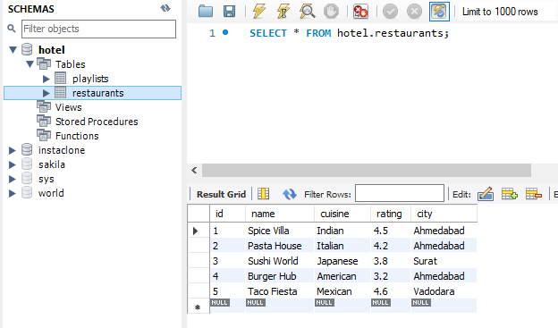
-- 2. Update Spice Villa's rating
UPDATE Restaurants
SET rating = 4.7
WHERE name = 'Spice Villa';

-- 3. Delete restaurants with rating below 3.5
DELETE FROM Restaurants
WHERE rating < 3.5;

-- 4. Fetch top 2 restaurants in Ahmedabad
-- with rating above 4.0
SELECT *
FROM Restaurants
WHERE city = 'Ahmedabad'
AND rating > 4.0
LIMIT 2;

