VIDHYASAGAR R. MAURYA
BCA Graduate | Aspiring Java Full Stack Developer
📍 Gujarat, India
📞 [7990964010]
✉️ [mauryavidhyasagar6549@gmail.com]
🔗 LinkedIn: [Vidhyasagar Maurya]

PROFESSIONAL OBJECTIVE
Motivated and detail-oriented BCA graduate with a strong foundation in Java, SQL, web development, and database management. Experienced in developing academic and internship-based applications using technologies such as Java, PHP, MySQL, and SQL Server. Seeking an entry-level opportunity as a Java Full Stack Developer where I can apply my technical skills, learn industry practices, and contribute to real-world software projects.

EDUCATION

Bachelor of Computer Applications (BCA)

VNSGU
V.S. Patel College, Bilimora, Gujarat
Expected/Completed: 2026
Relevant areas of study:
- Object-Oriented Programming
- Database Management Systems
- Web Development
- Software Development
- C / C++ Programming
- Java Programming
- SQL & RDBMS

ACADEMIC PERFORMANCE
BCA – V.S. Patel College, Bilimora
- Successfully completed BCA Semester 6
- Developed multiple academic projects involving web development, databases, and programming
- Applied programming concepts including OOP, data structures, SQL, CRUD operations, and database connectivity
Academic Performance: [CGPA: 8.02 | Percentage: 80.20% | First Class with Distinction (BCA, Semester 6)]

TECHNICAL SKILLS
Programming Languages
- Java
- C
- C++
- PHP
- JavaScript
Web Technologies
- HTML
- CSS
- Bootstrap
- JavaScript
Database Technologies
- MySQL
- SQL
- RDBMS
Frameworks / Technologies
- ASP.NET Core MVC
- Firebase Realtime Database
Tools
- Visual Studio
- Git & GitHub
Core Concepts
- Object-Oriented Programming
- Database Management Systems
- CRUD Operations
- SQL Queries
- MVC Architecture
- Web Application Development

EXPERIENCE

Software Development Intern
[Izzonet web solution Pvt. Ltd.] | Nov 2025 – Dec 2025
- Worked on an ASP.NET Core MVC Product Management System.
- Implemented CRUD operations for product management.
- Worked with Microsoft SQL Server for database operations.
- Used MVC architecture to organize application components.
- Practiced database connectivity, data handling, and web application development.
- Gained practical exposure to software development and project workflow.

PROJECTS

1. Automobile Parts Management Website
Technologies: PHP, MySQL, HTML, CSS, Bootstrap
- Developed a web-based automobile parts management application.
- Implemented database connectivity using MySQL.
- Designed responsive web pages using Bootstrap.
- Created functionality for managing automobile-related products and information.
- Applied CRUD and database management concepts.

2. E-Commerce Customer Data Analysis
Technologies: Python, Data Analysis
- Developed a Python-based data analysis project for an e-commerce dataset.
- Analysed customer-related data to identify useful patterns and insights.
- Applied data processing and analysis techniques.
- Prepared an academic project report based on the analysis.

CERTIFICATIONS & TRAINING
- Java Full Stack Development – TOPS Technologies (Training)
- ASP.NET Core MVC Internship – [Izzonet web solution Pvt. Ltd.]
- certificates
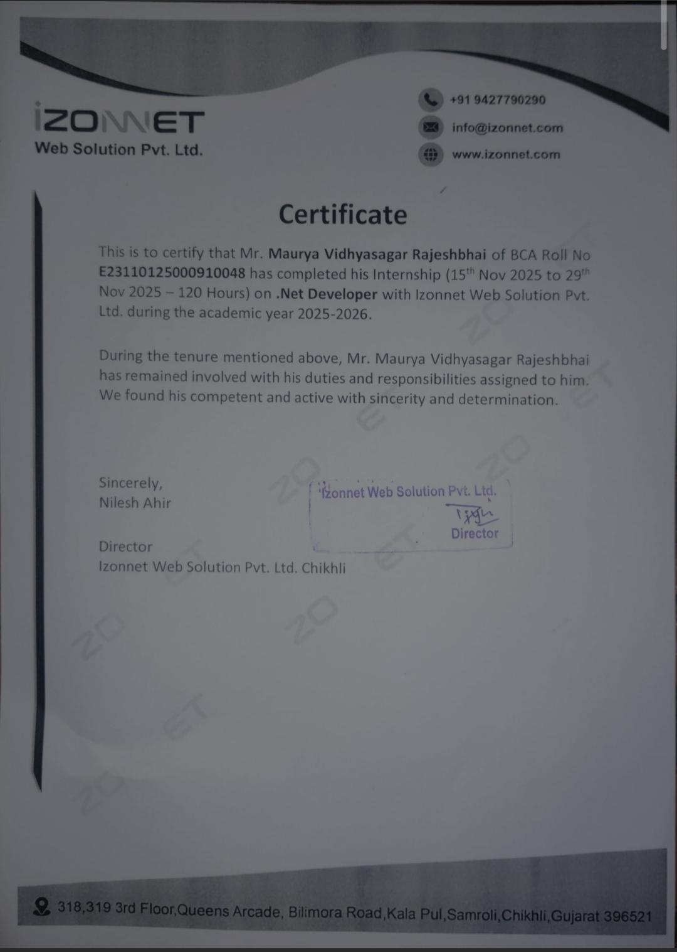

ACHIEVEMENTS
- Successfully completed BCA Semester 6.
- Completed an internship involving ASP.NET Core MVC and SQL Server.
- Developed multiple academic projects using different programming languages and technologies.
- Built practical experience with database-driven web applications.

INTERESTS
- Full Stack Web Development
- Java Application Development
- Database Technologies
- Learning New Programming Technologies
- Building Real-World Projects

SOFT SKILLS
- Problem Solving
- Communication
- Teamwork
- Time Management
- Quick Learning
- Adaptability
- Logical Thinking

DECLARATION
I hereby declare that the information provided above is true and correct to the best of my knowledge.
Place: Gujarat
Date: ___________
Vidhyasagar R. Maurya

