Q1).
Install MySQL Workbench on your computer, connect to the local MySQL server, and take a screenshot of the default databases shown in the Schemas panel.
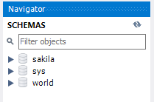
Q2) .
Create a new database called InstaClone in MySQL Workbench, then create a table named Users with columns: user_id (INT, primary key), username (VARCHAR), email (VARCHAR), and followers_count (INT).
Query :-
1). create database InstaClone;
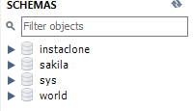
2). create table Users( user_id int primary key auto_increment ,user_name varchar(30) ,email varchar(50),followers_count int );
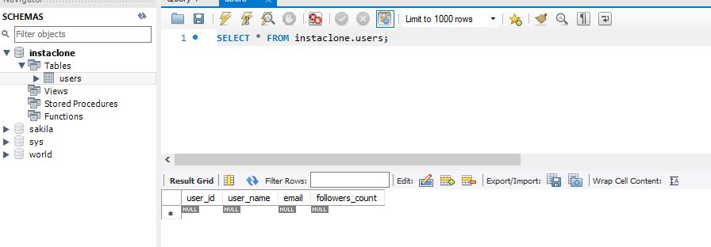
Q3).
Insert 3 sample users into the Users table you created, using realistic Instagram-style usernames and follower counts.
Query :-
insert into users (user_name,email,followers_count)values('mvs_6549','mvs6549@gmail.com',16000),
('megha', 'megha@gmail.com',7000),
('rahul', 'rahul@gmail.com',8000);


Q4).
Create another table in the InstaClone database called Posts with columns: post_id (INT, primary key), user_id (INT), caption (VARCHAR), and post_date (DATE). Add a foreign key from Posts.user_id to Users.user_id to establish a relationship.
Query :-
create table post( post_id int primary key auto_increment ,user_id int,caption varchar(50),post_date date,foreign key(user_id) REFERENCES users(user_id));
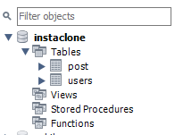
Q5).
Write a short comparison (3-4 lines each) of MySQL, PostgreSQL, Oracle, and SQLite, focusing on where each one is commonly used (for example: web apps, mobile apps, enterprise systems, etc.).
Ans:-
MySQL
MySQL is widely used for web applications and online services.
It is popular with websites, content-management systems, and e-commerce platforms.
It is known for being easy to use, reliable, and fast for common database workloads.
PostgreSQL
PostgreSQL is commonly used in web apps, analytics, and data-intensive systems.
It is favored when applications need advanced SQL features and complex queries.
It is popular in startups, SaaS platforms, and large-scale backend systems.
Oracle
Oracle Database is mainly used in large enterprise systems.
Banks, governments, telecom companies, and large corporations commonly use it.
It is valued for strong security, scalability, reliability, and enterprise features.
SQLite
SQLite is commonly used in mobile apps, desktop applications, and embedded systems.
It stores the entire database in a single file and requires no separate database server.
It is especially suitable for local application data and lightweight, self-contained projects.

