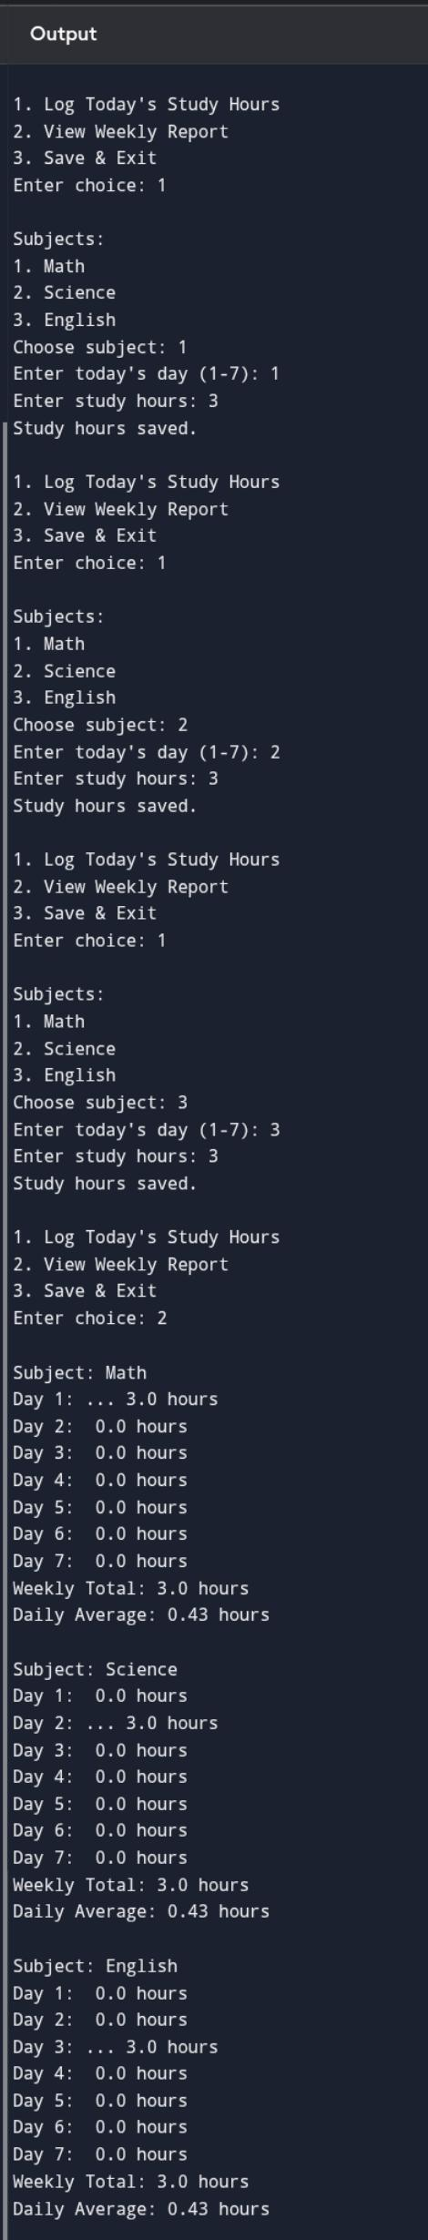
Choice 3 is not doen because I am running it in phone (online c compiler it can’t create a file so) the choice 3 is not run

