Q1.)
Create a SQL query using GROUP BY to show the total number of orders placed by each user in an 'orders' table, displaying user_id and order_count.
Query:-
select count(order_id),user_id as totalorder from ecom.orders group by user_id;
Output:-
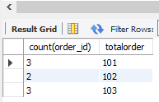
Q2.)
Write a SQL query to display the names of restaurants from a 'restaurants' table that have received an average rating above 4.0, using GROUP BY and HAVING.
Query:-
select avg(rating),name_s as hname from ecom.restaurants group by name_s having avg(rating)> 4.0 ;
Output:-
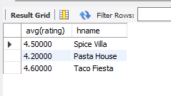
3.)
Suppose you have a 'payments' table with columns user_id, amount, and payment_date. Write a subquery to find user_ids who have made a single payment above ₹2000 in any transaction.
Query:-
SELECT user_id,amount from payments where amount > 2000;
Output:-
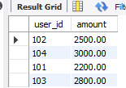
4.
Using a nested subquery, display the names of movies from a 'movies' table that have a higher average rating than the overall average rating of all movies.<br><br><em><strong>Hint:</strong> Use a subquery to calculate the overall average rating, then compare each movie's average rating against it in the main query.</em>
Query:-
SELECT AVG(rating) AS overall_average
FROM movies;
Query:-
SELECT movie_name, AVG(rating) AS average_rating
FROM movies
GROUP BY movie_name
HAVING AVG(rating) > (
SELECT AVG(rating)
FROM movies
);
Output:-



