Q1).
Create a table called Restaurant with columns: id, name, location, and cuisine. Apply NOT NULL constraint to name and location, and make id the PRIMARY KEY.
Query:-
CREATE TABLE Restaurant (
id INT PRIMARY KEY,
name VARCHAR(100) NOT NULL,
location VARCHAR(100) NOT NULL,
cuisine VARCHAR(50)
);
Output:-
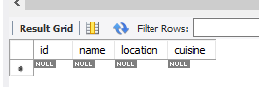
Q2).
Create a table called FoodOrder with columns: order_id, restaurant_id, user_id, and order_total. Set order_id as PRIMARY KEY, and add a FOREIGN KEY constraint on restaurant_id referencing Restaurant(id)
Query:-
CREATE TABLE FoodOrder (
order_id INT PRIMARY KEY AUTO_INCREMENT,
restaurant_id INT,
user_id INT,
order_total INT,
FOREIGN KEY (restaurant_id) REFERENCES Restaurant(id)
);
INSERT INTO FoodOrder (restaurant_id, user_id, order_total)
VALUES
(1, 101, 1500),
(2, 102, 2500),
(3, 103, 800),
(4, 104, 3000),
(5, 105, 1200),
(6, 106, 2200);
Output:-
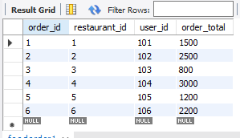

Q3).
Insert 6 rows into a table called SpotifyUser with columns: user_id, username, email, and subscription_type. Ensure that username is UNIQUE and email is NOT NULL.<br><br><em><strong>Hint:</strong> Use the UNIQUE and NOT NULL constraints when creating the table.</em>
Query:-
CREATE TABLE SpotifyUser (
user_id INT PRIMARY KEY,
username VARCHAR(50) UNIQUE,
email VARCHAR(100) NOT NULL,
subscription_type VARCHAR(20)
);
INSERT INTO SpotifyUser
(user_id, username, email, subscription_type)
VALUES
(101, 'rahul_music', 'rahul@gmail.com', 'Premium'),
(102, 'aman_beats', 'aman@gmail.com', 'Free'),
(103, 'priya_songs', 'priya@gmail.com', 'Premium'),
(104, 'neha_playlist', 'neha@gmail.com', 'Premium'),
(105, 'rohan_vibes', 'rohan@gmail.com', 'Free'),
(106, 'simran_tunes', 'simran@gmail.com', 'Premium');
Output:-
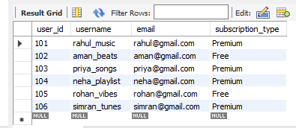
Q4).
Create a VIEW named TopSpendersView that shows usernames and order_total from a FoodOrder table where order_total is greater than 1000.
Query:-
CREATE VIEW TopSpendersView AS
SELECT
SpotifyUser.username,
FoodOrder.order_total
FROM FoodOrder
JOIN SpotifyUser
ON FoodOrder.user_id = SpotifyUser.user_id
WHERE FoodOrder.order_total > 1000;
Output:-
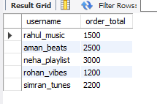
5.
Write a SQL query to list all users from the TopSpendersView who have spent more than 2000, sorted by order_total descending.<br><br><em><strong>Constraint:</strong> Only use the TopSpendersView for your query, not the original FoodOrder table.</em>
Query:-
SELECT username, order_total
FROM TopSpendersView
WHERE order_total > 2000
ORDER BY order_total DESC;
Output:-
