1.Create a SQL script to insert a new order into an Orders table, then use COMMIT to save the transaction and verify that the new order persists after reconnecting to the database.Assume the table is:
Query:-
CREATE TABLE Orders (
OrderID INT PRIMARY KEY,
UserID INT NOT NULL,
OrderDate DATETIME NOT NULL,
TotalAmount DECIMAL(10,2) NOT NULL,
Status VARCHAR(30) NOT NULL
) ;
INSERT INTO Orders
(OrderID, UserID, OrderDate, TotalAmount, Status)
VALUES
(1, 101, NOW(), 500.00, 'Delivered'),
(2, 102, NOW(), 750.00, 'Delivered');

SELECT * FROM Orders;
USE ecommerce_db;
START TRANSACTION;
INSERT INTO Orders
(OrderID, UserID, OrderDate, TotalAmount, Status)
VALUES
(1001, 101, NOW(), 750.00, 'Placed');
COMMIT;
Output:-
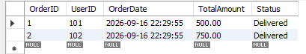
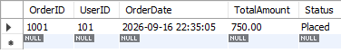
2.Simulate a Zomato-style food order process: insert two new items into an OrderItems table, then use ROLLBACK to undo the changes before committing. Check that no new items remain in the table after rollback.
Query:-
CREATE TABLE OrderItems (
OrderItemID INT PRIMARY KEY,
OrderID INT NOT NULL,
ProductID INT NOT NULL,
Quantity INT NOT NULL,
Price DECIMAL(10,2) NOT NULL,

FOREIGN KEY (OrderID)
REFERENCES Orders(OrderID)
) ;
INSERT INTO OrderItems
(OrderItemID, OrderID, ProductID, Quantity, Price)
VALUES
(1, 1, 101, 2, 100.00),
(2, 1, 102, 1, 300.00);
SELECT * FROM OrderItems;

START TRANSACTION;

INSERT INTO OrderItems
(OrderItemID, OrderID, ProductID, Quantity, Price)
VALUES
(2001, 1001, 501, 2, 250.00);

INSERT INTO OrderItems
(OrderItemID, OrderID, ProductID, Quantity, Price)
VALUES
(2002, 1001, 502, 1, 250.00);

SELECT *
FROM OrderItems
WHERE OrderItemID IN (2001, 2002);

ROLLBACK;

SELECT *
FROM OrderItems
WHERE OrderItemID IN (2001, 2002);
Output:-
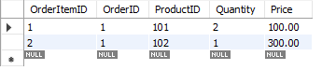
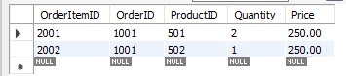
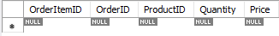
3.
In a Flipkart-like shopping cart scenario, use SAVEPOINT to mark a point after adding a product to the Cart table, add another product, then use ROLLBACK TO SAVEPOINT to undo only the last addition. Show the final contents of the Cart table.
Query:-
CREATE TABLE Cart (
CartID INT PRIMARY KEY,
UserID INT NOT NULL,
ProductID INT NOT NULL,
Quantity INT NOT NULL
) ;
INSERT INTO Cart
(CartID, UserID, ProductID, Quantity)
VALUES
(1, 101, 501, 1);
SELECT * FROM Cart;

START TRANSACTION;
INSERT INTO Cart
(CartID, UserID, ProductID, Quantity)
VALUES
(3001, 101, 701, 1);
SAVEPOINT product_added;
INSERT INTO Cart
(CartID, UserID, ProductID, Quantity)
VALUES
(3002, 101, 702, 2);

SELECT *
FROM Cart
WHERE UserID = 101;

ROLLBACK TO SAVEPOINT product_added;
COMMIT;
SELECT *
FROM Cart
WHERE UserID = 101;
Output:-
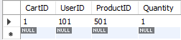
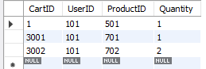
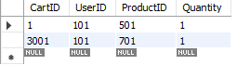
4.
Write a trigger on a Wallet table that automatically deducts the purchase amount from the user's balance whenever a new transaction is inserted, similar to how Paytm updates wallet balance after a payment.
Query:-
CREATE TABLE Wallet (
UserID INT PRIMARY KEY,
Balance DECIMAL(10,2) NOT NULL
) ;
INSERT INTO Wallet
(UserID, Balance)
VALUES
(101, 5000.00),
(102, 3000.00);
SELECT * FROM Wallet;
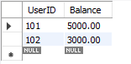
SELECT * FROM Wallet
WHERE UserID = 101;
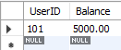
DELIMITER $$
CREATE TRIGGER deduct_wallet_balance
AFTER INSERT ON Transactions
FOR EACH ROW
BEGIN
IF NEW.TransactionType = 'PURCHASE' THEN
UPDATE Wallet
SET Balance = Balance - NEW.Amount
WHERE UserID = NEW.UserID;
END IF;
END $$
DELIMITER ;
SELECT * FROM Wallet
WHERE UserID = 101;
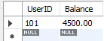
SELECT * FROM Transactions
WHERE TransactionID = 4001;
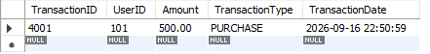

5.

Use ChatGPT to generate a SQL test scenario where a trigger incorrectly updates a user's balance after an expense entry. Paste the scenario and your corrected trigger code, explaining how you fixed the error.<br><br><em><strong>Hint:</strong> Ask ChatGPT for a buggy trigger example and a test case that exposes the bug.</em>Buggy trigger
Query:-
DELIMITER $$

CREATE TRIGGER buggy_expense_trigger
AFTER INSERT ON Transactions
FOR EACH ROW
BEGIN
IF NEW.TransactionType = 'EXPENSE' THEN
UPDATE Wallet
SET Balance = Balance + NEW.Amount
WHERE UserID = NEW.UserID;
END IF;
END $$
DELIMITER ;

UPDATE Wallet
SET Balance = 5000.00
WHERE UserID = 101;

SELECT * FROM Wallet
WHERE UserID = 101;
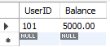
INSERT INTO Transactions
(TransactionID, UserID, Amount, TransactionType)
VALUES
(5001, 101, 1000.00, 'EXPENSE');

SELECT * FROM Wallet
WHERE UserID = 101;
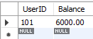
DROP TRIGGER IF EXISTS buggy_expense_trigger;

DELIMITER $$

CREATE TRIGGER correct_expense_trigger
AFTER INSERT ON Transactions
FOR EACH ROW
BEGIN
IF NEW.TransactionType = 'EXPENSE' THEN
UPDATE Wallet
SET Balance = Balance - NEW.Amount
WHERE UserID = NEW.UserID;
END IF;
END $$
DELIMITER ;

UPDATE Wallet
SET Balance = 5000.00
WHERE UserID = 101;

INSERT INTO Transactions
(TransactionID, UserID, Amount, TransactionType)
VALUES
(5002, 101, 1000.00, 'EXPENSE');

SELECT * FROM Wallet
WHERE UserID = 101;
