Sistema Notificacions Android per a Aules Moodle

Vidal Joven Montull

**Resum** — Actualment, l’ús de les noves tecnologies en l’àmbit educatiu s’ha vist incrementat gràcies a tots els avantatges que ha aportat a tots els sectors de la comunitat educativa. Una d’aquestes avantatges és el fet de poder fer arribar als usuaris finals, alumnes i professors, tota la informació que desitgen amb un moviment senzill, obrir el dispositiu mòbil. Basant-nos en aquesta idea s’ha portat a terme aquest projecte.

L’aplicació respon a la necessitat de tenir una eina que permeti amb molta facilitat a l’usuari saber la nota obtinguda en l’entrega d’una tasca en els Sistemas d’Aules Moodle.

AppNotify, és l’aplicació fruit de la realització d’aquest treball final de Grau, la qual permetrà als alumnes rebre les notificacions, que es produeixin en les retroaccions per part dels professors en la qualificació de les entregues realitzades, en els seus dipositius Android.

La motivació del projecte va ser millorar la idea original de l’aplicactiu natiu de Moodle, de tal manera que l’alumne sàpigues de primera mà quina ha set la seva qualificació en l’entrega realitzada, sense la necessitat d’entrar a l’Aula Moodle.

**Paraules Clau** — Moodle, Notificacions Push, Android, qualificacions, alumnes, professors.

**Abstract —** CurrentlyThe use of new technologies in education has been increased thanks to everyone who has contributed benefits to all sectors of the educational community. One of these advantages is being able to reach end users, students and teachers, all the information you want with a simple movement, open the mobile device. Based on this idea has been carried out this project.

The application responds to the need for a tool that allows the user to very easily find the mark obtained in the delivery of work in Moodle Classroom Systems.

AppNotify, the application is the result of the completion of this final level, which will allow students to receive notifications that occur in feedback mechanisms by teachers in grade deliveries made in its Android dipositius .

The motivation of the project was to improve the original idea aplicactiu native Moodle, so that students know firsthand what their qualifications are set in the delivery done without the need to enter the Moodle classroom

.

**Index Term — Moodle, Notificacions Push, Android, qualificacions, alumnes, professors.**

xxxx-xxxx/0x/$xx.00 © 200x IEEE Published by the IEEE Computer Society

————————————————

1. E-mail contacte: [vijom14@gmail.com](mailto:vijom14@gmail.com)
2. Menció: Enginyeria Software
3. Treball tutoritzat per: Daniel Ponsa (dEIC)

• Curs 2015/16

—————————— ◆ ——————————

# 1 Introducció

L’

Objectiu del present article és presentar la solució per a la implementació d’una aplicació per a rebre les notificacions que es produeixen en les Aules Moodle[xxx] dels alumnes com a resposta a les necessitats que aquets han mostrar en l’estudi realitzat.

En l’actualitat podem trobar al mercat diverses varietats d’aplicacions que faciliten la tasca als alumnes, en podem trobar algun exemple més endavant, però cap ofereix una solució exacte pel problema que s’ha plantejat com a base del projecte, oferir a l’alumne una notificació personalitzada, molt més útil que les actuals.

Per tant des de la anàlisis del problema, les necessitats i altres factors es presentarà una solució aplicada en un cas concret i específic.

La motivació d’aquest projecte era crear una aplicació alternativa a l’actual aplicatiu que hi ha sobre l’antic Campus Virtual i sobre l’actual aplicació nativa de Moodle, ja que l’any vinent l’antic Campus serà obsolet i es realitzarà una migració a les Aules Moodle.

* 1. **Objectius**

L’objectiu principal del treball és poder crear un sistema propi de Notificacions Push[xxx] per a poder rebre les qualificacions de les tasques entregades en les Aules Moodle.

Aquets objectius estan directament relacionats amb els diferents entregables, els quals haurem de implementar en diferents entorns sobre els quals treballarà l‘aplicatiu:

* Entorn Servidor: Serà l’encarregat de connectar l’aplicació amb Google Cloud Message (GCM) [xxx]. Aquest servei serà l’encarregat d’enviar les notificacions als usuaris finals.
* Entorn Client: Format per l’aplicació Android, donarà la informació necessària de l’usuari al servidor per tal de poder-la tractar i enviar les notificacions.

Es pot obtenir una visió més detallada dels objectius observant l’arbre d’objectius en l’Annex A1. Arbre d’Objectius.

Aquest article està estructurat de la següent manera. A la Secció2 es presenten les experiències i aplicacions prèvies que s’han considerat més rellevants en els sistemes existents, les quals s’han tingut en compte per desenvolupar el nou aplicatiu web. La metodologia seguida pel desenvolupament de l’aplicació s’exposa a la Secció 3. La Secció 4 recull els resultats i els elements generats al llarg del desenvolupament del projecte. Finalment, la Secció 5 presenta les conclusions i futures línies de treball.

# 2 Estat de l’art

E

n l’actualitat les aplicacions mòbil s’estan convertint en un model de negoci molt extens. Això provoca que existeixin una gran varietat d’aplicacions en el Google Play[xxx] per a dispositius Android, tal i com es pot veure a la imatge que hi ha a continuació.

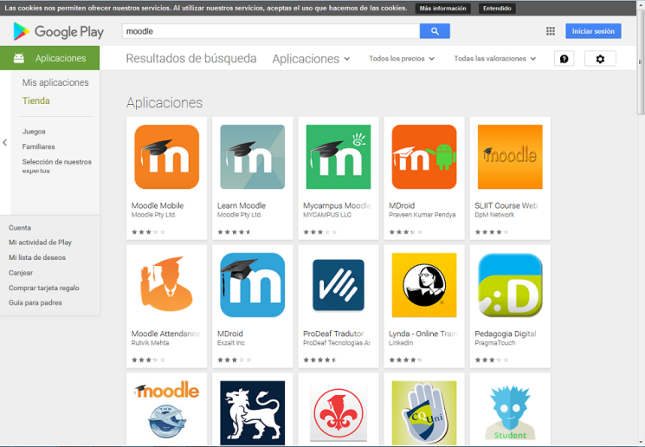

Imatge 1: Aplicacions disponible a Google Play

Totes les aplicacions que trobem al Google Play ofereixen les següents característiques:

* Navegar pel contingut dels cursos de l’alumne
* Rebre notificacions instantànies de missatges i altres events.
* Buscar de maner ràpida persones i contactar amb elles.
* Veure les qualificacions dels cursos.

En el cas de los notificacions, s’han analitzat diverses aplicacions i s’han comprovat quines són aquestes notificacions i que notifiquen en tot moment.

Basant-nos en els requeriments recollits entre els Stakeholders s’ha pogut recollir els aspectes que més importància tenen i s’ha realitzat el projecte en base a ells. Aquest document és pot trobar en la referencia que hi ha la Bibliografia [xxx].

En l’estudi que s’ha portat a terme sobre les aplicacions existents ens centrarem en l’aplicació oficial de Moodle, Moodle Mobile, sobre la que s’han pogut obtenir les següents conclusions:

* Es genera una notificació quan un alumne realitza l’entrega d’una tasca. Es pot veure en la imatge de l’Annex A2, quina notificació rep l’alumne al seu dispositiu.
* Es genera una notificació quan es qualifica l’entrega per part del professor. Es pot veure en la imatge de l’Annex A3, quina notificació rep l’alumne al seu dispositiu.

Es realitzen més notificacions en els dispositius, però el projecte es basarà en el segon punt, el qual gràcies als requeriments recollits es millorarà per obtenir la satisfacció del Stakeholders.

# 3 Metodologia

A

continuació s’exposarà la metodologia que s’ha seguit per dur a terme el projecte, fent èmfasi en les fases d’anàlisi, disseny i implementació.

* 1. **Elicitació i anàlisi de requeriments.**

En aquest projecte s’ha desenvolupat una aplicació des de zero i no s’havia especificat cap restricció prèvia-ment. Per tant, observant i analitzant els sistemes existents es va elaborar un primer llistat amb els requisits necessaris per poder definir un sistema que millorés als que ja existien. A partir de reunions setmanals amb el tutor, el qual és un dels Stakeholdersprincipals, es valoraven els requeriments proposats i es triaven els més prioritaris per ajustar la complexitat de l’aplicació amb el temps de desenvolupament disponible.

Simultàniament es va realitzar el sondeig de diferents Stakeholders, en aquest cas alumnes, usuaris de l’aplicació mòbil. En aquest cas es van obtenir els requeriments necessàries per poder dur a terme el projecte i que pogués satisfer als usuaris.

En un principi vàrem decidir conjuntament amb el tutor centrar-nos en les notificacions que rebrien els alumnes i els professors. Per qüestions de temps i desconeixement de l’entorn Moodle es va decidir retallar el projecte i centrar-nos bàsicament en les notificacions que rebrien els alumnes quan es realitzes la publicació de les qualificacions, per part del professor, sobre les tasques que haguessin entregat.

* 1. **Disseny del sistema**

Donat l’anàlisi de requeriments i l’arbre d’objectius s’ha organitzat el projecte en diferents sistemes o apartats de la següent manera, els quals s’explicaran a continuació.

* + 1. **Estudi Base de Dades Moodle.**

L’estudi de la base de dades és un element imprescindible per entendre el comportament de les Aules Moodle, ja que sense aquest estudi seria molt difícil saber d’on podem obtenir la informació necessària que mostrarem als usuaris.

* + 1. **Estudi Aules Moodle.**
  1. **Implementació**
     1. **Mòdul Android**
     2. **Mòdul Servidor**

# 4 Resultats

IEEE Computer Society style is to note citations in individual brackets, followed by a comma, e.g. “[1], [5]” (as opposed to the more common “[1, 5]” form.) Citation ranges should be formatted as follows: [1], [2], [3], [4] (as opposed to [1]-[4], which is not IEEE Computer Society style). When citing a section in a book, please give the relevant page numbers [2]. In sentences, refer simply to the reference number, as in [3]. Do not use “Ref. [3]” or “reference [3]” At the beginning of a sentence use the author names instead of “Reference [3],” e.g., “Smith and Smith [3] show ... .” Please note that references will be formatted by IEEE Computer Society production staff in the same order provided by the author.

# 5 Conclusions

If you are using Word, use the MathType add-on (<http://www.mathtype.com>) for equations in your paper (Insert | Object | Create New | Microsoft Equation or MathType Equation). “Float over text” should not be selected.

For display equations as seen below, number equations consecutively with equation numbers in parentheses flush with the right margin, as in (1). First, use the equation editor to create the equation. Then, select the “Equation” markup style. Press the tab key and write the equation number in parentheses. To make your equations more compact, you may use the solidus ( / ), the exp function, or appropriate exponents. Use parentheses to avoid ambiguities in denominators. Punctuate equations when they are part of a sentence, as in

 (1)

Be sure that the symbols in your equation have been defined before the equation appears or immediately following. Italicize symbols (*T* might refer to temperature, but T is the unit tesla). Per IEEE Computer Society, please refer to “(1),” not “Eq. (1)” or “equation (1),” except at the beginning of a sentence: “Equation (1) shows ... .” Also see *The Handbook of Writing for the Mathematical Sciences*, 1993. Published by the Society for Industrial and Applied Mathematics, this handbook provides some helpful information about math typography and other stylistic matters. For further information about typesetting mathematical equations, please visit the IEEE Computer Society style guide: <http://www.computer.org/portal/web/publications/style_math>.

Please note that math equations might need to be reformatted from the original submission for page layout reasons. This includes the possibility that some in-line equations will be made display equations to create better flow in a paragraph. If display equations do not fit in the two-column format, they will also be reformatted. Authors are strongly encouraged to ensure that equations fit in the given column width.

# 6 Bibliografia

## 6.1 Figures and Tables

Because IEEE Computer Society staff will do the final formatting of your paper, some figures may have to be moved from where they appeared in the original submission. Figures and tables should be sized as they are to appear in print. Figures or tables not correctly sized will be returned to the author for reformatting.

Detailed information about the creation and submission of images for articles can be found at <http://www.computer.org/portal/web/peerreviewjournals/author#figures> where you can [View transactions art_guide.pdf (PDF, 4.69MB)](http://www.computer.org/cms/Computer.org/Journal%20templates/transactions_art_guide.pdf) . We strongly encourage authors to carefully review the material posted here to avoid problems with incorrect files or poorly formatted graphics.

Place figure captions below the figures; place table titles above the tables. Figure captions appear as left justified. Table captions are restricted to one sentence and are formatted as title case. Any additional sentence in a table caption will be formatted as a footnote below the table (see Table 1 in this document). If your figure has two parts, include the labels “(a)” and “(b)” as part of the artwork. Please verify that the figures and tables you mention in the text actually exist. Figures and tables should be called out in sequential order, as this is how they will be placed in your paper. For example, avoid referring to figure “8” in the first paragraph of the article unless figure 8 will again be referred to after the reference to figure 7. **Please do not include figure captions as part of the figure. Do not put captions in “text boxes” linked to the figures. Do not put borders around the outside of your figures.** Per IEEE Computer Society, please use the abbreviation “Fig.” even at the beginning of a sentence. Do not abbreviate “Table.” Tables are numbered numerically.

For journals that use print for publication, please verify with IEEE Computer Society that the journal you are submitting to does indeed accept color before submitting final materials. **Do not use color unless it is necessary for the proper interpretation of your figures.**

Figures (graphs, charts, drawing or tables) should be named fig1.eps, fig2.ps, etc. If your figure has multiple parts, please submit as a single figure. Please do not give them descriptive names. Author photograph files should be named after the author’s LAST name. Please avoid naming files with the author’s first name or an abbreviated version of either name to avoid confusion. If a graphic is to appear in print as black and white, it should be saved and submitted as a black and white file (grayscale or bitmap.) If a graphic is to appear in color, it should be submitted as an RGB color file.

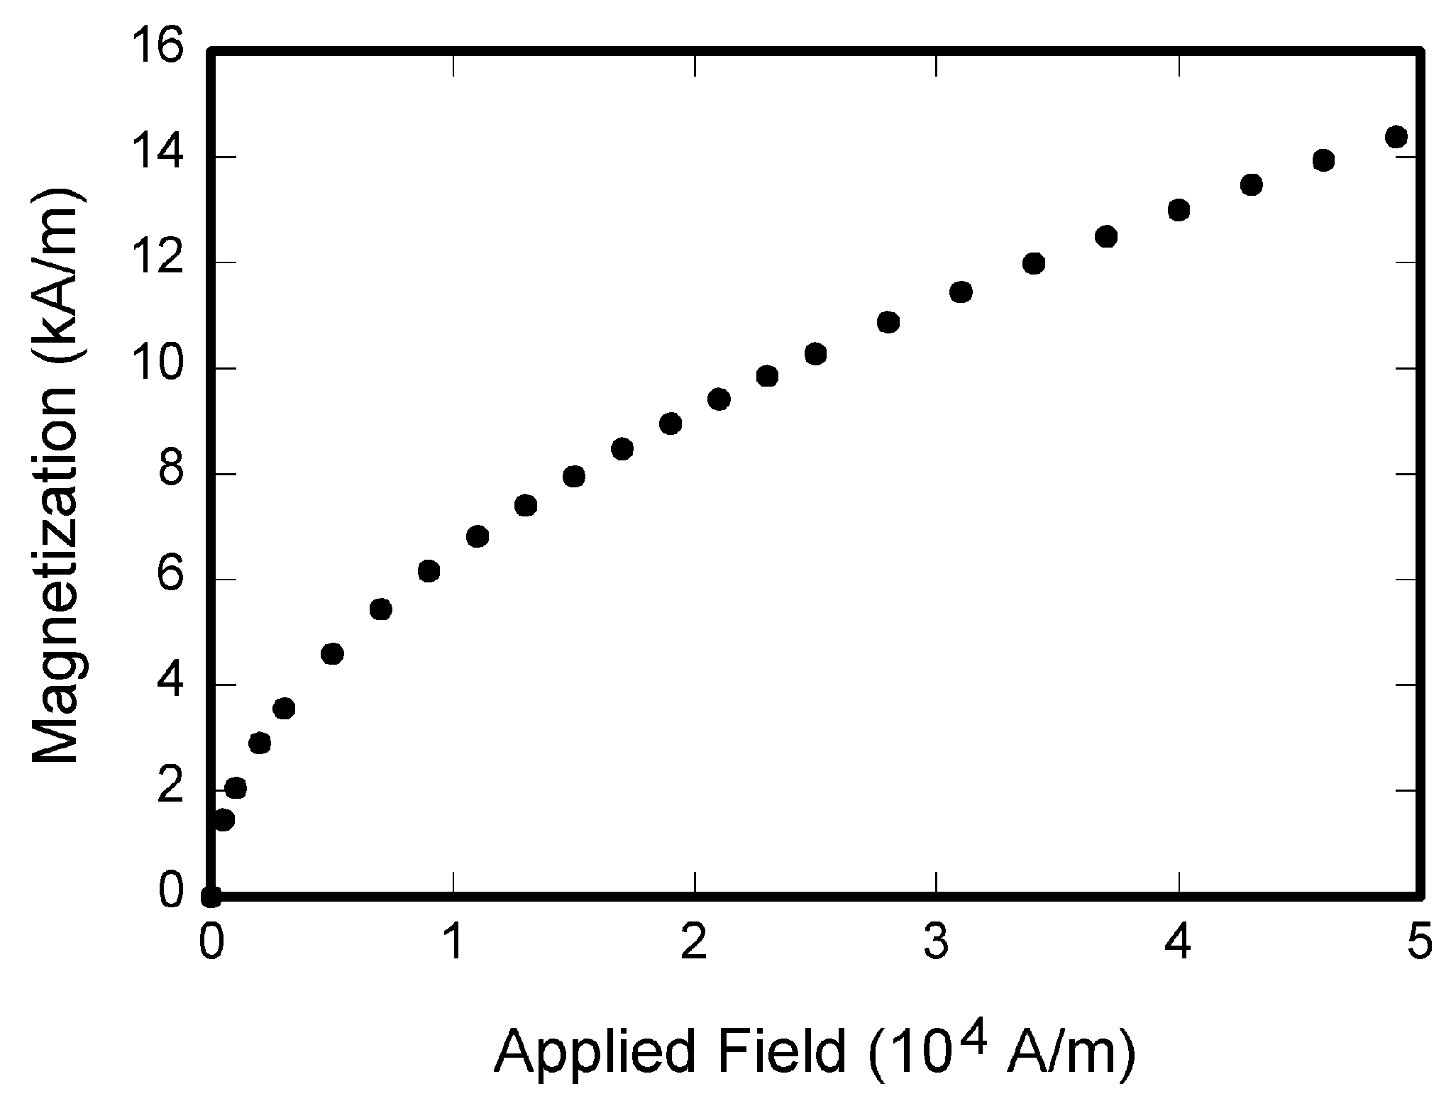

Fig. 1. Magnetization as a function of applied field. Note that “Fig.” is abbreviated. There is a period after the figure number, followed by one space. It is good practice to briefly explain the significance of the figure in the caption.

Figure axis labels are often a source of confusion. Use words rather than symbols. As an example, write the quantity “Magnetization,” or “Magnetization *M*,” not just “*M*.” Put units in parentheses. Do not label axes only with units. As in Fig. 1, for example, write “Magnetization (A/m)” or “Magnetization (Am−1),” not just “A/m.” Do not label axes with a ratio of quantities and units. For example, write “Temperature (K),” not “Temperature/K.” Table 1 shows some examples of units of measure.

Multipliers can be especially confusing. Write “Magnetization (kA/m)” or “Magnetization (103 A/m).” Do not write “Magnetization (A/m) × 1,000” because the reader would not know whether the top axis label in Fig. 1 meant 16,000 A/m or 0.016 A/m. Figure labels should be legible, approximately 8 to 12 point type. When creating your graphics, especially in complex graphs and charts, please ensure that line weights are thick enough that when reproduced at print size, they will still be legible. We suggest at least 1 point.

## 6.3 Footnotes

Number footnotes separately in superscripts (Insert | Footnote)[1]. Place the actual footnote at the bottom of the column in which it is cited; do not put footnotes in the reference list (endnotes). Use letters for table footnotes (see Table 1). Please do not include footnotes in the abstract and avoid using a footnote in the first column of the article. This will cause it to appear above the affiliation box, making the layout look confusing.

TABLE 1  
Units for Magnetic Properties

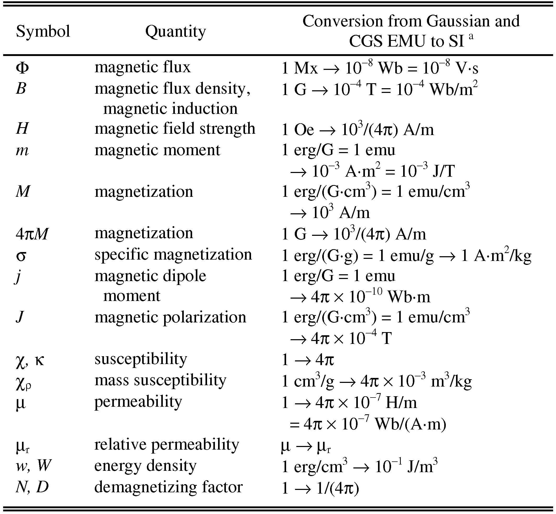

Statements that serve as captions for the entire table do not need footnote letters.

aGaussian units are the same as cgs emu for magnetostatics; Mx = maxwell, G = gauss, Oe = oersted; Wb = weber, V = volt, s = second, T = tesla, m = meter, A = ampere, J = joule, kg = kilogram, H = henry.

## 6.4 Lists

The IEEE Computer Society style is to create displayed lists if the number of items in the list is longer than three. For example, within the text lists would appear 1) using a number, 2) followed by a close parenthesis. However, longer lists will be formatted so that:

1. Items will be set outside of the paragraphs.
2. Items will be punctuated as sentences where it is appropriate.
3. Items will be numbered, followed by a period.

## 6.5 Theorems and Proofs

Theorems and related structures, such as axioms corollaries, and lemmas, are formatted using a hanging indent paragraph. They begin with a title and are followed by the text, in italics.

**Theorem 1.** *Theorems, corollaries, lemmas, and related structures follow this format. They do not need to be numbered, but are generally numbered sequentially.*

Proofs are formatted using the same hanging indent format. However, they are not italicized.

**Proof.** The same format should be used for structures such as remarks, examples, and solutions (though these would not have a Q.E.D. box at the end as a proof does). □

# 7 End Sections

## Appendices

Appendices, if present, appear online as supplemental material. In the event multiple appendices are required, they will be labeled “Appendix A,” “Appendix B, “ etc.

IEEE Computer Society Transactions accepts supplemental materials for review with regular paper submissions. These materials may be published on our Digital Library with the electronic version of the paper and are available for free to Digital Library visitors. Please see our guidelines below for file specifications and information. Any submitted materials that do not follow these specifications will not be accepted. All materials must follow US copyright guidelines and may not include material previously copyrighted by another author, organization or company. More information can be found at <http://www.computer.org/portal/web/peerreviewjournals/author#supplemental>.

## 7.2 Acknowledgments

The preferred spelling of the word “acknowledgment” in American English is without an “e” after the “g.” Use the singular heading even if you have many acknowledgments. Avoid expressions such as “One of us (S.B.A.) would like to thank ... .” Instead, write “F. A. Author thanks ... .” Sponsor and financial support acknowledgments are included in the acknowledgment section. For example: This work was supported in part by the US Department of Commerce under Grant BS123456 (sponsor and financial support acknowledgment goes here). Researchers that contributed information or assistance to the article should also be acknowledged in this section. Also, if corresponding authorship is noted in your paper it will be placed in the acknowledgment section. Note that the acknowledgment section is placed at the end of the paper before the reference section.

## 7.3 References

Unfortunately, the Computer Society document translator cannot handle automatic endnotes in Word; therefore, type the reference list at the end of the paper using the “References” style. See the IEEE Computer Society’s style for reference formatting at: <http://www.computer.org/portal/web/publications/style_refs>. The order in which the references are submitted in the manuscript is the order they will appear in the final paper, i.e., references submitted nonalphabetized will remain that way.

Please note that the references at the end of this document are in the preferred referencing style. Within the text, use “et al.” when referencing a source with more than three authors. In the reference section, give all authors’ names; do not use “et al.” Do not place a space between an authors' initials. Papers that have not been published should be cited as “unpublished” [4]. Papers that have been submitted or accepted for publication should be cited as “submitted for publication” [5]. Please give affiliations and addresses for personal communications [6].

Capitalize all the words in a paper title. For papers published in journals not published in English, please give the English citation first, followed by the original foreign-language citation [7].

## 7.4 Additional Formatting and Style Resources

Additional information on formatting and style issues can be obtained in the IEEE Computer Society Style Guide, which is posted online at: <http://www.computer.org/portal/web/publications/styleguide>. Click on the appropriate topic under the Special Sections link.

# Conclusion

Although a conclusion may review the main points of the paper, do not replicate the abstract as the conclusion. A conclusion might elaborate on the importance of the work or suggest applications and extensions. Authors are strongly encouraged not to reference multiple figures or tables in the conclusion—these should be referenced in the body of the paper.

**Acknowledgment**

The authors wish to thank A, B, C. This work was supported in part by a grant from XYZ.

**References**

1. J.S. Bridle, “Probabilistic Interpretation of Feedforward Classification Network Outputs, with Relationships to Statistical Pattern Recognition,” *Neurocomputing—Algorithms, Architectures and Applications,* F. Fogelman-Soulie and J. Herault, eds., NATO ASI Series F68, Berlin: Springer-Verlag, pp. 227-236, 1989. (Book style with paper title and editor)
2. W.-K. Chen, *Linear Networks and Systems.* Belmont, Calif.: Wadsworth, pp. 123-135, 1993. (Book style)
3. H. Poor, “A Hypertext History of Multiuser Dimensions,” *MUD History,* http://www.ccs.neu.edu/home/pb/mud-history.html. 1986. (URL link *include year)
4. K. Elissa, “An Overview of Decision Theory,"unpublished. (Unpublished manuscript)
5. R. Nicole, "The Last Word on Decision Theory," *J. Computer Vision,* submitted for publication. (Pending publication)
6. C. J. Kaufman, Rocky Mountain Research Laboratories, Boulder, Colo., personal communication, 1992. (Personal communication)
7. D.S. Coming and O.G. Staadt, "Velocity-Aligned Discrete Oriented Polytopes for Dynamic Collision Detection," *IEEE Trans. Visualization and Computer Graphics*, vol. 14,  no. 1,  pp. 1-12,  Jan/Feb  2008, doi:10.1109/TVCG.2007.70405. (IEEE Transactions )
8. S.P. Bingulac, “On the Compatibility of Adaptive Controllers,” *Proc. Fourth Ann. Allerton Conf. Circuits and Systems Theory*, pp. 8-16, 1994. (Conference proceedings)
9. H. Goto, Y. Hasegawa, and M. Tanaka, “Efficient Scheduling Focusing on the Duality of MPL Representation,” *Proc. IEEE Symp. Computational Intelligence in Scheduling* *(SCIS ’07)*, pp. 57-64, Apr. 2007, doi:10.1109/SCIS.2007.367670. (Conference proceedings)
10. J. Williams, “Narrow-Band Analyzer,” PhD dissertation, Dept. of Electrical Eng., Harvard Univ., Cambridge, Mass., 1993. (Thesis or dissertation)
11. E.E. Reber, R.L. Michell, and C.J. Carter, “Oxygen Absorption in the Earth’s Atmosphere,” Technical Report TR-0200 (420-46)-3, Aerospace Corp., Los Angeles, Calif., Nov. 1988. (Technical report with report number)
12. L. Hubert and P. Arabie, “Comparing Partitions,” *J. Classification,* vol. 2, no. 4, pp. 193-218, Apr. 1985. (Journal or magazine citation)
13. R.J. Vidmar, “On the Use of Atmospheric Plasmas as Electromagnetic Reflectors,” *IEEE Trans. Plasma Science*, vol. 21, no. 3, pp. 876-880, available at http://www.halcyon.com/pub/journals/21ps03-vidmar, Aug. 1992. (URL for Transaction, journal, or magzine)
14. J.M.P. Martinez, R.B. Llavori, M.J.A. Cabo, and T.B. Pedersen, "Integrating Data Warehouses with Web Data: A Survey," *IEEE Trans. Knowledge and Data Eng.*, preprint, 21 Dec. 2007, doi:10.1109/TKDE.2007.190746.(PrePrint)

# Annex

**A1.**

**A2.**

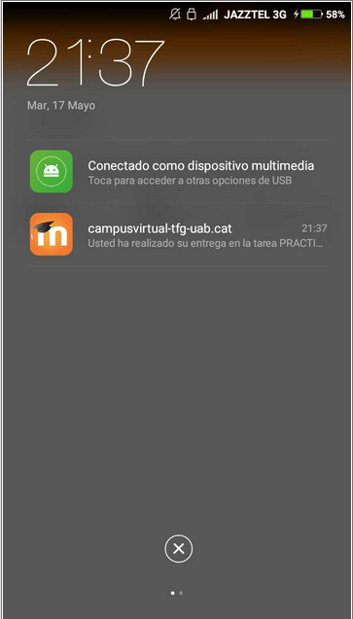

**A3.**

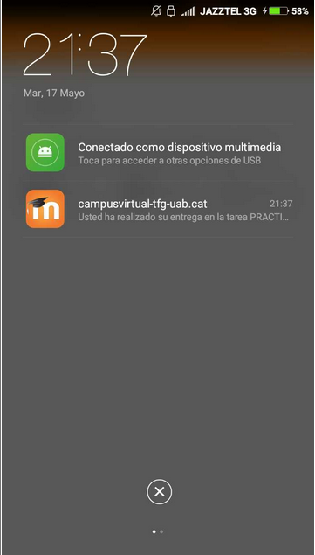

**First A. Author** Allbiographies should be limited to one paragraph consisting of the following: sequentially ordered list of degrees, including years achieved; sequentially ordered places of employ concluding with current employment; association with any official journals or conferences; major professional and/or academic achievements, i.e., best paper awards, research grants, etc.; any publication information (number of papers and titles of books published); current research interests; association with any professional associations. Author membership information, e.g., is a member of the IEEE and the IEEE Computer Society, if applicable, is noted at the end of the biography.

**Second B. Author Jr.** biography appears here.

**Third C. Author** biography appears here.

1. It is recommended that footnotes be avoided (except for the unnumbered footnote with the receipt date on the first page). Instead, try to integrate the footnote information into the text.