

**Discrete Mathematics (BCSC 1010)**

**Practice Questions on Relation**

1. R be a relation on set of integers Z defined by R = {(x, y) | x-y is divisible by 3}. Show that R is an equivalence relation.

2. Show that the “divides” relation is the set of positive integers in not an equivalence relation.

3. Let R be the relation on the set of real numbers such that xRy if and only if x and y are real numbers that differ by less than 1, that is|x − y| < 1. Show that R is not an equivalence relation.

4. (Congruence Modulo m.) Let m be an integer with m > 1. Show that the relation R = {(a, b) | a ≡ b (mod m)} is an equivalence relation on the set of integers. (Hint: a ≡ b (mod m) means a − b is divisible by m).

5.Let R be the relation on the set of integers such that aRb if and only if a = b or a = −b. Determine whether it is an equivalence relation?

6.Let R be the relation on the set of real numbers such that aRb if and only if a − b is an integer. Is R an equivalence relation?

7. Suppose that R is the relation on the set of strings of English letters such that aRb if and only if l(a) = l(b), where l(x) is the length of the string x. Is R an equivalence relation?

8. Show that the “divides” relation is the set of positive integers in not an equivalence relation.

9. Let R be the relation on the set of real numbers such that xRy if and only if x and y are real numbers that differ by less than 1, that is|x − y| < 1. Show that R is not an equivalence relation.

10. Let R be the relation on the set of ordered pairs of positive integers such that ((a, b), (c, d)) ∈ R if and only if a + d = b + c. Show that R is an equivalence relation.

11. Let R be the relation on the set of ordered pairs of positive integers such that ((a, b), (c, d)) ∈ R if and only if ad = bc. Show that R is an equivalence relation.

12. Which of these relations on {0, 1, 2, 3} are equivalence relations? Determine the properties of an equivalence relation that the others lack.

a) {(0, 0), (1, 1), (2, 2), (3, 3)}

b) {(0, 0), (0, 2), (2, 0), (2, 2), (2, 3), (3, 2), (3, 3)}

c) {(0, 0), (1, 1), (1, 2), (2, 1), (2, 2), (3, 3)}

d) {(0, 0), (1, 1), (1, 3), (2, 2), (2, 3), (3, 1), (3, 2),(3, 3)}

e) {(0, 0), (0, 1), (0, 2), (1, 0), (1, 1), (1, 2), (2, 0),(2, 2), (3, 3)}

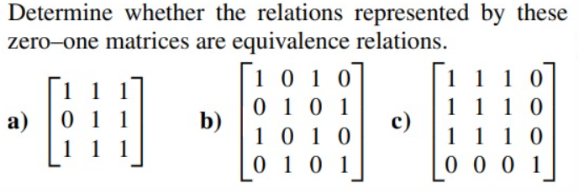13.

14. Represent each of these relations on {1, 2, 3} with a matrix.

a) {(1, 1), (1, 2), (1, 3)}

b) {(1, 2), (2, 1), (2, 2), (3, 3)}

c) {(1, 1), (1, 2), (1, 3), (2, 2), (2, 3), (3, 3)}

d) {(1, 3), (3, 1)}

15. Draw the directed graph that represents the relation {(a, a), (a, b), (b, c), (c, b), (c, d), (d, a), (d, b)}.

16. List the ordered pairs in the relations represented by the following directed graphs:

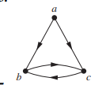

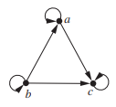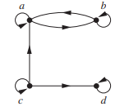

17. For each of these relations on the set {1, 2, 3, 4}, decide whether it is reflexive, whether it is symmetric, whether it is antisymmetric, and whether it is transitive.

a) {(2, 2), (2, 3), (2, 4), (3, 2), (3, 3), (3, 4)}

b) {(1, 1), (1, 2), (2, 1), (2, 2), (3, 3), (4, 4)}

c) {(2, 4), (4, 2)}

d) {(1, 2), (2, 3), (3, 4)}

e) {(1, 1), (2, 2), (3, 3), (4, 4)}

f ) {(1, 3), (1, 4), (2, 3), (2, 4), (3, 1), (3, 4)}