ShopSphere
Cloud-Native E-Commerce Platform
System Architecture Design and Module Breakdown
Week 2 Deliverable - High-Level Architecture, Module Specifications, Technology Stack, Scalability and Maintainability

Item | Detail
Document type | Software Architecture Document (SAD), version 1.0
Project | ShopSphere - hypothetical multi-vendor online retail platform
Prepared by | Vidisha
Date | October 2026
Status | Draft for review; baseline for Week 3 onward

Table of Contents

(If page numbers do not appear, right-click the table and choose Update Field.)

1. Introduction

1.1 Purpose
This document defines the high-level software architecture for ShopSphere, a hypothetical cloud-native e-commerce platform. It identifies the major components, explains how they interact, breaks the system into well-defined modules, justifies the technology choices, and shows how the design supports growth, independent development, and testing. It is intended as the foundation for the detailed design, implementation, and testing phases that follow.

1.2 Project Overview
ShopSphere lets shoppers browse a product catalogue, search, build a cart, apply promotions, pay online, and track deliveries. Merchants and administrators manage products, prices, stock, and orders through a separate portal. The business is expected to start with a few thousand daily users and grow to hundreds of thousands, with sharp traffic spikes during sales events. This growth profile is the main driver of the architectural decisions below.

1.3 Scope
- In scope: customer web and mobile experience, admin portal, domain services, data storage, and integration with payment, shipping, and messaging providers.
- Out of scope (this phase): detailed database schemas, UI wireframes, infrastructure-as-code, and the recommendation/ML engine (reserved as a future extension).

1.4 Architectural Drivers
Driver | Requirement | Architectural response
Scalability | 10x traffic spikes during sales; growth to 500k daily users | Stateless services, horizontal autoscaling, caching, read replicas, async events
Availability | 99.9% monthly uptime for browse and checkout | Multi-zone deployment, health checks, circuit breakers, graceful degradation
Maintainability | Several teams working in parallel; frequent releases | Modular domain services, clear APIs, independent CI/CD pipelines
Security | Handle personal data and payments safely | Zero-trust service access, OAuth 2.0/OIDC, TLS everywhere, PCI scope reduction via hosted payment fields
Performance | Page load under 2.5 s (p75); API p95 under 300 ms | CDN, SSR, Redis caching, dedicated search engine
Extensibility | New channels, payment methods, and features over time | Event-driven integration, adapter pattern for third parties, versioned APIs

1.5 Architectural Principles
- Separation of concerns: presentation, business logic, data access, and integration are separate layers with one-directional dependencies.
- High cohesion, low coupling: each module owns one business capability and its data (the database-per-service pattern).
- API-first: every module exposes a documented contract (OpenAPI/gRPC/event schema) before implementation.
- Design for failure: timeouts, retries with back-off, idempotent operations, and fallbacks are standard on every remote call.
- Twelve-factor operations: configuration via environment, stateless processes, logs as streams, and disposable containers [R3].
- Evolutionary design: start with a small number of well-bounded services and split further only when data justifies it.

2. High-Level System Overview

2.1 Architectural Style
ShopSphere uses a layered, service-oriented (microservice-style) architecture combined with an event-driven backbone. Layering keeps responsibilities clear inside the system; domain services keep business capabilities independently deployable; and asynchronous events decouple long-running or non-critical work (e-mail, analytics, reporting) from the customer-facing request path [R1][R5].
The design deliberately avoids two extremes. A single monolith would couple release cycles and make independent scaling impossible, while dozens of fine-grained services would add operational overhead disproportionate to a new product. The ten domain services below align with business capabilities and can be deployed initially as a smaller number of containers (a "modular monolith first" approach) and separated later without changing their contracts.

2.2 Major Components and Interactions
The system is organised into six logical groups, shown in Figure 1:
- Presentation (M1-M3): web storefront, admin portal, and mobile app. They contain no business rules; they render data and send user intent to the API.
- Edge (M4): CDN/WAF and the API Gateway/Backend-for-Frontend, which is the single entry point for authentication checks, routing, rate limiting, and response aggregation.
- Business logic (M5-M14): domain services that implement the rules of the business.
- Event backbone (M15): a durable message log through which services publish and consume domain events.
- Data access (M16): repository components and the data stores they wrap.
- Integration (M17): adapters that isolate the core from external provider APIs.
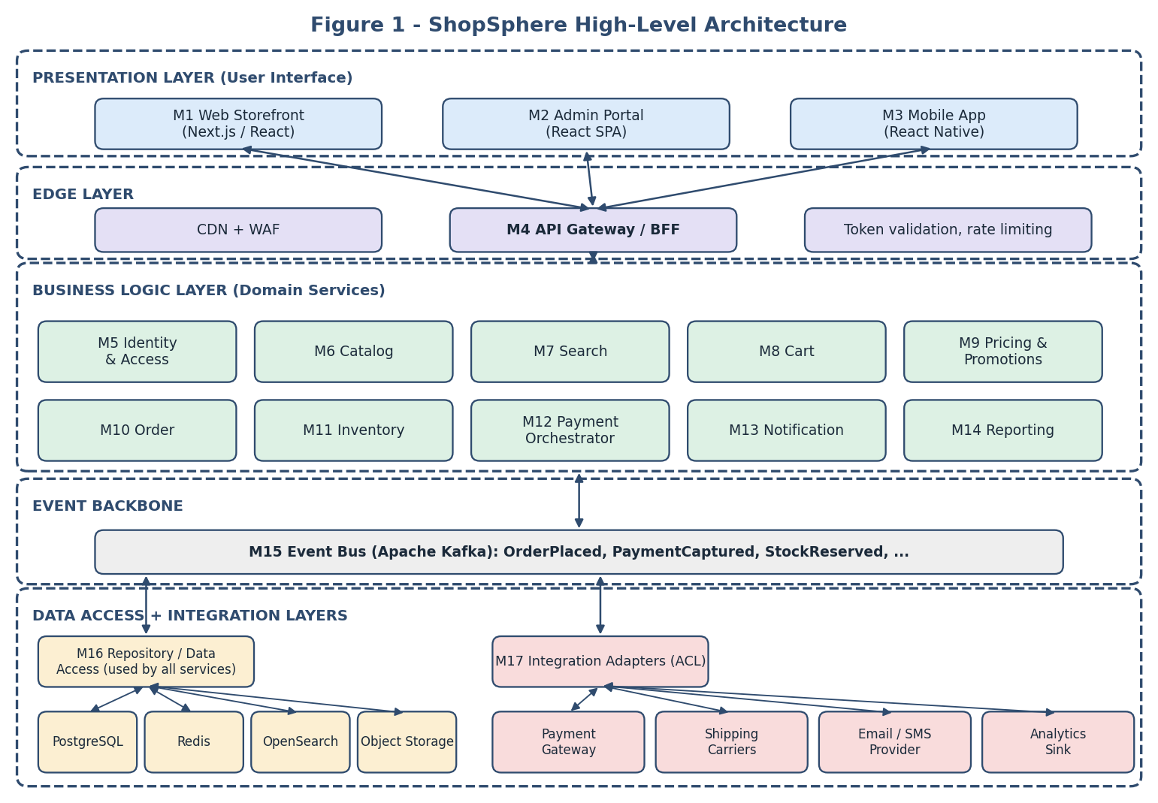
Figure 1: Layered high-level architecture with modules M1-M17

2.3 Communication Styles
Style | Used for | Rationale
REST/JSON over HTTPS | Client to Gateway; Gateway to services for queries | Universal tooling, cacheable, easy to debug
gRPC | Synchronous service-to-service calls on the critical path (Order to Inventory, Order to Payment) | Strongly typed contracts, low latency, built-in deadlines
Events (Kafka) | State-change notifications and side effects | Loose coupling, replayability, absorbs bursts
Webhooks | Inbound notifications from payment and shipping providers | Provider-driven; verified by signature and processed via M17

2.4 Checkout Interaction Flow
Figure 2 traces the most important use case, placing an order, across the modules. The synchronous part (steps 1-7 and 11-12) is limited to what the customer must wait for: reserving stock and authorising payment. Everything else, such as sending confirmation messages, updating reports, and notifying shipping, is triggered asynchronously by the OrderPlaced event, so a slow e-mail provider can never delay or fail a purchase.
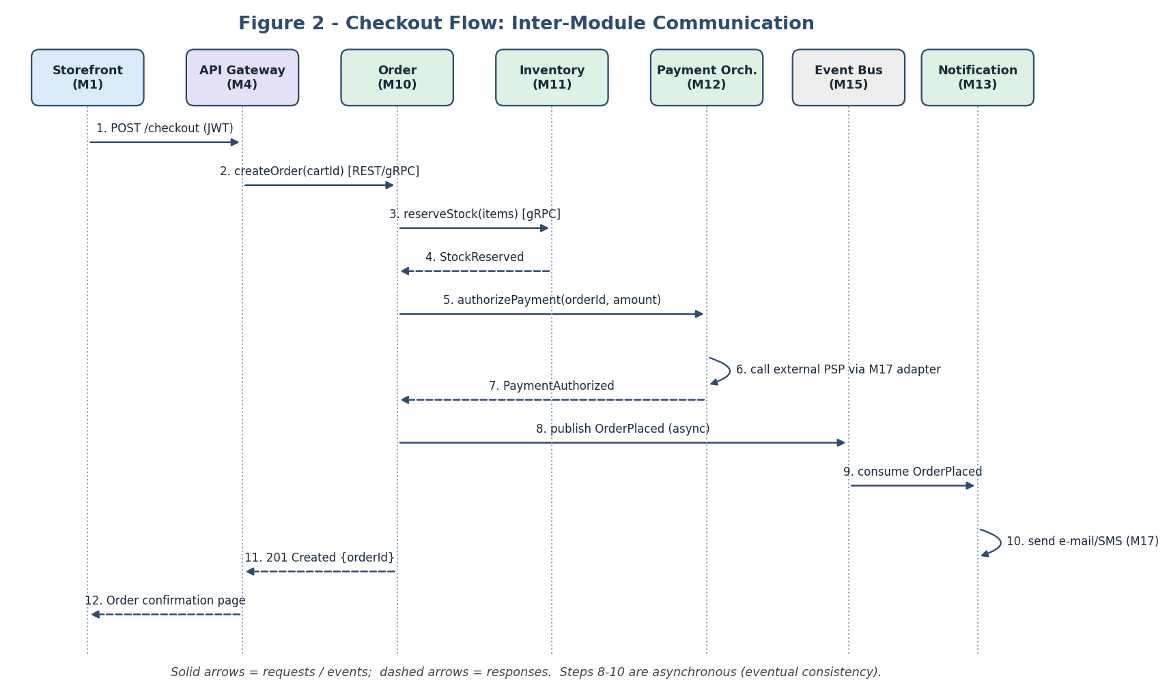
Figure 2: Checkout sequence showing synchronous and asynchronous module interaction
Failure handling follows the saga pattern: if payment authorisation fails, the Order module issues a compensating ReleaseStock command and marks the order as Failed. Each step is idempotent, using an idempotency key supplied by the client, so that retries cannot create duplicate orders or double charges [R6].

3. Module Breakdown
Table 1 summarises the modules; sections 3.1 to 3.4 specify each one by layer. For every module the responsibilities, inputs, outputs, and inter-module communication are given.
ID | Module | Layer | Primary responsibility
M1 | Web Storefront | User interface | Customer-facing website (browse, cart, checkout, account)
M2 | Admin Portal | User interface | Catalogue, order, and user management for staff
M3 | Mobile App | User interface | Native-feeling iOS/Android shopping experience
M4 | API Gateway / BFF | Edge | Single entry point, routing, auth enforcement, aggregation
M5 | Identity and Access | Business logic | Registration, login, tokens, roles and permissions
M6 | Catalog | Business logic | Products, categories, media, attributes
M7 | Search | Business logic | Full-text search, filtering, facets, suggestions
M8 | Cart | Business logic | Shopping cart lifecycle and validation
M9 | Pricing and Promotions | Business logic | Price calculation, discounts, coupons, tax
M10 | Order | Business logic | Order lifecycle and checkout orchestration (saga)
M11 | Inventory | Business logic | Stock levels, reservations, replenishment signals
M12 | Payment Orchestrator | Business logic | Payment state machine, refunds, reconciliation
M13 | Notification | Business logic | E-mail, SMS, and push messages from templates
M14 | Reporting | Business logic | Dashboards and analytical read models
M15 | Event Bus | Infrastructure | Durable publish/subscribe backbone
M16 | Repository / Data Access | Data access | Persistence abstraction, caching, migrations
M17 | Integration Adapters | Integration | Anti-corruption layer for third-party systems
Table 1: Module catalogue

3.1 User Interface Modules

M1 - Web Storefront
The primary shopping channel. It is a server-side-rendered React application so that product pages are fast and indexable by search engines.
Responsibilities | Render home, category, product, cart, checkout, and account pages  Client-side form validation and state management  Accessibility (WCAG 2.2 AA) and responsive layout  Hold no business rules; defer all decisions to the API
Inputs | User actions (clicks, forms); JSON responses from M4; static assets from CDN
Outputs | HTTP requests to M4 with a bearer token; analytics events; rendered HTML
Communication | HTTPS/REST to M4 only. Never calls domain services or databases directly.
Quality notes | Component tests (Jest, React Testing Library), end-to-end tests (Playwright), Lighthouse performance budget in CI

M2 - Admin Portal
A single-page application used by merchants and support staff. Kept separate from M1 because its users, security posture, release cadence, and UX needs differ.
Responsibilities | Manage products, prices, and stock; process orders and refunds  Manage users and roles; view reports from M14  Role-based UI rendering (hide, never rely on it for security)
Inputs | Staff actions; REST responses from M4 (admin API scope)
Outputs | Commands such as createProduct, adjustStock, refundOrder
Communication | HTTPS/REST to M4; staff authenticate with MFA through M5
Quality notes | Separate deployment and domain; stricter CSP; audit trail for every mutating action

M3 - Mobile App
A cross-platform mobile client sharing API contracts and a design system with M1.
Responsibilities | Browse, search, checkout, order tracking  Push-notification registration and deep links  Offline-tolerant cart and cached catalogue pages
Inputs | Touch input; REST responses from M4; push payloads from M13
Outputs | REST requests with token; device token registration
Communication | HTTPS/REST to M4 (mobile-optimised BFF endpoints); push channel from M13 via platform services
Quality notes | Unit tests with Jest; device-farm UI tests; staged rollouts via app stores

3.2 Edge Module

M4 - API Gateway / Backend-for-Frontend
The front door for all clients. It decouples client needs from the internal service topology so services can be split, merged, or renamed without client changes [R7].
Responsibilities | Route requests; validate JWT signature and scopes; enforce rate limits and quotas  Aggregate calls (e.g. a product page = Catalog + Pricing + Inventory + reviews)  Translate between client-friendly REST and internal gRPC  Apply request logging, correlation IDs, and CORS policy  Expose version-prefixed APIs (/v1, /v2)
Inputs | Client HTTPS requests; public signing keys from M5; routing configuration
Outputs | Aggregated JSON responses; downstream requests; access logs and metrics
Communication | Synchronous REST/gRPC to M5-M12 and M14; no direct access to data stores
Quality notes | Contract tests against each downstream OpenAPI spec; load tests for rate-limit behaviour; stateless so it scales by adding pods

3.3 Business Logic Modules
Each domain service follows the same internal structure: a thin API controller, an application/service layer containing business rules, a domain model, and a repository interface implemented by M16. This ensures consistent onboarding and testing across teams.

M5 - Identity and Access
Manages who a user is and what they may do.
Responsibilities | Registration, login, password reset, MFA, social login (OIDC)  Issue short-lived access tokens and rotating refresh tokens  Role-based access control (customer, merchant, support, admin)  Consent and personal-data management (GDPR-style export/erasure)
Inputs | Credentials, OIDC assertions, role changes from M2
Outputs | Signed JWTs, user profile, UserRegistered / UserDeleted events
Communication | REST/gRPC from M4; publishes events to M15; sends verification mail through M13
Quality notes | Built on a mature standard-compliant identity server rather than custom crypto; OWASP ASVS checklist [R8]

M6 - Catalog
System of record for product information.
Responsibilities | CRUD for products, variants, categories, attributes, and media metadata  Publish/unpublish workflow with validation  Provide read-optimised product views (heavily cached)
Inputs | Product commands from M2; image uploads to object storage
Outputs | Product DTOs; ProductCreated / ProductUpdated events
Communication | REST/gRPC from M4; events to M15 (consumed by M7, M14); data through M16
Quality notes | Read-through cache in Redis with event-driven invalidation

M7 - Search
Delivers fast, relevant discovery without loading the transactional database.
Responsibilities | Maintain a search index built from catalogue events  Full-text queries, typo tolerance, filters, facets, sorting, auto-suggest
Inputs | Search queries from M4; ProductCreated/Updated and StockChanged events
Outputs | Ranked product IDs with facets; index-lag metrics
Communication | Consumes from M15; queries OpenSearch via M16; REST to M4
Quality notes | Index is disposable and rebuildable by replaying events; relevance regression tests on a fixed query set

M8 - Cart
Holds a shopper's intended purchase before checkout.
Responsibilities | Add, update, remove items; merge guest and signed-in carts  Validate availability and price at read time  Expire abandoned carts; emit CartAbandoned events
Inputs | Cart commands from M4; price results from M9; availability from M11
Outputs | Cart view with totals; CartAbandoned event
Communication | gRPC to M9 and M11; data in Redis (fast, TTL-based) with PostgreSQL snapshot for signed-in users
Quality notes | Property-based tests for total calculation; idempotent item updates

M9 - Pricing and Promotions
Single source of truth for what the customer pays.
Responsibilities | Compute line prices, discounts, coupons, shipping charges, and taxes  Rule engine for promotions (percentage, bundle, threshold, time-boxed)  Return a price breakdown that is stored with the order
Inputs | Cart lines, customer segment, coupon code, shipping address
Outputs | Itemised price quote with rule explanations
Communication | gRPC from M8 and M10; rule data via M16; tax-rate lookups through M17
Quality notes | Pure, deterministic functions make it ideal for table-driven unit tests

M10 - Order
Owns the order lifecycle and orchestrates checkout.
Responsibilities | Create orders from carts and persist an immutable price snapshot  Orchestrate the checkout saga across M11 and M12; compensate on failure  Manage states: Created, Paid, Packed, Shipped, Delivered, Cancelled, Refunded  Write events using the transactional outbox pattern
Inputs | Checkout command (with idempotency key); PaymentAuthorized/Failed; ShipmentUpdated events
Outputs | Order record; OrderPlaced, OrderCancelled, OrderShipped events
Communication | gRPC to M11, M12, M9; events to M15; data via M16
Quality notes | State-machine unit tests; saga failure-injection tests; contract tests with M11/M12

M11 - Inventory
Prevents overselling.
Responsibilities | Track on-hand and reserved quantities per SKU and warehouse  Reserve stock with expiry; commit on payment, release on failure or timeout  Low-stock alerts
Inputs | ReserveStock / ReleaseStock commands; stock adjustments from M2; goods-received events
Outputs | Reservation result; StockReserved, StockChanged, LowStock events
Communication | gRPC from M10, M8; events to M15 (consumed by M7, M13)
Quality notes | Optimistic locking or atomic conditional updates; concurrency tests simulating flash-sale contention

M12 - Payment Orchestrator
Manages payment state independently of any single provider.
Responsibilities | Create payment intents, authorise, capture, refund, and track status  Handle provider webhooks idempotently and reconcile daily  Never store card numbers; use provider-hosted fields/tokens to limit PCI scope
Inputs | authorizePayment / refund commands from M10; provider webhooks via M17
Outputs | PaymentAuthorized, PaymentFailed, PaymentCaptured, RefundIssued events
Communication | gRPC from M10; outbound calls to payment gateway only through M17; events to M15
Quality notes | Provider sandbox in CI; fault-injection (timeouts, duplicate webhooks); strict audit logging

M13 - Notification
Turns business events into customer and staff messages.
Responsibilities | Subscribe to events and map them to templates (order confirmation, shipping, password reset)  Respect user channel preferences and quiet hours  Retry failed sends; keep delivery status
Inputs | Domain events from M15; template and preference data
Outputs | E-mails, SMS, push messages; NotificationSent / Failed events
Communication | Consumer of M15; sends through M17 adapters
Quality notes | Template snapshot tests; dead-letter queue monitoring

M14 - Reporting
Provides business insight without burdening transactional systems (CQRS read side).
Responsibilities | Build denormalised read models of sales, stock, and customer behaviour  Serve dashboards to M2; export data to an analytics warehouse
Inputs | All domain events from M15
Outputs | Aggregated metrics via REST; scheduled exports
Communication | Consumer of M15; REST to M4; export through M17
Quality notes | Replayable projections; data-quality checks comparing totals with Order service

3.4 Infrastructure, Data Access, and Integration Modules

M15 - Event Bus
The asynchronous backbone for domain events.
Responsibilities | Durable, ordered-per-key event log with consumer groups  Schema registry for versioned event contracts (backward-compatible evolution)  Dead-letter topics and replay
Inputs | Events published by M5-M13 (via outbox relays)
Outputs | Event streams for subscribed consumers
Communication | Kafka protocol; events use a common envelope (id, type, version, timestamp, correlation ID, payload)
Quality notes | Consumer-driven contract tests; lag alerts; capacity plan reviewed per quarter

M16 - Repository / Data Access
Encapsulates how data is stored so business code never depends on a specific database technology.
Responsibilities | Repository interfaces per aggregate (OrderRepository, ProductRepository)  Implementations using ORM or query builder for PostgreSQL; Redis cache adapters; OpenSearch client  Connection pooling, transactions, retries, migrations (versioned, forward-only)  Read/write routing: writes to primary, reads to replicas  Transactional outbox table writer
Inputs | Domain objects and queries from services
Outputs | Persisted state; domain objects; cache hits/misses
Communication | In-process library per service plus network calls to its own data stores. Each service owns its schema; no cross-service database access.
Quality notes | Repository interfaces are mocked in unit tests; integration tests run against throw-away containers (Testcontainers)

M17 - Integration Adapters
An anti-corruption layer that keeps third-party models and failures from leaking into the core.
Responsibilities | Payment gateway, shipping carrier, e-mail/SMS, tax, and analytics adapters behind stable internal interfaces  Authenticate to providers; verify webhook signatures; map provider errors to internal error codes  Apply timeouts, retries with jitter, circuit breakers, and bulkheads  Allow providers to be swapped through configuration
Inputs | Internal commands (e.g. CreatePaymentIntent, CreateShipment, SendEmail); provider webhooks
Outputs | Normalised results and events; provider call metrics
Communication | Library or sidecar used by M9, M12, M13, M14; outbound HTTPS to external systems, inbound webhooks via M4
Quality notes | Contract tests against provider sandboxes and recorded stubs (WireMock); chaos tests for provider outages

4. Data Architecture
Each domain service owns its data and exposes it only through its API or events. This avoids a shared-database bottleneck and allows each service to choose the most suitable store.
Data store | Used by | Purpose and reason
PostgreSQL | M5, M6, M8 (snapshot), M9, M10, M11, M12 | ACID transactions for orders, stock, and payments; mature, open source, strong JSON support [R9]
Redis | M4, M6, M8, M5 (sessions) | Low-latency cache, rate-limit counters, and carts; TTL support [R10]
OpenSearch | M7 | Full-text search, faceting, relevance tuning
Object storage (S3-compatible) | M6, M10 (invoices) | Cheap, durable storage for images and documents, served via CDN
Kafka topics | M15 | Event log with retention for replay and projections
Analytics warehouse | M14 | Historical reporting without load on OLTP databases

- Consistency model: strong consistency inside a service boundary; eventual consistency across services, with sagas and compensations for multi-step workflows.
- Caching: cache-aside for catalogue and price lookups; invalidated by ProductUpdated events; short TTL as a safety net.
- Data protection: encryption in transit (TLS 1.2+) and at rest; field-level encryption for sensitive attributes; data retention and anonymisation jobs.
- Backups: point-in-time recovery for PostgreSQL; RPO 5 minutes, RTO 1 hour; restore drills each quarter.

5. Technology Stack and Rationale
Choices favour mature, widely documented, open technologies with strong communities, which lowers hiring and maintenance risk. Reference numbers [R1]-[R14] point to the public sources listed in section 10.
Module(s) | Technology | Rationale
M1 Web Storefront | Next.js (React, TypeScript), Tailwind CSS | Server-side rendering and static generation improve first-load speed and SEO; React has a large ecosystem and component model suited to reuse [R11]
M2 Admin Portal | React SPA, TypeScript, component library | Shares skills and design system with M1; SPA suits data-heavy back-office tools
M3 Mobile App | React Native, TypeScript | One codebase for iOS and Android; reuses API clients and business-neutral code from the web
M4 Gateway / BFF | Kong or Envoy-based gateway plus a Node.js (NestJS) BFF | Proven edge proxies provide rate limiting and auth plugins; a thin BFF lets frontend teams shape responses [R7]
M5 Identity | Keycloak (OIDC / OAuth 2.0) | Standards-based, avoids building security primitives; supports MFA and social login [R8]
M6-M14 Domain services | Java 21 with Spring Boot (alternatively Kotlin); gRPC and OpenAPI | Mature ecosystem, strong typing, extensive testing tools, wide hiring pool; Spring supports resilience and observability integrations [R12]
M7 Search | OpenSearch / Elasticsearch | Industry-standard inverted-index search with facets and analyzers
M15 Event Bus | Apache Kafka with Schema Registry | High throughput, durable log, replay, strong ecosystem [R13]
M16 Data access | PostgreSQL 16, Spring Data / jOOQ, Flyway, Redis | Relational integrity for money and stock; Flyway gives repeatable migrations [R9][R10]
M17 Adapters | Resilience4j, OpenAPI-generated clients, WireMock | Circuit breaker, retry, and bulkhead patterns packaged as libraries
Platform | Docker, Kubernetes, Terraform, GitHub Actions / GitLab CI, Argo CD | Portable container orchestration with autoscaling, rolling updates and GitOps [R14]
Observability | OpenTelemetry, Prometheus, Grafana, Loki, Tempo | Vendor-neutral tracing, metrics, and logs; correlation IDs link them across modules
Security tooling | OWASP ZAP, Dependabot / Trivy, Vault | Automated dynamic and dependency scanning; central secret management [R8]

Polyglot flexibility: because modules communicate only via contracts, a team may adopt another language for a specific service (for example Python for a future recommendation engine) without affecting the rest of the system.

5.1 Deployment View
Figure 3 shows how the modules are packaged as containers and deployed across namespaces of a Kubernetes cluster spanning three availability zones, with data services provided as managed offerings to reduce operational burden.
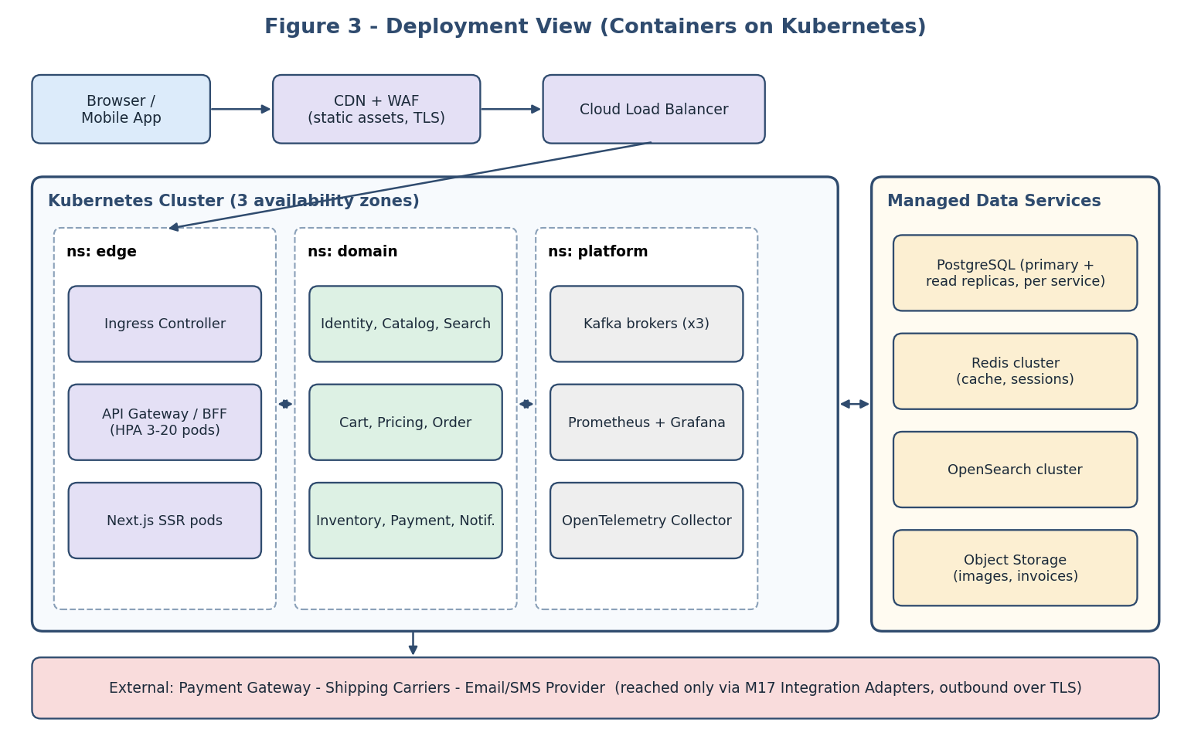
Figure 3: Deployment architecture on Kubernetes with managed data services

5.2 Cross-Cutting Concerns
Concern | Approach
Authentication and authorisation | OIDC login at M5; JWT checked at M4 and re-validated by services; fine-grained RBAC at service level; service-to-service mTLS
Observability | Structured JSON logs with correlation ID; RED metrics (rate, errors, duration) per endpoint; distributed traces; SLO dashboards and alerts
Resilience | Timeouts on every call, retries with exponential back-off and jitter, circuit breakers, bulkheads, graceful degradation (e.g. show cached catalogue if Pricing is slow)
Configuration and secrets | Environment-based configuration; secrets in Vault or cloud KMS; feature flags for safe rollouts
API versioning | Semantic versioning; additive changes only within a version; deprecation window of at least six months
Security | Input validation, OWASP Top 10 controls, WAF rules, dependency and container scanning in CI, least-privilege IAM

6. Scalability

6.1 Horizontal Scaling of Stateless Services
All services keep no session state in memory. Kubernetes Horizontal Pod Autoscalers add or remove instances based on CPU and request-rate metrics; the Gateway, Storefront, Search, and Catalog services, which see the highest read traffic, scale independently of the Order or Payment services, which see far lower traffic but need higher consistency.

6.2 Scaling the Read Path
- CDN caches static assets and cacheable API responses at the edge.
- Redis caches hot product and price data; PostgreSQL read replicas serve reporting and non-critical reads.
- Search is offloaded to OpenSearch, so catalogue browsing never touches transactional tables.

6.3 Scaling the Write Path
- Database-per-service allows each database to be sized and tuned separately; high-volume tables (orders, events) can be partitioned by date or customer.
- Kafka absorbs bursts: notification, reporting, and indexing work queues up and is processed at the consumers' pace.
- Inventory reservations use atomic conditional updates and may be sharded by SKU if a hot-item bottleneck emerges.

6.4 Resilience Under Peak Load
- Rate limiting and load shedding at M4 protect core services.
- Queue-based checkout fallback can be enabled by feature flag during extreme spikes.
- Scheduled pre-scaling before planned sales; load tests (k6) run in CI against a staging environment.

6.5 Support for Future Enhancements
Future enhancement | How the architecture accommodates it
Recommendation engine | New service consumes product and order events from M15 and exposes a REST endpoint through M4; no change to existing services
New payment methods / providers | Add an adapter in M17; M12 and M10 remain unchanged
Multi-currency and multi-region | Currency handled in M9; regional deployments replicate stateless tiers, with data partitioned by region and Kafka mirroring
Marketplace / multi-vendor payouts | New Vendor and Settlement modules subscribe to order and payment events
Additional channels (voice, kiosk, B2B API) | New client or BFF added at the edge; domain services reused
Loyalty programme | New service driven by OrderPlaced; offers exposed through M9 rules
Splitting a service | Because contracts and data ownership are explicit, a module can be extracted into its own deployable with no consumer changes

7. Maintainability and Independent Development

7.1 Independent Development
- Clear ownership: each module has an owning team, a repository (or directory with code owners), and a README describing responsibilities and contracts.
- Contract-first: OpenAPI/protobuf/event schemas are agreed and versioned before coding. Teams can build against generated stubs and mocks while dependencies are still in progress.
- Consistent service template: a starter project provides logging, metrics, health checks, security defaults, and the same layer structure, reducing cognitive load between modules.
- Layer rules: controllers depend on services, services on repository interfaces, never the reverse. Architecture tests (e.g. ArchUnit) enforce these rules in CI.

7.2 Independent Deployment
Each module has its own pipeline: build, test, scan, containerise, deploy to staging, run smoke tests, then progressive rollout (canary or blue-green) to production. Backwards-compatible database migrations (expand, then contract) and feature flags allow code to be deployed without being released, and any module can be rolled back without affecting others.

7.3 Testing Strategy
Level | Scope and tools | Isolation technique
Unit tests | Domain logic, price rules, state machines (JUnit, Jest) | Repositories and adapters mocked; target at least 80% coverage on business logic
Integration tests | Service with its real database, cache, or broker (Testcontainers) | Throw-away containers per test run
Contract tests | Consumer-driven contracts between modules (Pact, schema registry compatibility checks) | Each side verified against the contract without the other running
Component tests | A single deployed service via its API with dependencies stubbed (WireMock) | External calls stubbed
End-to-end tests | Critical journeys: search, add to cart, checkout, refund (Playwright) | Small, stable suite in staging
Non-functional tests | Load (k6), security (OWASP ZAP), resilience (fault injection) | Run on schedule and before major releases

Following the test pyramid, most checks are fast unit and contract tests, giving a rapid feedback loop; few slow end-to-end tests protect the revenue-critical flows.

7.4 Module Independence Matrix
The table below shows, for each key module, what must exist for it to be developed and tested alone.
Module | Depends on (at runtime) | How it is isolated for development and test
M1 / M3 | M4 only | Mock API server generated from OpenAPI
M4 | Domain services | Stub services; contract tests
M8 Cart | M9, M11 | Stub gRPC servers from protobuf; Redis container
M10 Order | M11, M12, M9, M15 | Fake Inventory/Payment; embedded Kafka
M11 Inventory | M15 (publish only) | Fully testable with PostgreSQL container
M12 Payment | M17 (provider) | Provider sandbox or WireMock
M13 Notification | M15, M17 | Replay recorded events; fake mail adapter
M7 Search | M15, OpenSearch | Rebuild index from fixture events

7.5 Governance and Evolution
- Architecture Decision Records (ADRs) capture the context, options, and rationale of significant decisions.
- Quarterly architecture review checks coupling, dependency direction, and the need to split or merge services.
- Technical-debt backlog and fitness functions (build time, test flakiness, cyclic dependencies) track maintainability over time.
- Documentation as code: API docs, diagrams (C4 model), and runbooks live in the repositories and are reviewed with code.

8. Risks and Mitigations
Risk | Impact | Mitigation
Distributed-system complexity | Harder debugging, partial failures | Tracing, correlation IDs, standard templates, start with a few deployables
Eventual consistency surprises | Stale reads (e.g. search lagging stock) | Re-validate at checkout; show lag metrics; document consistency guarantees
Third-party outage | Failed payments or messages | Adapters with circuit breakers, retries, secondary provider option, queued notifications
Hot-SKU contention | Slow or failed reservations during flash sales | Atomic updates, sharding by SKU, queue-based checkout fallback
Schema/contract drift | Integration breakage | Schema registry compatibility rules and contract tests in CI
Operational overhead | Slower delivery, cost | Managed services, GitOps, platform team, cost dashboards

9. Conclusion
The proposed architecture separates ShopSphere into four clearly bounded concerns: user interface (M1-M3), business logic (M5-M14), data access (M16), and integration (M4, M15, M17). Each concern is realised by modules with explicit responsibilities, contracts, and owners. Stateless services, caching, a dedicated search engine, and an event backbone allow the platform to scale with demand, while contract-first interfaces, per-module pipelines, and a layered testing strategy let teams develop, test, and release modules independently. The design can therefore serve as a stable baseline for detailed design, implementation, and testing in the next phases, and can evolve through additional modules rather than rewrites.

10. References (Publicly Available)
Ref | Source | Location
R1 | Fowler, M. and Lewis, J. - Microservices (article). | martinfowler.com/articles/microservices.html
R2 | Microsoft - Azure Architecture Center: Architecture styles and cloud design patterns. | learn.microsoft.com/azure/architecture
R3 | Wiggins, A. - The Twelve-Factor App. | 12factor.net
R4 | AWS - Well-Architected Framework. | docs.aws.amazon.com/wellarchitected
R5 | Fowler, M. - What do you mean by "Event-Driven"? | martinfowler.com/articles/201701-event-driven.html
R6 | Richardson, C. - Microservices.io: Saga, Transactional Outbox, API Gateway patterns. | microservices.io/patterns
R7 | Microsoft - API gateway and Backends-for-Frontends patterns. | learn.microsoft.com/azure/architecture/patterns
R8 | OWASP - Application Security Verification Standard and Top 10. | owasp.org
R9 | PostgreSQL Global Development Group - PostgreSQL Documentation. | postgresql.org/docs
R10 | Redis - Documentation. | redis.io/docs
R11 | Vercel - Next.js and React documentation. | nextjs.org/docs ; react.dev
R12 | VMware/Broadcom - Spring Boot reference documentation. | docs.spring.io/spring-boot
R13 | Apache Software Foundation - Apache Kafka documentation. | kafka.apache.org/documentation
R14 | Kubernetes Authors - Kubernetes documentation. | kubernetes.io/docs
R15 | Brown, S. - The C4 model for visualising software architecture. | c4model.com
R16 | Newman, S. - Building Microservices, 2nd ed., O'Reilly (book). | oreilly.com

