SUBMISSION -1

NAME: VIDISHA GROVER

CODE: GSBSP-BR52

HTML CODE: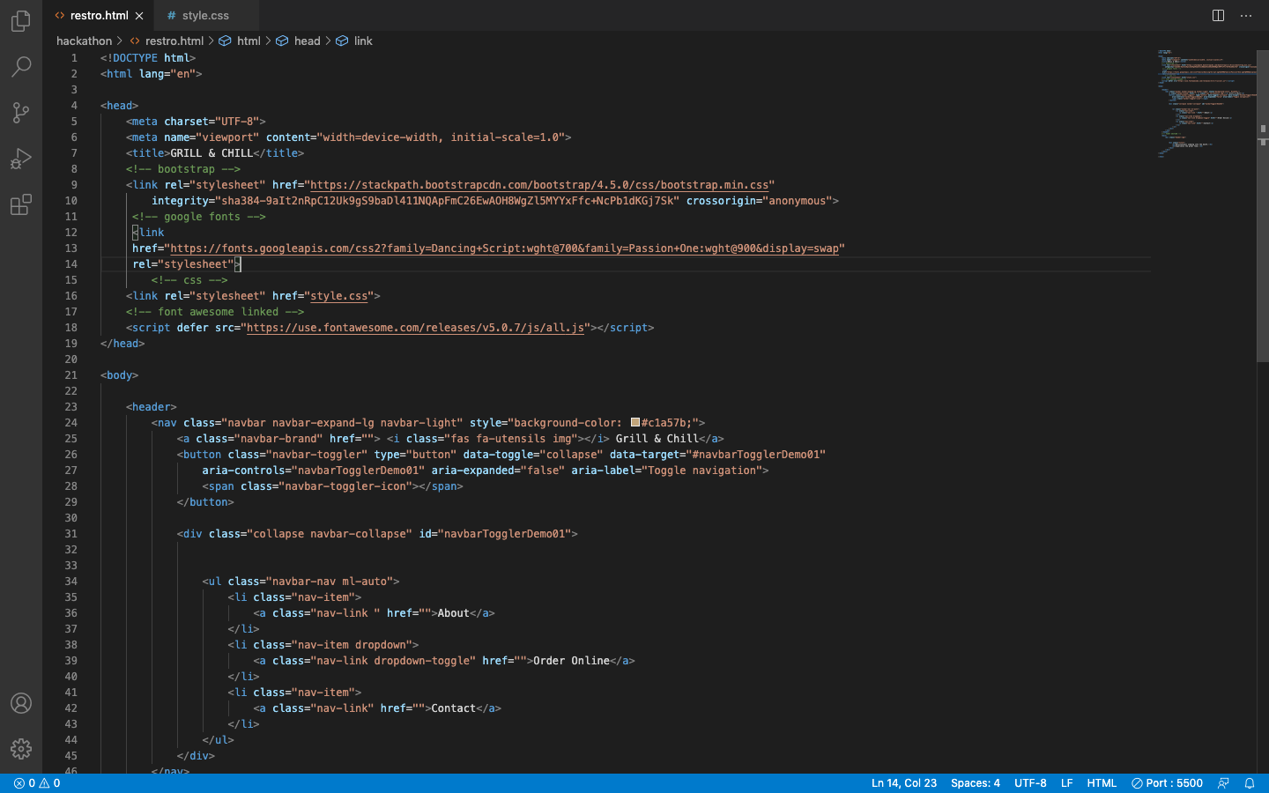

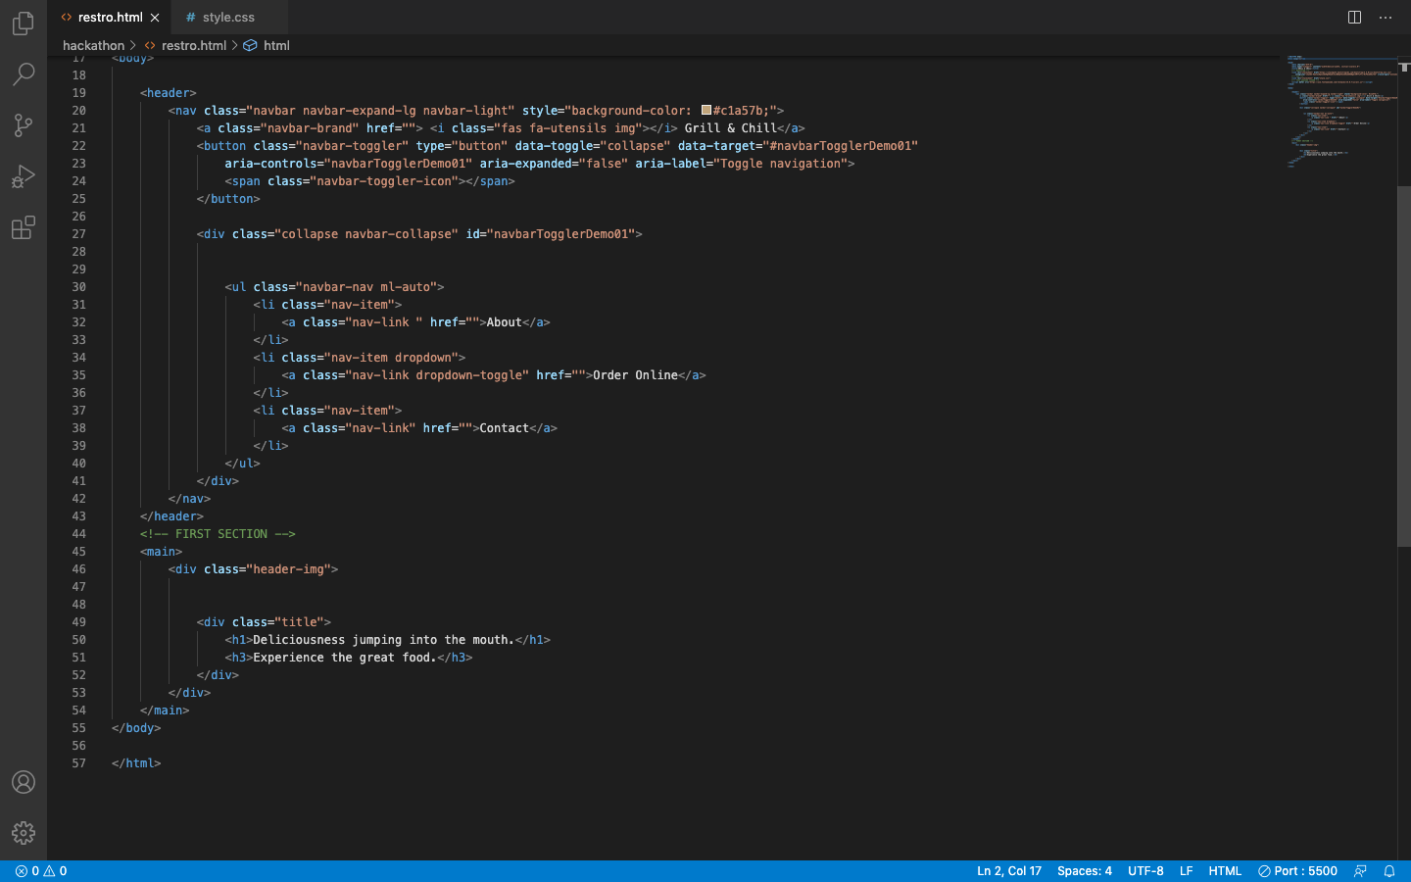

CSS CODE: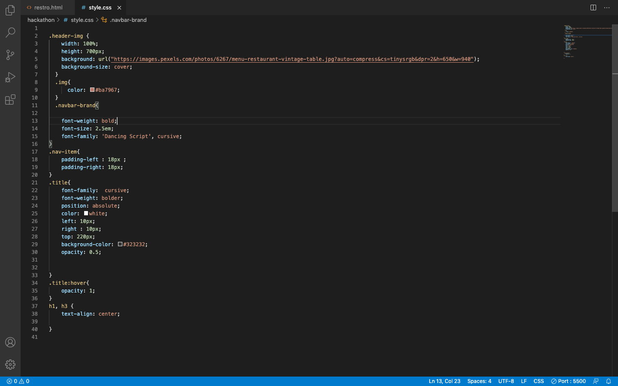

WEBSITE: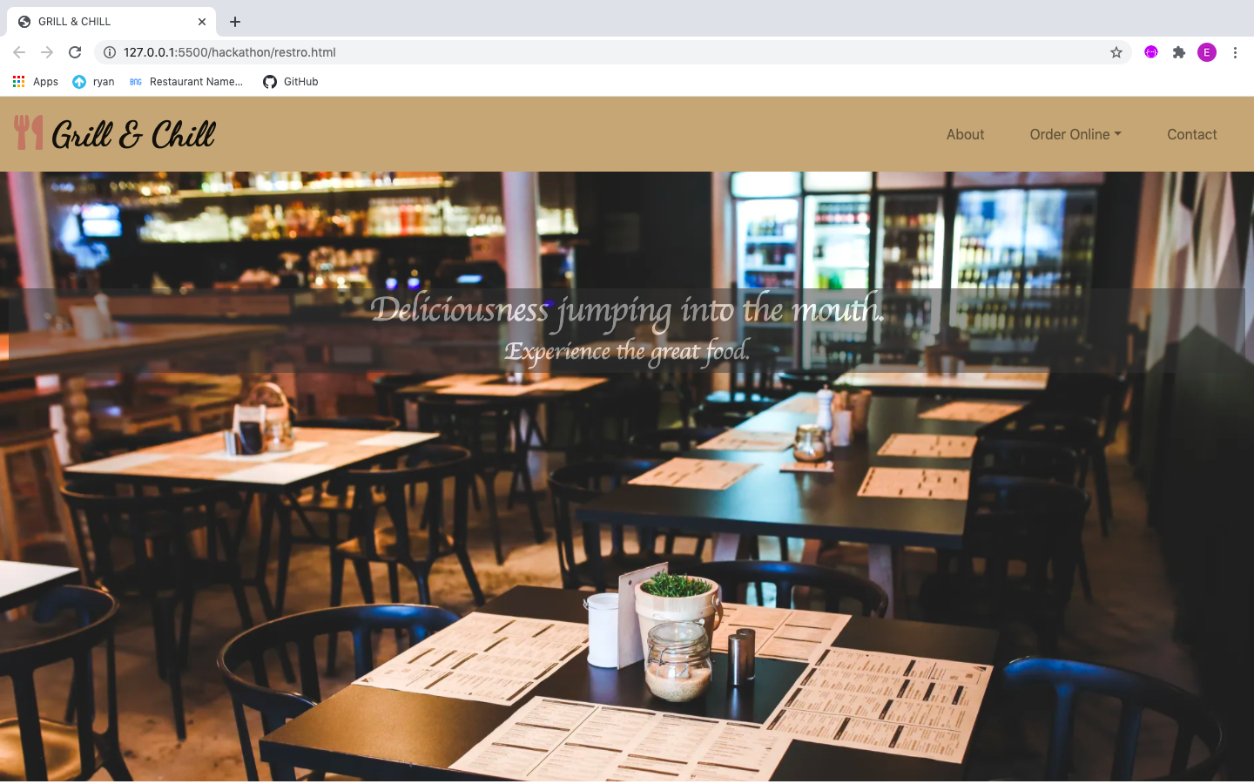

Except writing HTML and CSS codes i have taken help from BOOTSTRAP , GOOGLE FONTS , FONTAWESOME.COM for the logo and

[PEXELS.COM](http://PEXELS.COM) for the background image.

POINTS COVERED:

1. NAV BAR
2. HOME PAGE
3. COMPANY LOGO