SUBMISSION -2

NAME: VIDISHA GROVER

CODE: GSBSP-BR52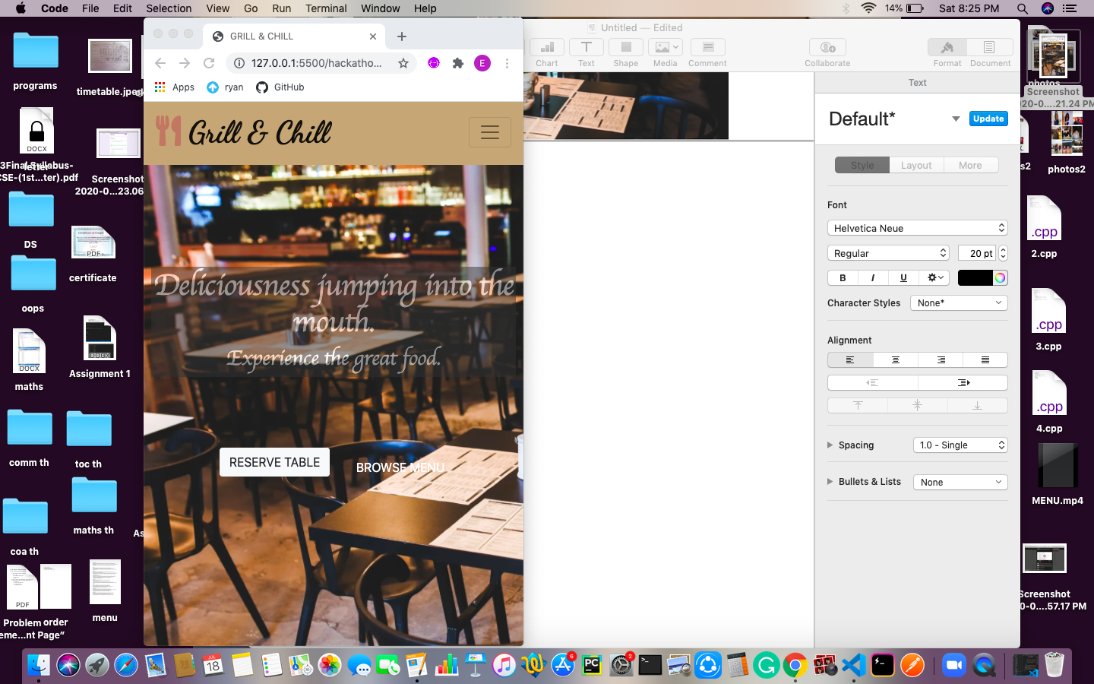

Made little changes in home page added two buttons.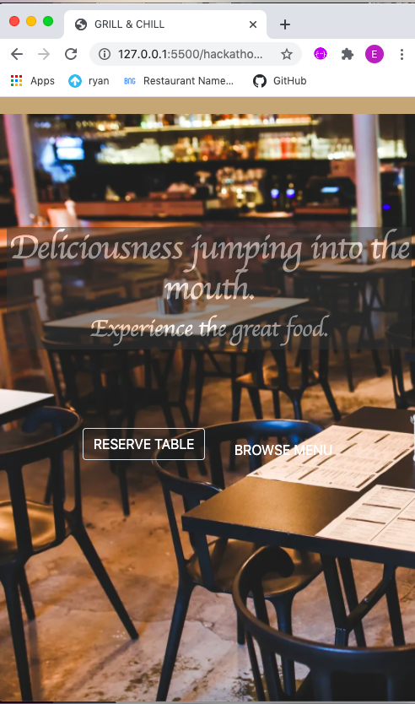

Added hover property for buttons.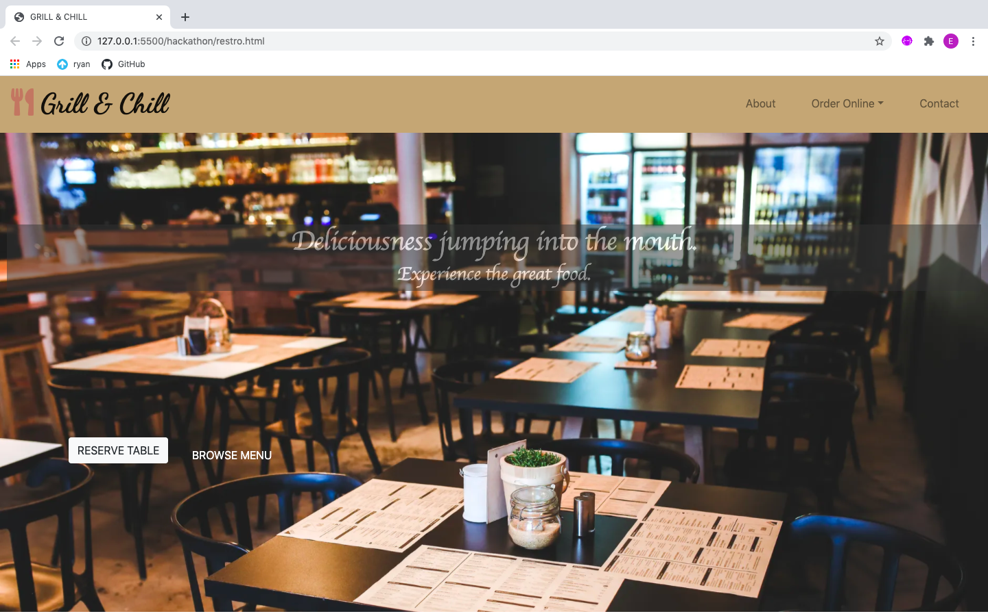

Added **ABOUT** section: Given basic description and added icons from [fontawesome.com](http://fontawesome.com) to make the section little more attractive. 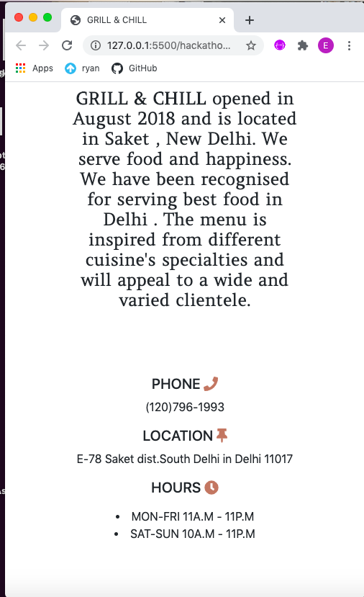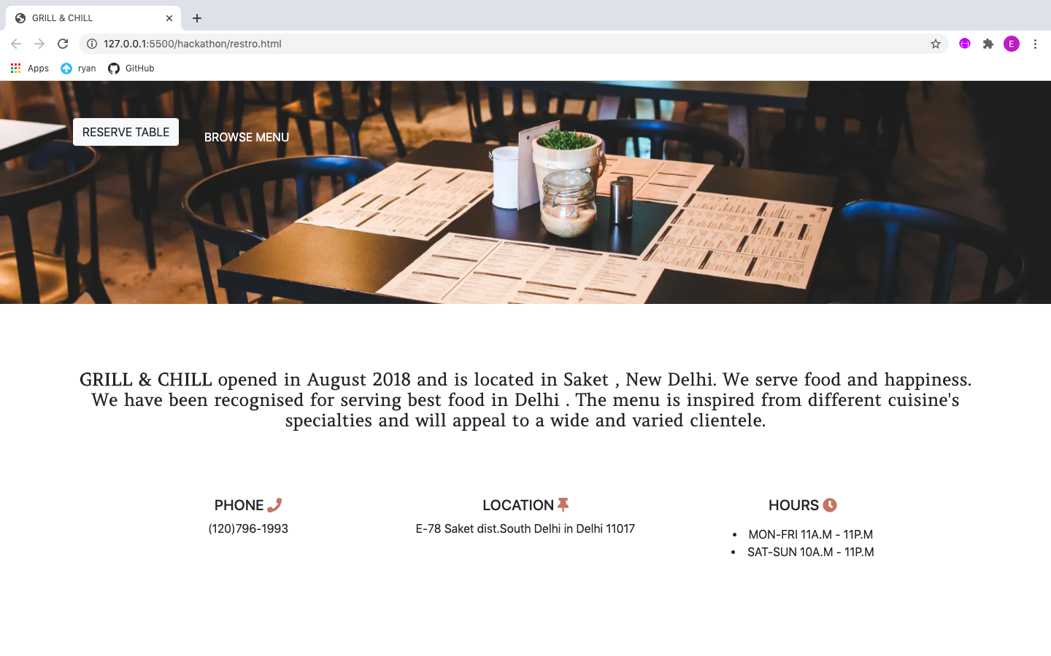

Added a carousel using Bootstrap to have reviews and rating section and added wonderful fonts using Google fonts. Added this section to make website more realistic .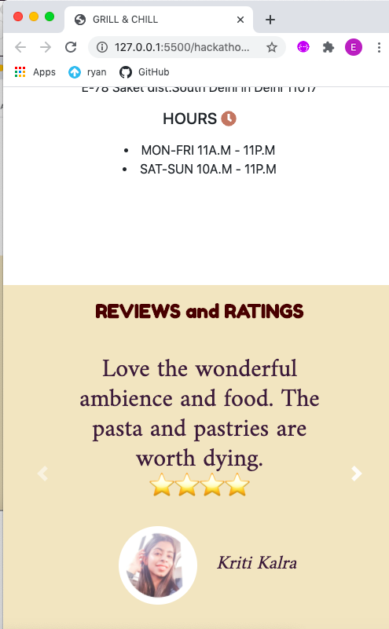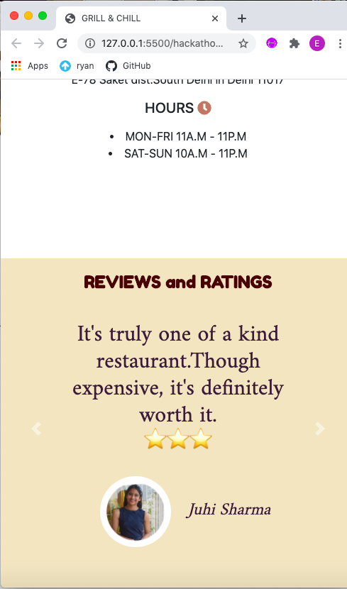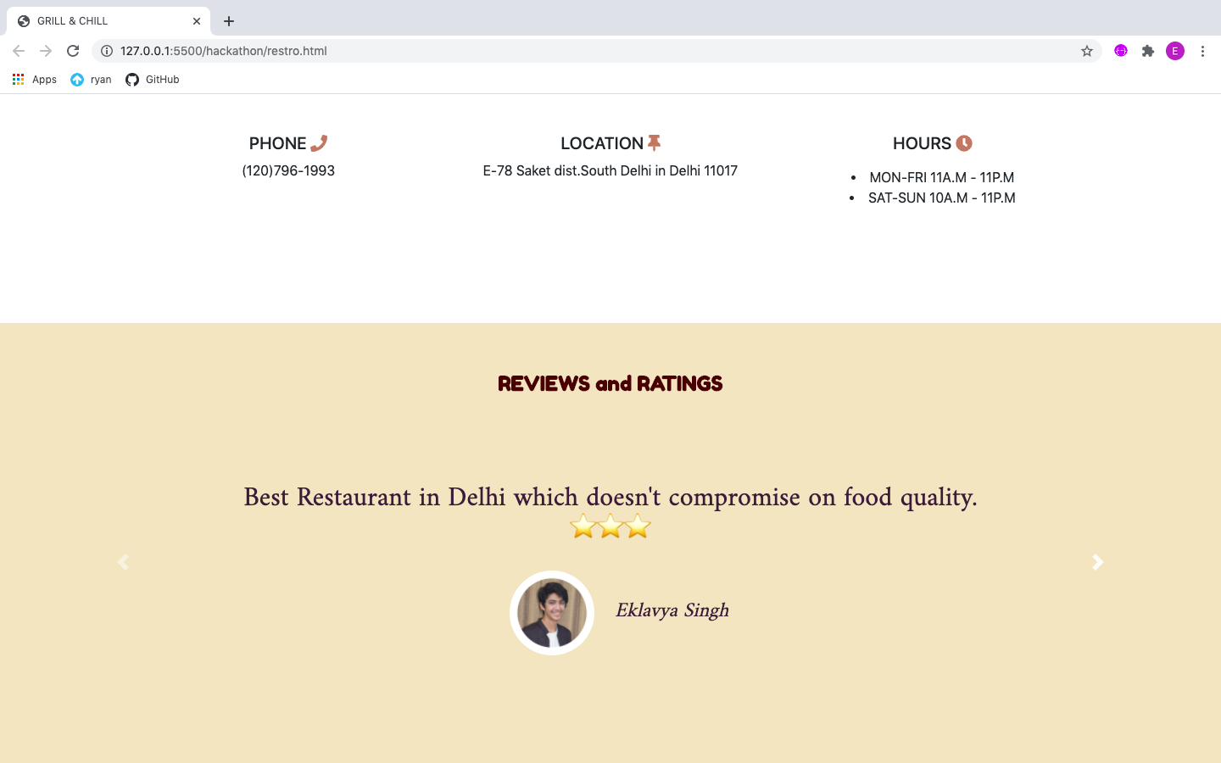

Except HTML & CSS codes I have taken help from BOOTSTRAP to add buttons & carousel , [FONTAWESOME.COM](http://FONTAWESOME.COM) for adding icons , GOOGLE FONTS for adding different fonts , JSS for carousel feature and I have used my family names and images for reviews and ratings section.

POINTS COVERED:

1. NAV BAR
2. HOME PAGE
3. COMPANY LOGO
4. ABOUT SECTION
5. BUSINESS LOCATION