SUBMISSION -3

NAME: VIDISHA GROVER

CODE: GSBSP-BR52

MENU section includes exactly 30 dishes with their related contents.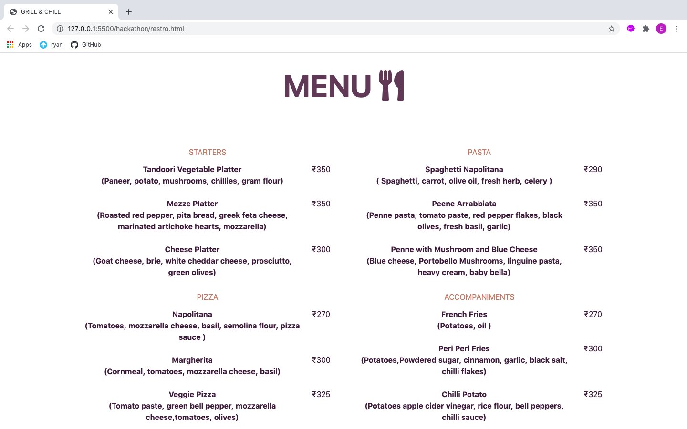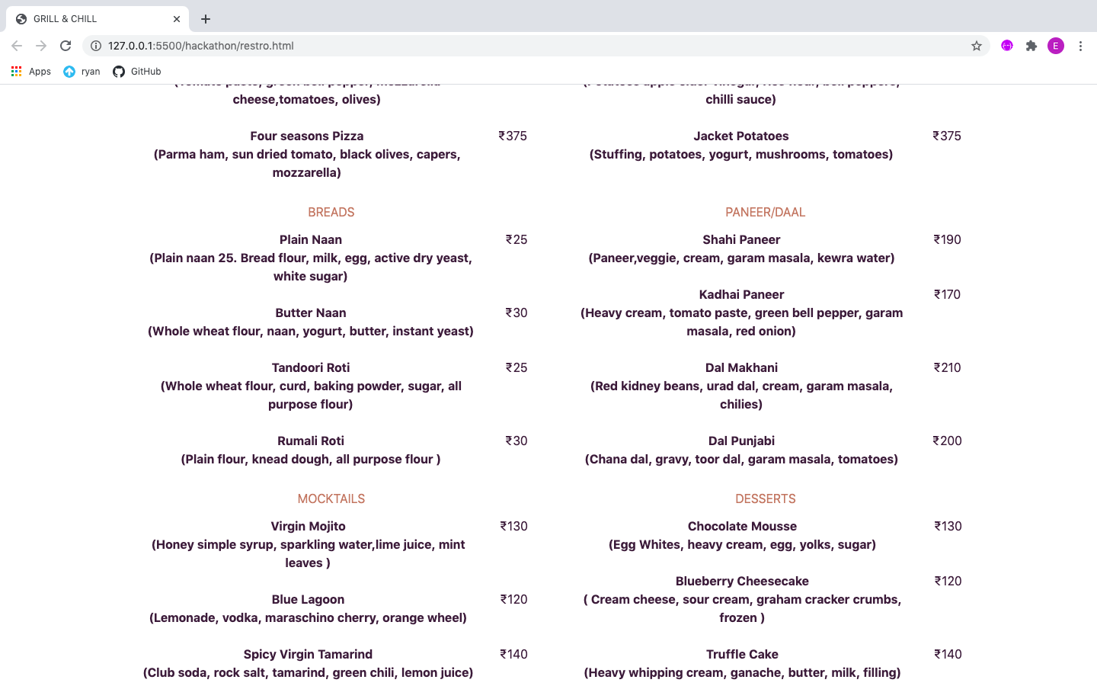

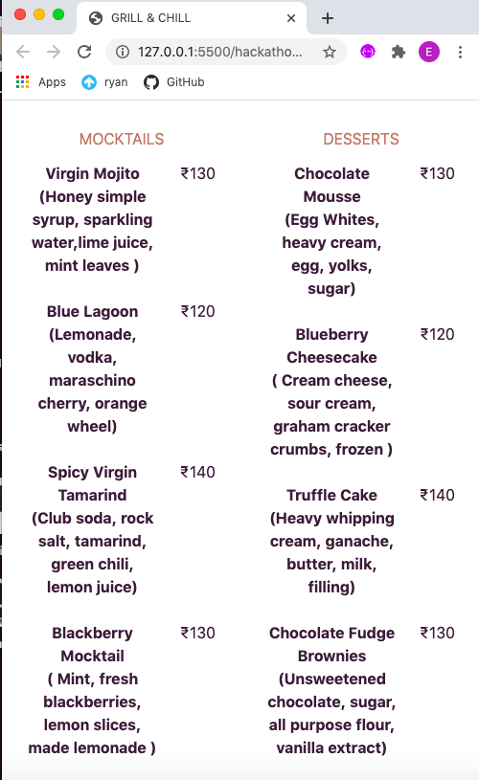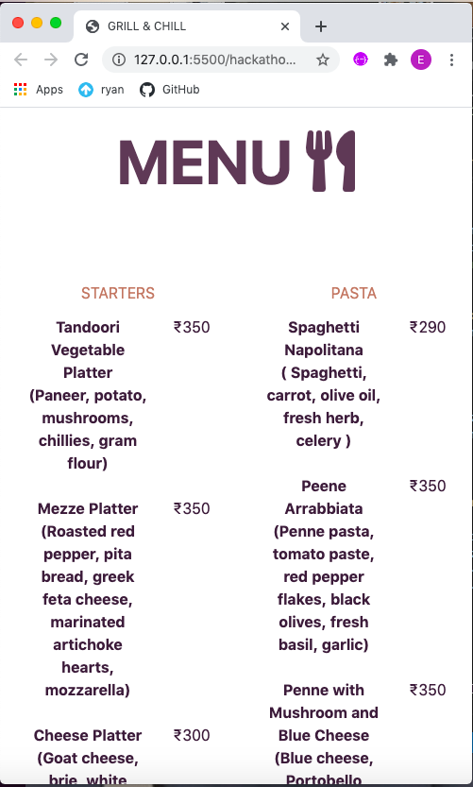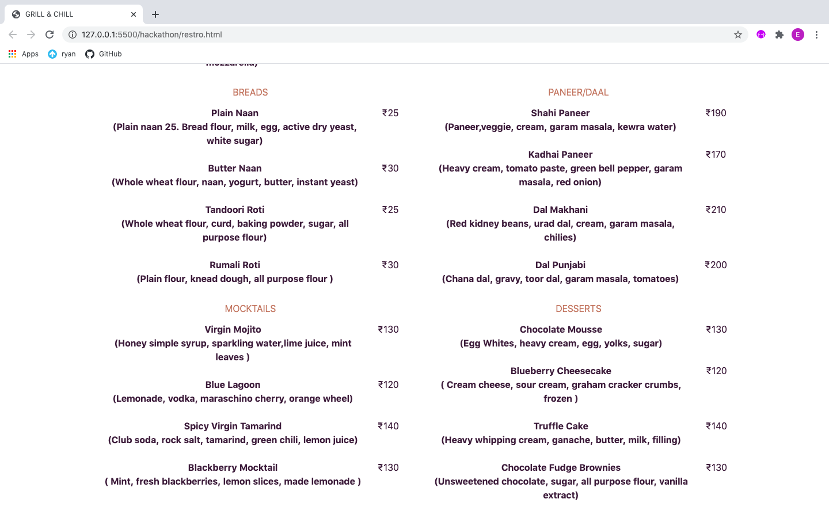

POINTS COVERED UPTIL NOW:

1. NAV BAR
2. HOME PAGE
3. ABOUT SECTION
4. MENU WITH 30 DISHES AND THEIR CONTENTS
5. COMPANY LOGO
6. BUSINESS LOCATION